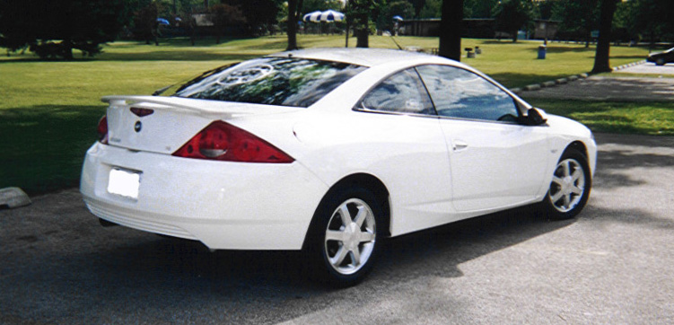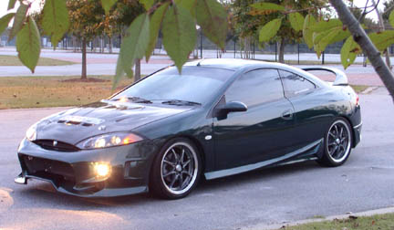

Dear Fellow Cougar Owner,

Each and every month a group of folks meet that have the same vehicle and share the knowledge of this beautiful vehicle, the Cougar. There is absolutely no cost involved with this, nor any other obligations. We currently have members in the Atlanta Metro, Savannah, Macon, and other outlying areas in the state of Georgia. Whether you have a modified Cougar or a totally stock Cougar you are invited to attend the meets that are held! Now you may ask how do I find out when these meets are and how can I get to know the people around Georgia better? Well you can simply point your web browser to www.fastcougar.com/forums. Scroll on down to the C.O.O.G.A section and you will see a set area for the Cougar Owners of Georgia. Join up and you can start posting on this message board! If you have any questions or you are having troubles feel free to email dgnzcoug@hotmail.com.

Sincerely,
COUGAR Owners of Georgia

