Reflection of 2008
http://www.angelfire.com/mn/saldapal/reflection.2008.html

Despite the "economic" outlook of 2008, I'm looking forward (e.g. Minnesota Vikings football team going to their first playoffs in 4 years!) to the "New Year" because of my trust (see FAITH) in God! Please pray for wisdom and knowledge that I can share with giving "hope" for the community (Stevens County) I live in through Steven's Forward. I've faced some challenges in the past and gone this far-with God's help! Going to keep persevering! I've watched many movies (evil vs. Good), which it looks like "evil" was winning; however, Good comes overtop at the end. That's the way I see it in our daily life challenges or battles. We go through seasons (e.g. Winter, Spring, Summer, etc...) in life, but we know it's not going to last forever. Don't give-up no matter what circumstances you go through. The Heavenly Father- Creator has a plan and purpose in your life!
To "try" preparing myself for 2009's "poor economic" outlook, I decided to look for a possible "second" (backup) career in teaching ESL (see GoodnewsEverybody: Liberal Arts-English). In 2008, I took my first college course since I graduated from college back in 1999. It was also my first online course too, which I was somewhat "weary" when I first took it in the Summer quarter. I've been volunteering as the coordinator for the Morris Literacy Project-ESL Classes and GED classes with the local Morris Community Ed for over 4+ years now!
I had a great "bonding" time with my nephew (Stefan), who turned 1 years old in September! Also, spending time with my niece (Alysa), who turned 4 in August. Coming home (St. Paul) to family once a month was something "extra" to look forward to when "hanging-out" with them! During part of the summer (1+ week of the 3 months), I had the opportunity to take my relatives visting from the Philippines to various parts (e.g. Duluth) of Minnesota-including my town of residence-Morris!.
Living in the college-town where I went to school (95'-99') gives me the opportunity to "keep-in-touch" with many alumns. I had a great time hanging out with friends (Shannon and Joey, Gina) that has been coming here the last 4+ years during UMM Homecoming. Also, meeting "new" people through alumns...
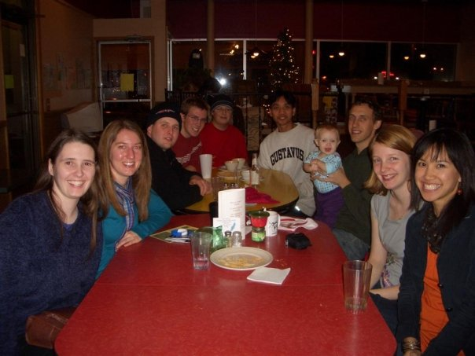
November 22nd of 2008 at Common Cup
As I was challenged in 2008, I was "layed" off from work (Stevens County D.A.C.-full-time job, which I worked some hours at Prairie Community Services-part-time job-thank God) for close to a month in May. During this time, I was able to work some hours at my part-time job (group home)-used to be my full-time job when I first started in 1999. Also, I worked on my "side-hobby" (e.g. multi-media projects, created new sites=> GoodnewsMorris.info & GoodnewsMinnesota.info) I thought it was God's timing for me to go back to my job (community-setting) because of the circumstance (feel free to contact me for more details). Other challenges were: Window broke on my car at Sauk Centre before driving to the cities before Christmas (see story), etc...
I was just reading (Monday, December 29th of 2009) my "Reflection of 2007" to see what I can write about 2008. My "New Year's Resolution for 2008" is to continue to "slow down more" and take it day my day as was last year. Please feel free to remind me throughout 2008 of this to keep me accountable!
Like all past years, 2008 too had some challenges/disappointments (e.g. friend in prison)-lesser and also victories/blessings (e.g. going on my 3+ years with Special Touch Ministries, teacher once a month for Sunday School (a.k.a. "Children's Church) at my local church, playing for my local church softball team....
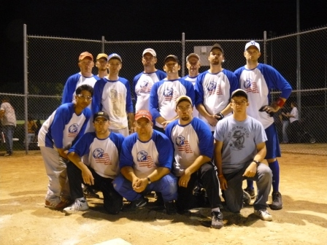
Record: 5-13

{Photo Gallery}
-American Eagle (see Morris Community Church Newsletter-Nov 08', Minnesota Twins went from "below" .500 record in 2007 to "almost" clinching the Division Championship) . Also, our very own Twin-Justin Morneau wins the "Homerun Derby" (followed by second place-Josh Hamilton's inspirational story.
I thanked Him for this blessing, which I asked Him how I can use it to bless others. I hope and pray that you too can ask God how you can bless/give to those who are "unfortunate". In 2008, I challenge you all to "Count Your Blessings" before going to bed; no matter what circumstances you faced during each day! Feel free to contact me (e-mail me your own reflections of the past year or keep me updated throughout this new year or even let me know of any particular prayer requests-I'm part of a weekly morning prayer group through my local church) when you are around the Morris area of Minnesota to visit because "me casa es tu casa"!

