Aquarium Wave Generator
Mechanical Engineering Senior Project

Project #: 589-04A
Advisor: Dr. Andrew Gerhart

Submitted by:
Aaron Goodwin
Mike Pyrkosz

April 30, 2004
Lawrence Technological University

Table of Contents

Executive Summary…………………………………………………………………… ii
1. Introduction…………………………………………………………………………… 1
2. Vision and Mission Statement ……………………………………………………... 2
3 Product Description………………………………………………………………….. 3
4. Market Research……………………………………………………………………...4
5. Specification Development
- Customer Survey…………………………………………………………….5
- Pairwise Comparison………………………………………………………..6
- QFD…………………………………………………………………………...7
6. Concept Design Analysis
- Specification Requirements and Weights………………………………...8
- Functional Decomposition……………………………….…………………9
7. Selected Concept……………………………………………………………………10
8. Diverting Valve and Plumbing Diagram……………………………………………11
9. Theoretical Analysis For Valve and Plumbing System…………………………..12
10. Valve Components and Prototype Fabrication…………………………………. 15
11. Testing and Evaluation…………………………………………………………….16
12. Results……………………………………………………………………………….17
13. Conclusions and Recommendations……………………………………………..18
12. Project Timing
- Gantt Chart………………………………………………………………….19
13. References………………………………………………………………………….20
14. Appendix
- BlueLine HD Flow Chart…………..………………………………………22
- Resumes………………………………………………………………...23,24
Executive Summary

This proposal details preliminary information about the proposed senior project, Aquarium Wave Generator. The purpose of this project is to design, build and test a wave-generating device that will meet the needs of saltwater reef aquarist. Waves and currents are important to marine invertebrates (corals) and other biological process, which occur in the ocean. A reef aquarist who desires to kept corals in an aquarium will need a product that can reproduce the ocean’s wave motion. A Vision statement and a Mission Statement are presented. A short description of the device’s function along with necessary research is presented. A list of survey questions, developed to help meet customer’s needs and define engineering specifications, is also included, along with a Pairwise Comparison and QFD Chart. Total hypothetical cost for the one-year project is expected to be $141,392. A Gantt chart and division of responsibilities are also shown.

Introduction

Water movement is one of the most important requirements for coral health. In the ocean, currents, waves, surges, internal waves, and tides provide this movement.

Currents are formed by winds and tides that move large masses of water. They are predominately unidirectional (laminar). These occur at depths below 50 feet. Waves occur as ocean currents move toward the shore and the depth of the substrate decreases causing the wave to form and break as it reaches shore. This flow is considered oscillatory and occurs at water depths of 15-50 feet. As these waves impact physical objects below the surface, a surge is formed. This type of flow is more violent than current and oscillatory flows and shapes the reef structure. Surges occur at depths less than 15 feet and are responsible for causing internal waves around corals and other physical objects as waves impact them. Tides are caused by gravitational effects from the moon and result in large amounts of water to be exchanged. This removes biological waste and rain diluted saltwater from ocean reefs and replaces used nutrients.

Since corals are sessile animals, they rely on water movement to sustain them. Water movement is responsible for moving nutrients past them for capture. It also removes waste from the animal and allows gas exchange (respiration) to take place. When these biological processes occur efficiently, photosynthesis and calcification rates increase. The caring aquarist will want to provide adequate water movement for the health of his corals. Different species of corals require different types and speeds of water movement.

This project will present research data collected from biologists on the ocean’s water motion and what aquarists want in a wave device. Data from these two sources will be combined to determine the best design. Testing of the device against realistic water motion data will determine if the design is meeting its target specifications.

Vision Statement

Develop a wave-generating device, for aquarium use, that mimics the ocean’s water motion.

Mission Statement – Wave Generating Device
Product Description | • Device to simulate the alternating flow of ocean currents
Key Business Goals | • Produce alternating flow based on collected data from the ocean  • Requires minimal in-tank space or is externally mounted  • Easy to add-on to existing aquarium  • Improve on current market products
Primary Market | • Average amateur aquarist
Secondary Market | • Public and commercial aquarium facilities
Assumptions and Constraints | • Final product cost not to exceed competitive market price  • Use readily available components to produce device
Stakeholders | • Purchasers and users  • Retailers  • Distributors

Product Description

The device designed for this project will simulate the oscillating motion of ocean currents. There are many different devices that are commercially available, but each of these has different performance abilities and varied costs. Each of the available devices, currently on the market have advantages and disadvantages. Our product will attempt to improve on the features offered commercially. The wave-generating device must be small, so as to not take up valuable in-tank space and be aesthetically pleasing. An externally mounted device with outputs into the tank is desirable. The device should be easy to add on to an aquarium that is currently running, but should not require the tank to be emptied and dismantled.

Water motion and velocity of the flow should be comparable to that found in nature. The wave-generating device should have some type of flow adjustment to reduce the velocity of the water output. The aquarist should also be able to adjust the direction of the water output to achieve desired results. Different corals require different water motion requirements. In the ocean, Stony corals experience water flow rates of 5 to 10 inches per second. Soft corals receive water flow rates of 0.5 to 6 inches per second (Borneman 337). Proper placement of a coral in an aquarium will help to provide the correct amount of flow for a particular coral.

Market Research

To obtain a better idea of what specifications the product needs to meet, research is required. This research will come from a number of sources. Books on aquariums and on the biology of coral life forms can be used to get a better understanding of what the product needs to do. The Internet will be a useful tool in looking at existing products on the market to generate different ideas for the product. Finally interviews with professional and amateur aquarists will be valuable in determining prospective customer wants and needs. These interviews can be conducted either in person or on Internet forums.

Specification Development

Customer Survey

Part of the research for this product was to survey the persons most likely to be interested in it. This included: Professional aquarists, marine biologists, pet-store owners, and amateur aquarists. To gather this information, surveys were posted on five Internet forums.
The following questions were asked:

- What are the dimensions of your aquarium (length, height, depth)?
- How many gallons of water does it hold?
- What type of corals do you have in your tank? (Mushrooms, Soft, or Stony)
- What type of water motion do your corals require? (laminar, oscillary, or surge flow)
- What method do you currently use for generating this motion?
- How much did you spend in setting up your present water movement system?
- Would you prefer a device inside the tank or outside the tank?
- How much in-tank space are you willing to use for such a system?
- Would you prefer PVC slip connections or hose barbs for inlets and outlets?
- Is it important to be able to turn off this device or connect it to a timer?
- Should there be adjustment of the wave flow or frequency or direction?
- Is it important to be able to disassemble for cleaning?
- Would you require a warranty on the device before buying it?

Based on these questions, the most important requirements were: the product must be water tight, reliable, provide adequate water flow, and have the ability to disassemble for cleaning. Most people would also expect the product to come with a warranty. These and other customer requirements were organized and weighted in the Pairwise Comparison shown in Table 1.

Research on the Internet provided a survey of popular aquarium sizes in use by saltwater hobbyists. The most common sizes were 125, 75, and 55-gallon tanks. These come in standard shapes and thus the dimensions of these tanks are readily available. The initial design will be sized and tested in a 125-gallon tank. The dimensions of this tank are 18.5” high x 72.5” long x 18.5” deep.

The Quality Function Deployment (QFD in Table 2) was used to relate customer requirements to engineering specifications. These specifications were then assigned target values that the design should achieve.

Table 1: Pairwise Comparison

Table 2: Quality Function Deployment

CUSTOMER REQUIREMENTS |  | ENGINEERING REQUIRMENTS |  |  |  |  |  |  |  |  |  |  |  |  | BENCH-  MARK
Aquarium Wave Generator |  | Weight (total = 100) | Flow output | Water velocity | Height of Device | Width of Device | Depth of Device | Noise Level | Useful Life | Valve Flow Inlet | Valve Flow Outlet | Rotational Speed of Valve | Set-up Time Required |  | SCWD (“squid”) Wavemaker
Function | Mounted Outside Tank | 6 |  |  | 6 | 6 | 6 | 7 |  | 7 | 7 |  | 9 |  | 5
Function | Mounted Inside Tank | 0 |  |  | 9 | 9 | 9 |  |  |  |  |  | 8 |  | 1
Function | Velocity of Water Flow | 8 | 8 | 9 | 3 | 3 | 3 | 5 |  | 9 | 9 | 7 |  |  | 3
Function | Amount of Water Flow | 8 | 9 | 8 | 3 | 3 | 3 |  |  | 9 | 9 | 7 |  |  | 2
Function | Function in Different Tank Shapes/Sizes | 5 | 9 | 8 | 5 | 5 | 5 |  |  |  |  |  |  |  | 4
Function | Variety of Models Available | 1 | 9 | 9 | 2 | 2 | 2 |  | 6 | 9 | 9 | 9 | 7 |  | 1
Function | Easy to Add to Existing Aquarium | 6 |  |  | 8 | 8 | 8 |  |  | 8 | 8 |  | 9 |  | 4
Function | Water Tight | 10 |  |  |  |  |  |  | 9 |  |  |  |  |  | 5
Function | Reliable | 10 | 7 | 8 |  |  |  | 4 | 9 |  |  |  |  |  | 3
Function | Quiet Operation | 5 | 5 | 5 |  |  |  | 9 |  |  |  | 8 |  |  | 4
Function | Visual Indicator of Operation | 2 |  |  |  |  |  |  | 7 |  |  |  |  |  | 1
Function | Power Switch | 2 |  |  |  |  |  |  | 8 |  |  |  | 7 |  | 1
Function | Compatible with a Timer | 6 |  |  |  |  |  |  | 5 |  |  |  | 7 |  | 3
Function | Accurate Instructions | 2 |  |  |  |  |  |  | 4 |  |  |  | 9 |  | 4
Function | User-Friendly Instructions | 1 |  |  |  |  |  |  | 4 |  |  |  | 9 |  | 3
Function | Disassembly for cleaning | 9 |  |  |  |  |  |  |  |  |  |  |  |  | 1
Function | Compact | 4 |  |  |  |  |  |  |  |  |  |  |  |  | 3
Function |  |  | 7 | 7 | 9 | 9 | 9 |  |  | 7 | 7 |  | 8
Cost | Inexpensive | 5 | 7 | 7 |  |  |  | 9 | 9 | 7 | 7 |  |  |  | 4
Cost | Warranty | 8 | 2 | 2 |  |  |  |  | 9 |  |  |  |  |  | 3
 | Units |  | gpm | in/s | in. | in. | in. | db | years | in. | in. | rpm | hours
 | Targets |  | 20 | 5-10 | 8 | 14 | 3 | 0 | 3 | 1 | 1 | 4 | 4
 | SCWD (“squid”) Wavemaker |  | 11 | 3 | 8 | 5 | 4 | 0 | 1 | .50 | .50 | 10 | 4
ENGINEERING SCORES: 9 = Strong Relationship; 1 = Weak Relationship

BENCHMARK SCORES: 5 = Meets customer requirements; 1 = Does not meet customer requirements

Table 3: Specification Requirements and Weights

Above in Table 3, engineering specifications (metrics) from the QFD were rated with respect to level of importance on a scale of 1 to 5. This rating was based on customer requirements. For example, survey responses revealed that a water tight and reliable product was most important. Therefore, the metric, “useful life”, was rated a 5 because it most accomplishes what potential customer’s want in a wave generating device.

Next, ideal values were determined for each of the metrics based on customer surveys and research data of measured water motion in the ocean. Since ideal values may prove cost prohibitive to the average consumer, marginal values are also provided.

Metric No. | Metric | Imp. | Units | Marginal Values | Ideal Value
1 | Flow Output | 4 | gpm | 10 | 20
2 | Water Velocity | 4 | in/s | 3-13 | 8
3 | Height of Device | 3 | in. | 4-12 | 8
4 | Width of Device | 3 | in. | 10-18 | 14
5 | Depth of Device | 3 | in. | 1-5 | 3
6 | Noise Level | 3 | db | >60 | >30
7 | Useful Life | 5 | years | 1-5 | 5
8 | Valve Inlet Diameter | 4 | in. | .38-1.62 | 1
9 | Valve Output Diameter | 4 | in. | .38-1.62 | 1
10 | Rotational Speed of Valve | 3 | rpm | 0.25-4 | 1
11 | Set-up Time Required | 2 | hours | 1/2-8 | 1/2

Wave Generator
Energy (Electricity)
Water
Energy
(Water Motion)
Water

Figure 1: Function Diagram

Function Statement:

Wave Generator will simulate the oscillating motion of ocean currents by generating water motion in a tank using a mechanical device. This device will be mounted outside of the aquarium with minimal obstruction inside the aquarium (see Figure 1 for “black box” depiction).

Subfunctions:

- 1. Generate oscillating water motion in aquarium
- 2. Water tight
- 3. Adjustable flow output

The Wave Generator design must accomplish each of these subfunctions to meet customer requirements and therefore have a chance of success as a product. When combining methods of accomplishing each subfunction, various concepts were developed. Some combinations were discarded as impractical. Each of these concepts was rated based on its approximated performance against the engineering metrics. Most of these concepts are available commercially. One concept stood out with the most potential for success. The selected concept (shown below) functions similar to the benchmark product (SCWD pronounced “Squid”). The selected design will accomplish the same effect but with different internal components. At the beginning of this project, the SCWD was not available commercially.

Selected Concept

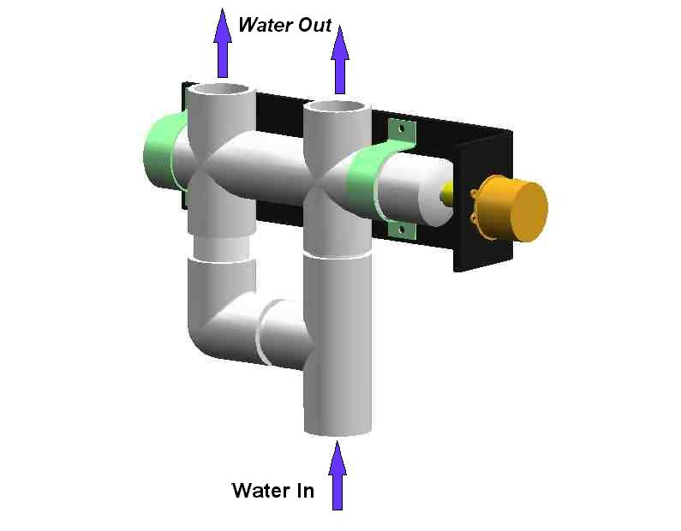
Figure 2

In this concept drawing, a valve is shown with a single inlet and two outlets. The flow of water alternates between the outlets. This would be accomplished by putting a cylinder in between the inlet and outlets. The cylinder would have two holes in it that are inline with the outlets and 90 degrees from each other. The cylinder is connected to a motor that rotates nominally at 1 rpm. When one hole lines up with its respective outlet, all of the water is diverted to that pipe. As the motor rotates the cylinder, the flow is gradually decreased in that pipe and gradually increased into the second outlet until all the water is flowing through it. The diverter valve concept connects to a single pump and allows the pump to run continuously. One outlet of the valve is plumbed to one end of the tank and the second outlet on the opposite side. The flow gradually increases and decreases, more like a wave on a reef (Figure 3).
Figure 3: Diverting Vale shown with required pump and pluming
Pump Outlet
(2) Places

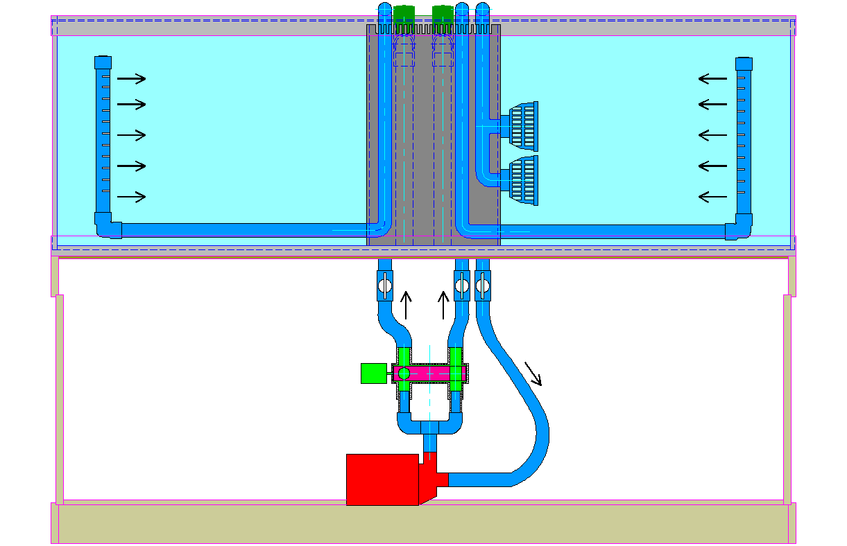
Magnetic Drive Pump
Diverting Valve
Pump Intake

Theoretical Analysis For Valve and Plumbing System

The selected size of the valve and plumbing lines were based on space restrictions and recommended flow rates. The engineering metric for valve inlet and outlet diameter was 1 inch. All of the components, in contact with the water, required the use of plastic materials. This prevents corrosion caused by the saltwater. It also prevents leaching of metals into the saltwater. PVC fittings and pipe were used for the valve body and connected plumbing. The Plastic Pipe and Fittings Association recommends a maximum water velocity of 5 to 8 feet per second in PVC pipe (PPFA 2). Based on a 20 gallon per minute flowrate (see engineering metric), nominal 1 in. PVC pipe (1.033 in. I.D.) was selected to transport the water to and from the valve. Water velocity calculations were done to check this pipe size.

$$\begin{aligned}\text{Properties of saltwater }(\text{Munson, Young, and Okiishi inside cover}): \\ \text{Density }ρ=1\text{.}\text{99}\frac{\text{slugs}}{{\text{ft}}^{3}} \\ \text{Specific weight }γ=\text{64}\text{.}0\frac{\text{lb}}{{\text{ft}}^{3}} \\ \text{Kinematic viscosity }ν=1\text{.}\text{26 E-5}\frac{{\text{ft}}^{2}}{s} \\ \\ \text{Pipe inside diameter}=1\text{.}\text{033 in}\text{.}=0\text{.}\text{08608 ft}\text{.} \\ \text{Area}=\frac{π}{4}D^{2}=\frac{π}{4}(0\text{.}\text{08608}\text{ft})^{2}=0\text{.}\text{00582}{\text{ft}}^{2} \\ \text{Volumetric flow Q}=\text{20 }\frac{\text{gallons}}{\text{min}\text{.}}=0\text{.}\text{04456}\frac{{\text{ft}}^{3}}{s} \\ V=\frac{Q}{A}=\frac{0\text{.}\text{04456}\frac{{\text{ft}}^{3}}{s}}{0\text{.}\text{00582}{\text{ft}}^{2}}=7\text{.}\text{66}\frac{\text{ft}}{s}<8\text{.}0\frac{\text{ft}}{s} \\ \\ \text{So, 1 in}\text{.}\text{ PVC pipe is adequate}\end{aligned}$$

Next, using the mechanical energy equation, total dynamic head losses were calculated. This is the sum of all losses caused by elevation changes, friction, and plumbing fittings. The total elevation loss is 2.05 feet. Calculations were based on using a BlueLine HD 70 centrifugal pump. The flow chart from the pump manufacturer provided the volumetric flow rate for various head losses.
After a few iterations, the following losses were calculated.

$$\begin{aligned}\text{Minor losses from plumbing fittings:} \\ \text{Sum of loss coeficients for plumbing fittings, }{ΣK}_{L}=2\text{.}\text{64} \\ h_{L}={ΣK}_{L}\frac{v^{2}}{2g}=2\text{.}\text{64}∗\frac{(9\text{.}\text{838}\frac{\text{ft}}{s})^{2}}{2∗\text{32}\text{.}2\frac{\text{ft}}{s^{2}}}=3\text{.}\text{97}\text{ft} \\ \\ \text{Friction losses through pipe:} \\ \text{Length of pipe }ℓ=8\text{.}\text{45 ft}\text{.} \\ \text{Friction factor f from Moody chart }(\text{Re}=\text{67,000; }\frac{ε}{D}=0)\text{, f}=0\text{.}\text{02} \\ h_{L}=f\frac{ℓ}{D}\frac{v^{2}}{2g}=0\text{.}\text{02}∗\frac{8\text{.}\text{45}\text{ft}}{0\text{.}\text{08608}\text{ft}}∗\frac{(9\text{.}\text{838}\frac{\text{ft}}{s})^{2}}{2∗\text{32}\text{.}2\frac{\text{ft}}{s^{2}}}=2\text{.}\text{95}\text{ft} \\ \\ \text{Total Dynamic Head }(\text{TDH})=\text{ 2}\text{.}\text{05 ft}\text{.}+\text{ 3}\text{.}\text{97ft}\text{.}+\text{ 2}\text{.}\text{95 ft}\text{.}=8\text{.}\text{97}\text{ ft}\end{aligned}$$

The BlueLine pump is stronger that anticipated and produces velocities higher than initially desired. Using the flow chart, this pump pushes 26.3 gallons per minute at 8.97 ft.

The valve body was sized to maintain a 1 in. diameter passage for the water to flow through. To accomplish this, 1-1/4 in. PVC fittings were used to form the valve body. Reducing bushings were installed at the inlet and outlets to allow 1 in. fitting connections for the rest of the plumbing system.

The two outlets from the valve are plumbed behind the 125 gallon test tank using flexible PVC pipe. Flexible PVC U-fittings are used connect the pipe from behind the tank to the pipes inside the overflow box. The overflow box is used to allow water to drain below the tank for filtering. It is also used to conceal the plumbing lines inside the tank. The pipe exits at the bottom of the overflow box through 1 in. bulkheads. The pipe connected to these bulkheads travels under the sand substrate inside the tank, which conceals it from view. This pipe carries water to one end of the tank, where an elbow and a vertical submerged jet manifold are connected. The submerged jet manifold is made from ¾ in. pipe. It contains a series of holes that are evenly spaced along its length. From these holes the water exits into the tank. As shown in Figure 3, a submerged jet manifold, located at each end of the tank, is connected to its respective valve outlet.

In order to provide an even distribution of water flow between each of the holes in the pipe, the sum of the area of all of the exit holes must not exceed the cross-sectional area of the pipe.

$$\begin{aligned}\text{For 3/4 in}\text{.}\text{ pipe:} \\ \text{Pipe inside diameter}=0\text{.}\text{810}\text{ in}\text{.} \\ \text{Area}=\frac{π}{4}D^{2}=\frac{π}{4}(0\text{.}\text{810}\text{in})^{2}=0\text{.}\text{5153}{\text{in}}^{2} \\ \text{Using 1/4 in}\text{.}\text{ holes; Area of one hole}=0\text{.}{\text{04909in}}^{2} \\ \text{Number of holes}=\frac{0\text{.}{\text{5153in}}^{2}}{0\text{.}{\text{04909in}}^{2}}=\text{10 holes}\end{aligned}$$

So, each submerged jet manifold contains 10 holes evenly spaced along its 14 in. length (see Figure 4). This provides jets of water at various elevations along the height of the tank.

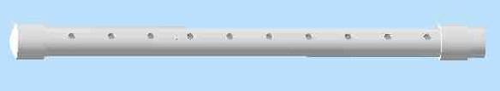

Figure 4: Submerged Jet Manifold

Valve Components and Prototype Fabrication

Prototype drawings can be found in Appendix #??
Note: There are two different models that have been created: One using 1 ¼ in fittings, and One using 1 in fittings. The 1 ¼ in model was the primary test prototype, while the 1 in model was a scaled down version made for display purposes. Each of these utilized unique valve cylinders.
Materials used include the following:
2x 1 ¼ PVC Cross
1x 1 ¼ PVC Tee
1x 1 ¼ PVC Elbow
1x 1 ¼ PVC Solid Cap
1x 1 ¼ PVC Threaded Cap
1x 1 ¼ PVC Thread adapter
20” 1 ¼ PVC pipe, (for connectors)
1 ½” Dia. x 12” Lng. Acetal
½” Dia. x 12” Lng. Acetal
½” EPDM rubber o-ring
¾” Dia. x 1 ½”Lng. 6061-T6 Aluminum
20” x 4” x ¼” Acrylic
2x 1 ¼” Pipe straps
6x 1/4-20 - 1” Lng. bolts
6x 1/4-20 nuts
2x 10-24 set screws
1 rpm AC Gearmotor (TM01MTR4475) + mounting bolts
8 rpm DC Gearmotor (TM01MTR4540) + mounting bolts
PWM DC Motor Speed Controller (6067KT)

Once materials were acquired individual pieces were machined using a lathe and mill. Then the valve body was glued, and the valve assembled.

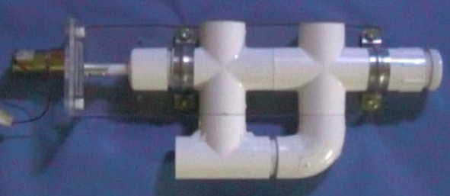

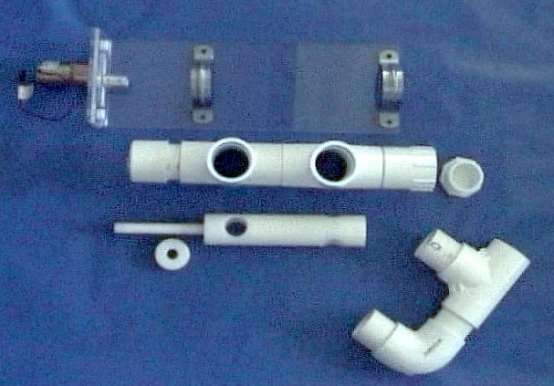

Figure 5: Assembled valve and its components

Testing and Evaluation

Equipment Used-
120 gal Test tank.
BlueLine HD 70 Pump
Submerged Jet Manifolds were constructed from 1” Dia. Pipe.
Lots of flexible PVC Piping and other fittings
5 gal bucket
Stopwatch
18” Ruler
Streamer stands were constructed from extra Acrylic plates and 1/8” rigid plastic tube for qualitative analysis

Test Procedures-

Qualitative testing: Qualitative testing was done by placing the streamer stands in the bottom of the tank and observing how the streamers reacted to changes in water flow.

Noise level…HOW MEASURED

Quantitative testing: Flow output was measured by replacing one of the submerged jet manifolds with a hose that was routed to a 5 gal bucket. The valve and pump were turned on for a timed cycle, and the amount of water in the bucket was measured. Velocity at jet was calculated by dividing this number by the flow cross-sectional area. In-tank velocity was measured using an 18” Ruler and stopwatch, and timing a particle of macro-algae.
Results

Shortly after the valve and pump were turned on, it became apparent that the valve was allowing water to pass through both outlets for too much of the cycle. Since both submerged jet manifolds were pointed at each other, the water motion from each end of the tank collided in the middle. This resulted in random swirls and eddies in this part of the tank (see Figure 6).

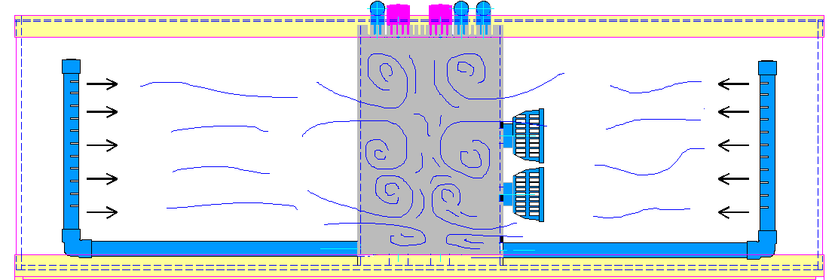

Figure 6
The volumetric flowrate of the water was measured and compared with the engineering metric set for this project. The flowrate through the valve was 26.4 gallons per minute. The target value was 20 gallons per minute.

From the measured flowrate, the velocity from each submerged jet was calculated. The water exits each jet at 8.63 feet per second. The water mass in the tank quickly slows down the velocity of the water jets. Thus, particles in the tank are moved about at an average velocity of 2 feet per second. The target value was 0.7 feet per second. This velocity as measured in the ocean, refers to a bulk fluid motion. The jets of water do not quite create this type of motion, so a higher velocity than the target value is good.

The valve was checked for noise, however none could be heard. Having the valve mounted under the aquarium, inside a cabinet, muffled any sounds the valve made.

The valve and pump were allowed to run continuously to determine the useful life to the valve. The o-ring was the first component to fail. After 30 minutes of operation, the o-ring began to leak and allow water to drip from the driveshaft. The target value for useful life was set at 5 years. Further investigation will be required to improve o-ring life. The valve was also susceptible to debris that passed through it and became trapped. This caused undue rotational resistance and hence motor wear.

Conclusions and Recommendations

The purpose of this project was to simulate ocean movement inside a salt-water reef aquarium. To do this a rotary valve was constructed, as described above, to alternate water flow from opposite sides of the tank. It was found that water was able to pass through both channels throughout the full cycle. This created flow pressure on both sides of the tank; the result being a great deal of random movement inside the tank. Although, random movement is also good for most corals, it is not the type of movement that this project was trying to create.

When the Open House display model was constructed, a redesign of the valve cylinder was made in an attempt to assuage the water passage issue. This redesign left the center of cylinder intact, while allowing water to flow through notches cut in the sides when the valve was opened. In this way, a full diameter would be utilized to stop the flow when the valve was closed. It was found that despite this effort, water was still able to flow around the cylinder when closed. This was caused by the fact that the cylinder diameter is such that it would fit inside the pipe connectors used; however, the crosses themselves have a larger inside diameter than the connectors. Therefore, since the connectors do not extend through the intersection of the water flow and the valve cylinder, the water has clearance to pass above and below the cylinder.

In addition to the space around the cylinder, it was determined that the portions of the cycle that each channel was “on” had too much overlap. A future design that would alleviate both problems has been conceptualized. This design would use a single cross that has the water flow inlet opposite the driveshaft; the valve cylinder would have a single bore on one end for water in, and transfer the water to one of the two outlets through a window in the side. In this way, each channel can be completely closed for different parts of the cycle.
Table 14: Project Gantt Chart

References

Borneman, Eric. Aquarium Corals: Selection, Husbandry, and Natural History.
New Jersey: T.F.H. Publications, 2001.

Munson, Bruce R., and Donald Young. Fundamentals of Fluid Mechanics. New
Jersey: John Wiley & Sons, 2002.

PPFA. “Specification Sheet for PVC pipe and fittings”. 28 October 2003.
<http://www.ppfahome.org/pdf/pvcpipewaterspec.pdf>.

Ulrich, Karl, and Steven Eppinger. Product Design and Development. Boston:
McGraw-Hill, 2000.

Appendix

- BlueLine HD flow chart
- Resumes (pages 24, 25) for - Aaron Goodwin
- Mike Pyrkosz

