Method 1: Turn grammar checker from “Grammar only” to “Grammar and style”
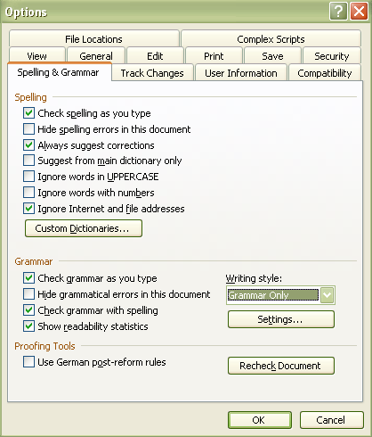
Click on: tools> options> Spelling and Grammar
Then, change grammar checker from “Grammar only” to “Grammar and style”.

Click on the “settings” button.
You may uncheck “contractions”, But make sure that “Use of first person” is checked.

Now, don’t click “ignore” during spell-check unless you really know what you’re doing!

Most common Error Message:
Passive Sentence: Don’t write, “The ball was kicked by the boy.” Instead, put the person who did the kicking up front: “The boy kicked the ball.”

Method 2: Proofread with CONTROL-F
Step 1: Press CTRL and F at the same time and this box will appear: 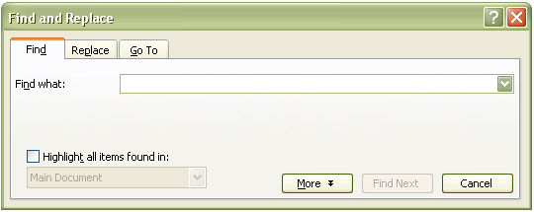
Step 2: type a word in. (See proofreading list below for some examples.)
Step 3: press FIND NEXT.
Step 4: look at each instance of the word or punctuation mark that is found, and then see if it is used correctly.
Step 5: press FIND NEXT to find more. Continue this until it says no more are found.

Look For the Most Common Errors:

You –If this word comes up and is not in a quote, figure out how to get rid of it. Sometimes, it can be changed to people or one.
Of – If it can be replaced with the word have and it makes sense, do so.
There is a place; it has the word here in it.
Their means belongs to them. It has heir in it. (An heir is someone who will come to possess property).
Where is a place; it has here in it. Where is my pencil?
Were is a verb. They were going to come over.
Then: First this, then that. If this, then that.
Than: Better this than that.
’s –Check to make sure that the word possesses the word that comes after it. If it isn’t, the apostrophe probably should be deleted.
Lot - Unless it means a place to park a car or a place to build a house, replace it with something better.
Its –If it can be changed to it is, then do so.
Aloud means out loud.
Allowed means permitted.
Kind of means a type of, as in "A hammerhead is a kind of shark.” This phrase does not mean a little or somewhat.
U -- If you use Instant Messaging or Text Messaging, do this search. You will have to check “find whole words only”.
Way – This word can only mean (1) a path (2) a method. It can never mean extremely.
Loose, Lose – The first is something that is not tied down or caged: The dog is loose. The second means to misplace: Don’t lose this money.
Cant – probably should be can’t.
Wont– probably should be won’t
Collage - art made of small pictures put together
College -- a university or academy
Defiantly – done with disrespect for authority
Definitely – without a doubt
Die, died, dying--the end of life
Die, died, dieing –to use a tool called a die
Dye, dyed, dyeing--to color or stain
Does - a form of “do” – I do, he does.
Dose - a measurement of medicine or poison
Exited, exiting--having left, leaving
Excited, exciting--stirred up emotionally
Conscience--that little spark within that guides us.
Conscious--awake.
Minuet - a musical piece
Minute - a measurement of time; can also mean tiny
Accept – to take willingly. Do not confuse with except.
Except - excluding; everything but this. Do not confuse with accept.
Barely--hardly, scarcely; Barley-- a grain

Method 2 is adapted from http://www.argo217.k12.il.us/departs/english/blettiere/CONTROL_F_Proofreading_TKM.pdf

