George Orwell’s novel 1984
Major Characters
Winston Smith: (age 45)
Works at the Ministry of Truth where he “doctors” or rewrites history to suit the party line.
Seems adjusted to his life on the outside, but seems to want something more internally.


Julia: (intro pg 9-10) (age 26)



O’Brien: (intro pg 10-11, 17-18)

Minor Characters
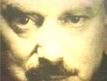  Big Brother Is the leader | 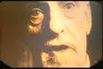  Emmanuel Goldstein: (intro pg 13-14) is the prime traitor and author of “the book,” The Theory and Practice of Oligarchic Collectivism. Everything gets blamed on Goldstein or his followers.
  The Parsons: (intro pg 20-24) Parsons comes from a typical Outer Party Family. He believes whatever the government tells him to believe, always smells of sweat, and is fat but athletic. Even when arrested he remains loyal. | 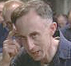  Syme is a philologist, a specialist in Newspeak who is politically orthodox and a hard worker. Nevertheless, Winston thinks he’s going to be vaporized: This fellow just thinks too much.
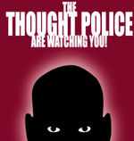 | The Brotherhood
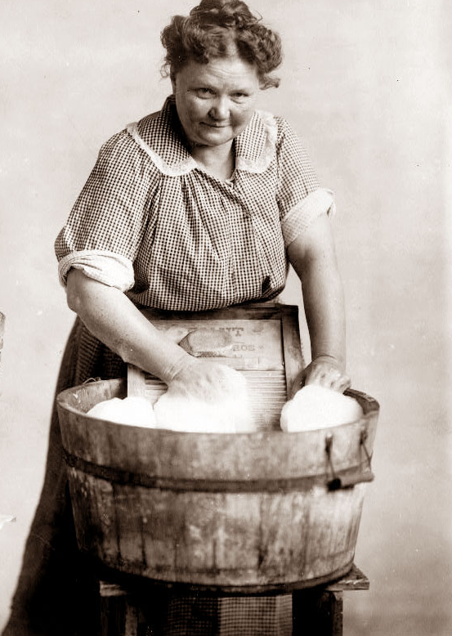  The Proles: (Part 1, Chapter 7) short for proletariat, the working class; about 85% of the population; uneducated but well fed and well entertained. "They were born, they grew up in the gutters, they went to work at twelve, they passed through a brief blossoming period of beauty and sexual desire, they married at twenty, they were middle-aged at thirty, and they died, for the most part, at sixty. Heavy physical work, the care of home and children, petty quarrels with neighbors, films, football, beer, and, above all, gambling filled up the horizon of their minds.” | 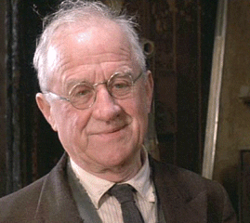  Mr. Charrington: proprietor of the shop, with the room that Winston and Julia rented, he seems a kind old man. He is in fact an informer to the Thought Police.

Terminology
Thoughtcrime and Thoughtcriminal

Oceania

Eurasia and Eastasia

Hate Week

Miniluv, Minipax, Miniplenty, and Minitrue

Newspeak and Oldspeak

The Golden Country

Plot Outline

Part One
- Introduction 1-20
  - London in 1984
    - The Telescreen
    - The Ministries and the Slogans
    - Big Brother
  - The Diary
    - Last Night’s Movie
  - The Two Minute’s Hate
    - Julia (unnamed as yet) and O’Brien
    - Emmanuel Goldstein & the Brotherhood
- Mrs. Parsons & Kids 20-29
  - The hangings
  - The Spies
- Memory: Just Dreams & Fragments
  - Dream of his Mother 29
  - Memory relies on History 30
  - The Physical Jerks 31
  - A Memory Fragment 32-33
- Controlling the Past
  - Winston’s Job
  - The Fantasy of Statistics
- Syme and Newspeak
  - Lunch
  - Syme’s Job – Destroying words
  - Parsons boasts of his Kids
  - Being Watched – Facecrime
- Sex
- Proles and History 69-81
  - The Proles I
    - Their possibilities 69-70
    - Their general description 70-72
  - History
    - A Children’s Textbook 72-73
    - History Unreliable 73-74
    - Jones, Aaronson, & Rutherford
    - Evidence Once in his Hands
- A Walk Amongst the Proles
  - The Steamer & The Lottery 83
  - The Interview 86
  - Back to Charrington’s 93
Part Two
- Making Contact
- Message delivered
- Rendezvous in the Square
- With Julia in the Woods
- Katherine; murder
- the purpose of sexual deprivation
- From the Woods; In the Church Tower
- Back to Charrington’s
- Black market 140
- The Rat
- Syme Vanishes
  - Syme Vanishes
  - Return to Charrington’s Flat
  - Political Talk
    - Possibilities for their relationship
    - Julia’s Disconnect
- Invitation to O’Brien’s Flat
- Winston’s Mother & the Vow 159
  - Winston’s Mother & Sister
  - The Proles are Still Human.
  - The Vow
- Inside O’Brien’s Flat 167
- The Book 179
- We are the Dead

Part Three
- The Place Where there is no Darkness
- Ampleforth, Room 101
- The Method
- 1st beatings
- 2nd endless interrogations
- 3rd Sessions with O’Brien
    - Where the past is
    - Self-control
    - Martyrs
    - Electroshock therapy
- The Party’s Motives
- Capitulation
- Physical recovery
- Rebellion in a cyst
- Obeying Big Brother is Insufficient
- Room 101
- The Chestnut Tree Café

