Samuel Parris (Major Character – Day 12)  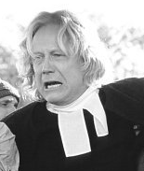Reverend Parris is the church leader for the town. He is fearful that accusations of witchcraft may fall on his household. He is worried about his daughter, Betty, who appears to be in a coma. He comes from the Barbados and ways does not understand the people of Salem. He doesn’t think that the people here respect the ministry enough. |  | Abigail Williams (Major Character – Day 12)  Abigail Williams has lived with her uncle Samuel Parris ever since being fired by the Proctors. She acts meek with her uncle, but when she’s with the group of girls she is not only in charge, telling them what they should and shouldn’t say, she is fierce. Before the play began, she had an affair with John Proctor, a married man, and she strongly believes that he still loves her. |  | Tituba  (minor Character – Day 12)  She is the servant of Samuel Parris. She comes from the Barbados and the other girls lay blame of witchcraft on her because of her Caribbean background.
John Proctor 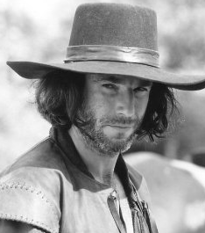(Major Character)  John Proctor is a strong-willed man who doesn’t like all the preaching about Hell that Rev. Parris does. He is outspoken in this opposition. Although he has cheated on his wife with a young girl, he is a big enough man to have come back to her; he tells Abigail he will never touch her again. | Thomas Putnam (minor character – day 13)    Mr. Putnam believes in the witchcraft. He is a backer of Rev. Parris. Putnam tries to claim John Proctor’s tract of timber, but the others say Putnam’s grandfather falsely willed it to him. |  | Giles Corey (minor character – day 13)  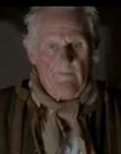  Giles Corey is an older person – the others accuse him of being deaf. Giles likes it when John Proctor stands up to Rev. Parris. He tells Rev. Hale that his wife reads books but won’t let him see them – this comes back to him.
 | Ann Putnam (minor character – day 13)  Mrs. Putnam strongly believes in witchcraft. She thinks that the girls are under a curse and not just acting silly. All of her children died as babies except Ruth., and she blames their deaths on witchcraft. |  | Rebecca Nurse (minor character – day 13)  Rebecca does not believe that the girls’ behavior is due to witchcraft; she thinks that the girls need a doctor instead. She backs John Proctor up when he complains about Rev. Parris always preaching about Hell, but she tries to rein him in when he starts talking rebelliously.

John Hale (Major Character, day 14)    Mr. Hale is an expert in witchcraft. He comes to Salem with zeal to crush any wickedness he finds there. He has pride in his learning. As he observes, however, he begins to believe that what he sees looks less like witchcraft and more like human malice. | Elizabeth Proctor (Major Character, day 16)  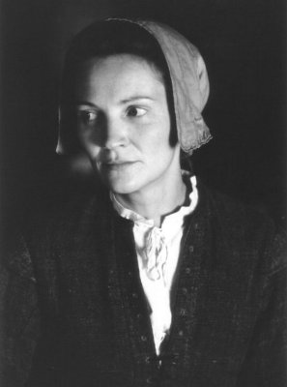  Elizabeth is John’s wife. She fired Abigail Williams after she found out about the adultery. It is unclear whether she has forgiven him, but she clearly has not forgotten it. Elizabeth is meek, as is shown when she is unable to control her teenage servant Mary Warren. |  | Mary Warren (Major Character – day 16)  Mary Warren is one of the girls accused of witchcraft. She is a servant in the Proctor’s house. She is a frightened girl, but one that is honest.
Francis Nurse (minor character – day 20)  Nurse is a wealthy landowner in Salem. He is respected, but has land disputes with his neighbors. |  | Judge Danforth (Major Character – day 21)  Danforth is the deputy governor of Massachusetts and the presiding judge at the witch trials. Honest and scrupulous, at least in his own mind, Danforth is convinced that he is doing right in rooting out witchcraft. However, he is too easily convinced by Abigail and the others. What is more, he doesn’t change any of his opinions when Abigail suddenly leaves town.
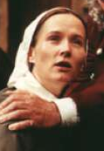Martha Corey (minor character)
Martha Corey’s reading habits get her into trouble.

