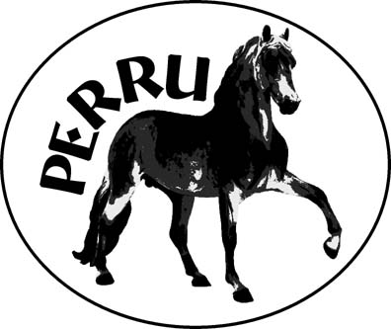

Peruvian Enthusiasts

& Recreational Riders Unlimited

A social club promoting the passionate enjoyment of the Peruvian Horse

Membership Application

Name(s) of adults in membership_______________________________

Juniors in membership_______________________________________

Ranch Name_______________________________________________

Address__________________________________________________

Town_______________________Province______Postal_____________

Telephone___________________Email__________________________

Fax number__________________ Preferred method of contact:_______

Individual $10.00 □ Family (Couple + minor children) $20.00 □

Membership is annual and does not require ownership of a Peruvian Horse. Members are welcome from any province or state. Annual membership entitles members to receive a discount on entry fees to most events and they also are eligible to participate in the Passion of Riding program.

Signature(s) of Adult members ________________________________

Make cheques or money orders payable to: PERRU

Mail to: Phone contacts for more information:
PERRU (403) 546-4320 Wanda Malsbury, President
C/O Chris Thurn, Secretary (403) 546-3106 Chris Thurn, Secretary
Box 586 (403) 546-4331 Mimi Busk-Downey, Treasurer
Linden, Alberta T0M 1J0

Affiliated Club of the Peruvian Horse Association of Canada
Affiliate organization of the Alberta Equestrian Federation.

