Peru’s Sacred Quest Tour
Pre-Inca and Inca Sites
with Lima, Trujillo, Cusco / Machu Picchu / Sacred Valley

Itinerary - Dates to be determined

Day 1 - Arrive in Lima Peru - transfer to hotel in Miraflores
Day 2 - City Tour, visit the Cathedral, Catacombs, Gold Museum. Late day transfer to airport for flight to Trujillo, transfer to beautiful Hotel on the square.
Day 3 - Tours of Moche temple Huaca de la Luna, and Chan Chan, ruins near Trujillo. Stay in Trujillo.
Day 4 – Travel overland to Chiclayo, visit new museum showcasing finds from Tomb of the Senor de Sipan. Transfer to Hotel in Cajamarca.
Day 5 – Tours near Cajamarca, late day flight to Lima.
Day 6 - Horse show Championships, shopping at Indian Market. (Larco Museum for those who are not going to horse show.)
Day 7- Several options that will include horseback riding on the beach and through the Lurin Valley, or excursions to haciendas, Pachacamac ruins for those who missed it.
Day 8 -- Several options including horseback riding, Optional trip to Nazca Lines if desired, (cost to be quoted) or tour of Cieneguilla valley near Lima.
Day 9 - Closing Ceremonies of horse show 9:00 - 1:00, then free afternoon to pick up any activities that have been missed during the week. This would be the day for city tour for those who did not arrive for the previous Sunday. Those who are not going to Cusco-Machu Picchu will transfer to airport late evening for the flight home.

Day 10 - Morning flight to Cusco, transfer to gorgeous hotel one block from main square, rest, pickup for tour of Cusco 1:00 PM. Visit the Inca Fortess of Cusco, Colonial Cathedrals, Temple of the Sun.
Day 11 - luxury tourist bus tour from Cusco to Sacred Valley. Stops at artisans making silver jewelry, a learning center for weaving Alpaca artifacts, a world famous ceramics artist, lunch in Urabanba, plus a tour of the ruins of Ollantaitambo, which are missed by many tours but are equal to any. Transfer to hotel in beautiful hotel Sacred Valley.
Day 12 - Luxury Train to Machu Picchu and back to Sacred Valley. (Note that it is only 2 hours train, instead of 4 hours from Cusco as most tours. This means you arrive before the main influx of tourists and get to stay longer during the day.)
Day 13 - Check out at 11:00; leisurely drive back to Cusco over different route and visit to Las Salinas salt fields. Transfer to same hotel near square. Free afternoon and evening in Cusco to explore the stores and sights.
Day 14 - Mid-morning flight back to Lima, transfer to hotel, get luggage out of storage if you left some there. Free afternoon and evening to organize for trip home, last minute shopping and last dinner as a group. Transfer to airport late evening for flight home.

The pricing for the entire itinerary is $3190 US. based on double occupancy. Single supplement for the whole trip is $475.

Included: All transfers to and from airports, ground transportation, flights inside the country, hotel, breakfasts, some meals if indicated, tours as indicated, visits to breeding farms.
Not included: Airfare roundtrip to Peru (may use airline points, purchase own ticket or we can arrange the best fare for you); International departure tax to leave Peru (about $28.00); horseback riding ($50 - $85/day); lunches and dinners unless invited by haciendas; optional tours.

If you are interested in booking on this tour, please download the CM Tour Agreement, contact is to determine dates that it will next run by email or phone.

Crescent Moon Tours
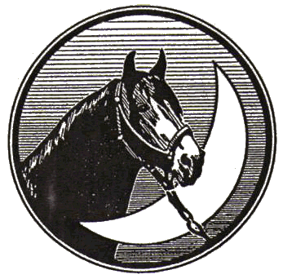
Dale Downey & Mimi Busk-Downey
Box 449, Acme, Alberta, Canada T0M 0A0
Phone (403) 546-4331

