I traveled to Manitoba with my Dad and Mom!
On the way to Manitoba we stopped at Lake Manitou!
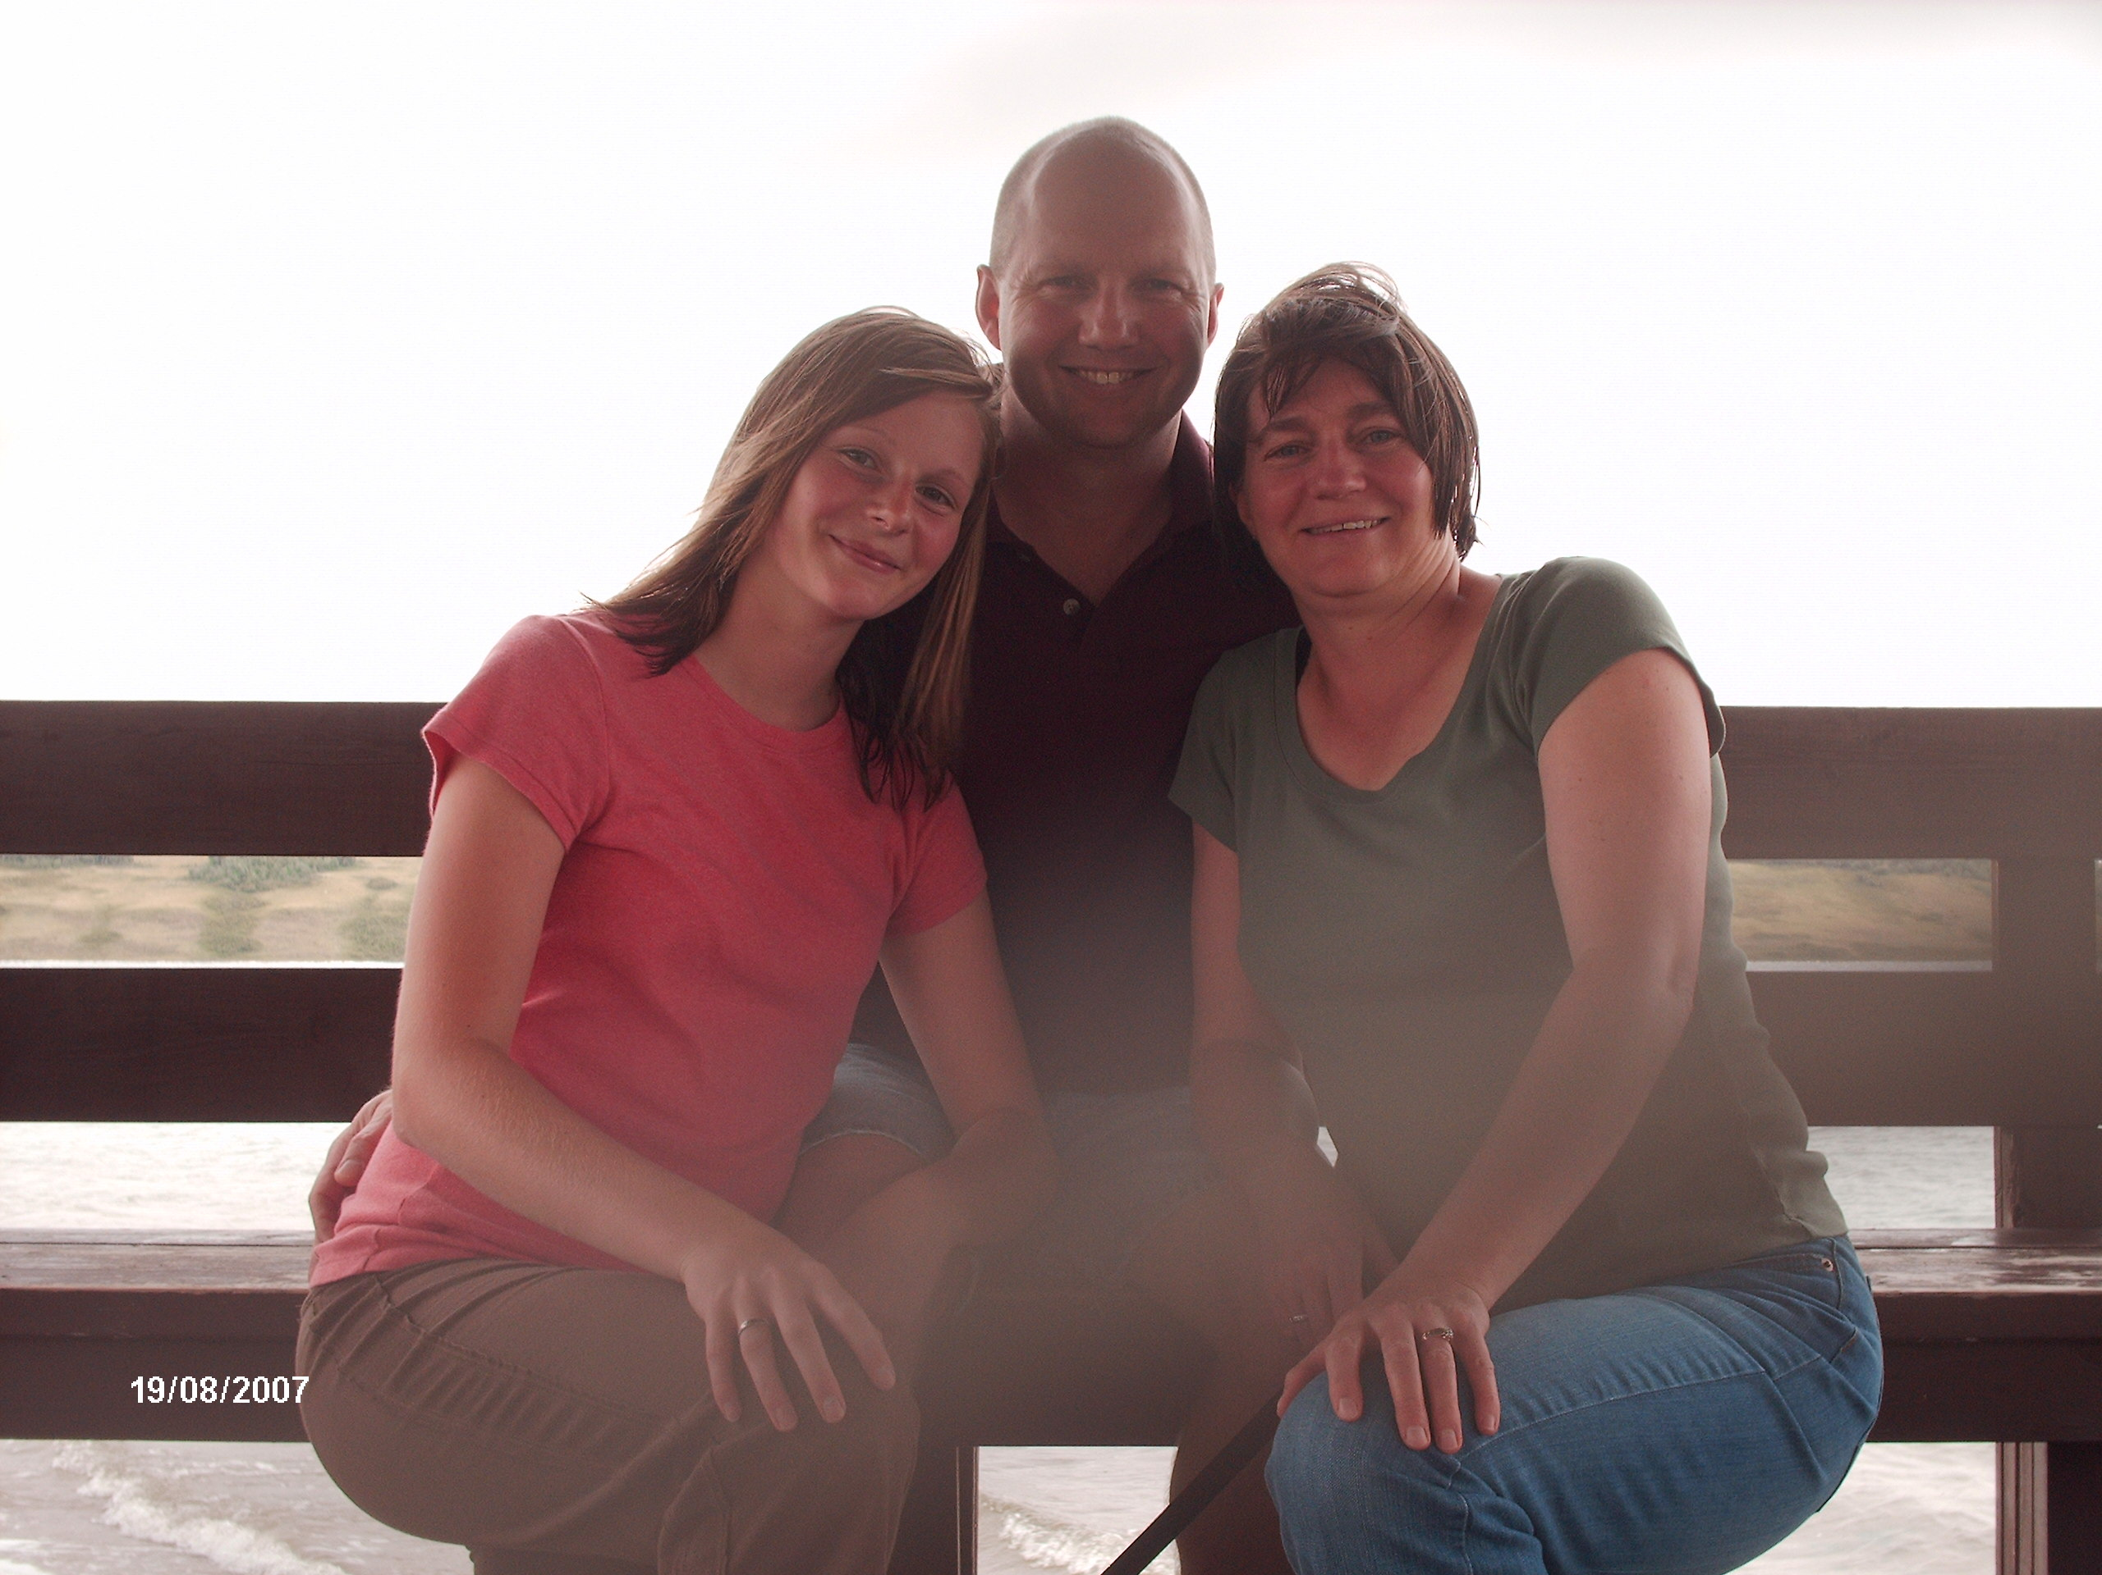
This is me at my Grandma’s house holding her dog whose name is Cocoa!
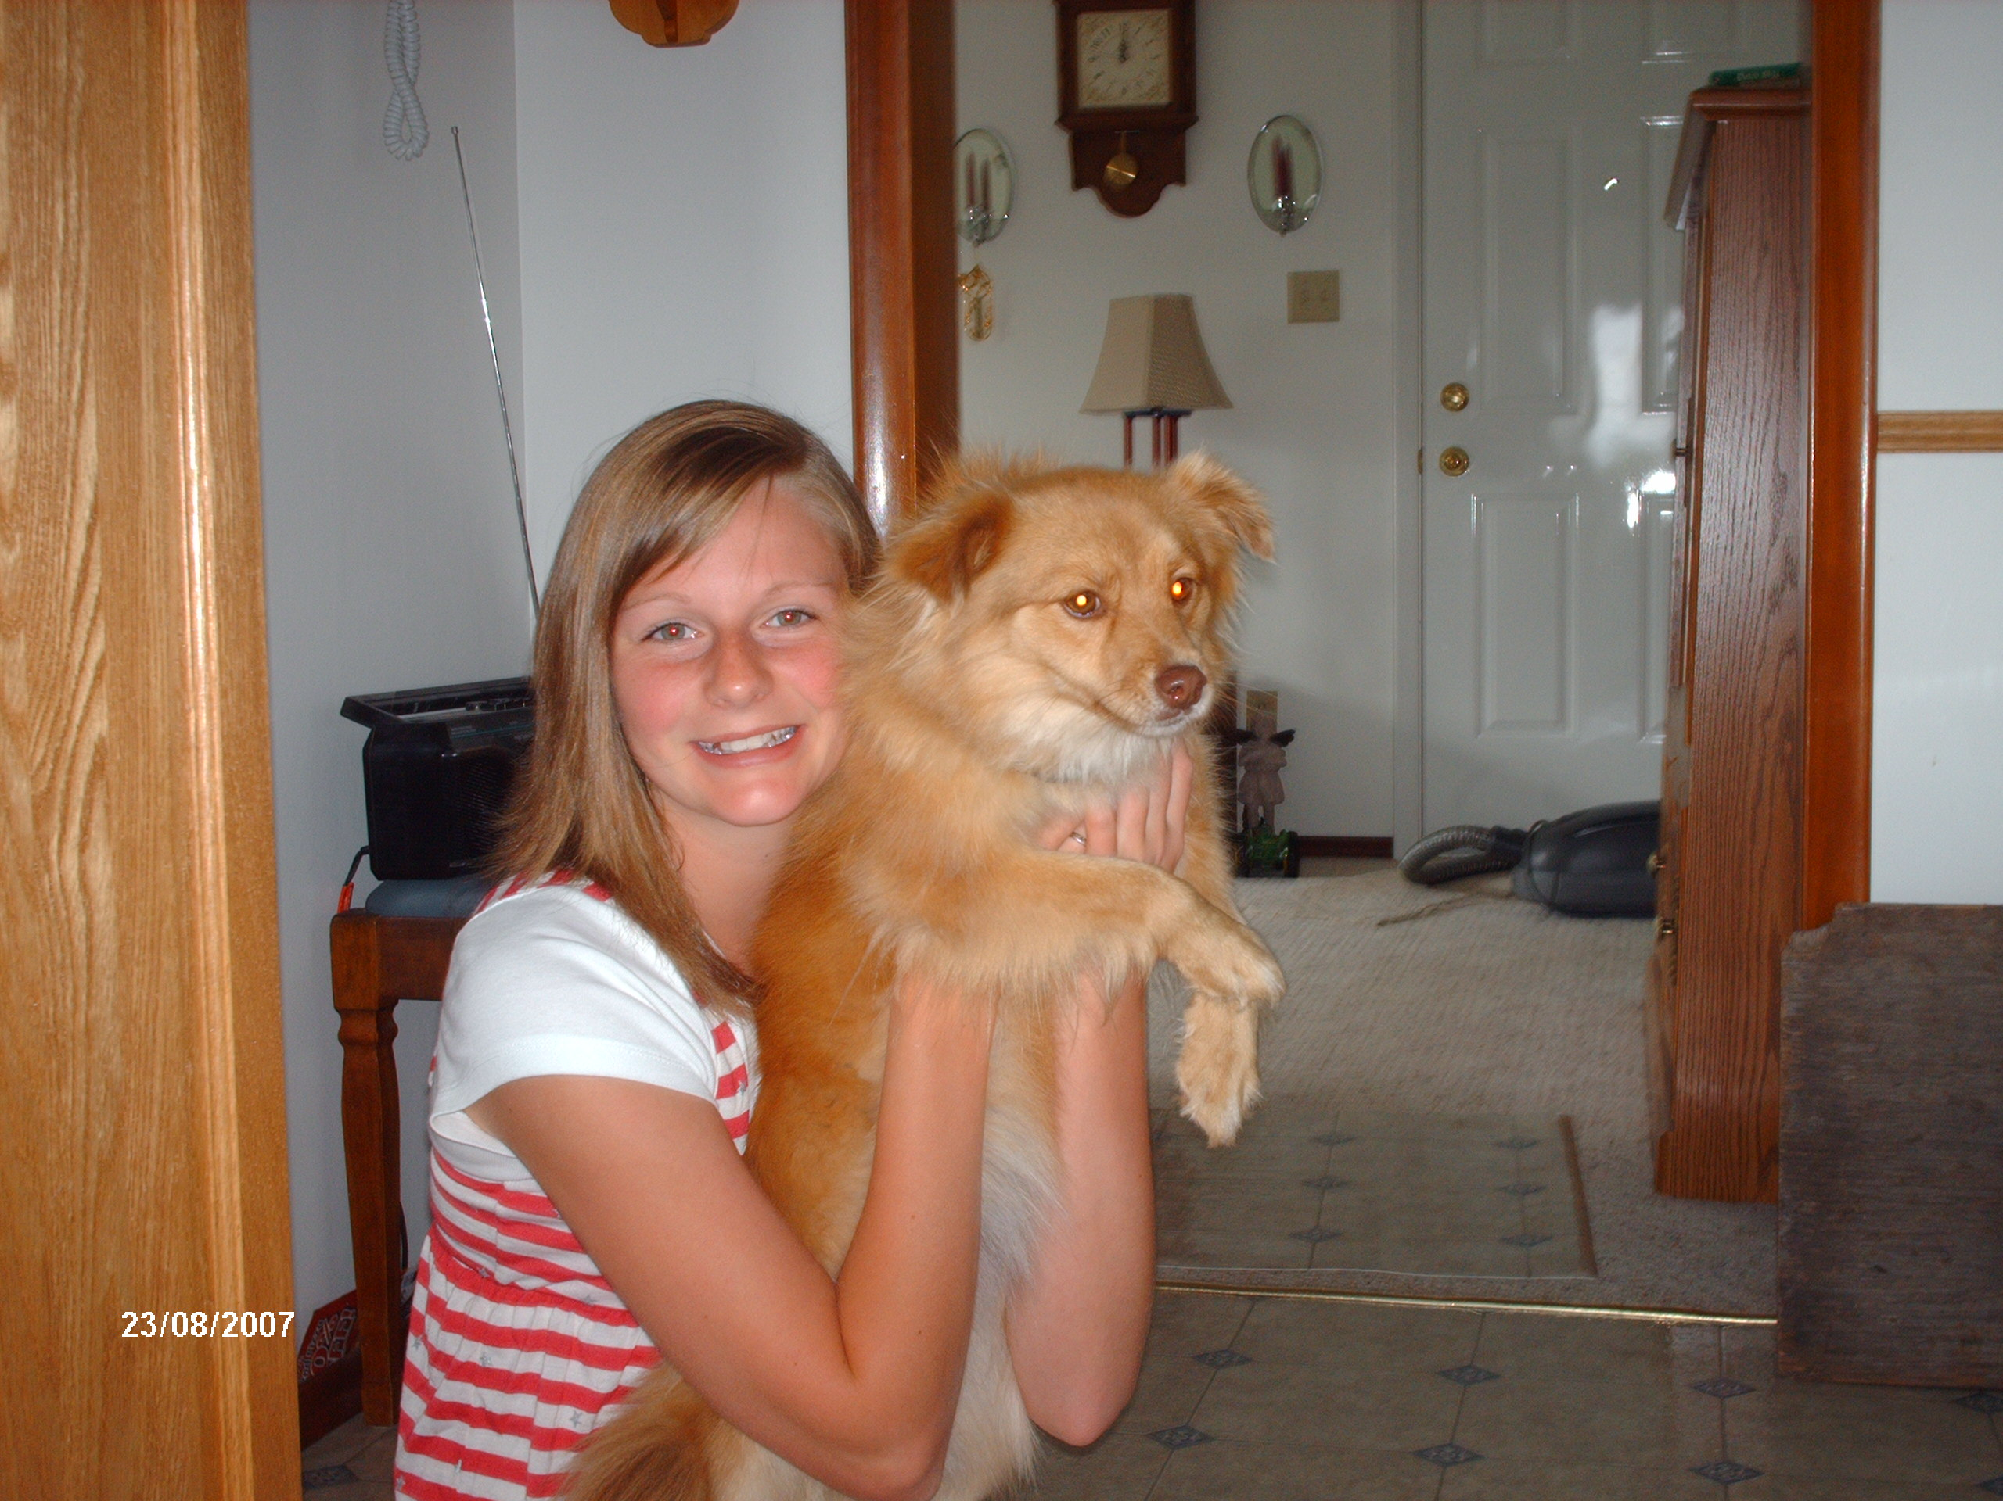
On our way home we stopped at the Moose Jaw tunnels! They were really neat!


