Costa Rica: July 2007

I visited Cost Rica on a 12 day Mission Trip.
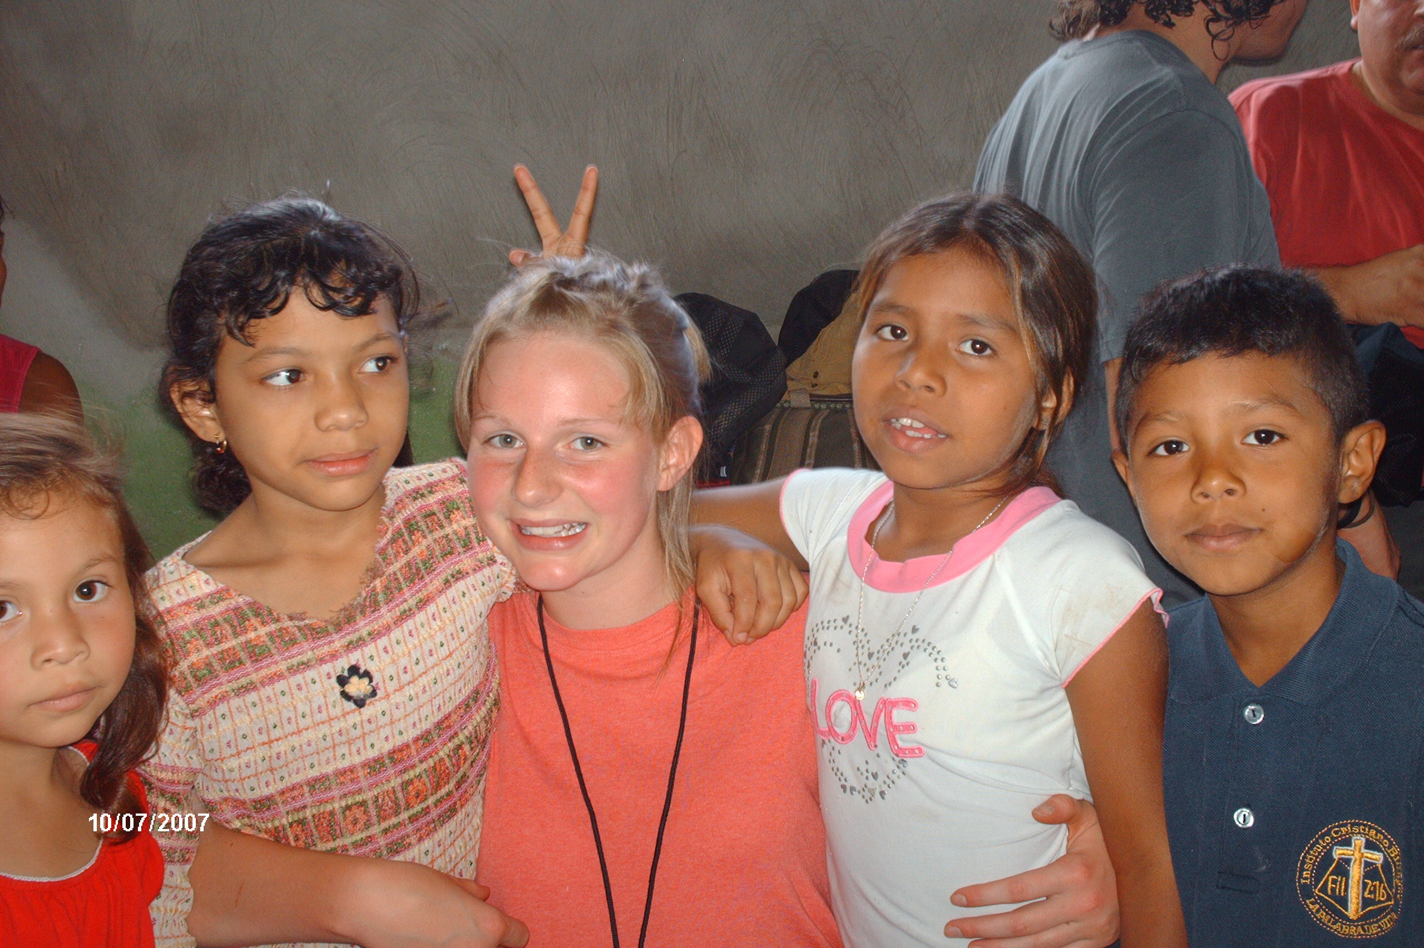
We did a 5 day Vacation Bible School with Costa Rican kids.
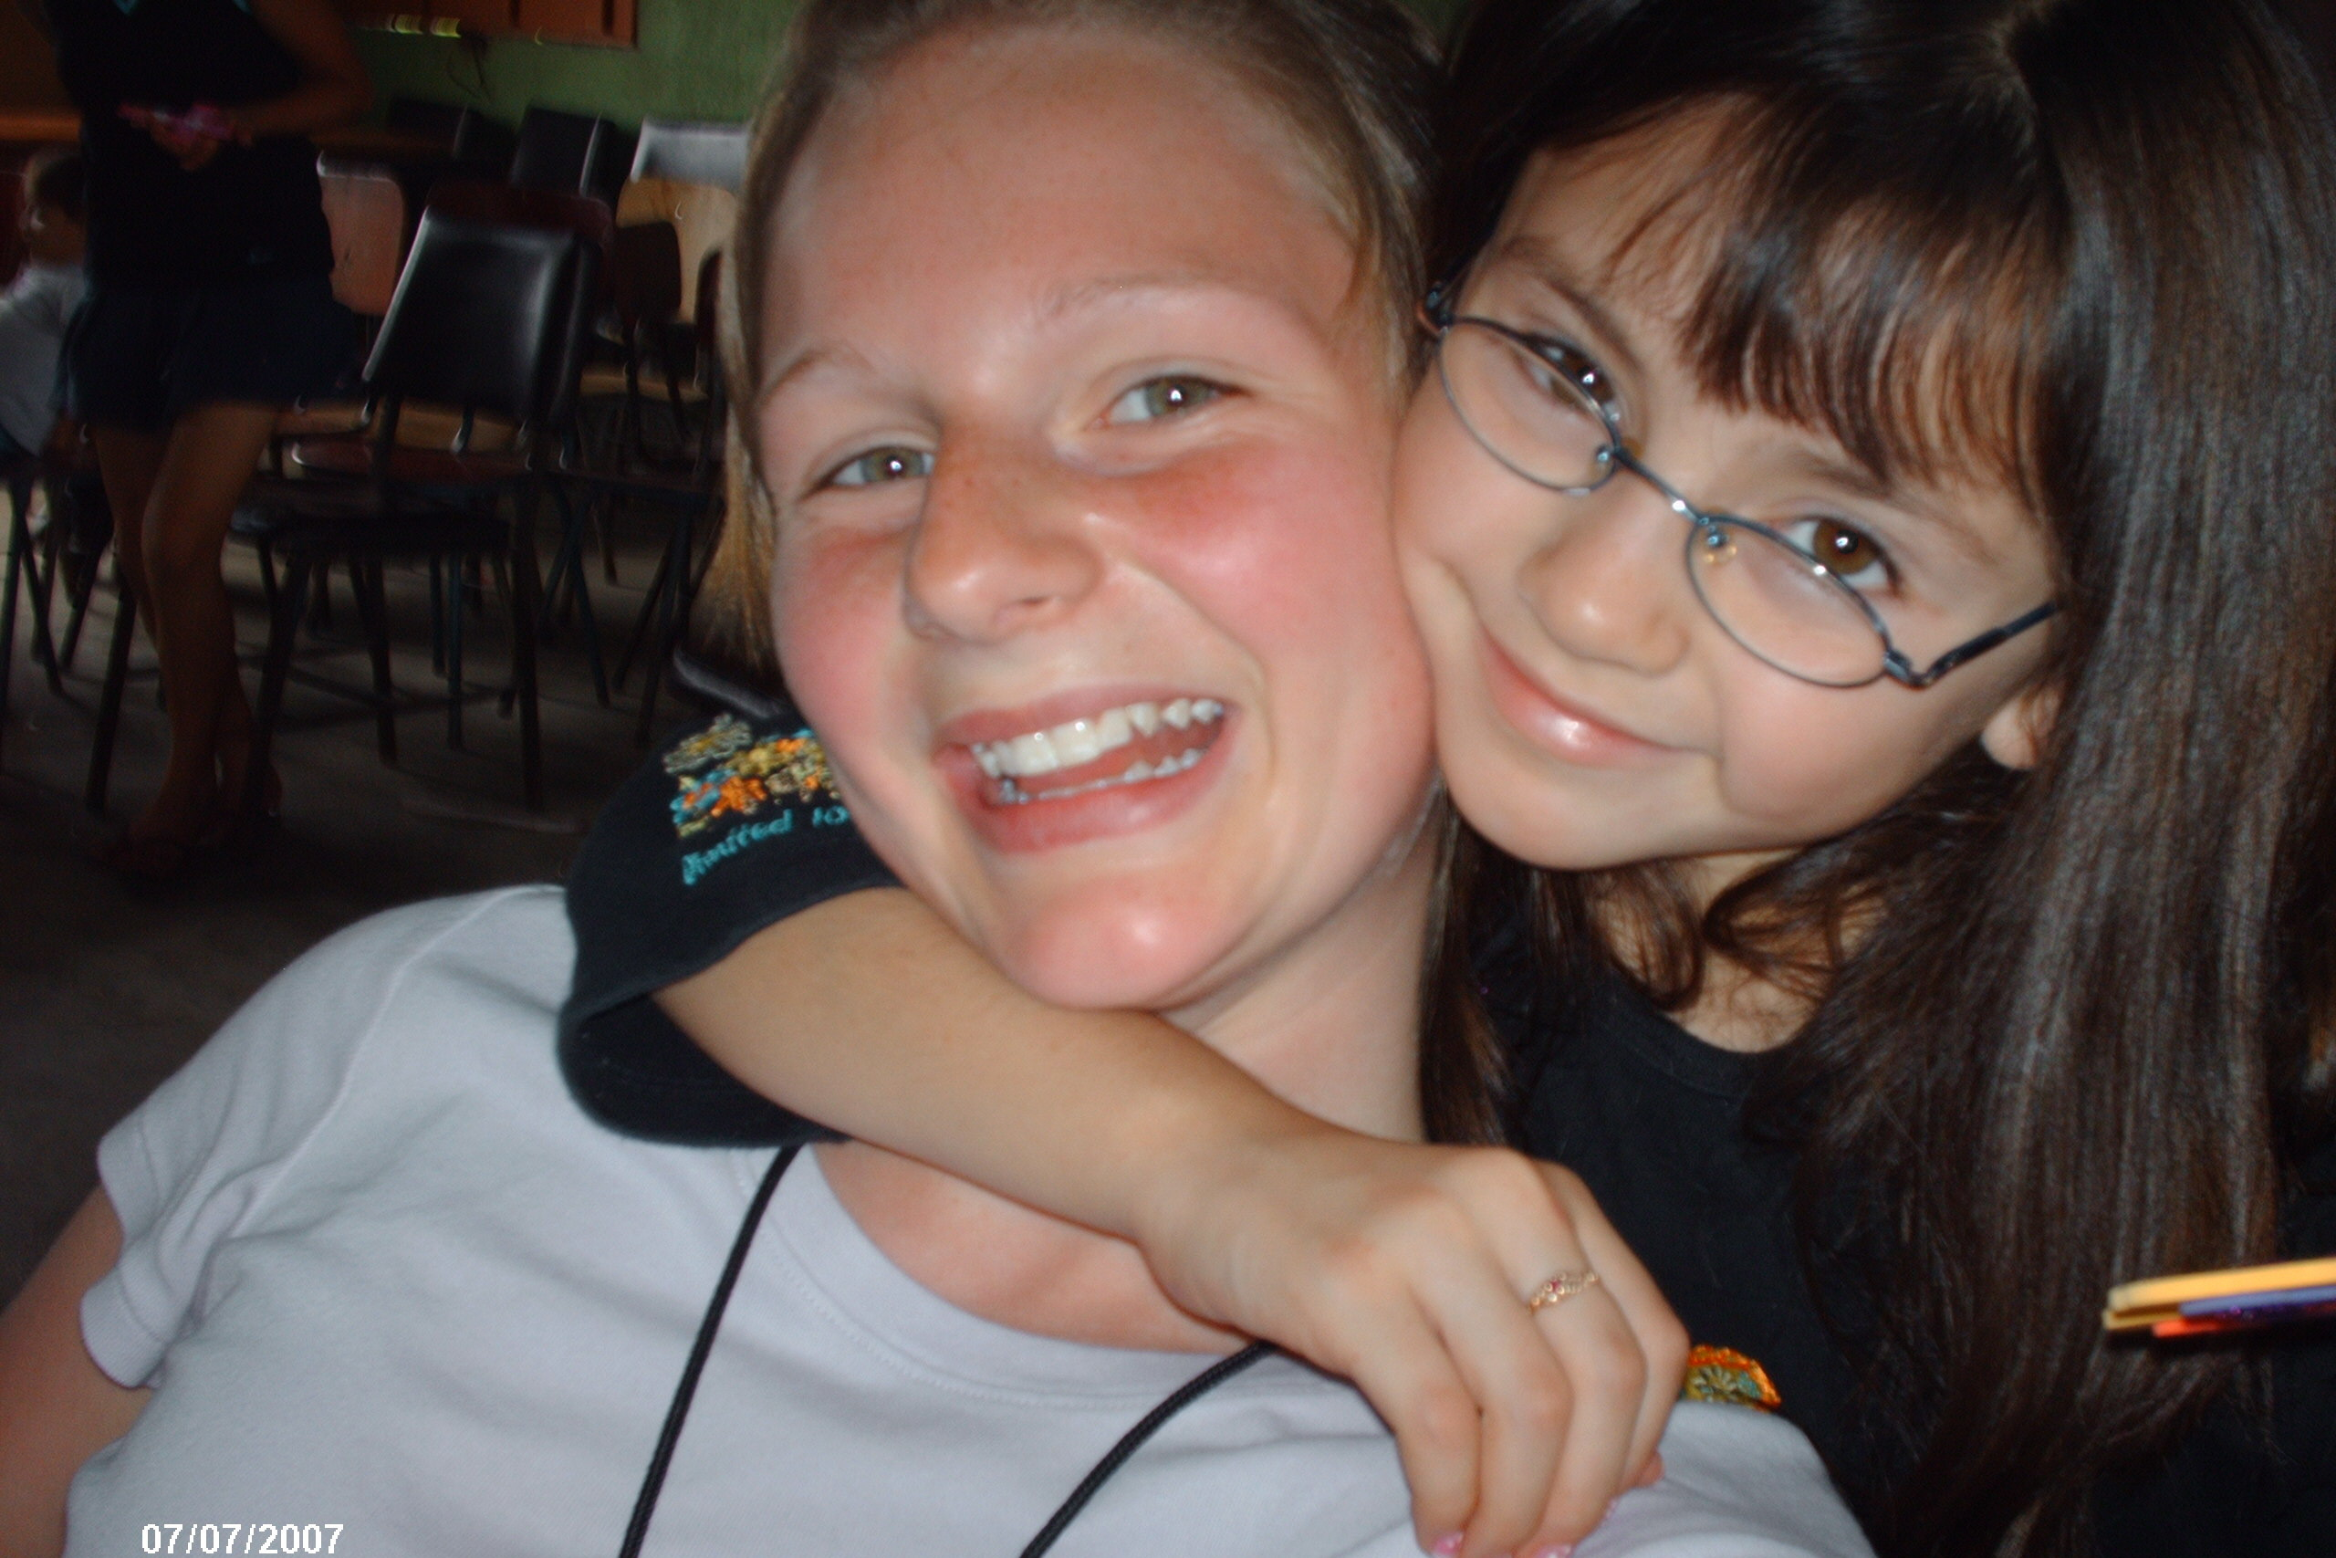
This is my friend Courtney, my brother Joel, and myself on the flight home!


