UL Anime Doujinshi

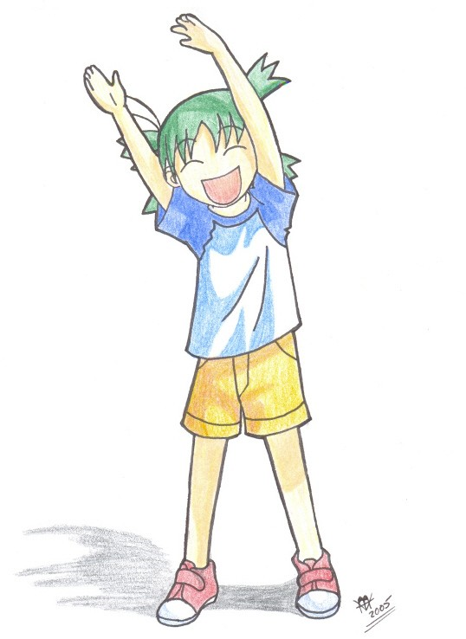

Youtsuba&!



Welcome reader!
I hope you enjoy this edition of the UL Anime Doujinshi. The students of the University of Louisiana at Lafayette’s Anime Society publish this newsletter. Inside these pages you will find the latest anime news, reviews, and interesting tidbits of information that will give many happy feelings!

~The UL Anime Society~

Website of the Month
www.engrish.com
It’s a wonderfully funny website where we can see the results of Japanese people using our language. Keep this site in mind before you get your next Japanese word tattoo.
Quote of the Month “If you can understand this without mind-altering drugs, then your work is flawed."
- T.C. Adams

What’s Playing at the UL Anime Society:
Pretty Guardian Sailor Moon
Yakitate Japan
Now and Then, Here and There
AND MORE!

Meetings Are:
Tuesdays 6:00 – 10:00 pm

Table of Contents
Page 3: Editors Note
Page 4: Topcat’s Corner
Page 5: Gamer’s Alley
Page 7: Review Last Exile
Page 8: Fan Art
Page 9: Movie Rev. Princess Mononoke
Page 10: Book Rev. Japanese Tales &
Trigun

Interested in becoming a writer for the UL Anime Doujinshi? Want your name in a publication? Contact President Sterling through the UL Anime Mailbox at Guillory Hall.

Writers:

Editor-in-Chief: Michael David Raso
Editorial Writer: T.C. Adams
Illustrator: Brandon (Youtsuba&!)
Illustrator: Rachelle

Reviewer: Pirate King Atomsk
Game Reviewer: Nicholas "Zitch" Istre
Newsletter Founder: Blair Gee

Sponsor: Cody
President: Sterling Birdwell
Vice-President: Nick Anderson
Treasurer: James the Greatest
Secretary: Ninja Van

Founder of UL Anime Society: Joey Benoit

Time for Change

Blair Gee created the UL Anime Doujinshi (affectionately named the Doujin). Not only that but he also ran the UL Anime Society. He worked hard to make this dream come true. He put up with a lot of crap from various people, not the least of which were his own fellow “club” members. Some paid their dues and some didn’t. Either way, he kept it going for a while. However, even though he’s still around he has turned over the reigns of the UL Anime Society to Sterling. And through Blair and Sterling, I have taken over the UL Anime Doujinshi. Now that I’m running it I’m going to do things differently, of course.

Some of reasons for change are simply to make me feel as much a part of the creative process as possible. Others more than likely involve ego. And still many of us go on about, “When I’m King.” Well, in this case, I am. Some of the changes are cosmetic (I have trouble reading 10 point font). Some are more…structural. But change it will.

I want more pictures, more reviews, and more editorials. I want angry editorials.

Some Things Will Stay the Same

The first thing I want to be clear on is that I’m not much of a censor. Blair didn’t censor much and I don’t have a problem with profanity, hate mail, or many of the other things that make some people squirm either. This is a college newsletter. Most of us in college are legally adults. Therefore, I think this should be run as an adult publication. Except for the H & C edition, which will

be edited by…Mr. Chuckles. That’s a little too adult to get my pretty hands dirty.

In this issue you’ll see examples of my standards. I don’t censor TC and I don’t mind what he says or how he says it. I think some things should piss us off and should make us think, “Hey, maybe he has a point.” If you’re comfortable with fare more explicit than Tenchi, you’ll be fine. However, if Pokeomon is as strong as you can handle things, you probably shouldn’t be attending meetings, let alone reading this.

Besides, if it really upsets people, I’ll be fired or forced to change it to fit your standards. But while we’re still in the experimental stage, we’re using mine.

A Staff to Die for!

I can’t thank these people enough for the contributions they’ve put into this issue. I’ve had many fine people contribute including, TC Adams, Brandon, Brandon, Pirate King Atomsk, and others. I edit this thing and set the tone, but without them, this would have been just a couple of half-assed reviews and pictures of my dog. So thanks guys. You’ve really added a style and insight that wouldn’t be here otherwise

Oh, and there was going to be stuff on Mechacon but no one sent anything.

- Michael David Raso
(Editor-in-Chief)
DreamScapesXIV@aol.com

Wow, manga-kas and animators must love shrooms. Hell, think about it. Cat girls, for example... what the hell? A woman with a tail and cat-ears. And then of course "H". Who doesn't love tentacles? Sickening, yet alluring like a young eighteen-year-old massage parlor attendant with soft hands and hard ways (fuck you and your hate mail...). All of that, my good readers, is not the point of this little diatribe. And I'm sure many of you are wondering exactly when I'm getting to the point.

Well, the point is, anime is pretty goddamned weird. Cool, but goddamned weird. I feel that the first commandment of such works is, "Thou shalt not mix physics with anime." When you do such a thing, a small rip in the space-time matrix opens up unleashing a large amount of demons, hell spawn, and circus midgets.

Bridget the Midget
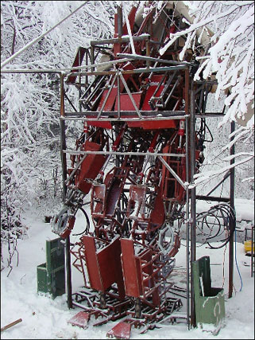
Crap... did I say midget? I meant to say short-ass. But I digress. Think about the large robots and mecha in our beloved titles. First off, I doubt something that big is gonna be that damn mobile. Along with the principles of thermal shock in reference to high temperature exhausts and the cold, lifeless vacuum of space, mecha on the scale demonstrated in anime is impossible. Yes, I know several projects are underway to build mecha. They might be able to pull off something from MechAssault, but that's it. Again, fuck you and your hate mail... unwashed fan boy.

Real Mech - >

Another commandment would have to be, "If you can understand this without mind-altering drugs, then your work is flawed." WHAT THE FUCK IS UP WITH FLCL, YAKITATE JAPAN!, AND CHROMARTIE HIGH!?!?!?!? I love these shows very much, but frankly, I don't know what the hell is going on. This particular commandment I don't so much mind. After all, we watch these shows to escape a disappointing reality.

And that brings me to my final point. To all the fan boys, myself included: Reality might suck, but it is reality. Not all fan boys are guilty of wanting to make real life more like anime, but some of you people scare the hell out of me. Touch me, and I will bash you in the head with the cold, unrelenting wrath of a South Tokyo fishmonger's wife on Valium and a steady dose of estrogen supplements (Yay!! Hate mail from the women too!). Look, it's this simple. Talk about anime. Be enthusiastic about anime. Hell, seek all the knowledge you can about your favorites. Just remember one thing... it's a goddamned cartoon, and you need to get laid.
- “Staff Pirate” T.C. Adams
(Editorial and Reviewer)
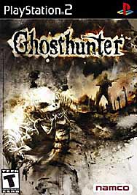
PS2 Game Review
Ghost Hunter
Genre: Adventure/Horror
Released by: Namco
Rating: 8.4 / 10
It's a dark and stormy night (well, it is!)
You park outside a large, abandoned school with your attractive new female partner and prepare to check on a routine call. It's your first night on the job as a small town cop coming to the big city. Your name is Lazarus Jones: laid back, wise-cracking (and somewhat metro-sexual) officer of the law. According to your partner, this is a mere routine check-up call that is probably the cause of pranksters trying to scare local construction workers. As you enter, she explains to you that this was the murder site of 10 students years ago by a professor who was never caught - and never seen again. She tells you it was as if he had disappeared. Being the core skeptic, you can't help but feel otherwise.
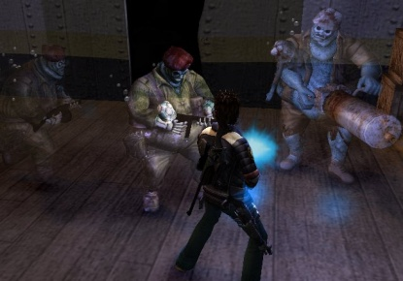After you split up to run your rounds within the school, you soon find a large tank with a gigantic red button in the basement. Well, your first reaction? Press it!
Unfortunately, you're also an idiot and soon come to realize the tank was the holding place of hundreds of captured ghosts - and you just released them! You proceed to smack yourself, but it's okay... up until you find that one of the ghosts has captured your partner, anyways. Then you know you're kind of stuck taking care of this one. Luckily, the keeper of the ghosts left a program (in the form of a digital "head-in-a-box") to instruct you on how to capture them again. He also left a portal, which sends you to the places they scattered back to.
You are now Lazarus Jones - Ghost Hunter. Out to save your partner, and seemingly less importantly to you - the world.

Well, I can safely say this is the first adventure/horror game with a comedy
twist I can remember in a long time. I'm serious! Think Silent Hill meets Ghostbusters. You'll encounter a huge array of interesting ghosts, human characters, digital characters, weapons, and individual stories of horror. You even have an Astral form which you can project from your body to aid you in your quest! So what's the good, the bad, and the ugly of Ghost Hunter? And yes, I'm borrowing this one.
(The Good): Everything I've said so far. Let's face it, it's Namco. This game is a great play, but be sure to rent before you buy.
(The Bad): It's short. I finished it in about 15-20 hours. Also, some of the areas obviously are repetitive in scenery to make up for a lack of time towards the end of the game. You won't notice it until the second portal, but it happens. No effect on gameplay, though. Also, the subtitle text runs horribly out of sync with the dialogue but again, hardly enough of a problem to lower it's rating.
(The Ugly): The giant dead Grandmother in the rocking chair, hovering over a pit of giant dead baby bones. Wow.
All in all - make sure you pick this one up for a weekend at home. It'll scare you, creep you out, and make you laugh at the same time. I enjoyed it thoroughly.
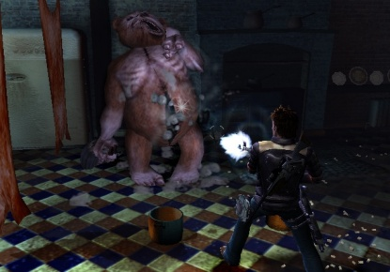
- Pirate King Atomsk
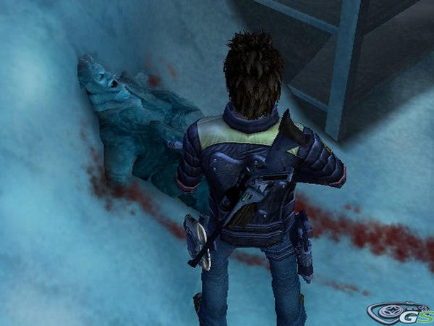
(Game Reviewer)

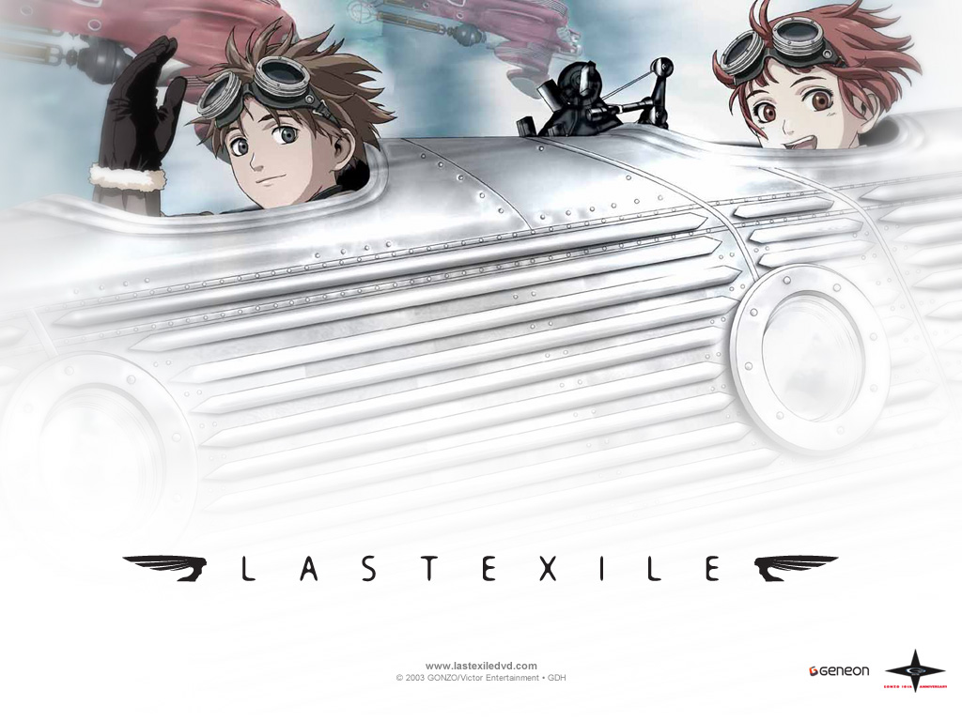
Last Exile
It’s a world with interesting characters, vehicles, and ships. The characters are deep too.
The downside is that it has a very weak story and what felt like a slow start. That's not to say that it wasn't enjoyable to watch. No, I found it quite enjoyable and I found the characters to actually be pretty engaging.

I did like the airship designs. They really felt like older style aircraft carriers, especially in the internal layouts. Unfortunately, the main story left far too many questions at the end. A second watching may reveal a bit more, but it doesn't feel like the series has a deeper side to it that would help connect the dots.

Animation
For the most part, the combination of computer graphics and hand-drawn animation looked very sharp. The Visuals do not disappoint.

Sound
Voice acting seemed pretty good. I didn't notice anything out of whack, but nothing really impressed me. Sound effects were good. I do enjoy the piston-based propeller engine sound that the van ships had. Wind and other environmental effects did their job. I really don't like the opening music style, though the bagpipes are a nice touch. I felt the ending theme was a little better. Background music mostly did the job. Some songs (usually a few of the techno tracks) didn't feel right in the spots they

were used, but the orchestral, choral, and piano scores were well used.

Story
This is where this series breaks down. I felt that explaining a few more things would have help the series better (who exactly were the "Guild"? Where the hell did they come from? Alvis's role could have been explained better.) How Claus's and Lavi's background was explained could have been done much better. As it is, it was simply shown with Lavi narrating it to the audience. I felt that killed the immersion into the story a bit. I think it would have been better if it was told to another character, or simply have no narration at all. It was supposed to be a dream sequence anyway. The ending also felt rushed (which may have been the real reason for the other problems with the story line).
How the characters come together was a nice touch. I did rather enjoy that. In the end, the biggest problem with the plot is starting so many side stories at the detriment to the main plot and not finishing many of those side stories.

Character
I'd have to say, the characters are one of the stronger parts of this series. Their motivations are pretty well explained. My only complaint is the main "bad guy" (or girl in this series) felt flat, but every other major character's backstory was fleshed out pretty nicely.

Value
As I said, a second run may reveal more, and I will update this if I find this to be true. But the storyline really does seem like it lacks depth. But if you enjoy deeper characters, I'd have to say that this might please you. I'll have to end this review with "Choose the skies you fly in, and look to see what's there."
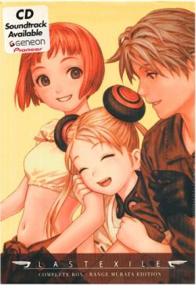
- Nicholas "Zitch" Istre
(Anime Reviewer)
His article originally appeared on AnimeNfo
For more of his work check it out.

By Rachelle
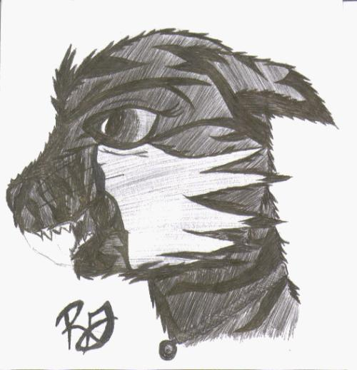

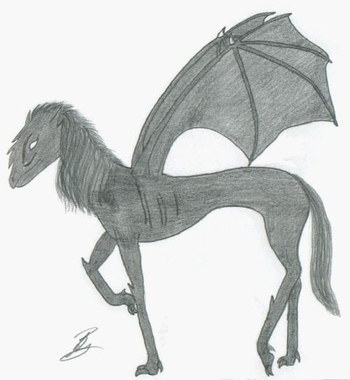

Princess Mononoke
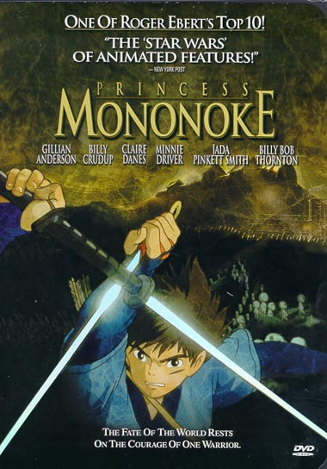
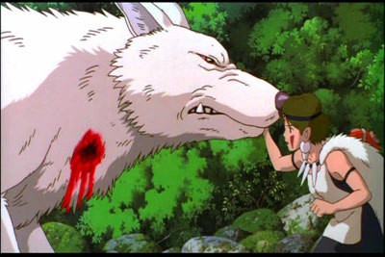
I’m not the biggest fan of Studio Ghibli. I didn’t like Spirited Away as much as I thought I would. And Kiki’s Delivery Service seemed kind of interesting, but stupid too. There is one film though that I am always amazed by no matter how many times I see it. That film is of course, Princess Mononoke.
Princess Mononoke is the story of a young man named Ashitaka. One day this brave man has his village attacked by a goo-covered monster. While fighting the monster Ashitaka has his arm covered in the goo. It turns out that this goo will probably kill him. Thus he is exiled from his village and on a quest to cure himself.

But the move is so much more than a quest for a cure. It’s about nature, bravery, heroism, and trying to live by the right ideals. It’s something I see in Vash the Stampede (Trigun) and it’s something that also impresses me about Ashitaka too. Of course it’s difficult to live a life of righteousness without being self-righteousness (in the real world) but Ashitaka does it with both annoyance and aplomb.
Visually the movie is still stunning. This is especially true when you realize my only source is a VHS copy. The animation is incredible and the scenes are so beautiful that some may simply be in a state of amazement the first time they see it.

Probably a scene that best exemplifies this is simply when Ashitaka is riding his on his elk past the trees and leaves. It seems so simple, but it is so fast and so real that I often find myself lost in the moment.

The visuals are good and the sound may be even better. The music composed by Joe Hiashi (who also composed the music for the excellent live-action Kikujiro) really does an incredible job. Almost every bit of his music is absolute poetry to behold. While the quiet peaceful songs of the forest will soothe you, it will be the war songs that truly get your heart racing.

If you haven’t seen this movie, you must. If you have seen Princess Mononoke, go see it again! It’s definitely a classic to watch subbed or dubbed.
Grade: + A
Caution: Contains graphic violence and adult language.- Michael David Raso

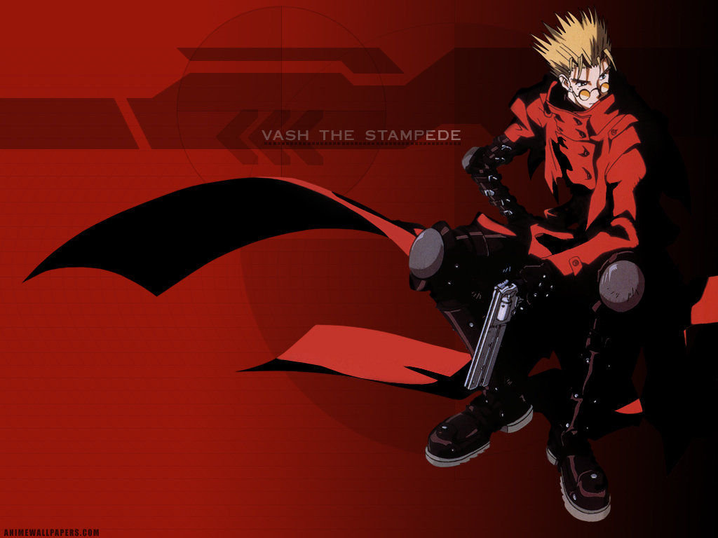
Japanese Tales

Compiled, edited, and translated by Royall Tyler. Pantheon Books.

The UL Anime Society is first and foremost a body of students and anime fans alike that gather to watch anime. That said, the club also tries to foster more understanding and knowledge about the Japanese culture. I've had this book for about 2 years now, and I still can't stop reading it. This book is a collection of very old stories, old wives tales, legends, and the like from various periods of ancient Japan.

Modern readers may not understand a lot of what's going on in these stories. Many of them are very far-fetched accounts, and a great number of the tales involve the old gods and buddhas of Japan. Still, it's all a nice way to see inside of the mindset of the ancient Japanese citizen. Some of these stories even have a lot in common with Aesop's Fables. There is a lot of focus on being a good person and living according to a set of morals.

Probably the best parts of the book are the listing of works that stories and tales are taken from, as well as the very in depth explanations of the old Japanese lore and mindset. For anyone interested in a good look at Japanese culture, and probably a damn good look at why some anime turns out the way it does, then pick this one up.

5 empty tankards of grog out of 5

Contains adult language, violence, crude humor, and sexual situations (yarrrr....).

- Staff Pirate TC Adams

Trigun Volumes 1 - 4

Trigun is the story of a man named Vash Stampede who causes trouble wherever he goes while trying to do the right thing. It’s a really good anime and an okay manga. What’s weird is that the manga came first.

Seeing the anime and reading the manga are two very different things. While I found the anime to mostly be a concise and very enjoyable experience. I found the first four volumes of the manga to lack the emotional feel of the anime and thought the manga to be rather confusing.

Perhaps it’s just me?

Wolfwood’s there. So are the rest of the gang too. But it just doesn’t feel right.

Isn’t that strange when the manga disappoints while the anime delivers.

It obviously had potential. After all, it’s one of the best series ever made. Howevever, it just isn’t as good as the anime.
C +
Contains adult language and violence

- Michael Raso

Japanese Word of the Month: “Tsunami”

Meaning: What fucks up the deadline for the Doujinshi

