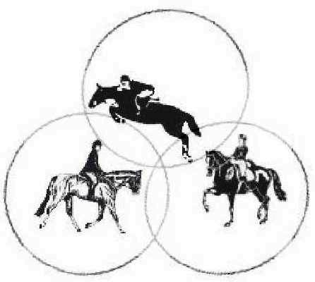
Trinity Stables

Volunteer Application

Contact Information
Last Name |  |  |  |  |  |  |  |  |  |  |  | First |  |  |  |  |  |  |  |  | M.I. |  | Date
Street Address |  |  |  |  |  |  |  |  |  |  |  |  |  |  |  |  |  |  |  |  | Apartment/Unit #
City |  |  |  |  |  |  |  |  |  |  |  | State |  |  |  |  |  |  |  |  | ZIP
Phone |  |  |  |  |  |  |  |  |  |  |  | E-mail Address
Date Available to start |  |  |  |  |  |  |  |  |  | Social Security No.
Please list hours and days available:
Have you ever worked with horses before? |  |  |  |  |  |  |  |  | YES |  | NO |  | If so, list below

horse Experience
Where? |  |  |  |  |  |  |  |  |  |  | Address
From |  |  |  |  | To
Where? |  |  |  |  |  |  |  |  |  |  | Address
From |  |  |  |  | To
Where? |  |  |  |  |  |  |  |  |  |  | Address
From |  |  |  |  | To

interests
Please check where you would be interested in volunteering.
 |  |  | STALL CLEANING
 |  |  | PAINTING
 |  |  | REPAIRS – PLEASE LIST SPECIALTIES (FOR EXAMPLE – PLUMBING, ELECTRICIAN, ETC.)
 |  |  | BRUSHING, GROOMING HORSES
 |  |  | BARN CLEANING
 |  |  | LUNGING HORSES FOR EXERCISE
 |  |  | TACKING FOR LESSONS
 |  |  | HELPING AT SHOWS/CLINICS
 |  |  | ANY AND ALL

Rider's Liability Forms

______I understand that Trinity Stables, it's employees, and associates are not liable for any accidents, injuries, or thefts to animals and personal property at the stables.
______I, the undersigned, acknowledge that horseback riding is an inherently risky activity and hereby release Tom and Michele Adams, and any other person associated with Trinity Stables from ANY liability for injury, damage, or loss to myself, my horses, or my equipment.
______I understand that Trinity Stables requires the use of helmets for each rider. Riders WILL NOT be allowed to ride without a helmet with safety harness.

_____In the event of an accident and/or injury, I hereby give permission for myself (or my child) to be treated by medical personnel and if needed, transported to the nearest hospital.

_____I understand that I am volunteering to help out at Trinity Stables, and I understand that absolutely NO money will exchange hands for this work.
UNDER KENTUCKY LAW, a farm animal activity sponsor, farm animal professional, or other person does not have to eliminate all risks of injury of participation in farm animal activities. There are inherent risks of injury that you voluntarily accept if you participate in farm animal activities.

My signature indicates that I have read and agree to the above statements.
______________________________________DATE________________

