

 14 th ANNUAL
 BENEFIT WALK FOR ANIMALS 

When: SUNDAY, JUNE 23 (Rain or Shine)

Time: 12:00 PM –1:00 PM, REGISTRATION. 1:00 PM-3:00 PM, WALK

Where: WOLLASTON BEACH/CADDY PARK, QUINCY
REGISTRATION IS AT CADDY PARK (ACROSS FROM THE BEACH)
Activities Include:
- Fun activities for the kids and Face Painting! 
- Bake Sale and Refreshments “Ask The Groomer” will be here with advise on your pet’s grooming needs
- Educational literature on helping you care for your cat (helpful tips and behavioral sheets). Also available: CE-CE’S TEE SHIRTS AND DOG/CAT SAMPLES
Ce-Ce & Friends Humane Society is a non-profit, all volunteer, no-kill, “cage free” cat shelter located in Weymouth. Visit our website at www.angelfire.com/ma3/cecenfriends. Please call 781-331-6115 to get your sponsor forms, this is a 4-mile fun walk; you do not have to walk to join in on the fun, but please stop by to cheer on the walkers! 100% of the proceeds go to benefit the shelter, providing food, spay/neuter and medical care. Doggies are always welcome, but they must be on a leash.
Below are some of Ce-Ce residents waiting for their forever homes.

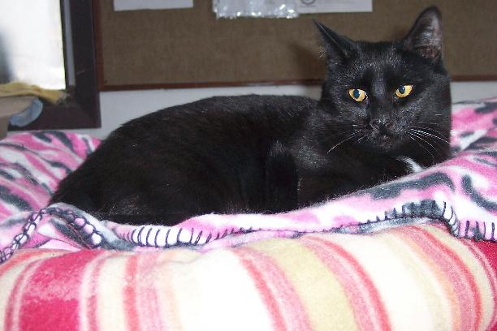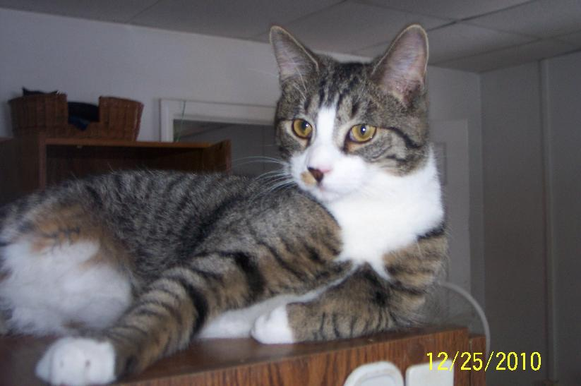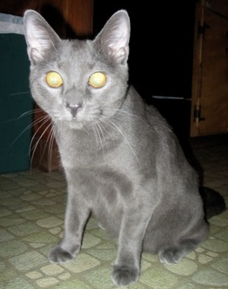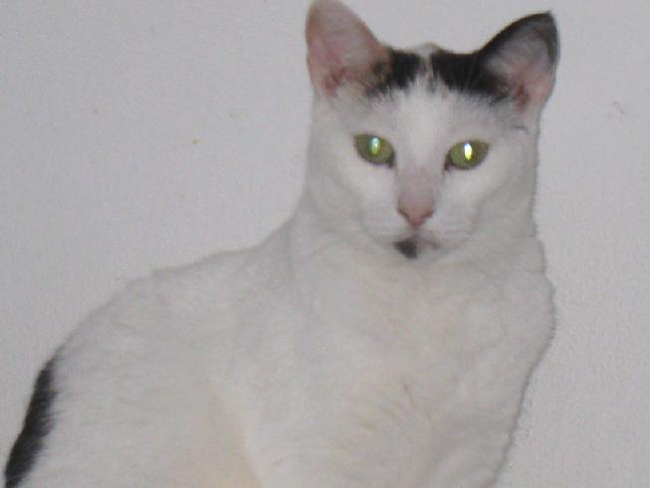
BLACKIE TAMMY SMOKEY Maribelle
 WE APPRECIATE YOUR SUPPORT

