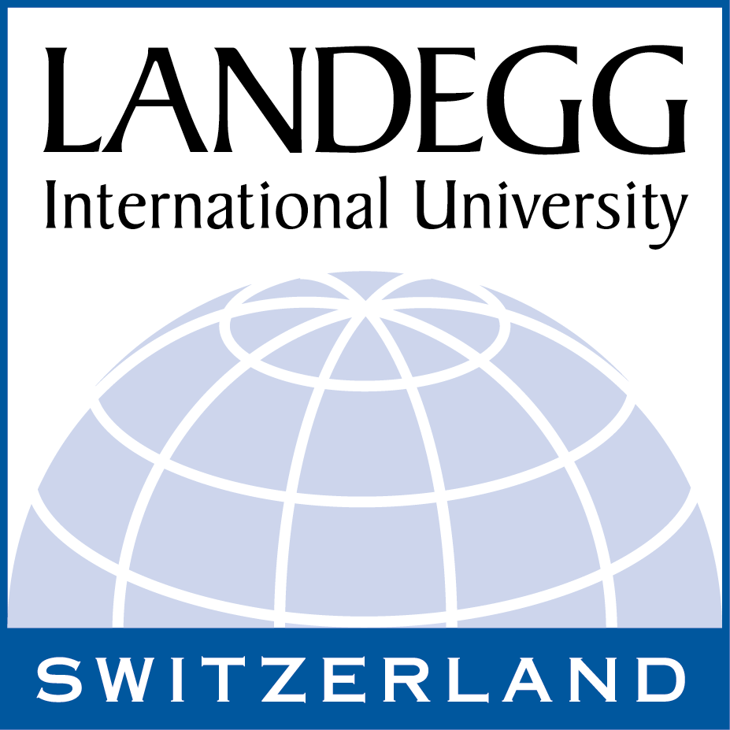

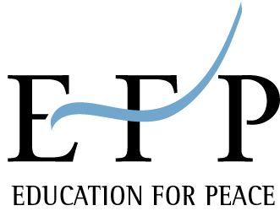

BIOGRAPHICAL SKETCH

Professor Dr. H.B. Danesh is the President of Landegg International University and Director of its International Education for Peace Institute (EFP-International), both located in Switzerland
Dr. Danesh is an author and international lecturer and consultant with over thirty years of academic and clinical experience as a psychiatrist. His areas of research and expertise include spiritual psychology, causes and prevention of violence, marriage and family therapy, death and dying, consultation and conflict resolution, ethics, and world order and peace studies.

In addition to several scientific papers in his areas of specialty, Dr. Danesh is author of the following books:

The Violence-Free Society: A Gift for Our Children (1979),
Unity: The Creative Foundation of Peace (1986),
The Psychology of Spirituality (1994), and
The Violence-Free Family: The Building Block of a Peaceful Civilization (1995).
To the Peoples of the World: A Baha'i Statement on Peace (1986), Editor.
Conflict-Free Conflict Resolution: A Developmental Approach (Scheduled for Publication in 2000)
The Mysterious Case of the I.W.’s, A book on death for children (Scheduled for publication in 2001),
Peace Moves, A book on peace for young individuals (translated in the three Bosnian languages and used as one of the main documents for the Education for Peace Project of Landegg Academy in Bosnia and Herzegovina.)

Five of the above titles have been translated from English into several other languages including Chinese, Bosnian, Russian, French, German, Japanese, Portuguese, Czech, and Spanish. Currently Dr. Danesh is writing a book on the characteristics and dynamics of healthy marriage.

Dr. Danesh is listed in Who’s Who in the World, 2002, Who's Who in America, 1993-94 and 1995-96, Who's Who in Religion, 1992-93, The Dictionary of International Biography, 1979, and Who's Who in the East, 1977 and 1979.

