TWIN CITY CHAIN GANG & SOUTHERN NATIONAL DISC GOLF
PRESENT

THE 5TH ANNUAL OUACHITA RIVER OPEN
JUNE 5TH & 6TH
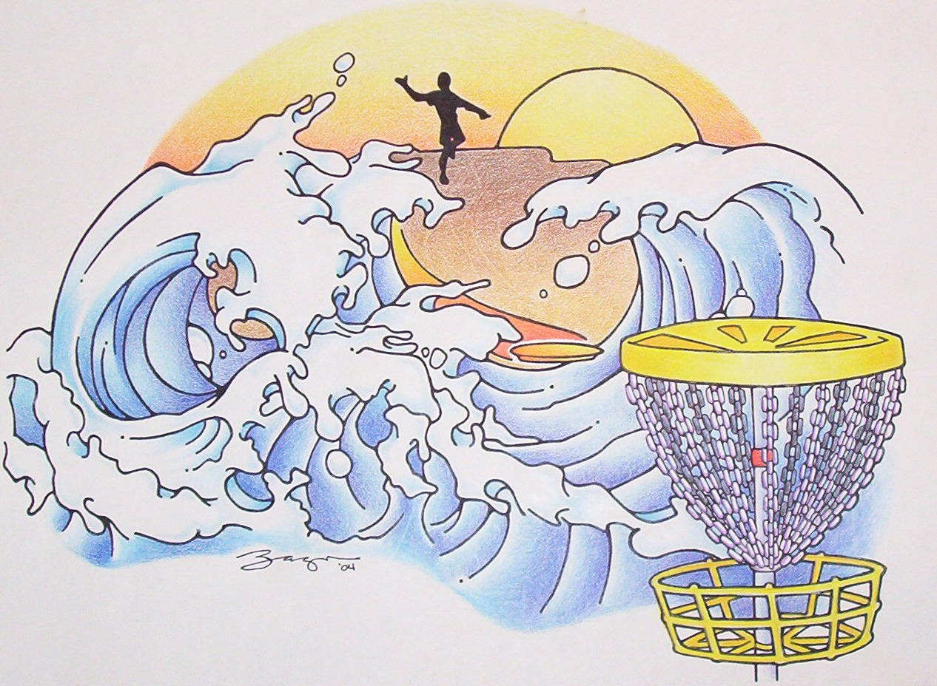
LAZARRE PARK
WEST MONROE, LA

OPEN- $49 SATURDAY
PRO MASTER- $49 REGISTRATION 8:00-9:00 am
GR MASTER- $49 PLAYER MEETING 9:30 am
PRO WOMEN- $39 TEE OFF 10:00 AM
AM MASTERS- $39 2ND ROUND TBA
ADV AM- $39
AM- $34
AM WOMEN- $29 SUNDAY
NOVICE & JR- $17 PLAYER MEETING 8:30 am
TEE OFF 9:00 am
FINAL SIX FOR TOP 4 PRO
SCORES

NOVICE & JR RECEIVE CHOICE OF TWO DISCS OR A SMALL DISCGOLF BAG. NOV. & JR PLAY SATURDAY ONLY.
T-SHIRTS WILL BE $5.00
EXTRA MONEY ADDED TO PRO PURSE
*** THIS IS THE FIRST SNDG TOURNAMENT OF THE ***
2004-2005 SEASON

FOR ADDITIONAL INFO CALL NOLAN GREENWOOD @ 318-397-2509 OR JIMMY MOAK @ 318-388-5600

