Apocrypha: The Sumerians and Akkadians

“It happened, when men began to multiply on the face of the earth, and daughters were born to them, that the sons of Elohim saw that the daughters of men were beautiful, and they took for themselves wives of all which they chose. And Yahweh said, ‘My Spirit will not strive with man forever, because he also is flesh; yet will his days be one hundred and twenty years.’ The Nephilim were in the earth in those days, and also after that, when the sons of Elohim came to the daughters of men. They bore children to them: the same were the mighty men of old, men of renown.” -Genesis 6:1-4

The Cradle of Civilization

Jericho is the oldest known city in the world, stretching back 10,500 years into the past. At 846 feet below sea level, it is also the lowest city. The ancient settlement is located in a fertile landscape on a major Mediterranean trade route and surrounds a permanent spring near the Dead Sea. By 8000 BC, the population reached 1,500, far above any other site of the time. Around the same time protective walls were erected around the settlement. Jericho is famous today for the Bible story in which Yehoshua (Joshua) follows Yahweh’s command to march the army of the Hebrew refugees from Egypt around the city for seven days before sounding seven trumpets, causing the city’s walls to come down.
The second oldest archaeologist site is Chatal Huyuk, further north in Turkey, dated at 6700 B.C. Both sites have turned up evidence of the ritual decoration of skulls, dating back to the proto-Neolithic and Neolithic eras. Some skulls have been scraped, painted with red ocher or bitumen, while others have had shells placed over the eye sockets.

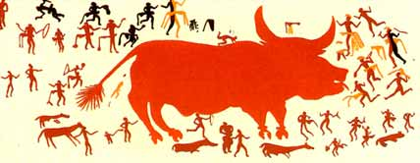
Chatal Huyuk Hunting Painting

Civilization first sprung up in the Mesopotamia’s fertile crescent, an area stretching from the Mediterranean sea, down the rich land fed by the Tigris and Euphrates rivers, all the way to the Persian Gulf, creating a landscape of great fruitfulness of life amongst a harsh desert wasteland. On the west side of that crescent is Jerusalem (“City of Peace“). At the eastern point are the ancient cities of Ur (“City”) and Eridu (“Good City”) in Iraq.
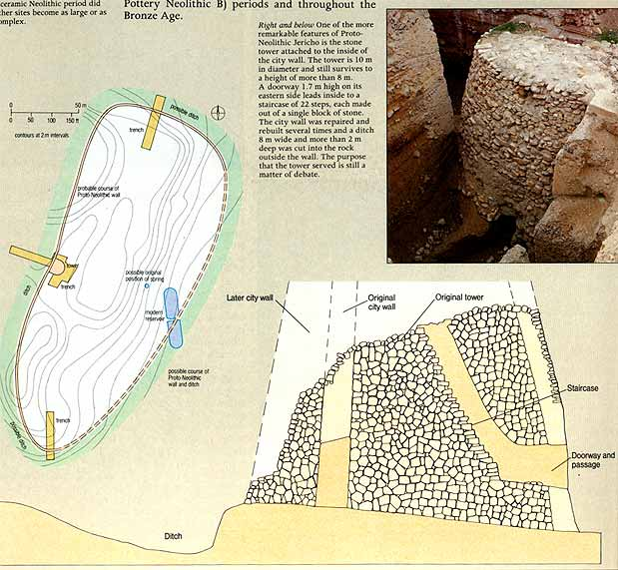
Neolithic Tower, Jericho, 8000 BC²

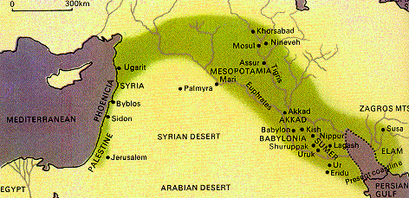
Fertile Crescent, Mesopotamia

The expansion of farming settlements across the Tigris and Euphrates is reflected by a series of four cultures, which are separated by their pottery styles. The first community that can be attested to is the Hussuna culture (6500-6000 BC), who lived on the Iraqi/Syria/Turkey border, where later day Assyria would be make it‘s capital. They bred sheep, goats, pigs and cattle as well as farmed. They also grew barley and smelt copper and lead. They were the first to create painted pottery and the first to use the stamped seal, which became a popular symbol of ownership in Mesopotamia.
They were later replaced by the Halafian culture (6000-5400), which spread out much further than the Hussuna and were ruled by chiefs who amassed large amounts of wealth and probably controlled all matters of trade. Contemporary with the Halafians is the Samarran culture (6000-5500), which overlaps the Hussuna on their southern border. Unlike the Halafians, the Samarrans developed large scale irrigation techniques that allowed them to farm on the more barren southern land. The Ubaid culture (5900-4300), stretched out down the banks of the Tigris and Euphrates to the Persian Gulf, also branching out west to Ugarit and the Mediterranean Sea. Large amounts of Ubaid pottery have also been found further south along the Persian Gulf including Bahrain island, indicating that there were trade links between Mesopotamia and Arabia. Their advanced irrigation techniques allowed them to harvest an almost rainless land. Clay tokens mark the first evidence of a monetary system. Around 5000 B.C. the first towns and temples were built. Not too long after the invention of the plow, the sail and the wheel (first used in pottery), the Ubaid period came to a close after about 1,500 years, succeeded by the culture of the Uruk period. ³
The first cities emerged in this land around 4300 BC, the largest of which was Uruk (Erech; Iraq). It’s ancient city wall, measuring 9.5 miles, is attributed to the warrior-king Gilgamesh. Most cities of this early time held between 2,000 and 8,000 people but Uruk itself held over 10,000. At first, the temples built carried the same building traditions as that of the Ubaid culture, but they later grew in size and magnificence and were painted with mosaic patterns of red, white or black.
The Uruk period (4300-3100) is characterized by a great migration from the north, situated around the city of Nippur, to the south, around Uruk. This took place from the Early-Middle Uruk Period, when an ancient river fed by the joining of the Tigris and Euphrates flowed right next to Nippur, to the Jemdet Nasr Period, some 1,000 years later when the river’s course may have changed. ³
Although no one knows for sure where the Sumerians came from, they may have been Caucasians (migrants from the Caucasus mountains between the Black and Caspian sea) like their eastern neighbors from Elam (Iran).⁴ There’s no way to tell if the Sumerians were descendants of the Ubaid culture or if they simply conquered it, but they were firmly established in southern Babylonia in Iraq by at least 3500 BC.⁵ They are the first people known to use the 60 second minute, the 60 minute hour, the 360 degree circle and the 24 hour day (which they divided into four sets of 6 hours). This 60-base system was tied in with the fact that 60 was the sacred number of An, the head of their pantheon who resided in the heavens. Likewise, 50 was given to the air god Enlil and 40 to the god of the waters, Enki.
Sumerian clothes are portrayed in their seals as furry, probably being sheep or goat skin. Sumerian men wore kilts and grew their hair long. Most were clean shaven while others had curly mustaches and beards. Women’s dresses kept one shoulder bare and cloaks were worn in the winter. Priests and doctors kept their heads and faces shaved. Soldiers did not seem to wear any set uniform, except perhaps a pointy cap.⁵ Some Sumerian rulers wore loose ankle-length shawl over their left shoulder. There is some evidence that prior to 3000 B.C., the average Sumerian worked in the fields naked. ⁶
Wealthy families were able to send their male children to schools, where they studied economics, administration, and creative writing, often graduating to become scribes for the temple or palace. School texts indicate that tablet copying was a large part of the curriculum and that caning and scholastic bribery were practiced to a good extant. ⁵
A man was only allowed to marry only one wife but could take concubines and women could own property and sign business contracts. Although some marriage contracts forbid the taking of a concubine, little stigma was attached to married men going to temple prostitutes. Divorce (which involved a hem cutting ceremony before a witness) was allowed in some cases, such as the inability to conceive a child, but there are few documents of actual cases. Adoption was largely practiced, mostly for the desire of continuing the family name. Children were required to show great respect towards their parents at the threat of being disinherited or sold. To a lesser degree, respect was also demanded of an older brother or sister. ⁶
Slavery was practiced but slaves were still protected by law somewhat. Slaves could still conduct trade, take loans, and could even buy their way out of the circumstance. The majority of slaves were prisoners of war, but also consisted of criminals, debtors, children of slaves, and of those sold by their parents. A slave usually cost about 20 shekels, less than ass. Anyone could end up becoming a slave, so it was not truly a caste system and marriages between slaves and free people were quite common.⁶ Females were sold as concubines but sometimes provisions in the sale contract could provision her marriage to another slave.⁶

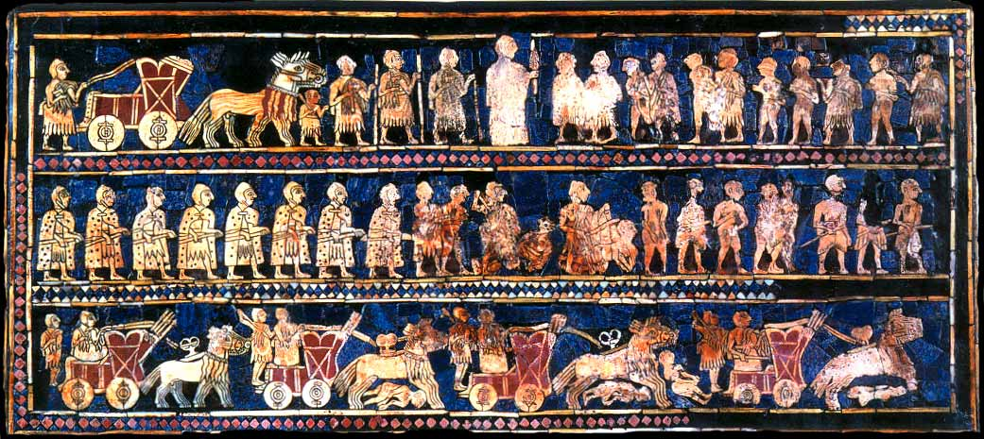
Standard from Ur

The name ‘Sumer’ is derived from the Babylonian name for the southern part of Babylonia. The Sumerians actually called their country Kengi (“Civilized land”) and called themselves Saggiga (“The black-headed ones” or perhaps “bald-headed ones”). The Sumerian language started off as pictograms etched into wet clay tablets and was probably the inspiration for Egyptian hieroglyphics. The Sumerians are generally believed to have invented writing as some of the earliest known texts come from them in Uruk around 3400 BC. By then it was already a complex system with over 700 signs. This pictography is believed to have been adapted into other languages, including the language of the Elamites and of the Indus Valley civilization, a culture that thrived in Pakistan and parts of Afghanistan and Northern India around 2500-1750 BC. Symbols drawn on Indus Valley pottery recently excavated from Harappa predate even the earliest Sumerian writing (3500 B.C.), but are not as complex.⁷ By 2000 BC, The Sumerians were using goods traded, however indirectly, from the Indus Valley. After the decline of the Indus Valley, the culture fell into obscurity until traces of it were rediscovered in the 1920s.

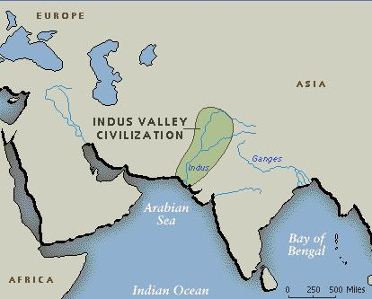

Around 2900 BC, Sumerian pictography was simplified into a language known as cuneiform, named for it’s left wedge-shaped strokes. The cuneiform were written sideways, losing the pictographic quality it once had. This is generally believed to be the first evidence of true language, although some archaeologists believe that inscriptions found in the tomb of the Scorpion King, Egypt’s first monarch, and dated to 3400-3300 B.C., qualifies as symbolic representation and therefore beat the Sumerians to the punch.⁸ Three different forms of Sumerian cuneiform developed before the language became widespread. Some of this language that they called ‘Emegir’ survives to this day: The Sumerian words mayakku (“confuse”/“intoxicate”) and kohl (“eyeliner”) are related to the Hebrew kakhal (“paint“) and the Arabian al-Kahl (“the eyeliner“), which is today termed ‘alcohol’. Similarly, the Sumerian word kanubi (“cane of two [sexes]”) is the root of the modern word ‘Cannabis’.

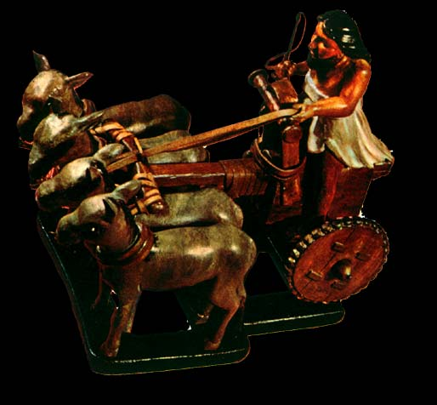
Sumerian charioteer, 2800 B.C.

Each of the Sumerian city-states was headed by a temple devoted to one of the gods of their pantheon, which owned about two-thirds of the land. Each god acted as a kind of mascot for the city, and actions done by armies of each city were often metaphorically described as the actions of the city’s personal god. The head of the pantheon resided in Uruk, which was often the capital of Sumer, although it was in fierce competition for kingship with most of the other cities, especially Ur and the Akkadian city of Kish. Although Nippur was never a capital itself, no king was considered legitimate without it being sanctioned by that city. Located in the very middle of Sumer and Akkad, 80% of all Sumerian literature found has been excavated from Nippur.

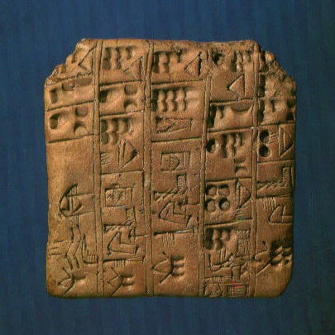

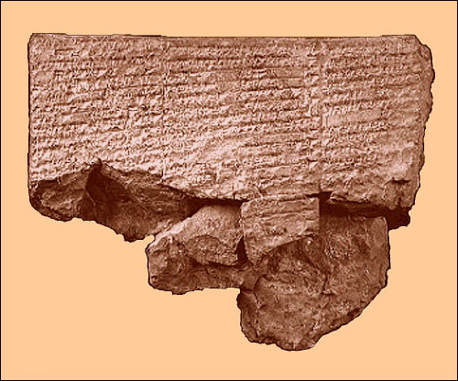
Nippur Tablet

The Separation of Heaven and Earth

The Sumerians believed that in the beginning there was only the primeval sea, which they called Nammu (“Mankind‘s Mother”). Nammu gave birth to An (“Heaven”) and Ki (“Earth”). It was the union of An and Ki, “heaven” and “earth”, which produced the Anunnaki, or Anunna, meaning “Heaven came to Earth“ or “Those who descended from Heaven to Earth.” The physical union of Heaven and Earth is described in the Sumerian text The Birth of Wood and Reed:

“The Great Earth made herself glorious, her body flourished with greenery. Wide Earth put on silver metal and lapis lazuli ornaments, adorned herself with diorite, chalcedony, carnelian, and diamonds. Heaven covered the pastures with irresistible sexual attraction, presented himself in majesty. The pure young woman showed herself to the pure Heaven. The vast Heaven copulated with the wide Earth, the seed of the heroes Wood and Reed he ejaculated into her womb. Sweet Earth, the good cow, received the rich seed of Heaven in her womb. The Earth, for the happy birth of the Plants of Life, presented herself.”

(Lapis luzuli is a dense blue semiprecious gemstone and diorite is a very hard green or gray volcanic rock. Chalcedony and carnelian are types of quartz.)
Another text, Gilgamesh, Enkidu, and the netherworld, begins with this introduction:

In those days, in those distant days, in those nights, in those remote nights, in those years, in those distant years; in days of yore, when the necessary things had been brought into manifest existence, in days of yore, when the necessary things had been for the first time properly cared for, when bread had been tasted for the first time in the shrines of the Land, when the ovens of the Land had been made to work, when the heavens had been separated from the earth, when the earth had been encircled by the heavens, when the name of mankind was fixed, when An had taken the heavens for himself, when Enlil had taken the earth for himself, when the netherworld had been given Ereshkigal as a gift; when he set sail, when he set sail, when the father set sail for the netherworld, when Enki set sail for the netherworld -- against the king a storm of small hailstones arose, against Enki a storm of large hailstones arose. The small ones were light hammers, the large ones were like stones from catapults [?]. The keel of Enki's little boat was trembling as if it were being butted by turtles, the waves at the bow of the boat rose to devour the king like wolves and the waves at the stern of the boat were attacking Enki like a lion.

What Enki did when he got there or why he went to the netherworld has not been recorded.
The expanse between heaven and earth, or lil (“air“, “wind“, “spirit“, “breath“), was the realm of the god Enlil (“Lord-Air”). An’s other son Enki (“Lord-Earth”) was actually the god of the freshwater under the earth. Unlike the air god Enlil, he was the son of Nammu, mother of all the gods, and was said to live deep within the abzu. Abzu, just like the modern word ‘abyss’ from which it is rooted, is a freshwater abode deep underneath the earth. The netherworld Ereshkigal (“Queen of the Great Below”) took charge of was called Kur, or Kurnugia (“Land of No Return”). It has been presumed from some of the damaged text that Enki defeated Kur, gaining Enki the title “Lord of Kur”.
Heaven was conceived of as being a hollow space enclosed by a solid substance (perhaps tin) in the shape of a vault, and the earth was believed to be a flat disk.⁵ Above the sky was the primeval ocean, where rain came from. This ancient belief of a primeval ocean above the sky is also found in the first verses of the Bible:

In the beginning Elohim created the heavens and earth. Now the earth was tohu [formless] and empty, darkness was over the surface of the tehom [deep], and the Spirit of Elohim was hovering over the waters. And Elohim said, “Let there be light,” and there was light. Elohim saw that the light was good, and he separated the light from the darkness. Elohim called the light “day” and the darkness “night”. And there was evening, and there was morning- the first day. And Elohim said, “Let there be an expanse between the waters to separate water from water.” So Elohim made the expanse and separated the water under the expanse from the water above it. And it was so. Elohim called the expanse “Shamayim”. There was evening and there was morning, a second day.” -Genesis 1:1-8

Translated in most Bibles as “God”, Elohim is actually the plural form for Eloh, or El, even though the sentence structure uses it as if it were a singular noun. While some contend that the word is a holdover from an earlier polytheistic society, others believe that this is representative of the Trinity, or the plurality of majesty, similar to how European kings referred to themselves in the plural. The New Advent Catholic Encyclopedia cites the same use of plurality to denote a single god in inscriptions from Phoenicia and Tel Amarna (Akhetaten) in Egypt. Derivatives of Elohim found in the Old Testament include: El Elyon (“Lord Most High”), El Sabaoth (“Lord of Hosts”/ “Lord of Armies”), El Shaddai (“Lord Almighty”), and El Olam (“Lord Everlasting“). The Babylonian El was short for El-lil (“Lord-Air”), who they also called Enlil. To the Canaanites, El was a proper name for the head of their pantheon; they also added an epithet to the name, referring to him as “El the Bull”.
The Hebrew words tohu and tehom are believed to be rooted in the name of the Babylonian goddess Tiamat, a great multi-headed dragon symbolizing the chaos of the primeval waters above the heavens. Like her Sumerian equivalent Nammu, she is the mother of all the gods. The Hebrew word Shamayim is equivalent to the Sumerian An, being a word for both sky and the heavens. Like the Sumerians, the Hebrews viewed the world as being constituted from layers including: the netherworld, the surface world, the heavens, and a watery void encircling all of it.

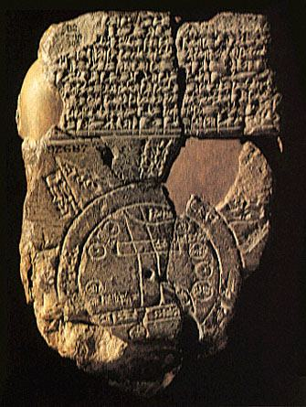
Map of the World, showing the ocean surrounding all land
with the Tigris and Euphrates Rivers running through the middle.

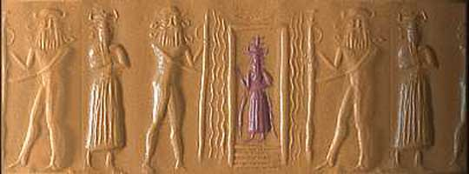
Enki in his underwater temple
The texts say that in these ancient times the gods acted like men and did all the work and labor. A text called The Debate between Winter and Summer describes how after stealing away with the earth, Enlil copulated with the hills and produced the two seasons, Emesh (“Summer”) and Enten (“Winter”). Like all gods, their births were quick and painless:

An lifted his head in pride and brought forth a good day. He laid plans for ...... and spread the population wide. Enlil set his foot upon the earth like a great bull. Enlil, the king of all lands, set his mind to increasing the good day of abundance, to making the ...... night resplendent in celebration, to making flax grow, to making barley proliferate, to guaranteeing the spring floods at the quay, to making ...... Lengthen [?] their days in abundance, to making Summer close the floodgates of heaven, and to making Winter guarantee plentiful water at the quay.
He copulated with the great hills, he gave the mountain its share. He filled its womb with Summer and Winter, the plenitude and life of the Land. As Enlil copulated with the earth, there was a roar like a bull's. The hill spent the day at that place and at night she opened her loins. She bore Summer and Winter as smoothly as fine oil. He fed them pure plants on the terraces of the hills like great bulls. He nourished them in the pastures of the hills.
Enlil set about determining the destinies of Summer and Winter. For Summer: founding towns and villages, bringing in harvests of plenitude for the Great Mountain of Enlil, sending laborers out to the large arable tracts, and working the fields with oxen; for Winter: plenitude, the spring floods, the abundance and life of the Land, placing grain in the fields and fruitful acres, and gathering in everything -- Enlil determined these as the destinies of Summer and Winter.
By hand Winter guided the spring floods, the abundance and life of the Land, down from the edge of the hills. He set his foot upon the Tigris and Euphrates like a big bull and released them into the fields and fruitful acres of Enlil. He shaped lagoons in the water of the sea. He let fish and birds together come into existence by the sea. He surrounded all the reed-beds with mature reeds, reed shoots and ...... reeds.

The fact that Winter created fish and birds in the same instance matches with the fifth day of creation as reported in the beginning of Genesis:

“And Elohim said: ‘Let the water teem with living creatures, and let birds fly above the earth across the expanse of the sky.’” -Genesis 1:20

Like in the Hebrew story of Kayin and Havel (Cain and Abel), the two seasonal metaphors Summer and Winter go to bring offerings for a sacrifice, except it is at E-Namtila, one of Enlil’s mountain temples. Like Cain, Summer builds the world’s first town. When the two of them go to sacrifice, Emesh brings cattle, sheep, rams, deer, stags, fattened pigs, porcupine, turtle, birds, eggs, crops, flour and malt while Enten brings figs, dried fruit, cool water, honey, beer, birds, fattened duck, carp, pomegranates, grapes, cucumbers and turnips. The two get into a quarrel about which sacrifice is better. At first Winter is too tired from working to argue but then, overcome with anger, he ‘reared himself’ and told Summer that he should not praise himself since all of Summer’s harvest had come through Winter’s toil. Summer countered that all of the straw that Winter hauled got thrown into the hearth because of the cold that Winter brought. This argument takes up the majority of the text. When Enlil makes his presence, the argument is settled:

Like a great bull Winter raised his head to speak: "Father Enlil, you gave me control of irrigation; you brought plentiful water. I made one meadow adjacent to another and I heaped high the granaries. The grain became thick in the furrows. Ezina came forth in splendor like a beautiful maiden. Summer, a bragging field-administrator who does not know the extent of the field, ...... my thighs grown tired from toil. ...... tribute has been produced for the king's palace. Winter admires the heart of your ...... in words."
Summer pondered everything in his head and calmed down. Summer spoke respectfully to Enlil: "Enlil, your verdict is highly valued, your holy word is an exalted word. The verdict you pronounce is one which cannot be altered -- who can change it? There was quarrelling of brother with brother but now there is harmony. For as long as you are occupying the palace, the people will express awe. When it is your season, far be it from me to humiliate you -- in fact I shall praise you."
Enlil answered Summer and Winter: "Winter is controller of the life-giving waters of all the lands -- the farmer of the gods produces everything. Summer, my son, how can you compare yourself to your brother Winter?" The import of the exalted word Enlil speaks is artfully wrought, the verdict he pronounces is one which cannot be altered -- who can change it?
Summer bowed to Winter and offered him a prayer. In his house he prepared emmer-beer and wine. At its side they spend the day at a succulent banquet. Summer presents Winter with gold, silver and lapis lazuli. They pour out brotherhood and friendship like best oil. By bringing sweet words to the quarrel (?) they have achieved harmony with each other.
In the dispute between Summer and Winter, Winter, the faithful farmer of Enlil, was superior to Summer -- praise be to the Great Mountain, father Enlil!

Even though Summer’s sacrifices are better, Winter’s sacrifice is found more pleasing because he worked harder for it. Perhaps Enten (“Winter”) was predestined to be the winner since the word ‘En’ (“Lord”) is in his name. The moral of the Sumerian version doesn’t translate over though: Abel’s sacrifice is looked on with favor because he brings in the fat portions from the firstborn of the stock. Instead, the resolution of The Debate between Winter and Summer becomes the source of conflict between Kayin and Havel.
Enki and the World Order further describes how the sea god Enki was commissioned by Enlil to establish the days of the month and to make the people and animals of the lands fertile. He purified the land of Dilmun and gave animals to the wandering nomads of Martu. The Old Testament makes 86 references to these nomads, calling them Amorites and sometimes equating them with Canaanites or the ancestors of the Canaanites.
The sea god Enki then filled the Tigris and Euphrates rivers:

After he had turned his gaze from there, after father Enki had lifted his eyes across the Euphrates, he stood up full of lust like a rampant bull, lifted his penis, ejaculated and filled the Tigris with flowing water. He was like a wild cow mooing for its young in the wild grass, its scorpion-infested cow-pen. The Tigris ...... at his side like a rampant bull. By lifting his penis, he brought a bridal gift. The Tigris rejoiced in its heart like a great wild bull, when it was born ....... It brought water, flowing water indeed: its wine will be sweet. It brought barley, mottled barley indeed: the people will eat it. It filled the E-Kur, the house of Enlil, with all sorts of things. Enlil was delighted with Enki, and Nibru was glad. The lord put on the diadem as a sign of lordship, he put on the good crown as a sign of kingship, touching the ground on his left side. Plenty came forth out of the earth for him.

After that, Enki then built a shrine for the sea and ordained the rains to the storm god Ishkur, who rode great storm clouds and threw lightning bolts as a weapon. Enki further organizes the ploughs of the farmlands and the wildlife of the earth:

He built the sheepfolds, carried out their cleaning, made the cow-pens, bestowed on them the best fat and cream, and brought luxury to the gods' dining places. He made the plain, created for grasses and herbs, achieve prosperity. Enki placed in charge of all this the king, the good provider of E-Anna, the friend of An, the beloved son-in-law of the youth Suen, the holy spouse of Inanna the mistress, the lady of the great powers who allows sexual intercourse in the open squares of Kulaba -- Dumuzi-Mother-Dragon-of-Heaven, the friend of An.

After Enki had assigned duties to Enlil’s sister Aruru (another name for Ninmah) and some of the minor gods, the love goddess Inanna came weeping and complaining that she hadn’t been given a job. Enki told her that he has already given her her voice, clothed her in the garments of women’s power, and the shepherd’s crook-staff. But he adds to that, giving her the ability to sense ill omens regarding battle. For that, Enki gave Inanna a spindle and colored thread, perhaps to weave the fates. Enki tells Inanna that she sows human heads like seed and never grew weary of her admirers. At this point, the text starts becoming unclear until it ends with a praise for Enki.
The E-Anna spoken of was the Inanna’s temple in Uruk and Kulaba was one of Uruk‘s districts. By Babylonian times Inanna texts have been found referring to her as the goddess of the morning star, i.e. Venus, but her association with that planet must have come much earlier. The majority of Sumerian text lists Inanna’s twin brother as the sun god Utu, which must be rooted to that astronomical effect: the ability to see Venus in the morning. Oddly enough, Inanna and the sun god Utu were children of the moon god, Nanna. Also known as Suen, he was the son of Enlil and Ninlil. As the goddess of love and fertility, Inanna was responsible for the fruitfulness of the land. To do this she enacted a Sacred Marriage Rite with Enki’s son Dumuzi. This was an event that usually marked the new year where the king took the role of Dumuzi and performed a fertility rite with a human representation of Inanna in order to ensure the land’s fruitfulness. The holiday seems to have started off as a local rite of Uruk around the third millennium BC and then grew to become incorporated throughout Babylonia. The “Mother Dragon of Heaven” epithet added to his name may be a reference to his grandmother, Enki’s mother: Nammu, goddess of the primeval sea. Dumuzi was sometimes referred to as “Beloved of Enlil”.

Sumerian Gods Family Tree

-----------------------------------------------Nammu (Tiamat)
| | |-------
| | | | (twins)
| -----------------------An----Ki (Ninmah?)
| | |
| Lugalbanda----Sirtur---Enki~~~Ninmah----Enlil------------------------Ninlil
| | (Ninsun)| | |3 | |4
| | | | | | |
| Gilgamesh | | Ninurta ---------- Ishkur* (Adad)
---------------------------|---------| (Ningirsu) |2 |1
| man | Nanna (Suen)-----Ningal
| | | |
| | ------------ ---- (twins)
-------------------------------|---------|------------------|--------------
| | ---------- |
| |1 |2 |3 |
Nergal--Ereshkigal Utu Inanna*--Dumuzi

*Sometimes referred to as the offspring of An and Ki
#: Chronology of birth (1: eldest, etc.)

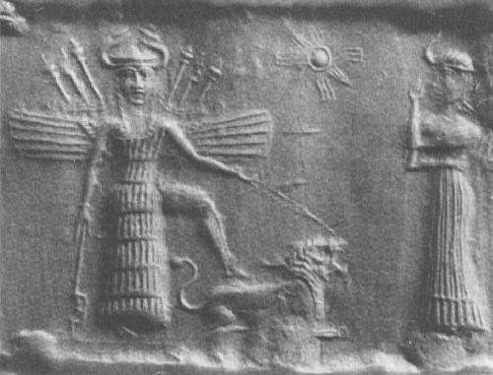
Inanna with wings, horns, and a crown, standing on a lion

Another text, called Enlil and Ninlil, describes what Enlil’s city of Nippur was like when Enlil (“Lord-Air”) and Ninlil (“Lady-Air”) were young and the city was still inhabited by the gods, who are at their most anthropomorphic. Ninlil’s mother Ninbarshegunu advises her not to go to the canal and bathe herself where Enlil is sure to see her. When Ninlil goes there and bathes anyway, Enlil comes up from the other side of the bank and begins to ask to make love to her. But Enlil seems unconvincing as Ninlil replies:

"My parts are little, they know not how to stretch; my lips are little, they know not how to kiss! If my mother learned about it she would be slapping my hand. If my father learned about it, he would be grabbing hold of me harshly, and it would not be for me, now, to tell my girlfriend, I should be drying up on her!”

But Enlil gets his servant Nusku to build him a boat and he sails across and has his way with her. She conceives Suen (the Akkadian name for the moon god Nanna, also known as Sin), and when they find out, the gods throw Enlil out of his own city. But Ninlil decides to follow him as he travels into the netherworld. Enlil meets the keeper of the gate and warns him not to tell Ninlil where he is when she gets there. When Ninlil arrives, she tells the gatekeeper about the moon god that she and Enlil conceived. She then asks the gatekeeper to impregnate her, enabling her to leave behind a substitute in the netherworld so that the moon god could escape to arise into the heavens. The gatekeeper leads Ninlil to his bedchambers, but Enlil sneaks in and takes his place, conceiving the netherworld god, Nergal, who later marries Ereshkigal and becomes the king of the netherworld. The episode is repeated when Enlil and Ninlil meet up with the river man, and Enlil conceives Ninazu, owner of the temple manor Egida in the same fashion. The routine is done a third time with Silulim the ferry man, the Sumerian version of Charon of Hades. This time Enlil conceives Enbilulu, the river warden. The text then ends with many praises for Father Enlil and one for Mother Ninlil.

Man and the Primeval Sea

The oldest creation account of the Sumerians was found in Enlil’s ancient city of Nippur, and is known as the Nippur Tablet or Eridu Genesis. Although badly fragmented, it gives an account of how the black headed people were created by An, Enlil, Enki and Ninhursag (Ninmah) to instigate some sort of peace and how kingship descended from heaven to Eridu. The Sumerian text Enki and Ninmah elaborates more fully, entailing how Nammu, mother of all the gods, went down to a place called the engur, which was deep inside the abzu, bringing the tears of the gods. She woke Enki from his deep slumber and told him of how the lesser gods were suffering under Enlil’s rule. She asked him to apply the skill deriving form his wisdom to create a substitute for the gods so that they could be freed from their toil. Enki went into the halankug, his pondering room, until he discovered the answer. He slapped his thigh in annoyance as he fashioned the design. He then returned from his pondering room saying:

"My mother, the creature you planned will really come into existence. Impose on him the work of carrying baskets. You should knead clay from the top of the abzu; the birth-goddesses [?] will nip off the clay and you shall bring the form into existence. Let Ninmah act as your assistant; and let Ninimma, Shu-Zi-Anna, Ninmada, Ninbarag, Ninmug, ...... and Ninguna stand by as you give birth. My mother, after you have decreed his fate, let Ninmah impose on him the work of carrying baskets."
Ninmah (“The Exalted Lady”) is the sister of Enlil and is also known as Ninhursag (“Lady of Mt. Hursag”) and Nintu (“Lady who gave birth”). It has been suggested that she is a later incarnation of Ki given Ninmah’s ‘Mother Earth’ characterizations.⁵ Through the help of her and Enki, the primeval sea gives birth to mankind. But the part of the text that deals with the birth is fragmented.
The birth of man is described in a later version of the creation story, the Akkadian Epic of Atrahasis, which dates to around 1600 B.C. Akkad is the region just north of Sumer, most popularized around Enlil’s city or Nippur. The region is known to have been inhabited since 3000 B.C. at the latest, about 400 years after concrete evidence of the Sumerians. The first Akkadian names attested to have been found in Sumerian documents dating to 2900-2800 B.C. The first texts written fully in the Akkadian language found date to 2500 BC. Akkadian stories are written in a Semitic language, called so because it is an ancestor language of ancient Hebrew. Like the Sumerian, Elamite, and Hittite languages, the Akkadian language was written using cuneiform.

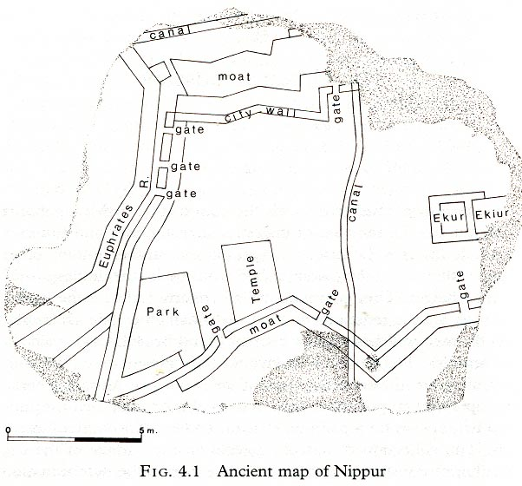

The Epic of Atrahasis tells how each of the elements of the world were divided amongst the gods at random:

They took the box of lots and cast the lots; the gods made the division. Anu [An] went up to the sky, and Ellil [Enlil] took the earth for his people. The bolt which bars the sea was assigned to far-sighted Enki.

This is very similar to how the Greek poet Apollodorus describes how Zeus and his brothers divided the world amongst themselves:

Armed with these weapons the gods overcame the Titans, shut them up in Tartarus, and appointed the Hundred-handers their guards; but they themselves cast lots for the sovereignty, and to Zeus was allotted the dominion of the sky, to Poseidon the dominion of the sea, and to Pluto the dominion in Hades.

The Dead Sea Scrolls version of the book of Deuteronomy also speaks of the division of lands amongst the “Sons of God“ (called the “Sons of Israel” in most Bibles), although in this case the set boundaries are based on nationality:

Remember the days of old; consider the generations long past. Ask your father and he will tell you, your elders, and they will explain to you. When the Elyon [Most High] gave the nations their inheritance, when he divided all mankind, he set up boundaries for the peoples according to the number of the sons of Elohim. For Yahweh’s portion is his people, Yah-Akov his allotted inheritance. -Deuteronomy 32:7-9

Yah-Akov (“Struggles with Yahweh”) is better known as Jacob, who was later given the name Yisra-El (Israel) in a divine encounter. His name is given here as a anachronism for the nation of Yisra-El. Yah-Akov was given the name after wrestling with a mysterious man until daybreak. As daybreak came and the man realized he couldn’t overpower Yah-Akov, he touched his hip, crippling it, and told Yah-Akov to let go of him. But Yah-Akov said he wouldn’t let go unless he got blessed by him. So the man asked Yah-Akov’s name and then gave him the name Yisra-El. Now forced to limp due to his injuries, he dubs the place Peni-El (“Face of El”) because he “saw the face of Elohim and lived.” This all happens the night before he meets with his estranged twin brother while in fear for his life.
In the Epic of Atrahasis, the Anunnaki forced the Igigi, the lesser gods, to dig the Tigris and Euphrates rivers. Their work was enormous but they groaned and blamed each other, but after 3,600 years they rose up in rebellion, set fire to their tools, and surrounded Enlil’s home, E-Kur (“House of the Mountain“).

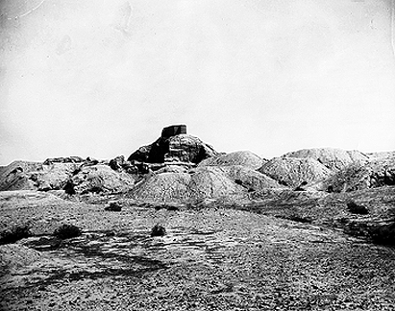
E-Kur (“House of the Mountain”), Nippur

Enlil’s vizier Nusku barred the door while Enlil sent for An and Enki. Nusku then went out to find out which one of them had declared the rebellion, but when he returned he told Enlil that all of them had made the decision since the excessive workload was killing them. At this, Enlil’s tears began to flow, and he called on An to destroy them. An and Enki told Enlil that the Igigi were right and that the warning sounds should have been heard. Nintu (Ninmah) then came up with the solution, saying:

On the first, seventh, and fifteenth of the month I shall make a purification by washing. Then one god should be slaughtered and the gods can be purified by immersion. Nintu shall mix the clay with his flesh and blood. Then a god and a man will be mixed together in clay. Let us hear the drumbeat [heartbeat] forever after, let a ghost come into existence from the god's flesh, let her proclaim it as her living sign, and let the ghost exist so as not to forget the slain god.

Geshtu-E, the god of intelligence was chosen to be sacrificed and Nintu mixed his flesh and blood with clay and the spittle of the Igigi. Mami (Ninmah) then relieved the Igigi of their burden and for that the lesser gods kissed her feet and gave her the title Mistress of All Gods. Enki and Ninmah then went into the room of fate. Ninmah cast a spell and pinched off 14 pieces of clay and made seven males and seven females. The birth goddesses were assembled and counted out ten months and then Nintu (Ninmah) slipped her staff into the womb, covered her head and performed her cosmological midwifery. She then decreed that when a mother gave birth mud brick would be set down and a celebration would be given in the father-in-law’s house for nine days.

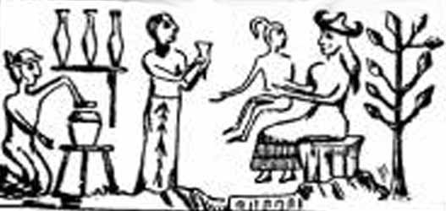
Birth goddesses attending Ninmah as she forms man next to the Tree of Life

After man is created Enki throws a feast for Nammu, Ninmah and all the midwife goddesses and they greatly praise him for the idea. During the feast Enki and Ninmah begin to talk:

Enki and Ninmah drank beer, their hearts became elated, and then Ninmah said to Enki: "Man's body can be either good or bad and whether I make a fate good or bad depends on my will." Enki answered Ninmah: "I will counterbalance whatever fate -- good or bad -- you happen to decide." Ninmah took clay from the top of the abzu in her hand and she fashioned from it first a man who could not bend his outstretched weak hands. Enki looked at the man who could not bend his outstretched weak hands, and decreed his fate: he appointed him as a servant of the king.

When Ninmah makes a blind person, Enki appoints him as the king’s chief musician. Then she fashions one with broken feet and Enki appoints him as a silversmith. Next she fashions someone with no bladder control, so Enki bathes him enchanted water and drives out the ‘namtar’ (“fate”) demon from his body. (Namtar demons were said to have no hands or feet and were responsible for death.) When Ninmah fashions a woman who can not give birth, Enki makes her a weaver for the queen. Finally, Ninmah fashions a neuter without sex organs, so Enki decrees that the person would stand before the king. In frustration, Ninmah throws the clay down. Enki then picks it up and says:

"I have decreed the fates of your creatures and given them their daily bread. Come, now I will fashion somebody for you, and you must decree the fate of the newborn one!"

Enki then fashions someone with a lolling head, bad eyes, a bad neck, bad lungs, shaky ribs, a bad heart and unhealthy bowels. He asks that she give his creature “it’s daily bread”. She tries to feed the babe bread but it can’t eat, nor can it stand up or sit down. Ninmah tells Enki the man he created is neither dead nor alive. Most of the rest of the conversation is fragmented, but it seems that Enki admits that his work is incomplete without her. Enki then announces that his penis be praised and that her wisdom be confirmed and the text ends saying that Ninmah could not rival Father Enki. A drunken god being the explanation for crippled people is also a theme of the Yoruba legends from Africa.
The Sumerian garden of paradise was called Dilmun. The Sumerian text Enki and Ninhursag describes this paradise with a striking number of Biblical parallels:

In Dilmun the raven was not yet cawing, the partridge not cackling. The lion did not slay, the wolf was not carrying off lambs, the dog had not been taught to make kids curl up, the pig had not learned that grain was to be eaten.

This part of the text bears a striking resemblance to a long repeated phrase written in the book of Yesha-Yahu (Isaiah):

The wolf will live with the lamb, and the leopard will lie down with the young goat;
The calf, the young lion, and the fattened calf together, and a little child will lead them.
The cow and the bear will graze. Their young ones will lie down together. The lion will eat straw like the ox. -Isaiah 11:6-7

There were also no diseases in Dilmun, no pain and no aging:

No eye-diseases said there: "I am the eye disease." No headache said there: "I am the headache." No old woman belonging to it said there: "I am an old woman." No old man belonging to it said there: "I am an old man." No maiden in her unwashed state ...... in the city. No man dredging a river said there: "It is getting dark." No herald made the rounds in his border district. No singer sang an elulam there. No wailings were wailed in the city's outskirts there.

Yesha-Yahu writes a similar description of the New Jerusalem that Yahweh gives to him:

I will rejoice in Yerushalayim [Jerusalem], and joy in my people; and there shall be heard in her no more the voice of weeping and the voice of crying. There shall be no more there an infant of days, nor an old man who has not filled his days; for the child shall die one hundred years old, and the sinner being one hundred years old shall be accursed. -Isaiah 65:19-20

This paradise of immortality is located on the island of Bahrain, in the Persian Gulf, two days sail from Mesopotamia according to Sumerian texts. The island is thought to have broken away from the Arabian mainland around 6000 B.C. Excavations on the island have retrieved the remains of one of the oldest civilizations in the world, dating back to 3500 B.C. But people did die there; the island hosts one of the largest necropolises ever excavated, turning up an estimated 170,000 burial mounds dating back to the second millenium B.C. The Dilmun empire also controlled a large part of the western shore.

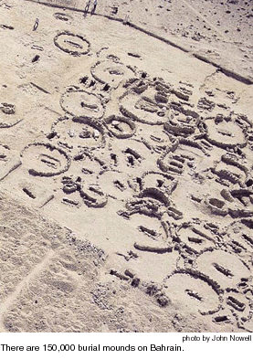

It was eventually annexed by the Assyrian and Babylonian empires. The Greeks arrived there in 300 B.C., naming it Tylos. Bahrain remained a Hellenistic culture for some 600 years. After going through Christian, Zoroastrian, and Manichian influences in the 600’s A.D., it came under the conversion of Islam, some say by Mohammed himself.
In Enki and Ninhursag, Enki came to Dilmun and blessed the land, asking that when Utu, the sun god, stepped into the heavens, the pools of salt water turned into fresh water. When the sun rises, the pools of salt water are purified for the people to drink. Enki begins to take the reed beds in a lovers’ embrace when Ninhursag (Ninmah) brushes him aside and says “No man takes me in the marsh.” Enki cries out and adjures her to lie down with him in the marsh and together they conceive a daughter named Ninsar (“Lady of Plants”). The pregnancy lasts nine days instead of nine months and the labor is painless. When Ninsar comes out to the bank, Enki has his servant Isimud sail him over to her and they conceive another daughter, Ninkurra (“Lady of the Mountains“). When Ninkurra goes to the bank, Isimud sails Enki over again and Enki conceives Uttu, who is possibly the Spider Goddess of Weaving⁵. Nintu (Ninmah) then tells Uttu that she will be seen when she goes to the bank and gives her some advice. When Uttu goes there and runs into Enki, she tells him that if he gathers some fruit for her then he will “indeed have hold of her halter.” Enki fills the dykes with water and cucumbers, and grapes and apples grow from it. Enki brings the fruit to Uttu’s house and makes love to her, but Uttu begins to feel great pain so Ninhursag takes the water (semen) out of her, and using it Ninhursag grows eight plants. Enki sees them from the marsh and decides to go and check them out. His servant Isimud tells him the names of the plants and Enki decides the destiny for each of them, but eats each of them as he does so. Ninhursag grows angry at this and curses him, saying she will not look at him with the life-giving eye until his dying day and then disappears. The Anunnaki begin to despair and sit down in the dust. A fox agrees to find her if Enlil will erect two standards of him in his city. Enlil agrees and when the fox finds her it tells her how all the other cities are suffering, so she rushes back to Enki and asks him where it hurts. Enki names eight parts of him that are in pain, so Ninhursag gives birth to eight deities to heal each body part, each with a name subsequent to that body part. When Enki’s ribs hurt, Ninhursag gives birth to Ninti, which can be translated “Lady of the Rib” or ”Lady of Life” since the Sumerian word ti means both. Chavah (Eve) was made from the rib of Adam (“Man”) and her name also means “Lady of Life”. Similarly, the eating of the fruit that causes the “Lady who gave birth” to curse Enki calls to mind the curse pronounced on Adam and Chava for eating the fruit of the Tree of Wisdom of Good and Evil. The gods giving birth painlessly gives a background for the pain of childbirth that is pronounced on woman-kind after Chavah eats the fruit.
The Sumerians also had their own version of the Biblical flood story, with King Ziusudra of Shurrupuk in the role of Noah. Although the king lists record the last king of Shuruppak as Ubara-Tutu (“Friend of [the god] Tutu“), the Eridu Genesis names Ziusudra (“Life of Long Days”) as the last king and only survivor. A later Babylonian text solves this inconsistency, identifying the “Man of Shuruppak” as the son of Ubara-Tutu.
Although badly fragmented, the Eridu Genesis describes how An, Enlil, Enki and Ninhursag (Ninmah) created the dark headed people and then sent a great flood to destroy them. Although the reason for this is lost, other texts describe that it was the noise of mankind that irritated Enlil. The gods convened a meeting in Shuruppak where An and Enlil convinced the council that mankind needed to be destroyed, although Enki, Nintur (Ninmah) and the love goddess Inanna were set against it. While King Ziusudra was humbly wording his wishes to an idol, he began to hear the voices of the divine council. He then heard Enki warning him of the decision to destroy mankind, enabling Ziusudra to build a large boat and gather all the animals and vegetation into it before the great flood came and killed off all mankind. Other accounts say that Enki was made to swear not to tell anyone so he instead whispered his advice to a wall where the king could hear him. After seven days and nights Ziusudra drilled a hole (or opened a window) and Utu sent his light into the boat’s interior. Ziusudra came out of the boat, kissed the ground, and then offered an ox and a sheep to the sun god. Here the text is fragmented at the point where Enlil appears, angry at Ziusudra’s survival, but Enki convinces Enlil that it’s a good thing. The text comes back with An and Enlil uttering the “breath of heaven” and “breath of earth”, granting Ziusudra “life like a god” and taking him “east, over the mountains, to Mount Dilmun.”, the Sumerian Eden.
The flood story is most definitely the most plagiarized legend to spread throughout the ancient world and Noach (Noah) has the largest number of cultural doppelgangers than any other Biblical hero: Ziusudra, Atrahasis, Utnapishtim (all kings). At 950, Noach is the second oldest man recorded in the Bible, right next to his seemingly inconsequential grandfather Metushelach (Methusaleh), who lived to be 969. When the flood came, it was a consequence of the wickedness of man (Gen. 6:5). This statement is directly preceeded by an event in which the “sons of Elohim” had children by the “daughters of men” who were “heroes of old”. Although Genesis doesn’t make a connection between the events, the Book of 1 Enoch does. It lays out when the 200 of the “Watchers”, led by Azaz-El, came down from heaven and sired giants with the daughters of man. Azaz-El taught them all the evil crafts of the world: how to make weapons, armor, astronomy, how to cast spells and apply make-up. This caused much blood to be spilled, and five of the Watchers who in Heaven: Micha-El, Gabri-El, Rapha-El, Sari-El, and Uri-El called out to the Elyon (Most High) for justice. This was the catalyst that caused the earth’s flooding. Genesis describes it as a rift in the heavens separating the primeval sea from the Earth:

“In the 600th year of Noach’s life, on the 17th day of the 2nd month- on that day the springs of the great tehom [deep] burst forth, and the floodgates of the heavens were opened.” -Genesis 7:11

Just as the primeval ocean took part in the creation of the world, so to did it act on the earth’s destruction. Instead of seven days and nights of flooding, Noach is warned seven days about the flood seven days beforehand and is told to bring seven of each animal (Gen. 7:1-4). Noach’s flood instead lasts for another special number of days and nights: 40. The number 40 appears constantly throughout the Bible and is considered to be holy. When Noach left the ark, he sacrificed clean birds to Yahweh and Yahweh promises never to flood the earth again. Noach’s three sons Yafet (Japheth), Cham (Ham), and Shem become the ancestors of three major families: The Yafethites (Europe), the Chamites (Africa and Canaan), and the Semites (Elam, Assyria, Aram, and Israel). The short story on the Tower of Babel then serves as a bridge to the story of Avram (later given the name Avraham). There is a break between the stories of the patriarch’s Noach and Avram in the Bible unparalleled in the rest of Genesis. Similar to Eridu Genesis, the first 10 chapters of Genesis act as a cohesive unit with the primeval flood breaking through acting as a finishing climax to the primeval separation of the waters for the creation. These chapters act almost like a prologue to the stories associated with the ancestral line of the Patriarchs of Genesis: Avram (Abraham), Yitzchak (Isaac), Yah-Akov (Jacob; later given the name Israel), and Yosef (Joseph). Exodus then begins a generation or so later with the prophet Moshe (Moses), and not breaking again until the end of Deuteronomy, the last of the 5 books known as the Torah, which are believed to have been dictated directly by God to Moshe.
In the Greek version of the world flood, Zeus visits the castle of King Lyacon and discovers the meat he was served was human. He then burned everyone to death in the castle except Lyacon, whom he turned into a wolf for the sake of poetic justice. Disgusted with humans in general, Zeus ordered the gods to kill mankind with a flood, but Prometheus sent a secret message to his son Deucalion in a dream and told him to build a large chest and escape the destruction with his wife Pyrrha. Prometheus (“Fore-thought”) is called the fashioner of man, and also like Enki is considered the wisest of the Titans, but Prometheus is best known for providing man with fire and then paying for it by being strapped to a rock by Zeus and having his liver eaten each day by an eagle. Another story tells how Prometheus tricked Zeus into allowing humans to sacrifice the worst parts of the animal. Going back to the story, when Zeus looked down and saw that only Deucalion and Pyrrha had lived, he ordered the gods to have the floods recede since he knew them to be good people. After nine days the chest landed on Mount Parnassus. The couple found a temple, brushed away the seaweed, and gave thanks to Themis, the Great Goddess of the Titans. She told them each to pick up the bones of their mother and throw it behind them. After they figured out what she meant, they picked up stones from the earth and threw them behind their back. The ones Deucalion threw turned into men and the ones Pyrrha threw became women. The new stone-men had tougher skin than the original clay-made humans.
The Chinese flood story from Chou dynasty, 1000 BC, is of a different origin, although many people believe the flood that it refers to is the same devastating event that Middle Eastern texts commemorate. In it, the water god Gong Gong (Kung Kung) fought with the king Zhuan Xu to settle who was superior. When Gong Gong lost the fight, he smashed the Buzhou (“Imperfect”) Mountain, breaking off a corner of the earth and one of the heavenly supports. The firmament tilted to the northwest, causing the sun, moon and stars all to drift in that direction. The void it created caused the rivers’ waters to rush in and cause a flood. Ti (“Lord”), who was either the emperor or the supreme god, ordered Kun to deal with it, but after nine years was executed by the emperor. His son Yu successfully completed his father’s work by channeling the waters to the sea.
It has been determined that the Euphrates did flood over in the year 2900 BC and caught some of the Sumerian cities in it’s wake, including Shuruppak. This would also fit in well with when the flood would have been based on the timeline derived from the Sumerian king lists. However, some geologists believe the flood stories came from a much more cataclysmic flood that occurred around 5600 B.C., when an ending Ice Age caused the world’s oceans to overflow into the Black Sea, which at the time had been a freshwater oasis, a veritable Garden of Eden.⁹

Son Rise

The first king of Eridu ruled for 28,800 years, at least according to all the Sumerian king lists. The ages of the Biblical Patriarchs can defy imagination, but the ancient kings of Sumer had reigns that were truly cosmic. The king lists have been found at different times in different places, but the first fragment was discovered in Enlil’s temple library in Nippur in the early 1900s. The most complete copy was bought in the antiquities market after the first World War and is now housed in an Oxford museum in England.
If not the oldest city in Sumer, Eridu owns the oldest temples that have ever been excavated, dating back to the middle of the sixth millennium BC. But although it was ancient, this was the only time it ever held power and may have been part of the neighboring city-state Ur after the flood. After Alulim’s extensive reign, Alalgar’s reign topped it with a 36,000 reign, before being toppled by En-Menluanna, when kingship was “taken to Bad-tabira.” En-Menluanna ruled a galactic 43,200 years but En-Menga failed to keep the trend and went back to ruling 28,800 years. The next 36,000 year-long ruler of Bad-tabira was Dumuzi the Shepherd.

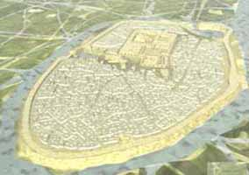
Ur, 3500 B.C.

The king list actually has two listings of Dumuzi on the lists. The second one, called ’the fisherman’ is one of the first kings of Uruk. Dumuzi is also the husband of the love goddess Inanna (daughter of the moon god Nanna). The title most associated with the deity Dumuzi is ‘the shepherd’, suggesting that he was the king of Bad-Tibira. But in the text Inanna’s Descent to the Netherworld, it is Uruk that Dumuzi is ruling over. Dumuzi the Fisherman was also the first king to enact the Sacred Marriage Rite.⁵
According to The Courtship of Dumuzi and Inanna, Dumuzi was the offspring of Enki and Sirtur. He is also linked to the god of the dawn Ningishzida (“Lord-Productive-Tree“). In Babylonian literature Dumuzi and Gizzida (Ningishzida) are guardians of Anu’s heavenly gates.

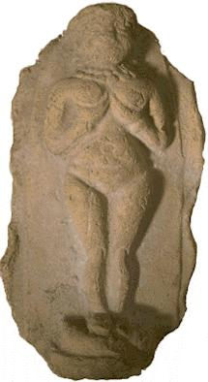
Engraving of Inanna

It is written in Sumerian texts that Inanna’s name is derived from Nin-anna (“Lady of Heaven”), but it also seems that the name is at least partially derived from her father. She is the first in a long line of love goddess incarnations that spread throughout the Near East and Western world. Her Semitic (Akkadian) name was Ishtar, the whore of Babylon. She was Aphrodite to the Greeks and Venus to the Romans. In the Old Testament she’s referred to as Ashtoreth (“Lady of Shame”), which was a derivation of her Canaanite name Asherah. Inscriptions from archaeological finds have shown that Asherah was popularly worshipped as the consort of Yahweh in both Israel and Judah.¹⁰ In contrast, the Old Testament refers to the state of Israel as Yahweh’s bride.
Asherah’s symbol of fertility was the upright pole, representing the Tree of Life. Two of the more appreciated kings of Judah in the 700s B.C., Chizki-Yahu (Hezekiah) and Yoshi-Yahu (Josiah), went on campaigns to rid the land of all of these “Asherah poles” (2 Kings 18:4, 23:15). However, the poles lived on in Greek art and later became the symbol of Hermes. Snakes, representing the male anatomy, were depicted mating while wrapped around the tree. Today the Asherah pole is illustrated in the caduceus on every ambulance and hospital in the western world.
The Asherah pole’s depiction is generally believed to have come form the ancient Mesopotamian treatment for Draconculiasis (“Little Dragon” of Medina), a parasitic guinea worm that comes from drinking water contaminated with cyclops crustaceans. These creatures carry the larva of the guinea worm, which once born, kills the cyclops and burrows into the intestinal wall. The male worms die shortly after mating in the abdominal cavity. The females, which can grow to be a meter long, go on a long journey to the foot, where they secrete a substance that causes inflammation so that when scratched and doused with water, the worm can spit it’s larvae into a new water source. The way to treat is it to wrap it around a stick daily so that it will be tight enough to slowly pull out. ¹¹
Many people believe Draconculiasis were the “fiery serpents” that the Hebrews were afflicted with during the exodus from Egypt:

They traveled from Mount Hor by the way to the Sea of Reeds, to compass the land of Edom: and the soul of the people was much discouraged because of the way. The people spoke against Elohim, and against Moshe [Moses], “Why have you brought us up out of Egypt to die in the wilderness? For there is no bread, and there is no water; and our soul loathes this light bread. Yahweh sent fiery serpents among the people, and they bit the people; and much people of Yisra-El [Israel] died. The people came to Moshe, and said, We have sinned, because we have spoken against Yahweh, and against you; pray to Yahweh, that he take away the serpents from us. Moshe prayed for the people. Yahweh said to Moshe, Make you a fiery serpent, and set it on a pole: and it shall happen, that everyone who is bitten, when he sees it, shall live. Moshe made a serpent of brass, and set it on a pole: and it happened, that if a serpent had bitten any man, when he looked to the serpent of brass, he lived. -Numbers 21:4-8

The caduceus remained a religious artifact for about 570 years, and then:

Now it happened in the third year of Hoshea, son of Elah, king of Yisra-El, that Chizki-Yahu [Hezekiah], the son of Achaz, king of Yehudah [Judah], began to reign. He was 25 years old when he began to reign; and he reigned 29 years in Yerushalayim [Jerusalem]: and his mother's name was Avi the daughter of Zekhar-Yah [Zechariah]. He did that which was right in the eyes of Yahweh, according to all that David his father had done. He removed the high places, and broke the pillars, and cut down the Asherah: and he broke in pieces the brazen serpent that Moshe had made; for to those days the children of Yisra-El did burn incense to it; and he called it Nechushtan. -2 Kings 18:1-4

Necushtan sounds like the Hebrew for bronze, snake and unclean thing. Necushtan sounds like the Hebrew for ‘bronze‘, ‘snake’ and ‘unclean thing‘. It is mentioned again in the Gospel of John:

“Just as Moses lifted up the snake in the desert, so the Son of Man must be lifted up, that everyone believes in him may have eternal life.” -John 3:14-15
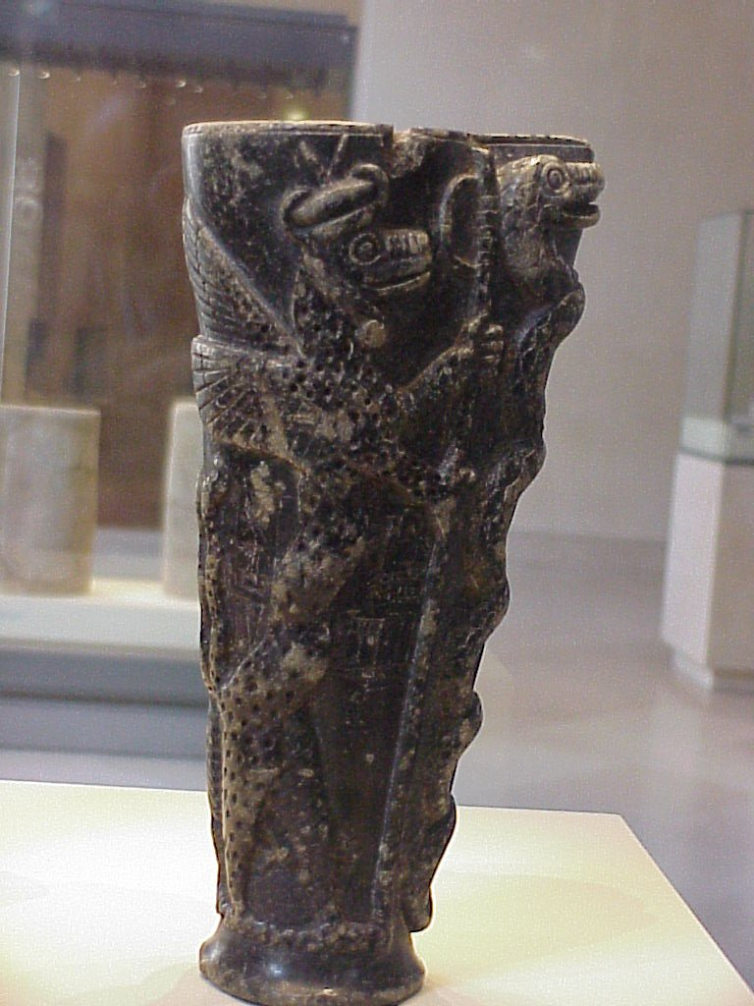
Sumerian Cup to Ningishzida:
Two sphinxes holding a caduceus, 2000 B.C.

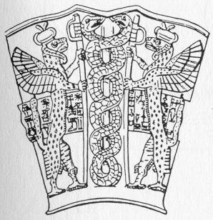
Frontal representation of caduceus in Cup to Ningishzida

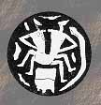
Copulation coin with snake

In The Courtship of Dumuzi and Inanna, Inanna’s brother Utu, the sun god, arranged for her to marry Dumuzi. But Inanna was not overjoyed at the idea of marrying the shepherd since she was in love with the farmer and she complained about the roughness of Dumuzi’s clothing to her brother. Utu tells Inanna that Dumuzi will be a good provider but she insults Dumuzi, telling the shepherd that without her parents and siblings he would have no roof over his head and would be driven away. Dumuzi is more calm and asks Inanna not to quarrel, but ensures her that his parents are just as good as her parents. He then asks to talk the situation over:

The words they had spoken was a word of desire.
From the starting of the quarrel came the lovers' desire.

Just like in Moonlighting. Dumuzi then went to the royal house with milk and cream and asked Inanna to open the door for him. Inanna asked her mother Ningal, who told her that Dumuzi was now to be her father and mother. In another version of The Courtship, Inanna tricks her mother and the two elopers make love under the moon while her mother thinks she is at the square with a girlfriend.⁵
At her mother’s command, Inanna bathed and anointed herself with scented oil. She then clothed herself in a royal white robe, readied her dowry, arranged the beads on her neck and took her seal in her hand. She opened the door for him and Dumuzi kissed her. She then spoke:

“What I tell you let the singer weave into song. What I tell you, let it flow from ear to mouth, let it pass from old to young: my vulva, the horn, the Boat of Heaven, is full of eagerness like the young moon. My untilled land lies fallow. As for me, Inanna, Who will plow my vulva? Who will plow my high field? Who will plow my wet ground? As for me, the young woman, Who will plow my vulva? Who will station the ox there? Who will plow my vulva?”

Dumuzi chivalrously suggests himself as a candidate for the task to which Inanna heartily replies:

“Then plow my vulva, man of my heart! Plow my vulva!”
At the king's lap stood the rising cedar. Plants grew high by their side. Grains grew high by their side. Gardens flourished luxuriantly.

Inanna then sings about how her “honey-man” is the man her womb loves best, detailing how her “eager impetuous caresser” sweetened her. Dumuzi in turn compares her breasts to a broad field and asks her to pour out the water that flows up from on high so that her servant could drink all she offered. To this Inanna replies:

“Make your milk sweet and thick, my bridegroom. My shepherd, I will drink your fresh milk. Wild bull Dumuzi, make your milk sweet and thick. I will drink your fresh milk. Let the milk of the goat flow in my sheepfold. Fill my holy churn with honey cheese.”

Inanna then promises Dumuzi that she will look over his house of life, which decides the fates of the land and gives the breath of life to all it’s people. Dumuzi replies:

“My sister, I would go with you to my garden. Inanna, I would go with you to my garden. I would go with you to my orchard. I would go with you to my apple tree. There I would plant the sweet, honey-covered seed.”

Dumuzi brought her into the garden and Inanna told him how she was bathed, anointed with oil, coated her mouth with sweet-smelling amber and painted her eyes with kohl (eyeliner). Inanna then decreed the fate of Dumuzi, that in battle she would be his leader, his armor-bearer in combat, his advocate in assembly and his inspiration in a campaign. As the first daughter of the moon, she declared that he had the right to kingship.

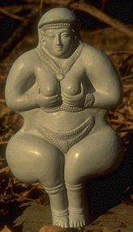
Inanna

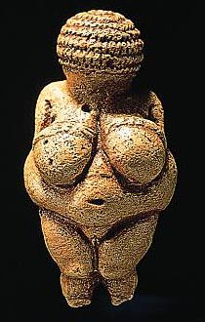
“Willendorf Venus”, Willendorf, Germany 25,000 B.C.
Similar Venus statuettes have been found in Czechoslovakia and Malta (off of Italy)

One particularly similar to this one, found in Paris, was carved out a mammoth tusk

Inanna’s servant Ninshubur led Dumuzi to “the sweet thighs of Inanna” and asks that Dumuzi’s shepherd staff of judgment protect both Sumer and Akkad, from the land of the haluppu tree (Uruk) to the land of the cedar (Lebanon). Dumuzi took Inanna to the sacred bridal bed and tounge-played “one-by-one” fifty times. Dumuzi then asked Inanna that she set him free, assuring her that she would be like a daughter onto his father. Inanna gives a fair adieu to her lover, ending the poem with Inanna describing the sweet allure of her holy statue Dumuzi.
The Courtship texts have much in common with the Hebrew Song of Solomon, also called the Shir Hashirim (“Song of Songs“), the Canticle of Canticles, or the Book of Wisdom. This Old Testament book is said to have been written by King Schlomo (Solomon) for a Shulamite maiden around 965 BC. The Song of Solomon is one of the five scrolls of Megilloth, which are read during Jewish feasts and is believed by some to be an allegory about God’s love for Israel. Just like in the Courtship of Dumuzi and Inanna, the husband is called a king and a shepherd, while his bride is also referred to as his sister:

“How fair is thy love, my sister, my spouse! How much better is thy love than wine, and the fragrance of your ointments than any spice! Your lips, oh my spouse, drop as the honeycomb: milk and honey are under your tongue. The smell of your garments is like the smell of Lebanon. You are a garden locked up, my sister, my spouse, a spring enclosed, a fountain sealed.” - Song of Solomon 4:10-12

The style, theme and a good deal of content of the texts are identical. Both canticles consist largely of lovers’ dialogues separated by musical refrains, both use the terms milk and honey as sexual euphemisms, and both move from the mother’s house to a special apple tree for the honeymoon:

“If only you were to me like a brother, who sucked the breasts of my mother! If I found you outside, I would kiss you; yes, and no one would despise me. I would lead you, bringing you into my mother's house, who would instruct me. I would have you drink spiced wine, the nectar of my pomegranate. His left hand should be under my head, and his right hand should embrace me. I charge you, oh daughters of Jerusalem, that you should not arouse nor awaken love until it so desires.
Who is this who comes up from the wilderness, leaning on her lover? Under the apple tree I roused you; there your mother conceived you; there she was in labor and bore you. Set me as a seal upon your heart, as a seal upon your arm, for love is as strong as death; jealousy as cruel as She‘ol [the netherworld]; It’s flashes are flashes of fire, like a mighty flame of Yah[weh]. “ -Song of Solomon 8:1-6

These kinds of alluring poems that you wouldn’t expect to be in the Bible were recited during the celebration of the ancient fertility rites in Sumer and Akkad. From this evidence, we can conclude that the real poetic inspiration behind the Biblical scripture is actually much older than Schlomo’s times. The part about the positioning of the hands and the reference to death at the end of the Song of Solomon is also very similar to some of the verses in one of the other Courtship poems:

Oh, my beloved, my man of the heart,
You- I have brought about an evil fate for you, my brother of a face most fair,
My brother, I have brought about an evil fate for you,
my brother of a face most fair,
Your right hand you placed on my vulva,
Your left hand stroked my head,
You have touched your mouth to mine,
You have pressed my lips to your head,
That is why you have been decreed an evil fate.

This evil fate is a foreshadow to the next story, Inanna’s Descent to the Netherworld, in which Inanna switches roles as a young virgin bride in love to hostile conqueror. The text reads that Inanna set her sights from heaven to the great below and left her office as en (priesthood/lordship) and lugar (temple servant) to set off to take over her dark sister Ereshkigal’s realm, taking with her seven magical articles of clothing. But as she came to the seven gates of Kurnugia, she was forced to remove them one by one. She complained about it but was told not to open her mouth against the rites of the netherworld. She then came to Ereshkigal’s throne room and forced her sister off the throne, taking it for herself. But then the Anunna (or Anunnaki), the seven judges, appeared and condemned her to death for her actions. Inanna’s servant Ninshubura appealed to Enlil, but he only replied:

"My daughter craved the great heaven and she craved the great below as well. Inanna craved the great heaven and she craved the great below as well. The divine powers of the underworld are divine powers which should not be craved, for whoever gets them must remain in the underworld. Who, having got to that place, could then expect to come up again?"

Inanna’s true father Nanna repeated Enlil’s response, but Enki decided to help. He removed some dirt from his fingernails and created the gala-tura and the kur-gara and gave instructions to his newly made spirit-constructions:

“Go and direct your steps to the underworld. Flit past the door like flies. Slip through the door pivots like phantoms. The mother who gave birth, Ereshkigal, on account of her children, is lying there. Her holy shoulders are not covered by a linen cloth. Her breasts are not full like a cagan vessel. Her nails are like a pickaxe[?] upon her. The hair on her head is bunched up as if it were onions. "When she says "Oh my heart", you are to say "You are troubled, our mistress, oh your heart". When she says "Oh my liver", you are to say "You are troubled, our mistress, oh your liver". [She will then ask:] "Who are you? Speaking to you from my heart to your heart, from my liver to your liver -- if you are gods, let me talk with you; if you are mortals, may a destiny be decreed for you." Make her swear this by heaven and earth.”
He also warns them not to drink water or eat bread while there, as is established in other stories that doing so traps you there. The phantoms flew off like flies and slipped through the doors of the netherworld unhindered. Just like he said, they found Ereshkigal she was nude, her breasts were sunken, he fingernails were grown out and her hair was bunched up. Following Enki’s advice they forced Ereshkigal to take the oath and asks that Inanna’s corpse be taken off the hook. They then sprinkled Enki’s healing plants and life giving water on her and Inanna rose up. But the Anunna returned, telling Inanna that she would have to bring back a substitute. She was then escorted out of Kurnugia by demons with maces and reeds. Their first stop was Genzer, but Ninshubura threw herself at Inanna’s feet. Remembering it was her who saved her life, she convinced the demons to move on. They came to Inanna’s singer and manicurist, Cara, who resided in the Sigkurcaga in Umma. He too threw himself at her feet and was dressed in the ‘filthy garments’, not unlike the sack-cloths that ancient Hebrews put on during times of great grief. She convinced the demons to move on to Bad-Tibira but once again feels pity for her victim and continues on to her own city. She went to the apple tree on the plain of Kulaba (Uruk) and there she found Dumuzi clothed in magnificent clothing and sitting on a great throne. At this she shouted angrily at him and gave him over to the demons. Dumuzi then paled and cried out to the sun god Utu, who was always appealed to in matters concerning justice. Utu heard his prayer and “accepted his tears”, another term similar to an expression found in the book of Yesha-Yahu, when Yahweh saved the prophet’s king from illness:

“Then came the word of Yahweh to Yesha-Yahu, saying, ‘Go and tell Chizki-Yahu [Hezekiah], thus says Yahweh, the Elohim of David your father, I have heard your prayer, I have seen your tears: Behold, I will add to your days fifteen years. I will deliver you and this city out of the hand of the king of Ashur; and I will defend this city.” -Isaiah 38:4-6

Utu helped Dumuzi by turning him into snake, which allowed him to escape, only to be recaptured and brought down to the netherworld. Despite her role in the matter, Inanna mourned bitterly, chastising those who still had their husbands or sons, and she tore her hair out in grief. The phantom houseflies offered to help Inanna but asked for something in return. Inanna decreed that the fly would have a home at taverns and live like ‘the wise ones’, and so they opened communication up with Ereshkigal and they agreed that Inanna would have Dumuzi half the year and Ereshkigal would have him the other half. From that he became the death and resurrection god, who symbolized the death and rebirth of life during the seasons.
This text is the origin of the nearly identical Greek myth of the seasonal divide, in which the love goddess Aphrodite, who like Inanna is identified with the morning star and fights with her dark sister Persephone over her young lover Adonis. Adonis was also known as “He on the tree” and is said to have a sacred grove located in Bethlehem⁸.
Another Greek incarnation of Dumuzi was the Dionysus, the god of wine. Those who shared in the passion of Dionysus were said to go through a rebirth. During the ceremonial worship of Dionysus, a large bearded mask representing the god-man was hung on a wooden pole and, dressed in purple garments and given a crown of ivy. Wine was consumed during the ceremony, of course. Many Greek writers accepted Dionysus as being the same as Osiris, the Egyptian god who was killed by his evil brother Set and then brought back to life by having his pieces reassembled by his wife. Osiris was also called “He who gives birth to men and women a second time”. The Greek poet Herodotus stated that the rites of Dionysus were derived from those of Osiris. In Alexandria, 300 B.C., the sage Timotheus fused the two deities together and gave him the name Serapis. ¹²
When the Romans took Dionysus for their own worship, they called him Bacchus. In Rome, the mysteries of his cult were closely guarded, and he was identified with an ancient god of wine, Liber Pater.¹³ Many legends connected with Dionysus were also used in the cult of Bacchus. Orpheus, who is depicted as a fisherman and is said to have died a violent death, is said to be a legendary prophet of Dionysus. He was said to have become a Bacchoi, an enlightened disciple who becomes an incarnation of Dionysus.¹²

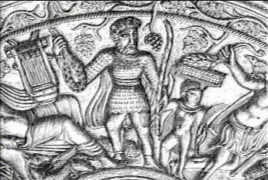
Orpheus holding a net and staff. Wheat and grapes representing
bread and wine grow next to him and a fish lies behind his feet.

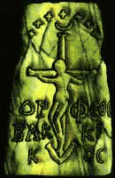
Plaster cast of an amulet; “Orpheus becomes a Bacchoi“, 300 A.D.
Seven stars and a crescent moon hang overhead
Housed in the museum of Berlin but lost during World War II.¹²

The worship of Dumuzi evolved into many different forms as it spread throughout Mesopotamia and Europe. The male-only worship of the Persian god Mithras was another god whose holy day was Christmas and marked by the sharing of gifts. By slaying a bull and eating it’s flesh and drinking it’s blood, Mithras was able to gain immortality to wait an return at the end of time. A common icon of Mithras pictured two torchbearers on either side of him; one holding the torch up to heaven and the other pointing it down to the netherworld. ¹²
Norse religion had it’s own Tree of Life, which was also said to be infested by birds and a snake. This world tree, Yggdrasill (“Horse of Ygg” / “Horse of Odin“), was said to be an ash tree that supported the universe and was so large that it’s roots spread out into different worlds. Three of the world tree’s roots ended at a magical well. The first was Urdarbrunnr (“Well of Urda”), where the three Norns: Urda (“Past”), Verdandi (“Present”), and Skuld (“Future”) decided the destinies of mankind, similar to the duties of the Greek Fates. The second was Mimisbrunnr (“Well of Mimir“), which was the source of all knowledge. There the supreme god Odin cut out one of his eyes in order to drink from the fountain of wisdom. The third root stretched deep down into Niflheim (“World of Cold”), better known as the name of the goddess who ruled over that world, Hel. This well, located next to Hel’s gates, was called Hvergelmir (“Bubbling Cauldron”), which provided the source of all rivers. There the great serpent Nidhog and it’s entourage of snakes ate dead bodies and gnawed at the world tree’s roots. It was said Nidhog was the one creature that was truly invincible and that it’s breath melted the flesh of anything living. Nidhog also sent insults and threats to the birds who lived on top of the tree via a squirrel named Ratatosk, who then relayed the birds’ threats back to the serpent. ¹⁴ The ash tree was also used by the chief Norse god, Odin, and his brothers Ve and Vili, to create the first man. An elm tree was likewise used to create the first woman. In order the learn the secrets of the dead through the nine runes of power, the “All-father” Odin also went through a ritual spiritual death and resurrection on the tree. ¹⁴
Odin’s Rune Song describes how Odin was hung on Yggdrasill for nine days:

"I know that I hung
On a wind-rocked tree
Nine whole nights,
With a spear wounded,
And to Odin offered
Myself to myself ;
On that tree
Of which no one knows
From what root it springs."

This is comparable to some of the passages in the New Testament:

“The law is not based on faith; on the contrary, ‘The man who does these things will live by them.’ Christos redeemed us from the curse of the law by becoming a curse for us, for it is written: ‘Cursed is everyone who is hung on a tree.’” -Galatians 3:12-13

“We are witnesses of everything he did in the country of the Jews and in Jerusalem. They killed him by hanging him on a tree, but Theos raised him from the dead on the third day and caused him to be seen.” -Acts 10:39-40

“But when they came to Jesus and found that he was already dead, they did not break his legs. Instead, one of the soldiers pierced Jesus’ side with a spear, bringing a sudden flow of blood and water.” -John 19:33-34

There are even tales in literature of pagan Vikings feasting with Christian ones in which the Christians made the sign of the cross and the pagans accepted it as the sign of the hammer, which was what they used to bless food, and so respected it as a sign of faith. The Christian theological connection between the Tree of Knowledge and the crucifixion of Jesus is that the self-sacrifice was to atone for the Original Sin that Adam cursed mankind with by eating the forbidden fruit. Because of this, Jesus is often referred to as the Second Adam. The portrait of Christ being crucified on a tree is assumed to be symbolic of the historic Roman execution, which is traditionally believed to have taken place directly over Adam’s grave, now located in the Chapel of Adam at the Church of the Holy Sepulchre in Jerusalem.
Judging by all of this, it becomes clear that the name “Odin” is actually a derivative of the original Sumerian name:

DuMuZi -> TaMMuZ -> aDoNiS -> oDiN

One of Sumer’s other cuneiform texts, Dumuzi’s Dream, tells a different story than the Inanna‘s Descent. Dumuzi has a chilling vision of his own demise and after crying out to the countryside, he tells his beloved sister, Geshtinanna, about it:

"A dream, my sister! A dream! In my dream, rushes were rising up for me, rushes kept growing for me, a single reed was shaking its head at me; twin reeds -- one was being separated from me. Tall trees in the forest were rising up together over me. Water was poured over my holy coals for me, the cover of my churn was being removed, my holy drinking cup was torn down from the peg where it hung, my shepherd's stick disappeared from me. An owl (?) took a lamb from the sheep house, a falcon caught a sparrow on the reed fence, my male goats were dragging their dark beards in the dust for me, my rams were scratching the earth with their thick legs for me. The churns were lying on their side, no milk was poured, the drinking cups were lying on their side, Dumuzi was dead, the sheepfold was haunted."

So shaken by the dream that Dumuzi describes it to his sister, who tells Dumuzi not to speak of it any more, and then gives her own dire prophecy:

My brother, your dream is not favorable, don't tell me any more of it! Dumuzi, your dream is not favorable, don't tell me any more of it! The rushes rising up for you, which kept growing around you, are bandits rising against you from their ambush. The single reed shaking its head at you is your mother who bore you, shaking her head for you. The twin reeds of which one is taken away and then the other is you and I -- first one and then the other will be taken away. The tall trees in the forest rising up together over you are the evil men catching you within the walls. That water was poured over your holy coals means the sheepfold will become a house of silence. That the cover of your holy churn was being removed for you means the evil man will bring it inside in his hands. "
Your holy drinking cup being torn down from the peg where it hung is you falling off the lap of the mother who bore you. That your shepherd's stick disappeared from you means the demons will destroy it. The owl [?] taking a lamb from the sheep house is the evil man who will hit you on the cheek. The falcon catching a sparrow on the reed fence is the big demon coming down from the sheep house.”

Dumuzi told his sister that he would hide in the grass and asked her not to reveal his hiding place. Two demons from the cities of Adab, Akcak, Uruk, Ur, and Nibru came and caught Geshtinanna, offering her fields of grains and rivers of water for his location, but she refused to tell them. So they left her and bribed Dumuzi’s friend, then caught Dumuzi in the ditches of Arali. Once again, Dumuzi appealed to Utu and this time he was changed into a gazelle and escaped. The demons followed him to Kuberish, the house of Old Woman Belili, and then to his sister’s holy sheepfold. Geshtinanna appealed to heaven and earth in Dumuzi’s behalf. She lacerated her face in public and her buttocks in private, but regardless, the ten demons caught up with him at the sheepfold and destroyed the bolt, the shepherd’s stick, and the holy churn (or cream mixer). They killed Dumuzi and the sheepfold became haunted.

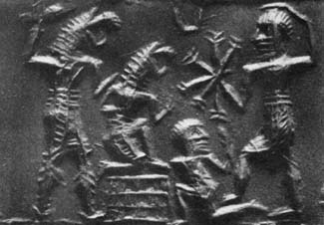
Dumuzi attacked by gala demons

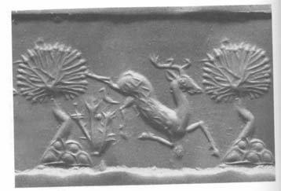
Gazelle

Dumuzi and Geshtinanna opens with demons allowing Geshtinanna to leave her imprisonment in the netherworld by substituting Dumuzi. The demons fasten Dumuzi in metal stocks and begin sharpening their axes. From bondage Dumuzi cried out to Utu, imploring him to turn him into a sajkal snake so that he could escape. Utu accepted his tears and changed him and Dumuzi slithered out of the stocks and then flew away. Dumuzi went to his sister Geshtinanna’s and she told him that demons were out looking for him. Just as she spoke, the demons appeared at her door and demanded that she tell him where Dumuzi was. Dumuzi escaped from the house before the demons broke in and began to torture Geshtinanna to get her to talk. They afflicted her loins with a skin disease and poured tar in her lap, but she said nothing. Unfortunately, the demons once again found Dumuzi in the sheepfold, sharpened their daggers and smashed in his hut. The last line has his sister wandering the streets saying, "My brother, let me take the great misfortune, come, let me…" This suggests that the substitution is cyclical, that Dumuzi’s sister took his place for half the year to reflect the changing seasons.

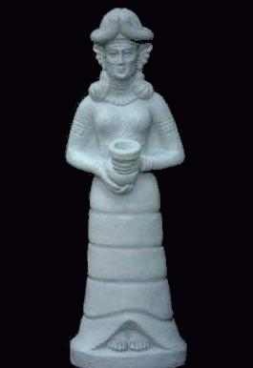
Inanna Statuette

The Saxon version of Inanna was known as Eostre, coming from the Babylonian Ishtar. Since long before Jesus‘ time, parents have told their children about a magic hare that brought painted eggs during the spring festival. To the Norse, Eostre was called Ostara, and the hare and the egg were her symbols, used to represent fertility during a season of new life. The notarized prolific nature of the rabbit family is also the reason Playboy uses it as their mascot. Germany inherited egg painting from the Romans and it is there that children first made grass nests for the hare to leave eggs in. In the 1500s the Easter hare was replaced by the Easter bunny. In the 1800s the first candy bunnies were made in Germany as well. Many Europeans today throw bonfires in honor of the holiday. Some of these are called “Judas Fires” in which pictures of Judas Iscariot are burned.
Easter falls on the first Sunday after the first full moon after March 20th, the nominal date of the Spring Equinox. The modern method of governing the date of Easter was devised in Alexandria in 325 AD. In Asia Minor the Megalensia festival was celebrated on the three days of the spring equinox by tying an effigy of the god Attis to a sacred pine tree and decorated with flowers.¹¹ The Christian tradition of a sunrise service on Easter is shared by ancient pagans, a practice recorded by the prophet Yechezk-El:

Then said he to me, Son of Man, have you seen what the elders of the house of Yisra-El [Israel] do in the dark, every man in his chambers of imagery? For they say, Yahweh doesn't see us; Yahweh has forsaken the land. He said also to me: ‘You shall again see yet other great abominations which they do.’ Then he brought me to the door of the gate of Yahweh's house which was toward the north; and see, there sat the women weeping for Tammuz [Dumuzi]. Then said he to me, Have you seen this, Son of Man? You shall again see yet greater abominations than these. He brought me into the inner court of Yahweh's house; and see, at the door of the temple of Yahweh, between the porch and the altar, were about twenty five men, with their backs toward the temple of Yahweh, and their faces toward the east; and they were worshipping the sun toward the east.
-Ezekial 8:14-16

The weeping for Tammuz was a ritual mourning over Dumuzi’s death, equivalent to the grieving on Good Friday. The sun rising in the east represented the rebirth of Dumuzi, just as it today represents the resurrection of Christ. East is actually called east because of it’s relation to Easter.

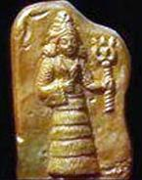
Inanna Coin

The Seven Heavens and a Wizards’ Duel

After Dumuzi the Shepherd’s reign, kingship was taken to Larak, then Sippar, and then Shuruppak. According to the Sumerian king lists the flood occurred well over 30,000 years ago and just like in Genesis, people had shorter life spans after the flood, or at least shorter reigns. After the great deluge, the lists say that kingship descended from Heaven to Kish. The First Dynasty of Kish is said to have lasted 24,510 years, with each of the 23 kings reigning from 306 to 1,500 years. However, the lists vary to some degree on who some of these kings were and how long they reigned. It’s founding ruler is the first ruler to have an Akkadian name. It’s last ruler, Agga, would get into a conflict with Gilgamesh. The title ‘King of Kish’ kept great significance long after the city ceased to be the seat of kingship. Sometimes kings even claimed the title when they had no rule over the city.
The kings of the next dynasty were by far the most popular than any other, and the first of it’s rulers became immortalized as heroes if not gods. The first dynasty of Uruk, which is estimated to have reigned 2800-2540 BC, has been called the Sumerian Heroic Age⁵. The first king of E-anna (“House of Heaven”; the original name of Uruk and also the name for Uruk’s temple to Inanna) was Meskiaggaseir, son of Utu (the sun god) and reigned as en (“priest”/“lord”) and lugal (“man of greatness”/“king”) for 325 years. He won the control of the region extending from the Mediterranean Sea to the Zagros Mountains. Meskiaggaseir was succeeded by his son Enmerkar, who led a campaign against the city of Aratta.
Restored from 20 tablets and fragments, Enmerkar and the Lord of Aratta is the longest Sumerian epic that has been uncovered. In it, Enmerkar is given three quests to prove that the Lord of Aratta should submit to Enmerkar as Inanna’s king. Like his father, ‘Lord-Merker’ is also called the son of Utu in the story, although the king lists only give that title to his genetic father. Throughout the story he refers to Inanna as his sister. The text starts off with praise for the city of Uruk-Kulaba and boasts that Inanna’s jipar (“temple“) was long founded before Dilmun existed, even before gold, silver and copper were used in commerce. Enmerkar asks Inanna to let the lord of Aratta bring gold, silver and lapus lazuli (blue gems) to adorn the temples of Inanna and Enki’s temple in Eridu:

"Let Susin and the land of Anshan humbly salute Inanna like tiny mice. In the great mountain ranges, let the teeming multitudes grovel in the dust for her. Aratta shall submit beneath the yoke to Uruk. The people of Aratta shall bring down the mountain stones from their mountains, and shall build the great shrine for you, and erect the great abode for you, will cause the great abode, the abode of the gods, to shine forth for you; will make your me [arts] flourish in Kulaba [Uruk], will make the abzu grow for you like a holy mountain, will make Eridu shine for you like the mountain range, will cause the abzu shrine to shine forth for you like the glitter in the lode. When in the abzu you utter praise, when you bring the me [arts] from Eridu, when, in lordship, you are adorned with the crown like a purified shrine, when you place on your head the holy crown in Uruk Kulaba, then may the ...... of the great shrine bring you into the temple, and may the ...... of the temple bring you into the great shrine. May the people marvel admiringly, and may Utu witness it in joy. Because ...... shall carry daily, when ...... in the evening cool ......, -- in the place of Dumuzi where the ewes, kids and lambs are numerous, the people of Aratta shall run around for you like the mountain sheep in the akalag fields, the fields of Dumuzi. Rise like the sun over my holy breast! You are the jewel of my throat! Praise be to you, Enmerkar, son of Utu!"

Enmerkar heeded Inanna’s advice and called his servant, telling him to travel over the Zubi (Zagros) mountains to Susin. He tells the servant to let the men of Susin grovel in the dust and make the Lord of Aratta submit to Uruk “Lest I make the people fly off from that city like a wild dove from its tree, lest I make them fly around like a bird over its well-founded nest.”

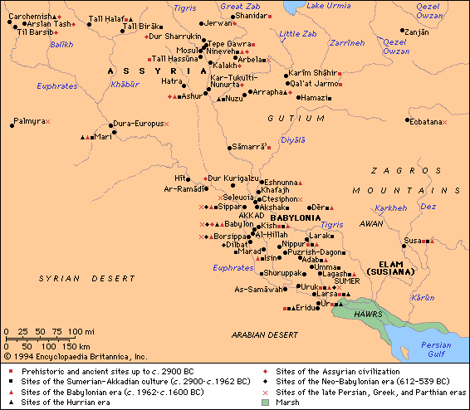

Susin, also known as Susiana or Susa, is the ancient name for the capital of Elam, which does sit at the foot of the mineral-rich Zagros mountains near the bank of the Karkheh Kur river. The name of this river is also related to the Sumerin word kur, a broad-based word meaning mountain, land, or the netherworld. It is also the river that lent it’s name to the Persian emperor Koresh, a.k.a. Cyrus the Great, known to the Jews as a Messiah after he led them out of Babylon in 539 BC. Excavations of Susa have also found the city to be 5,000 years old, and it’s art consists of winged animals such as bulls, which perhaps explains the reference to the people flying around like doves. Also found was a mud brick platform about 80x65 meters and 10 meters high, decorated with pottery cylinders stuck into a façade, which must have once held a great temple. Buildings were found nearby that may have been part of a temple. The four mounds were identified by W.K. Loftus in 1850 and excavated by Jacques de Morgan from 1897-1908. Among the valuable treasures also uncovered in the city: the obelisk of the Akkadian king Manishtusu, the stele of his successor Naram-Sin, and the Babylonian Code of Hammurabi. Susa remained a great capital until it was sacked and burned by the Mongols in the 1200s A.D.

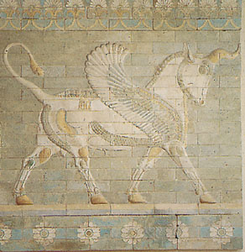
Winged Bull, Susa

Before Enmerkar’s messenger leaves on his mission, the king has one last thing for him to remember to recite, the Spell of Enki:

“On that day when there is no snake, when there is no scorpion, when there is no hyena, when there is no lion, when there is neither dog nor wolf, when there is thus neither fear nor trembling, man has no rival! At such a time, may the lands of Cubur and Hamazi, the many-tongued, and Sumer, the great mountain of the me of magnificence, and Akkad, the land possessing all that is befitting, and the Martu [Amorite] land, resting in security -- the whole universe, the well-guarded people -- may they all address Enlil together in a single language! For at that time, for the ambitious lords, for the ambitious princes, for the ambitious kings, Enki, for the ambitious lords, for the ambitious princes, for the ambitious kings, for the ambitious lords, for the ambitious princes, for the ambitious kings -- Enki, the lord of abundance and of steadfast decisions, the wise and knowing lord of the Land, the expert of the gods, chosen for wisdom, the lord of Eridu, shall change the speech in their mouths, as many as he had placed there, and so the speech of mankind is truly one.”

True to the nature of the Towel of Babel story, this “spell” relates a spiritual event in the past that caused everyone to speak different languages:

“Now the whole world had one language and one common speech. As men moved east, they found a plain in Shinar [Babylonia] and settled there.” -Genesis 11:1-2

Babylonia makes up the area comprised of Sumer and the northern Akkadia area. Returning to story, the messenger begins his trek to Aratta:

He journeyed by the starry night, and by day he travelled with Utu of heaven. Where and to whom will he carry the important message of Inanna with its stinging tone?
He brought it up into the Zubi Mountains, he descended with it from the Zubi Mountains. Susin and the land of Ancan humbly saluted Inanna like tiny mice. In the great mountain ranges, the teeming multitudes grovelled in the dust for her. He traversed five mountains, six mountains, seven mountains. He lifted his eyes as he approached Aratta. He stepped joyfully into the courtyard of Aratta, he made known the authority of his king.

From this we can see that the seven mountains that lay on route the Karkheh Kur represent the seven gates of Kur, the netherworld. They were believed to be the great pillars that separated the heavens from the underworld. The association between these pillars of heaven with mountains and the netherworld river can be found in the Greek Poet Hesiod’s Theogony (“Gods‘ Origin“):

And there dwells the goddess loathed by the deathless gods, terrible Styx, eldest daughter of back flowing Ocean. She lives apart from the gods in her glorious house vaulted over with great rocks and propped up to heaven all round with silver pillars.

Likewise, ziggurats, pyramidal temples built in Sumer and Akkad like the Tower of Babel, were built in seven levels, each one representing one of the heavens. References to these heavenly arches are also spoken of in the first apocryphal book of Henoch (Enoch):

And there I saw a place on the other side of an extended territory, where waters were collected. I likewise beheld terrestrial fountains, deep in the fiery columns of heaven. And in the columns of heaven I beheld fires, which descended without number, but neither on high, nor into the deep. Over these fountains also I perceived a place which had neither the firmament of heaven above it, nor the solid ground underneath it; neither was there water above it; nor anything on wing; but the spot was desolate. And there I beheld seven stars, like great blazing mountains, and like spirits entreating me. Then the angel said, This place, until the consummation of heaven and earth, will be the prison of the stars, and the host of heaven. The stars which roll over fire are those which transgressed the commandment of Elohim before their time arrived; for they came not in their proper season. Therefore was he offended with them, and bound them, until the period of the consummation of their crimes in the secret year. -1 Enoch 18:11-16

The scripture even mentions the precious stones that were associated with the Zagros mountains:

I went from there to another place, and saw a mountain of fire flashing both by day and night. I proceeded towards it; and perceived seven splendid mountains, which were all different from each other. Their stones were brilliant and beautiful; all were brilliant and splendid to behold; and beautiful was their surface. -1 Enoch 24:1-2

Even though this scripture is not included in the Bible canon, it is directly quoted in the book of Jude (1 Enoch 1:9; Jude 1:14), which also positively identifies the author of the first book of Henoch as the real Henoch from Genesis. St. Augustine likewise accepted the book to be genuine scripture, but it lost accreditation in the 300’s A.D. and the scripture was lost for centuries until a Greek-to-Ethiopic translation was rediscovered in Abyssinia in 1773. The first book of Henoch is also the earliest Hebrew text suggesting the division of souls between the elect and the damned and supplies some of the allegories that the parables of Jesus derive upon. The oldest portion of the text (chapters 1-36) has been dated by scholars to no earlier than the second century B.C.
The mountains which separated Heaven and Hell in ancient lore came to represent the proverbial seven heavens (and seven hells) in the latter day Zoroastrian religion of Persia (Iran). Each were believed to be a dimension in itself, where each layer of Heaven was more grandiose than the next and where each layer of Hell reserved a more horrible torment fit for the level of evil each person brought out. This concept of a multi-layered Heaven is found in non-apocryphal scripture as well:

I must go on boasting. Although there is nothing to be gained, I will go on to visions and revelations from Kuriou [the Lord]. I know a man in Christos who fourteen years ago was caught up into the third heaven. Whether it was in the body or apart from the body I do not know- Theos knows. -2 Corinthians 12: 1-2

It is even more prominent in the writings of the Islamic Qu’ran (Koran):

“For over My servants no authority shalt thou have, except such as put themselves in the wrong and follow thee.” And verily, Hell is the promised abode for them all! To it are seven gates: for each of those gates is a (special) class (of sinners) assigned. -Surah 15:42-44

The seven heavens and the earth, and all beings therein, declare His glory: there is not a thing but celebrates His praise; And yet ye understand not how they declare His glory! Verily He is Oft-Forbear, Most Forgiving! -Surah 17:44

When Enmerkar‘s messenger reaches his destination, then men of the city bow down to him in the dust. When he threatens the Lord of Aratta with bird metaphors, the king is at a loss for words and starts looking at his feet for an answer. The king tells the messenger that he will submit but only if they bring an amount of wheat for the famine they were experiencing, and not in sacks but in nets. The grain goddess Nisaba helps Enmerkar grow grain so fermented it wouldn’t fall through nets and Enmerkar asks that the king accept the sceptre of Uruk. When the messenger gets there, the king is still indignant and states that he will only submit to a sceptre made of genuine kumea. So Enki helps Enmerkar grow one and once again the messenger astonishes the Lord of Aratta. Finally, he suggests that the argument be settled with a tournament, only that the champions of the tournament be ones that have a shirt with no color on it. When his messenger returns, Enmerkar accepts the challenge, demands that the Aratta Lord heap gold, silver and lupus lazuli for Inanna at Uruk, and once again threatens total destruction. But the messenger’s mouth is “heavy”, so Enmerkar invents the art of writing messages in clay tablets in order for the messenger to remember everything. (Evidence indicates however that writing tablets had existed for some 600 years before then.) The well-travelled servant conveyed the message, but then Ishkur, the storm god, gets involved. He brings a raging storm like ‘a great lion’, which defeats the famine. This king is encouraged and tells the messenger that Inanna has in no way abandoned her house and bed in Aratta. The ending of the story is lost, but presumably, a champion with a shirt of no color refers to a magician, since it can barely be made out that a young wise woman shows up in Uruk and becomes Enmerkar’s queen.
In a different version of the tale, the name of the Lord of Aratta is Ensuhgirana. Enmerkar and Ensuhgirana starts off with a short praise for Uruk and tells how Enmerkar was destined to become a god. But in this version the Lord of Aratta is the first to claim superiority and tells the messenger of Enmerkar to submit, enumerating all the ways Inanna considered him the better. Enmerkar countered with his own tirade of browbeating, saying that Enlil had given him the true crown and sceptre, Ninurta held him on his lap, and that Aruru (Ninmah) extended her right breast to him. In a bid to prove his manliness, he includes how respondent the temple priestess is during the Sacred Marriage Rite:

When I go up to the great shrine, the mistress screeches like an Anzu chick, and other times when I go there, even though she is not a duckling, she shrieks like one.

He also makes it a point that Inanna’s temple was in Uruk, not Aratta, and the messenger returns to Susa. Defeated, Ensuhgirana held a council and asked it what he should do. Knowing they didn’t stand a chance against Enmerkar, the council tells him to hold back on his boasts, but Ensuhgirana replies that he will never submit to Enmerkar, even if his city becomes a mound of ruins. A sorcerer tells the Lord of Aratta that he will make Enmerkar submit to him and is hired for five minas of gold. The sorcerer goes to Uruk and talks to the cow and the goat. When asked, they tell him that the cheese and butter made from their milk would be eaten by Nisaba (Ninmah). When they told him this, he enacted a spell that caused their utters to dry up. The calves and kids began to starve and they wept bitterly. The wise woman Sajburru came to Uruk’s rescue and confronted the sorcerer on the Euphrates and proceeded to have a wizard’s duel. They both threw things, maybe fish spawns, into the water to enact each of their spells. The sorcerer made a carp come out but Sajburru made an eagle come out and snatch the carp. At the next throw, the sorcerer made a lamb but Sajburru made a wolf. Then the sorcerer made a cow and its calf but Sajburru made a lion. Then the sorcerer made a wild goat and a wild sheep but Sajburru made a mountain leopard. Then the sorcerer made a gazelle kid but Sajburru made a tiger and a lion. At that point the sorcerer’s face darkened and his mind became confused. The wise woman acknowledged that he had magic powers but asked where his sense was trying to do sorcery in the city that An and Enlil had predestined and Ninlil loved so much. The sorcerer pleaded ignorance and asked that he be allowed to go back to Aratta and sing praises of her greatness, but she reminded him that Nanna the moon god had made the cutting off of butter and milk a capital offense and threw him off the river’s bank. Having heard this, Ensuhgirana sent a message to Enmerkar admitting that from the moment of his conception he was not the equal of the his ‘older brother’, the true lord of Inanna. The final praise of the text goes to Nisaba.

Zeus Steals the Tablets of Destiny

It appears that Ensuhgirana wasn’t as complacent as he let on because another tale, Lugal-Banda in the Mountain Cave, also called Lugal-Banda and Mount Hurrum, begins with Enmerkar preparing an expedition against Aratta, “the mountain of the holy divine powers”, for rebelling against him. The troops wait for five days before they enter the mountains, on the sixth day they washed to purify themselves, and on the seventh day they entered the mountains. Half way there his eighth general, Lugal-Banda, got a sickness in the head that caused him to jerk around like a gazelle caught in a snare. He began to slow them down; they wanted to bring him back to Uruk, but didn’t know how they could, so they found a mountain cave and made a camp for him. They left him an axe and a dagger, plenty of food and beer and suspended some incense and other healing resins around his head, but Lugal-Banda soon become unresponsive. His brothers counseled each other, saying that if he rises again like Utu the sun god, then the food would help him walk again and maybe enable him to journey back to Uruk, but if Utu called their brother to the holy “valued” place, then it would be up to them to carry his body on their journey back. Then the men left.
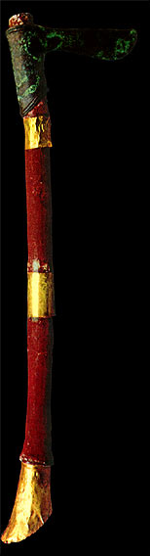
Golden Battle-Axe, Sumerian, 2500 B.C.

For two days he sat and perspired heavily, then he began to cry, telling Utu that there was no one there to feel sorry for him and asking that he not die lost in the mountains like a weakling. Utu accepted his tears and sent down some divine encouragement. Inanna appeared before Lugal-Banda and the general began to cry as if before is own father. Inanna accepted his tears and enveloped him like a woolen garment, then disappeared back to Uruk. The moon then came out an illuminated the cave and Lugal-Banda cried out to the moon god’s sense of justice and hatred of evil. Suen (Nanna) accepted his tears as well and Lugal-Banda was able to walk. The next day he praised Utu and the moon god’s wife Ningal before leaving the cave. Thanks to a god who took council with Enlil (probably Utu or Ningal) life saving plants began to grow and life saving water started to flow from the hills’ rivers. Lugal-Banda then left the cave to hunt for food. While out he started a fire by striking two stones together. Then, without even knowing how to bake caves with an oven, he baked some dough and garnished it with syrup from some roots he stripped. He then caught a wild brown bull and two goats either by trap or ambush. Then, with the help of some beer and white linen sheet, he went to sleep:

The king lay down not to sleep, he lay down to dream -- not turning back at the door of the dream, not turning back at the door-pivot. To the liar it talks in lies, to the truthful it speaks truth. It can make one man happy, it can make another man sing, but it is the closed tablet-basket of the gods. It is the beautiful bedchamber of Ninlil, it is the counsellor of Inanna. The multiplier of mankind, the voice of one not alive -- Zangara, the god of dreams, himself like a bull, bellowed at Lugal-Banda.

Zangara told him in his dream to sacrifice the bull and goats and to pour out the blood so that the snakes could smell it, so when Lugal-Banda awoke he wrestled the bull to the ground and did just that. The best parts of the bull were burned so that An, Enlil, Enki and Ninhursag could feast on them.
At this point the text becomes more and more fragmented. Following this there is a description of some demons:

They are gazelles of Suen running in flight, they are the fine smooth cloths of Ninlil, they are the helpers of Ishkur; they pile up flax, they pile up barley; they are wild animals on the rampage, they descend like a storm on a rebel land hated by Suen, indeed they descend like a storm.

It is also said that these helpers of Ishkur sing out in the dead of night, sneak into homes to nestle at peoples’ bedsides, and tie door pivots together. The story then moves on to the elders of city, who seem to have been able to enter the presence of the Anunnaki to confirm the power of the foreign lands. Then there is mention of 14 torch-bearers standing in battle. They pursue like wildfire, flash together like lightning and roar loudly like a great flood rising up in the storm of battle. Seven of these men are favored by Inanna, who wears a crown under a clear sky, and they stand proudly in battle as the holy shining battle-mace of An reaches to the edge of heaven and earth. Utu, who is called “the just god who stands alongside men“, then walks out from his chamber. There is then some dialogue regarding evil gods with evil hearts who are the interpreters of spoken evil and spy on the righteous gods. Here the text of the first segment ends and it is unknown if the second undecipherable segment of the tablet belongs to the same composition or not, but the story is continued in another text.
Lugal-Banda and the Anzu bird, alternatively known as Lugal-Banda and Enmerkar, opens with Lugal-Banda still lost deep within the Zabu mountains. He gets an idea to go an talk to the Anzu bird and to treat him and his wife respectfully. He figures that An will fetch Ninkasi, the beer goddess, who will help him get the Anzu bird drunk so that it can help him find his brothers, the troops of Uruk.

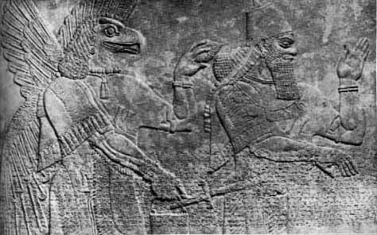

There are references to the Anzu bird in the other two stories of Enmerkar, but this is the first one that goes into detail about it. It is described as having sharks teeth and eagle’s claws and is so huge it hunts bulls. Its cry is said to shake the mountains and most likely represents thunder. This is most likely the origin of the mythical roc of Persian and Arabian lore. In the Sumerian language, Anzu was spelled Imdugud; it was only later found that it’s name was pronounced Anzu, or Zu. In Babylonia and Assyria they were believed to be wind demons called Pazuzu (one of which who made an silhouette appearance in The Exorcist).
While the Anzu bird is away hunting, Lugal-Banda sneaks into it’s nest and carefully makes celestial cakes for it’s chicks. He then paints their eyes and puts crowns on their heads. When the chicks’ parents come home, they at first think that someone stole the chicks and cry out so loudly that the noise reaches up to the gods and below to the abzu. But when they see how the chicks have been exulted, he cries out:

“I am the prince who decides the destiny of rolling rivers. I keep on the straight and narrow path the righteous who follow Enlil's counsel. My father Enlil brought me here. He let me bar the entrance to the mountains as if with a great door. If I fix a fate, who shall alter it? If I but say the word, who shall change it? Whoever has done this to my nest, if you are a god, I will speak with you, indeed I will befriend you. If you are a man, I will fix your fate. I shall not let you have any opponents in the mountains. You shall be 'Hero-fortified-by-Anzu'.”

Lugal-Banda makes his appearance and “partly from fright, partly from delight” begins flattering the giant bird. He starts telling them that they’re eyes are sparkling and how their wingspan is like a bird net stretched across the sky. He says that yesterday he escaped safely because of the Anzu bird and so leaves his destiny in their hands, naming the Anzu bird father and the bird’s wife mother. Anzu then tries to get out of the promise he gave and offers several bargains in exchange: a boatload of precious metals and food, the power to shoot arrows that never miss, the Lion of Battle helmet (which gave courage to it’s wearer) and finally the Milk of Dumuzi. To each of these offers the author replies: “Lugal-Banda who loves the seed will not accept this.” Apparently, being ’Hero-fortified-by-Anzu’ is not a power to be trifled with because the Anzu bird is worried about living up to his word and giving it to Lugal-Banda, saying that an ass should be kept on the straight path.

Lugal-Banda the pure answers him: "Let the power of running be in my thighs, let me never grow tired! Let there be strength in my arms, let me stretch my arms wide, let my arms never become weak! Moving like the sunlight, like Inanna, like the seven storms, those of Ishkur, let me leap like a flame, blaze like lightning! Let me go wherever I look to, set foot wherever I cast my glance, reach wherever my heart desires and let me loosen my shoes in whatever place my heart has named to me! When Utu lets me reach Kulaba [Uruk] my city, let him who curses me have no joy thereof; let him who wishes to strive with me never say "Just let him come!" I shall have the woodcarvers fashion statues of you, and you will be breathtaking to look upon. Your name will be made famous thereby in Sumer and will redound to the credit of the temples of the great gods."

Anzu gives in and bestows his powers on Lugal-Banda, at least satisfied that Lugal-Banda will have wooden idols of him carved out for the Sumerians. The Anzu bird then helped Lugal-Banda find his troops but told him not to say anything about him or the fate he fixed on him. When Lugal-Banda gets back to his brothers, we learn that he was abandoned as killed in battle. They ask how he was able to survive and cross the rivers and Lugal-Banda just replies that he walked over them or drank them. His companions then embrace and kiss him and give him food and drink. The troops then moved on, following the river until they finally reached their target: Aratta.
The army put the city under siege for an entire year. Enmerkar, the leader of the troops is well worried about it and can’t find anyone who wants to go back to Uruk because they’re all afraid they’ll get lost, but then Lugal-Banda volunteers. Enmerkar makes him swear by heaven and earth that he will go along and not drop any of their great emblems. Enmerkar then summons an assembly and begins to question himself and the goddess Inanna in front of them:

“My troops are bound to me as a cow is bound to its calf; but like a son who, hating his mother, leaves his city, my princely sister Inanna the pure has run away from me back to brick-built Kulaba [Uruk]. If she loves her city and hates me, why does she bind the city to me? If she hates the city and yet loves me, why does she bind me to the city? If the mistress removes herself from me to her holy chamber, and abandons me like an Anzu chick, then may she at least bring me home to brick-built Kulaba: on that day my spear shall be laid aside. On that day she may shatter my shield. Speak thus to my princely sister, Inanna the pure."

Lugal-Banda’s brothers ask to join him on his journey but he refuses despite great insistence. Lugal-Banda crossed the seven mountains and at midnight entered the temple of Inanna and prostrated himself before her offering table. Inanna asked why he had come all alone form Aratta. Lugal-Banda recites Enmerkar’s depressing soliloquy and Inanna tells him that if Enmerkar catches the tamarisk, a type of freshwater fish, and sacrifices it, the a-an-kara weapon, Inanna's battle-strength, will be given to his army and that will put an end to the subterranean waters that gives strength to Aratta. Inanna finishes saying, "If he carries off from the city its worked metal and smiths, if he carries off its worked stones and its stonemasons, if he renews the city and settles it, all the moulds of Aratta will be his." With the solution found, the text ends with a praise for Lugal-Banda. The open-ended finish to the story seems to indicate that there is a third text that concludes the epic. It has been said that Lugal-Banda is supposed to kill the Anzu bird but this may be an assumption since Lugal-Banda’s name is inherited by a god who also meets up with an Anzu.

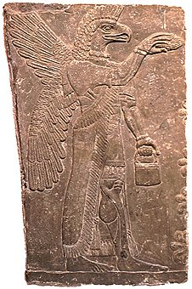
An Anzu bird (?) picking fruit from the Tree of Life

The Anzu bird takes on a much more negative role in Akkadian Myth of Anzu. The text begins with praises for Ninurta, already revealing that he defeated Anzu and also saying that he defeated the bull-man inside the sea and raised a dais for the lesser Igiggi. Enlil and Enki watch the Anzu bird, whose wings bring the South Wind, and whose body was like 11 coats of mail. Enki concluded that it had been conceived from the holy abzu and born out of the broad earth and suggested that it serve Enlil. Enlil made the Anzu an extra fate and appointed him the guardian of his chambers. This included guarding over the Tablets of Destiny, which gave Enlil the power to decree fate. These tablets identify Enlil as the current head of the pantheon instead of the heaven god. The air god seems to have replaced An, or Anu (His Akkadian name), sometime around 2500 B.C. Although earlier stories tell of the Tablets of Destiny giving Anu-power, the tablets here are said to confer Enlil-power.
Every day the Tablets of Destiny tempted the storm bird, so one day while Enlil was bathing in the holy waters, Anzu stole the tablets and flew off. Enlil’s chamber was stripped of it’s radiance and silence reigned. Enlil summoned his son Adad, or Hadad, the Akkadian name for Ishkur. But the “controller of the canals” only told his father that the Anzu was now undefeatable and that the gods would have to tremble at his utterance from now on. The gods next proposed Gerra, god of fire and the son of Anu, and then Shara, the son of Ishtar (Inanna), but both of them repeated Adad’s refusal. Enki suggested that they let him pick the Anzu’s conqueror and the Igiggi kissed his feet for taking up the cause. He called Mami (Ninmah) and just like in the Akkadian Creation story asked that her name be changed to Mistress of all the Gods. Enki asked the birth goddess if she would allow her most beloved son, Ninurta, to do the task. She agreed and the gods rejoiced at her decision.

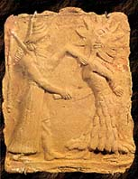
Ninurta kills a demon, Asag

The second tablet opens with a long soliloquy about poisoning arrows and slitting the throat of Anzu. Ninurta marshaled the “Seven of Battle”, which are said to be the seven evil winds. He and Anzu met on a mountainside and the storm bird bared it’s teeth and insolently shouted, “ I have taken away every single rite, and I am in charge of all the gods’ orders! Who are you, to come to do battle against me? Give your reasons!” Ninurta replied that he was the avenger of Enlil, who established the temple of Duranki (“Bond of Heaven and Earth”) in Nippur. The Anzu caused darkness to fall on the mountain and Ninurta began shooting arrows at him, but using the Tablets of Destiny, it caused the arrows to turn back into a reed, or the feathers back into birds, or the bowstring string back into a ram’s gut. Using his magical mace Shurur, Ninurta contacts Enki, who relays a plan to him. Enki then promises that once he defeated the Anzu his worship would be established over the four quarters. When Ninurta hears this, he brought out the “Seven of Battle”, the seven evil winds, and the gales went silent.
The first three lines of the third tablet are fragmentary but the story returns with both combatants bathed in the sweat of battle. The Anzu grew tired as Enki predicted and Ninurta follows his instructions precisely. When the Anzu’s wings slump down in fatigue, Ninurta cuts them off. Just as the Anzu wishes for his wings to grow back, Ninurta lets loose an arrow at it’s heart. The feathers on the arrow grow and pierce it’s heart and lungs, killing it. Ninurta got back the Tablets of Destiny and the wind carried the great bird‘s feathers as a sign of good news. Ninurta returns the Tablets of Destiny and for slaying the mountain is given complete dominion and every single rite. Among the 15 titles that are bestowed upon him are: Duku (“Holy mound” in Sumerian), Hurabtil (an Elamite god), Shushinak (patron god of the Elamite city Susa), Zababa of Kish, the warrior Tishpak, and also Lugal-Banda. The text ends going through a long list of aliases Ninurta is known by throughout the lands.
This legend seems to be designed as a response to the belief that Enlil had been replaced as king of the gods. The account is paralleled in the creation story of the Greeks. Though there are something like six accounts of how the Greek gods were born, probably the most popular account is from Theogony, written by the Greek poet Hesiod, who lived sometime around the 600 or 700s B.C.:
In the beginning there was only Chaos, the oldest of the gods, a shapeless mass of darkness and meaninglessness, said to be formed out of mist. Out of the Chaos came Nyx (Night; a great black bird), Erebus (Primeval abyss) and Tartarus. Nyx and Erebus joined
and Nyx laid an egg that hatched into Eros (Cupid; Love). From Eros came Light and Day. Once there was Light and Day, Mother Earth, or Gaea, appeared. The Greeks pronounced her name Ge; easily comparable to Ki, the Sumerian earth mother. The Romans called her Terra, from which we get the words terran and terrain.
Uranus, the god of heaven, was born of Gaea as she slept. He became her husband, and together they had many children. Their first-born children were hecatonchires, monsters with 50 heads and 100 hands, and the cyclopses, giants with one eye. The second born children were the titans. Uranus feared that his powerful sons might topple him from his position as Lord of the Universe so he cast the titans and hecatonchires into Tartarus, an underworld as far from Earth as Heaven was. Gaea was upset that Uranus had imprisoned them so she turned for help to her youngest, Chronos (“Chronology”), god of time and the upper sky. Chronos hated his father’s evil deeds as much as his mother so he ambushed his father while he was making love to the earth, castrated him with a jagged sickle, and threw his genitalia into the sea. This mixed with the sea water to create Aphrodite (Inanna), who is attended by Eros and Desire as well as some other goddesses as she enters the assembly of the gods. In other myths Aphrodite was the mother of Eros. The blood from the wound created the Erinyes (Furies), Giants, and Melian nymphs. After this more violent separation of Heaven and Earth, Chronos takes his place as Lord of the Universe.
The era that Cronus ruled was called as the Golden Age, but that was not because the gods were peaceful and just. The Titans (“Strainers”) were so named because Uranus believed that they wrongfully inflected terror and would one day pay for it. (Outside of Theogony, it has also been said that Ti-ta-an can be read “Those who live in Heaven” in Sumerian.) Nyx then gives birth to hateful Doom, black Fate, Death, and she bore Sleep and the tribe of Dreams. And though she lay with no one, Nyx give birth to Blame, Woe, the Hesperide nymphs, the Destinies, and the three ruthless Fates: Clotho the Spinner, who spins the thread of man's life; Lachesis, Disposer of Lots, who assigns each man his destiny; and Atropos, who cuts the threads of life. The three Fates gave men at their birth both good and evil to choose from. Nyx also gave birth to Nemesis (Indignation), Deceit and Friendship, hateful Age, and hard-hearted Strife. Strife bore Toil, Forgetfulness, Famine, Sorrow, Fighting, Battles, Murders, Manslaughters, Quarrels, Lying Words, Disputes, Lawlessness, Ruin and the worst of all Oath, who troubles those who swear falsely. Thegony then goes into a long list of gods, heroes, and monsters with paternities and short biographies.
Gaea was sorely disappointed to discover that Chronos had no intention of releasing his 100-handed brothers from their dark prison. Chronos married the titan Rhea and together they had Demeter, Hestia, Hera, Poseidon, and the pitiless Hades. Uranus and Gaea prophesied his own son would dethrone him so each time Rhea gave birth Chronos swallowed the newborn god. Determined to protect her sixth child from his father, Rhea gave birth in secret. She named the infant Zeus and sent him to the island of Crete, to be raised by nymphs. Then, pretending to obey her husband's command, Rhea wrapped a stone in a blanket and carried it to Chronos, who swallowed it without any notice. When Rhea thought Zeus was strong enough to challenge Chronos, she told him about his five brothers and sisters trapped inside his father's body and how he narrowly escaped the same fate. With the help of Gaea, Zeus forced his father to regurgitate his five brothers and sisters, as well as the stone (which was taken to Delphi). His children, who were led by their youngest brother, Zeus, waged war against him. However, Chronos was backed by most of his brothers and sisters, the titans. The war between the Olympians and the Titans was so terrible that it nearly destroyed the universe. When the titan Prometheus ("Forethought") could see that Zeus and his siblings were destined to win this war against Chronos, he abandoned his brothers and sisters and joined Zeus. He secretly advised the storm god to release Gaea's first-born children, the hecatonchires, informing him that they wielded thunder, lightning, and earthquakes as weapons. Once released, the monsters fought against Chronos and defeated the titans. Like Enlil, Chronos was then banished deep within the bowels of the earth. The other titans were imprisoned in the netherworld, called Tartarus, as well, although Chronos was able to take rule over the Elysian Fields, where the nicer parts of Tartarus was. Zeus, impressed by the effectiveness of the monsters' weapons, appropriated the thunder and lightning for his own use. The Olympians then chose the cloud-draped summit of Mt. Olympus to be their home.
But Mother Earth then gave Zeus another problem to contend with:

Now after Zeus had driven the Titans out of heaven, gigantic Gaea, in love with Tartarus, by means of golden Aphrodite, bore the youngest of her children, Typhoeus; the hands and arms of him are mighty, and have work in them, and the feet of the powerful god were tireless, and up from his shoulders there grew a hundred snake heads, those of a dreaded dragon, and the heads licked with dark tongues, and from the eyes on the inhuman heads fire glittered from under the eyelids: from all his heads fire flared from his eyes' glancing; and inside each one of these horrible heads there were voices that threw out every sort of horrible sound, for sometimes it was speech such as the gods could understand, but at other times, the sound of a bellowing bull, proud-eyed and furious beyond holding, or again like a lion shameless in cruelty, or again it was like the barking of dogs, a wonder to listen to, or again he would whistle so the tall mountains re-echoed to it.
This monster was so great that Olympus shook when he walked and even the imprisoned Titans were shaken up as the giant walked on top of the earth. But Zeus attacked the monster with his thunderbolts and set the dragon heads on fire.
According to the Greek poet Apollodorus, Zeus chased the monster with a sickle made of Adamant (Diamond). Typhoeus ran to Mount Casius (near Antioch in Syria), where Zeus fell on him, thinking he was badly wounded. Typhoeus then entwined the god with his serpent like tail, took the adamant scythe, and cut out the muscle tendons from Zeus’ hands and feet. He then deposited the defeated god and his sinews in a cave and set the drakaina Delphyne (a girl who was half animal) as a guard. But the Greek gods Hermes and Aigipan stole the sinews back and replanted them in Zeus, who then got in his chariot and resumed the attack. Typhoeus continued to flee in other lands, while throwing mountains at Zeus. Zeus destroyed these with his thunderbolts and finally defeated the monster, by throwing Mount Aitna on top of him, which still erupted fire from the thunderbolts Zeus used.
Returning to Theogony, when Typhoeus fell, the earth groaned under the great impact. The flame ran out along the darkening and steep forests of the mountains as he was struck and a great part of the earth burned in the wind of his heat. Earth melted in the blazing fire and Zeus threw the great monster into Tartarus.

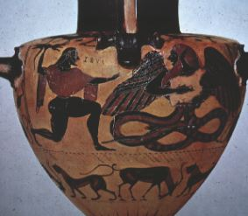
Zeus’ Battle with Typhoeus

From these comparisons it can be presumed that most of the important Greek gods originate from Sumerian, Akkadian and Elamite religion. From these ancient Sumerian texts, we can see Zeus’s humble beginnings as an Anzu bird, or Zu bird, before Greek poets and philosophers fashioned him into the licentious storm god recognized today. The name of Zeus forms two important roots in the Greek language: Theo and Dio. Theo is not only the root of Theogony, but also the modern words theology and theory, while dio is the root behind deity and the names of other gods such as his son Dionysus.
Like Enlil, Chronos lost his kingship to an usurper. In the Sumerian myth, Enlil's storm-god son Ninurta kills the storm-bird and gets the Tablets of Destiny back, restoring kingship to his father, but in all subsequent myths, it's the storm god who defeats his father and becomes king of the gods. The Greeks and Romans portray Chronos as evil and scheming, and his loss of kingship is permanent. Zeus replaces his father just as Chronos did to his own father Uranus. The Romans gave Chronos the name Saturn, which also gives us the name Saturday, the same day as the Hebrew Sabbath. The ancient festival Saturnalia is also the origin of the Christmas holiday.

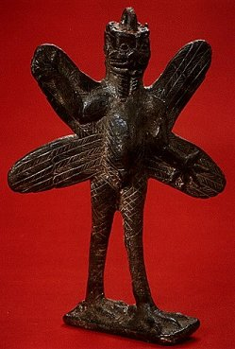
Pazuzu statuette, Assyria

The Anzu bird is described as being part lion and part eagle, which is believed to symbolize the mastery of heaven and earth. These bird-lion features may have been lost to the later concept of Zeus but they became associated with the Biblical cherubim (“Near ones” i.e. bodyguards), the Egyptian sphinx, the Babylonian and Assyrian lamassu, and the Greek griffons, which incidentally are called the “The Hounds of Zeus”. All are considered to be the guardians and a symbol of rulership. In the Middle Ages, the griffon came to be a symbol of Christ’s resurrection.
Hesiod’s descending sovereignty outline is based on a Hurrian text, or a derivative of it, which begins with a king prior to Anu. The Hurrians were a people of North Syria who rivaled the Hittites and were subsequently conquered by them. The Hittites, who lived south of the Black Sea in Turkey, absorbed as many legends as they could, including the Hurrians’, calling themselves the ‘country of a thousand gods’. The text Kingship in Heaven was discovered in the Hittite capital of Hattussas and was dated the 13th century BC, shortly before the capital was destroyed by the Philistines.

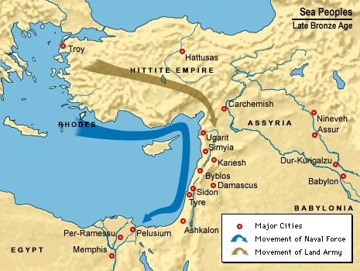
Hittite invasion of the Hurrian homeland of Syria

The text begins saying that in the olden days Alulu was king in heaven for nine years and then his cup bearer Anu vanquished him and Alulu escaped into the dark earth. But it was only another nine years until Anu’s own cup bearer betrayed him. Kumarbi is said to have rushed him and bit off his “knees”. Kumarbi swallowed Anu’s manhood and laughed, but then Anu gave him a dire premonition:

"Rejoice not over thine inside! In thine inside I have planted a heavy burden. Firstly I have impregnated thee with the noble Storm-god. Secondly I have impregnated thee with the river Tigris, not to be endured. Thirdly I have impregnated thee with the noble Tasmisus [The Storm-god‘s servant]. Three dreadful gods have I planted in thy belly as seed. Thou shalt go and end by striking the rocks of thine own mountain with thy head!"

Anu then went and hid himself in heaven. The text is fragmented here but it seems that Kumarbi tries to spit it back out and some of the semen hits Mt. Kanzuras and creates a god inside the mountain. Then filled with fury, Kumarbi goes back to his city Nippur and starts counting the months of his pregnancy. Anu somehow advises the storm god where to exit Kumarbi’s body and Teshub (the Storm-god) responds that the earth will give him strength, the sky would give valor, Anu would give him manliness and Kumarbi would give him wisdom. He is warned once again what will happen if he comes out of Kumarbi’s “tarnassas”. As Kumarbi is walking he falls down, and like Chronos tells his wife Ayas that he wants to devour his son. Ayas probably gives him a rock in this version too since whatever he ate hurts his mouth and he begins to moan. People were brought in to work magic on him and to keep bringing sacrificed meals to him. It is said that Teshub is born out of the “good place” and when the birth is reported to Anu, he plots to use him to defeat Kumarbi. Teshub prepares for the battle although the outcome is not preserved.
The inheritance of godly powers is a common motif amongst tales of the gods. The fact that Teshub is born from both Anu and Kumarbi is probably to show that Teshub was born from the best qualities of both them. Kingship in Heaven is found along with the Song of Ullikummi, which acts as a sequel to Kingship but may have been written by a different author. One perplexity about this story is that one would assume up to this point that as king of the gods, Kumarbi could easily be identified with Enlil, especially since his chief city is Nippur. But in this legend Ellil (Enlil) makes his own appearance and seems to denounce Kumarbi. This may have been an attempt of another author to disassociate Enlil with the villianous role Kumarbi takes. On the other hand, his actions do seem to parallel Kumarbi’s, so it may just be a misunderstanding. The text is in particularly poor condition, especially at the end.
The story begins with Kumarbi nursing an evil plot. He takes his staff and shoes and goes to his city of Urkis (Kish?) and sleeps with a great rock ten times. The mountain gives birth to Ullikummi, whose name may mean something like “Destroyer of Kummiya”. The Good-women and Mother-goddesses bring the newborn to Kumarbi and place him on his knees. Kumarbi embraces his son and has him dance up and down on top of his lap and says to his soul:

“What name [shall I give] him? The child which the Good-women and the Mother-goddesses presented me, [for the reason that he] shot forth from her body as a shaft, let him go and [his] name be Ullikummi! Let him ascend to heaven for kingship! Let him vanquish Kummiya, the beautiful city! Let him attack Storm-god and tear [him] to pieces like a mortal! Let him tread him under foot like an ant! Let him crush Tasmisus like a reed in the brake! Let him shot down all the gods from the sky like birds and let him break them to pieces like empty pots!”
Kummiya is unidentified but believed to be between the Tigris and Lake Van. Kumarbi then gave the boy over to the Isirra deities (handmaidens of the Fate Goddess Isirra). The Isirra deities take Ullikummi away and nurse him similar to how Zeus was raised by the Nymphs. The Isirra then places the child on Ellil’s knees and Ellil says:

“Who is that child whom the Good-women and the Mother-goddesses reared? No one among the great gods will see mightier battles. No one's vileness equals Kumarbi's. Just as Kumarbi raised Teshub, he has [now raised] this awesome diorite man as his rival.”
With these words the handmaidens place the diorite man on top of the right shoulder of Ubelluris, an Atlas-like giant who is carrying the world on his shoulders. The strong waters makes the diorite man grow and in a month he is an acre in height. After 15 days he grows up out of the sea until the sea reaches his loincloth. Here, the text becomes so fragmented that it is hard to distinguish the order of events. It seems that the Sun-god sees the diorite man and informs Teshub. Teshub and his sister Ishtar (Inanna) climbs to the top of Mount Hazzi (Mount Cassius) to see it for themselves. Teshub weeps bitterly, asking who could ever defeat such a monster, but Ishtar is not convinced. Teshub orders his servant Tasmisu to fetch his bulls and thunderstorms and goes to do battle with the diorite man. The gods fight him but Ullikummi is impervious to their attacks and makes his way to Teshub’s city of Kummiya, where the storm god is forced to admit defeat. Tasmisu informs Teshub’s Queen Heba of the city‘s loss and that her husband must remain in a ‘lowly place’ for now and the queen almost faints off the roof but is caught by her attendants. Teshub descends to the ‘city’ Abzuwa (abzu) and tries to gain the help of Ea (Enki). Ea informs Ellil and then goes to talk to the Atlas-giant Upelluri. Upelluri tells Ea that he hadn’t noticed when heaven and earth had been built on him, hadn’t even noticed when heaven and earth were separated with the great saw, but now the diorite man was causing his shoulder to hurt. When Ea heard this he got an idea. He had the ancient storehouses opened and brought back the saw that had freed heaven and earth. With this he cut the diorite man’s feet from under him and then urged the gods to renew the battle. The end of the story is lost but there’s little doubt what happens next.
By comparing the Sumerian Texts to Kingship in Heaven and Theogony, we can see the evolution of the story as it goes from the Sumerians to the Hurrians to the Greeks. For instance, neither Sumerian, Akkadian nor Babylonian texts ever portray any antagonism or sense of replacement between An and Enlil, although Enlil-Kumarbi’s role in the Hurrian/Hittite epic is that of a tyrant, which is then inherited by Greek version.
In both the Hurrian/Hittite and Greek legends, the fight takes place at Mt. Cassius (Hazzi), where the storm god loses his first battle with the monster. The Sumerian version also places the fight on a mountain. This verification of the battle site is probably a figurative representation of a historic battle. A passage in Milton’s Paradise Lost reads: “A gulf profound as that Serbonian bog, betwixt Damiata and Mount Cassius old, where armies whole have sunk.”
The story of Ninurta fighting the Anzu bird is a source of inspiration for the later creation story of the Babylonians, who have their own storm god Marduk fighting the multi-headed dragon Tiamat (Nammu) in order save the Anunnaki and man kind. Ninurta himself is considered a storm god because of his ability to control the winds. Many scholars believe the text is meant to explain the replacement of the totem animal deity- the bird representing the thick storm clouds- with a more modern anthropomorphic warrior storm god.⁶ The association Tiamat has with serpents is matched by the Greek Typhoeus, who has a snake’s tail and dragon heads growing from his shoulders. The image of a god with dragon heads growing from the shoulders can also be found on Dumuzi’s companion Ningishzida. Typhaeous himself is often represented as having a hundred dragon heads, as well as his children: the Hydra, the Chimera, and the hell-hound Cerberus. Dumuzi’s ancestry to the Mother Dragon Nammu mentioned often in Sumerian texts. The slaying of the dragon may have represented the triumph of the warrior-like storm god over the fleeing shepherd/fisherman god as the dominant deity over the seasons. Although the storm god took many different personal names throughout different cultures, some of them reflecting different identities amongst the original Sumerian pantheon, the vast majority of Mesopotamia knew these rain-bringing cloud-riders as Ba’als.

Sumerian Babylonian Canaaniute Hurrian Greek
Freshwater Apsu
Sky arch Anshar Alulu
Sky god An Anu Anu Uranus
Air god Enlil Ellil El the Bull Kumarbi Kronos
Storm god Ninurta Marduk Ba’al-Hadad Teshub Zeus
Nemesis Anzu Tiamat Yahm Ullikummi Typhoeus

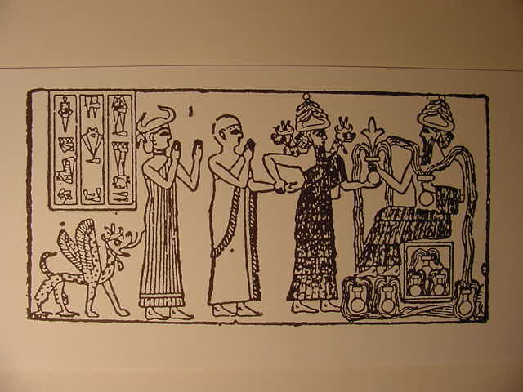
Dumuzi, King Gudea of Lagash, Ningishzida, and Enki

Gilgamesh Kills the Snake and Cuts Down the Tree of Knowledge

Amongst all the myth and folklore surrounding Lugal-Banda’s adventure, one thing we can take for granted is that the general was given a promotion due to what happened during the campaign against Susa. The king lists say that Lugal-Banda (“King Banda”) inherited the throne and reigned 1200 years and was raised to the status of a god. At the end of Lugal-Banda’s reign, En-Me-Bara-Gesi, a king of the Etana dynasty in Kish, became the leading ruler of Sumer around 2700 B.C. Etana the Shepherd was one of the longer-lived kings of the first dynasty of Kish, beating even Lugal-Banda by 300 years. Enmebaragesi conquered Elam and it is said that he tried to carry away the weapons of Elam as booty. Although he was king of Kish, he also constructed a temple to Enlil in Nippur, helping to indicate that while Kish was held as the political capital of Akkad, Nippur was the spiritual capital. Nippur also had a temple dedicated to Inanna that had been there since the end of the Uruk period (3200 B.C.). The next king of Uruk to rule after Lugal-Banda is cited as: “Dumuzi, the fisherman, whose city was Kuara, ruled for 100 years. He captured Enmebaragesi single-handed.” As indicated earlier, he is said to be the king who first enacted the Sacred Marriage Rite⁵. The next king was a son of Lugal-Banda’s wife, Ninsumun. His name was Gilga-Mesh (“Gilga the Hero”) and he was said to be two-thirds god and one-third human. The king lists say that his father is something like a phantom, which may have meant that Lugal-Banda was his foster father. Being two-thirds god probably meant that he had spiritual mother apart from her birth mother. His spiritual mother was Ninsun, which is believed to be another name for the goddess Sirtur, Dumuzi’s mother. He reigned a meager 126 years but became one of the most popular heroes of the ancient world, far surpassing the fame of the man he called his “holy father”.
The least fairy-tale-like of the Gilgamesh texts is about a conflict he has with King Agga of Kish, the son of Enmebaragesi. Gilgamesh and Agga opens with envoys from Kish coming to Uruk, carrying a message for Gilgamesh to submit to them. An assembly is convened and Gilgamesh eloquently argues how Kish should be put to the sword, citing that they could not submit to Kish because there were too many wells to be dug. The elders reply that is the very reason they should submit to Agga, but Gilgamesh has faith in Inanna. So he takes the case to the able-bodied men of the city, adding to his argument that they had never submitted to Kish before. The macho men in the assembly vow to give Agga a horrifying experience and Gilgamesh rejoices and tells his servant Enkidu:

“On this account let the weaponry and arms of battle be made ready. Let the battle mace return to your side. May they create a great terror and radiance. When he comes, my great fearsomeness will overwhelm him. His reasoning will become confused and his judgment disarrayed.”

It is said that not 10 days passed before Agga laid Uruk to siege. Unfortunately, it was the people of Uruk who became confused in battle. Gilgamesh asked his warriors to choose their most courageous warrior for a plan. They choose Birhurtura, who allowed himself to be captured and beaten by Agga and his men. As they beat him, he continued to boast of Gilgamesh‘s unbelievable power. Gilgamesh then climbed up onto the rampart and started casting down multitudes by “leaning over the side“. The able-bodied men were stationed at the city’s gate but only Enkidu fought on the outside of it. When Gilgamesh’s actions matched Birhurtura’s prophecy, Agga’s army became disheartened. The people of Uruk defeated the army and captured Agga. Gilgamesh then came and spoke to Agga saying:

"Agga my overseer, Agga my lieutenant, Agga my military commander! Agga gave me breath, Agga gave me life. Agga took a fugitive into his embrace, Agga provided the fleeing bird with grain."

Just how and when Gilgamesh served under Agga’s command goes unanswered, but Agga is released and the able-bodied men praise Gilgamesh as “The Great Rampart of An”.
We now return to Gilgamesh, Enkidu and the Netherworld, which calls back to the ancient days when heaven was first separated from earth and Enki sailed off to conquer Kur. The South Wind, which in later texts is described as a giant bird’s wing, uprooted a haluppu tree from the Euphrates. It isn’t known for sure what the haluppu is, but the willow tree is a popular suggestion. Inanna, respectful of Enlil’s words, picked up the tree and planted it into her garden in Uruk. She watered it with her feet, hoping that it would grow up to be a nice chair and bed.
Ten years went by but the bark did not split, and then a snake that could not be charmed (or “immune to incantations”) made itself a nest in the tree. The Anzu bird then settled into it’s branches with it’s young and a lilitu made itself a home in the trunk. All of this caused Inanna began to weep bitterly.
The lilitu, or Lilith, has long been associated with the Creation story in Jewish legend. Although the Anzu (“Heaven-Wisdom”) bird is not mentioned in the Garden in Eden, it’s name does bear some association with the Tree of Wisdom of Good and Evil that Eve at from. The Anzu, the Lilitu and the snake appear to symbolize Elamite nomads settling on what the Sumerians saw as their holy garden of Uruk. The use of these particular symbols is repeated by the prophet Yesha-Yahu when he describes how God is angry with the nations of the world. Once again, the bird-succubus-snake combination represents foreigners invading sacred territory, this time as Edomites infiltrating the Holy Land:

For Yahweh has a day of vengeance, a year of recompense for the cause of Zion. The streams of Edom shall be turned into pitch, and the dust of it into sulfur, and the land of it shall become burning pitch. It shall not be quenched night nor day; the smoke of it shall go up for ever; from generation to generation it shall lie waste; none shall pass through it forever and ever. But the ka’at [desert owl?] and the [porcupine / screech owl] shall possess it; and the [great] owl and the raven shall dwell therein: and he will stretch over it the line of confusion, and the plummet of emptiness. They shall call the nobles of it to the kingdom, but none shall be there; and all its princes shall be nothing. Thorns shall come up in its palaces, nettles and thistles in the fortresses of it; and it shall be a habitation of jackals, a court for ostriches. The wild animals of the desert shall meet with the wolves, and the wild goat shall cry to his fellow; yes, the Lilit shall settle there, and shall find her a place of rest. There shall the dart-snake make her nest, and lay, and hatch, and gather under her shade; yes, there shall the kites be gathered, everyone with her mate. Seek you out of the book of Yahweh, and read: no one of these shall be missing, none shall want her mate; for my mouth, it has commanded, and his Spirit, it has gathered them. He has cast the lot for them, and his hand has divided it to them by line: they shall possess it forever; from generation to generation shall they dwell therein. -Isaiah 34:8-17

The parasitic nature of these birds and snakes manifest themselves in the Norse World Tree Yggdrasil as well. The evil serpent Nidhogg constantly gnawed at it’s roots and the World Tree also suffered hardship from supporting the birds and stags that lived in it’s branches as well. The damage that was done to the great tree was counteracted by the care given to it by the Norns, who poured muddy water on it’s branches every day. ¹³
Lilith also appears in the Dead Sea Scrolls, and the impression given in this commentary on the book of Yesha-Yahu is that the Dead Sea community regarded the ‘wild animals’ of the Edomite desert to be evil spirits:

“And I, the Sage, declare the grandeur of his radiance in order to frighten and terrify
all the spirits of the ravaging angels and the bastard spirits, demons, Lilits, owls and [jackals...] and those who strike unexpectedly to lead astray the spirit of knowledge.…”
-Songs of the Sage, 11QPsAp

To the Sumerians lilitu were female demons who caused dysfunctions in sexuality and pregnancy. Their male equivalent were called lilu. They were thought to inhabit desert wastelands and as the word lil indicates, they were associated with the air or wind, which was symbolized by birds, most notably owls. The lilu and lilitu were faceless succubi who could prey on men in their dreams and render them helpless to their sexual advances. This caste of demons were known to the Hebrews as lilum, considered as an enemy of newborn infants and believed to perpetuate madness and despair, especially regarding unhappy wives and barren marriages. In Rabbinic legend, they were the sons and daughters of Lilith, Adam’s first wife. Lilith and another like her, Naamah (one of Kayin’s kindred, Tuval-Kayin’s sister), were also said to have gone to Schlomo's judgement seat, disguised as harlots of Jerusalem. Some legends say that Lilith ruled as queen in Zmargad and Sheba and was the demoness who killed the sons of Iyov (Job).

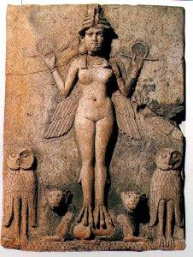
Lilith stele

In Rabbanic legend, Lilith was made of filth and sediment instead of dust. From Adam's union with the Lilith (or Naamah) sprang Amadeus (Asmodius), the king of demons and all his horde, which still plague mankind. Lilith became offended that Adam wanted her to lie beneath him sexually, saying, "Why must I lie beneath you? I also was made from dust, and am therefore your equal." Adam tried to compel her to obey him by force, but this only enraged Lilith, and she using the name of God as a magic word, she flew up into the air and left him. This ancient defiance to male sexual domination has led Lilith to be conceived as a modern heroine by feminist groups and music fairs. Adam complained that his “helpmeet” deserted him and so God dispatched the angels Senoy, Sansenoy and Semangelof after her. They found her at the Red Sea (Her kindred were said to be attracted to water), bearing 100 lilum a day. The angels threatened to drown her if she did not return but Lilith rebutted, "How can I die when God has ordered me to take charge of all newborn children?” Lilith then made a deal with the angels that if their names or likenesses were on an amulet displayed above the newborn child, she would spare the child. But for her actions God punished her, making 100 of her children die daily, and if she could not kill a human infant because of the amulet, she was forced to take it out on one of her kindred instead.
In Greek allegory, Lilith was known as Lamia, the beautiful queen of Libya, which was just west to Egypt and the Red Sea. Lamia was the daughter of the gods Belus (derived from the name Ba’al) and Libya. Zeus became Lamia’s lover and gave her the power to remove and replace her own eyes at will. But his wife Hera became enraged with jealousy and killed all of Lamia's children and turned her legs into a snake‘s tail. After this, Lamia found and ate all the children she could find for she could not bear to see a happy mother with her children. Her kindred were evil spirits called lamiae. These blood-sucking creatures were half-serpentine, with claws on their front legs and hooves on their hind legs. If you were bitten by a lamia, it could only be cured by the sound of a lamia’s roar.
Returning to the Gilgamesh story, Inanna goes to her brother Utu to help get rid of the snake, Anzu, and Lilitu that invaded her haluppu tree, but Utu does not stand before her in the matter, so she brings her problem to her other brother, Gilgamesh. Gilgamesh did stand by her on the matter though. He strapped on his belt of 50 minas weight, which to him felt more like the 30 shekels, a frequent sum found through scripture. He then lifted his heavy bronze axe and killed the snake. The Anzu bird and it’s young then flew back to the mountains and the phantom maiden took refuge in the wilderness. Gilgamesh then uprooted the tree, cut it up, bundled the wood, and made Inanna a bed and a chair out of it. This is probably representative of Gilgamesh building a temple for her. He also used the wood he also made two objects, a pikku and mukku. It has been speculated that objects were musical instruments, such as a drum and drumstick.⁵ If so, there may be some connection to this and the Greek story of Daphne, who was turned into a tree to escape Apollo’s lust at which one of her branches were then taken by the god to make a guitar. In any case, Gilgamesh continuously used the pikku and mukku to play in the main square, always praising himself in his abilities. But then the widows and young women began to bring accusations against him for taking young virgins as his own. This somehow caused his two sacred toys to fall into the netherworld. He tried to reach in after them but couldn’t get them and began to cry, promising to treat the carpenter’s wife like his mother or sister if he could just get them back. Enkidu offered to go into the netherworld and get them back for him, but Gilgamesh warned him of the rules that had to be obeyed while he was there: no clean garments, no ointment, no spear throwing, no shoes, no shouting, and no kissing or hitting your wife or child. But Enkidu didn’t listen and was caught doing all those things, and so got trapped in the netherworld.
Gilgamesh appealed to Enlil, saying that Enkidu had not fallen in battle, but Enlil did not stand by him on the matter. He then went to Eridu and made the same appeal to Enki, who had Utu open a hole into the netherworld and bring out Enkidu with a breeze. The two hugged and kissed and asked each other and Gilgamesh asked what the order of the netherworld was like, so Enkidu sat down to tell him, though he felt they would both weep at what he had to recall. Enkidu revealed that the people who had had the most sons were the happiest in the netherworld, with the man having seven sons being a companion of the gods, who sat on a throne and listened to judgments. Eunuchs were propped in the corner. Those eaten by a lion still felt the pain in their hands and legs. The leprous man was still separated from everyone else. The man who fell in battle did not have his mother or father to hold his hand and his wife still wept for him. The man who had no funerary offerings had to eat the bread crumbs tossed out on the street. But stillborn children played on a table of gold and silver laden with honey, and the ones who had died in their sleep now laid on the bed of the gods. But the ones Enkidu did not see were those who had been burned alive, since their spirit had went up into the sky with the smoke.
A version of this story found in Ur has Gilgamesh ask Enkidu if he saw a citizen from Girsu who had refused water to his mother and father. Enkidu says that they were put before a thousand Amorites and somehow restricted from something. The citizens of Sumer and Akkad are said to drink muddy water. Gilgamesh asks about his parents and is told they drink muddy water as well. Another text from Ur says that he returned to the city, outfitted himself with weapons, and then declared to Utu as he came from his bedchambers that his parents would drink clean water. He and the people of Uruk wept for nine days and then repulsed the people of Girsu. Another version from Me-Turan ends saying:

His heart was smitten, his insides were ravaged. The king began to search for life. Now the lord once decided to set off for the mountain where the man lives.

This ending serves as a transition to the next legend: Gilgamesh and Huwawa, sometimes given the anti-climatic name Gilgamesh and the Land of the Living. I’m no linguist but I think the definition they were shooting for was Land of Life, referring to the cedar forests of Lebanon. There are two versions of this story, with Version A being a little bit longer and in better shape. It begins with Gilgamesh telling his slave Enkidu that he was going to set off to the mountain where “the man” lives. Enkidu warns him that he should tell Utu since the Mountains of Cedar-Falling were his department. Gilgamesh sacrificed a white kid for Utu and asked him to be his helper. Utu replied that Gilgamesh was a prince in his own right but asked why he wanted to go to the cedar mountains, to which Gilgamesh replied:

"Utu, I have something to say to you -- a word in your ear! I greet you -- please pay attention! In my city people are dying, and hearts are full of distress. People are lost -- that fills me with dismay. I craned my neck over the city wall: corpses in the water make the river almost overflow. That is what I see. That will happen to me too -- that is the way things go. No one is tall enough to reach heaven; no one can reach wide enough to stretch over the mountains. Since a man cannot pass beyond the final end of life, I want to set off into the mountains, to establish my renown there. Where renown can be established there, I will establish my renown; and where no renown can be established there, I shall establish the renown of the gods."

Utu accepts his tears and tells Gilgamesh that there will were seven brothers, each one having a specific strength, who would help him. Gilgamesh rejoiced and called the people of the town saying, "Citizens! You who have a wife, go to your wife! You who have children, go to your children! Warriors, whether experienced or inexperienced, who have no wife, who have no children -- let such people join me at my side as the Companions of Gilgamesh." Fifty bachelors join him and he goes to the smith to have weapons made, then has men cut down ebony trees, apricot trees, haluppu trees, and square trees. The eldest of the seven brothers, who had lions’ paws and eagle’s claws, guided them to the mountains. One by one, he crossed the seven mountains of heaven, and after crossing the seventh mountain his intuition led him to the cedar trees and they began chopping them down. They scared Huwawa (or Humbaba) into his lair, where he began releasing his “terrors”, which affected everyone differently. Version B says the terrors flew at them like spears. Gilgamesh fell asleep while Enkidu was stricken with a profound longing. The fifty bachelors began flailing around Gilgamesh like puppies. Then Enkidu woke from his daydream and shuddered. He rubbed his eyes, noticing an eerie silence, and tried to wake Giilgamesh, saying:

"You who have gone to sleep, you who have gone to sleep! Gilgamesh, young lord of Kulaba, how long will you sleep for? The mountains are becoming indistinct as the shadows fall across them; the evening twilight lies over them. Proud Utu is already on his way to the bosom of his mother Ningal. Gilgamesh, how long will you sleep for? The sons of your city who came with you should not have to wait at the foot of the hills. Their own mothers should not have to twine string in the square of your city."

In version B aggressive words are enough, but in Version A Enkidu rubs oil- which cost the proverbial 30 shekels- on Gilgamesh’s chest to wake him up. Gilgamesh stood up like a bull, chided his laziness and vowed:

"By the life of my own mother Ninsun and of my father, holy Lugal-Banda! Until I discover whether that person was a human or a god, I shall not direct back to the city my steps which I have directed to the mountains."

Enkidu tried to make life appear more attractive, saying that Gilgamesh hadn’t seen Huwawa like he had. Enkidu told him that Huwawa‘s mouth was like a dragon‘s maw, his face a lion’s grimace, his chest like a raging flood, his brow devoured reed beds, and his tounge always wet with blood. Enkidu told Gilgamesh that he could go on to the mountains but he would go back home and tell his mother he was alive, though he would eventually have to tell her he was dead. In Version A Gilgamesh says:

"Look, Enkidu, two people together will not perish! A grappling-poled boat does not sink! No one can cut through a three-ply cloth! Water cannot wash someone away from a wall! Fire in a reed house cannot be extinguished! You help me, and I will help you -- what can anyone do against us then? When it sank, when it sank, when the Magan boat sank, when the magilum barge sank, then at least the life-saving grappling-pole of the boat was rescued! Come on, let's get after him and get a sight
of him! If we go after him, there will be terror! There will be terror. Turn back? Is that your advice? Is that your advice? Turn back? Whatever you may think -- come on, let's go after him!”

To which Enkidu replies:

“Before a man can approach within even sixty times six yards, Huwawa has already reached his house among the cedars. When he looks at someone, it is the look of death. When he shakes his head at someone, it is a gesture full of reproach. When he speaks to someone, he certainly does not prolong his words. You may still be a young man, but you will never again return to the city of the mother who bore you!"

This in itself causes Gilgamesh to freeze in terror. Huwawa then called out, saying:

"So come on now, you heroic bearer of a sceptre of wide-ranging power! Noble glory of the gods, angry bull standing ready for a fight! Your mother knew well how to bear sons, and your nurse knew well how to nourish children on the breast! Don't be afraid, rest your hand on the ground!”

Gilgamesh rested his hands on the ground and then came up with a plan reminiscent of Bugs Bunny. He called out to Huwawa saying that he would like to know where in the mountains he lived because he had brought his big sister, Enmebaragesi (Agga’s father), to be Huwawa’s wife. He then offered his little sister Ma-tur as a concubine if he could get his hands on those terrors, promising that he just wants to be his kinsman. Apparently taking him seriously this time, Huwawa hands over his first terror to him. Gilgamesh then trades eca flour (food of the gods), a waterskin, and two pairs of shoes for the rest of his terrors. After each trade, the Uruk warriors lopped off branches and bundled them at the foot of the hill for some reason. Version B only preserves the part about the shoes. Acting as if he was going to kiss Huwawa in order to seal the pact, Gilgamesh punches him in the cheek. Huwawa bares his teeth and starts rebuking Gilgamesh’s epithet as a hero. Gilgamesh demands the monster sit down and Huwawa obeys but begins to weep. For all of Enkidu’s hype, the monster turns out to be a big cry baby.

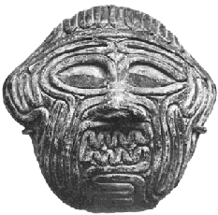
Huwawa

Gilgamesh and Enkidu then throw a halter over him, reign him like a horse, and tie his arms up. Huwawa tugs at Gilgamesh’s hands, asking to talk to Utu. He calls out to Utu that he had never known any parents and that Gilgamesh had sworn by heaven, earth and the mountains. Gilgamesh feels pity for him and suggests to Enkidu that they allow the captured bird to run back to his mother’s embrace. In version B, Gilgamesh suggests that Huwawa act as their guide back. In Version A, Enkidu replies,

"Come on now, you heroic bearer of a sceptre of wide-ranging power! Noble glory of the gods, angry bull standing ready for a fight! Young lord Gilgamesh, cherished in Uruk, your mother knew well how to bear sons, and your nurse knew well how to nourish children! -- One so exalted and yet so lacking in judgment will be devoured by fate without him ever understanding that fate. The very idea that a captured bird should run away home, or a captured man should return to his mother's embrace! -- Then you yourself would never get back to the mother-city that bore you!”

Enkidu also mentions something about captured priests going back to their temples and in Version B he warns that Huwawa could somehow mix up the mountain routes and get them lost in the mountains. At this point the rest of Version B is lost. Huwawa asks Enkidu how he could speak such hateful words to Gilgamesh. That only ticked Enkidu off and the slave cut his throat immediately, possibly aided by Gilgamesh. They then cut off his head and put it in a leather bag. When they entered Enlil’s temple and placed his head before him, Enlil grew angry, saying:

"Why did you act in this way? Was it commanded that his name should be wiped from the earth? He should have sat before you! He should have eaten the bread that you eat, and should have drunk the water that you drink! He should have been honored by you!”

Enlil then took the seven terror auras and gave them to the fields, the rivers, the reed-beds, the lions, the palace, and the last he gave to Nungal, goddess of prisoners.
Gilgamesh’s next adventure is called Gilgamesh and the Bull of Heaven, which starts off with the words, “I will sing a song of the man of battle, the man of battle…..”. Gilgamesh is described as having a long black beard and great athletic prowess, but the rest of the first segment of the text is corrupted. A couple lines are also missing from segment B, which opens with Inanna threatening Gilgamesh that she will not let him dispense justice in her holy temple. In a later Babylonian epic, this is because he spurns her advances and dares to sing a song about the evil fates of those who become Inanna’s lovers. Gilgamesh tells Inanna that he will not take over her portion as long as she doesn’t get in his way. Enraged at Gilgamesh, Inanna goes to An and asks that the Bull of Heaven be released. An warns that the bull would muddy the waters and leave huge cowpats. Inanna is willing for that to happen as long as it means the bull will kill Gilgamesh. She replies that if she does not get her way she will shout and it will be heard from heaven to earth, at which An becomes frightened and gives her the Bull. She grasped the lapus lazuli tether and guides it to the earth from on top of the ramparts. The great bull devoured the pasture, broke the palm trees and drank a mile of river water in one gulp. When it stood, it submerged Uruk. The text is more damaged at this point and harder to follow. At first Gilgamesh just sits in the tavern and drinks while telling his bard to play. Then he is before the great bull, threatening to turn it’s horns into oil flasks for Inanna’s temple. Gilgamesh, Enkidu and the men of the city defeat the bull and it falls into the dust. Enkidu calls out to Gilgamesh and offers the final stroke to him. Gilgamesh smites the bull’s skull with his axe weighing seven talents, so overbalancing the bull that it rose up and it’s blood rained down on the harvested crop. Like a master chef, Gilgamesh cut a slab of meat form the bull and threw it at the top of the ramparts, hitting Inanna and causing her to flee like a pigeon. Standing by the bull’s head and weeping bitter tears, Gilgamesh asks something like "Just as I can destroy you, so shall I do the same to her?" Gilgamesh then divides the meat among the people of Uruk and fulfills his promise to turn the bull’s horns into oil flasks for Inanna. It seems there is no grudge. The text ends saying that for the death of the Bull of Heaven it is sweet to praise Inanna, whatever that means.

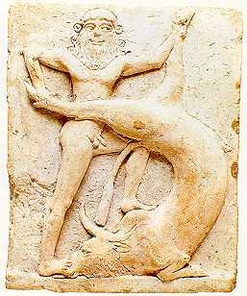
Gilgamesh and the Bull of Heaven

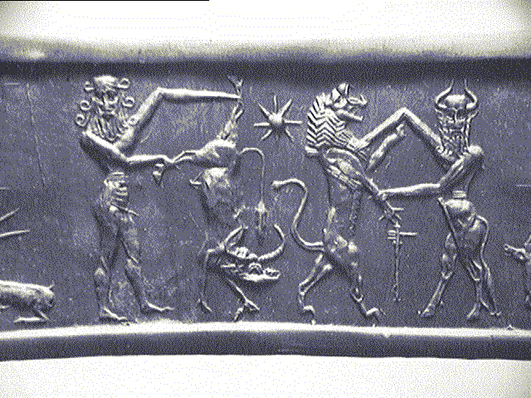
Gilgamesh and bull, lion and god

Most of texts of The Death of Gilgamesh are in poor state, so the story has to be pieced together through different versions that have been found in Nibru and Me-Turan, versions which have their own variances. Each text opens with praises for the hero Gilgamesh, citing his different titles, each line ending with “….has laid down and is never to rise again.” It says that he becomes ill and is bedridden for six days. His skin breaks out and he despaired as he could not eat or drink and it became clear that he was on his death bed. When Gilgamesh arrived at the assembly of the gods, they review the adventures of his life: fetching the cedar tree, killing Huwawa, setting up monuments for future generations, setting up temples to the gods, and having reached Ziusudra (Noah) in his dwelling place (this text has yet to be found). He also is said to have brought divine powers of forgotten lore to Sumer and correctly carried out the rites of hand and mouth washing. Enlil councilled Enki and Enki said to An that after they had granted immortality to Ziusudra they had made Enki promise never to give it to a mortal again, but Enki wanted to make an exception for Gilgamesh because of his mother. But instead it was decided that Gilgamesh would become one of the judges of the dead and that his word would be as heavily weighed as Ningishzida and Dumuzi. Gilgamesh became depressed but was told to not to be depressed since he was now to be counted as one of the Anuna gods:

"Oh Gilgamesh! Enlil, the Great Mountain, the father of gods, has made kingship your destiny, but not eternal life -- lord Gilgamesh, this is how to interpret (?) ...... the dream. The ...... and ...... of life should not make you feel sad, should not make you despair, should not make you feel depressed. You must have been told that this is what the bane of being human involves. You must have been told that this is what the cutting of your umbilical cord involved. The darkest day of humans awaits you now. The solitary place of humans awaits you now. The unstoppable flood-wave awaits you now. The unavoidable battle awaits you now. The unequal struggle awaits you now. The skirmish from which there is no escape awaits you now. But you should not go to the underworld with heart knotted in anger.

Gilgamesh is told not to be depressed because his family, the city elders, and his friend Enkidu would soon be joining him. The floodgates were opened and the Euphrates was diverted so that a great stone tomb with golden beams could be made in the river bed. When the tomb was finished:

His beloved wife, his beloved children, his beloved favorite and junior wife, his beloved musician, cup-bearer and ......, his beloved barber, his beloved ......, his beloved palace retainers and servants and his beloved objects were laid down in their places as if ...... in the purified (?) palace in the middle of Uruk.

Gilgamesh sets out gifts for Ereshkigal, Namtar, Dumuzi, and a bunch of other gods so that his friends and family would be received graciously. The circumstances regarding Enkidu’s death are changed in the later Babylonian legends that are made of him. One of the tablets from Nibru ends with praises for Gilgamesh but the one from Me-Turan replies to Gilgamesh’s depression by saying that Enlil provides people with offspring so that they will make funerary statues to set aside in temples so that their names, once uttered, would not sink into oblivion. That text ends with praises for Ereshkigal.
This kind of mass suicide following the death of a king or noble is also attributed to the Sumerians by the tomb of the noblewoman Pu-Abi in a royal cemetary found by the famed archaeologist Sir Leonard Woolley. This tomb was found untouched in Ur of the Chaldees. The queen wore golden jewelry and semi-precious stones. Buried with her were vessels of gold and silver, musical instruments, a small board game with game mechanics similar to Parchesi, two chariots with three oxen, and 59 bodies, six of whom were guards and 19 of them court ladies. They were still holding the cups that they poisoned themselves with. Pu-Abi’s tomb dated to 2500 BC, about a few hundred years after Gilgamesh.

The Cup Bearer Who Became King

After Gilgamesh, seven more kings are recorded as ruling over Sumer and Akkad from Uruk, each one reigning a pitiful 6 to 30 years a piece, before Mesannepadda (“An’s Chosen Hero”) conquered the city-state and made Ur the capital. The king lists say that the first dynasty of Uruk lasted 2,310 years but archaeologists believe that it was closer to 260. After this “Heroic Age“⁵, the reigns of individual kings never tops 1,000 again. Cylinder seals excavated from a royal cemetery in Ur bear the inscriptions “Meskalamdug, King” and “Akalamdug, King of Ur” have been found, both beneath recovered seal inscriptions of Mesannapadda, seeming to indicate that they ruled before him. The lavish cemetery dates from before Mesannapadda and holds around 17 tombs. Fifteen of them were found with anywhere from between 3 and 74 attendants buried with them in each tomb, most of them women.
Lugal-Kitun of Uruk and Mesalim of Kish were both defeated by Mesannepadda, who set up the first dynasty of Ur. The king lists say that this dynasty lasted 170 years while the current estimation puts it at around 110 years (2560-2450). Ur fell to foreign invaders, the Elamites from the city of Awan, west of Susa and the Karkheh river. The king lists say Awan held kingship for 356 years, but evidence seems to indicate that they began encroaching in Sumerian land about a decade before they overthrew Ur in 2450 BC. The Elamites held some dominion over Sumer for about 40 years (2460-2420) until they were driven out by En-Shakushanna of Uruk along with Elamites from Hamazi. The king lists do not mention this. No records of the 8 kings of the Second Dynasty of Kish could be found, but a lost dynasty consisting of 5 different kings were found who ruled concurrent with the rulers of Ur I and Awan. After 3,195 years Kish II was supposed to have been defeated by the Hadanish of Hamazi, an Elamite who ruled for 360 (more like 20) years. According to modern estimation Hamazi was a contemporary of the First Dynasty of Ur (2450-2430) rather than ruling 3,722 years afterwards.
The king lists say that Hamazi was defeated by Enshakushanna of Uruk, who founded the Second Dynasty of Uruk. After 3 kings and 187 years Uruk was said to have been defeated by Ur once again, although in reality they seem to have ruled side by side for about half as long. After 582 years, Ur II is said to have been defeated by Lugal-Annemundu of Adab, although there seems to have been a brief and unrecorded Elamite dominion before this. Later documents from Lugal-Ammemundu’s reign state that he controlled the entire fertile crescent, from the Mediterranean Sea to Elam. He was called “King of the Four Quarters of the Universe” and “He who made all the foreign lands pay steady tribute to him, who brought peace to the peoples of all the lands, who built the temples of all the great gods, who restored Sumer to its glory, who exercised Kingship over the entire world“. It is also said that 13 rulers banded together to rebel against him but were all defeated. Each of these rulers had a Semitic (Akkadian) name, even the ones from Elamite cities. It is said that Lugal-Annemundu later campaigned deep into the Zagros mountains, conquering territory to the north all the way to the land of Gutians. If this is true, then he would be the first emperor to unite all of Mesopotamia, but the king lists have nothing more to say about him other than he reigned for 90 years. Whatever the case, his dynasty did not last past his lifetime.
Even if Lugal-Annemundu did reign for 90 years, it still would not have been worth the attention the people of western Mesopotamia gave the fertile crescent for the next 160 or so years. Mari, a city on the far west side of the Euphrates, was the next capital on the king lists, whose recorded 6-king reign of 136 years is actually smaller than the modern estimation. The Anbu Dynasty of Mari is recorded as being defeated by Kubau the Tavern Keeper (alternatively: Inn Keeper), who is believed to have lived around 2400 BC. Her sole reign of 99 years is considered to be the Third Dynasty of Kish. Then, after 7 kings of Akshak rule another 99 years, Kubau’s son Puzur-Suen came back to wreck his mother’s revenge. Some king lists record this as the Fourth Dynasty while others list them as one dynasty. His reign is recorded as being 25 years, in which he then passed the crown to his son Ur-Zababa for 6 years. Although the kings lists say that there were 5 more kings after Puzur-Suen’s dynasty before kingship was taken over by Lugal-Zagesi, other records say that Ur-Zababa was a contemporary of Lugal-Zagesi. Most king lists record Lugal-Zagesi’s 25-30 year reign as the only king of the Third Dynasty of Uruk (2345-2316), but one of them omits Uruk III entirely. Lugal-Zagesi’s ambition was to fulfill the lost accomplishments of Lugal-Annemundu and reunite the lands of Akkad, Sumer, Elam and the Levant (Ugarit; Syria), although his objective would take a different form than he planned.
A text found in Lagash called Umma and Lagash tells of a dynasty in Lagash from around 2500 BC. The text states that in the days when the “King of Kish” was Mesalim, there was a border dispute between Umma and Lagash, two cities situated 18 miles apart from each other. The text opens saying that Enlil, father of all the gods, had established the boundary line through Mesalim, the “King of Kish” (though he does not appear in the king lists). However, the ishakku (priest-king) of Umma violated his word, ripped out the boundary line stele, and seized land away from Lagash. So according to Enlil’s command, Ningirsu (Ninurta) did battle with Umma, threw his great net upon them, and buried the bodies in a great mound in the plain. But apparently, this happened some time later, when Lagash came into military superiority under the reign of Eannatum. King Eannatum restored the stele, built several sanctuaries to the gods, and allowed the people of Umma to farm part of their territory, but only if they repaid them in grain for the service. Eannatum ruled concurrently with the dynasties of Ur I, Awan, Kish II, Hamazi, and Uruk II. From other sources we know he eventually claimed to have defeated Umma, Uruk, Ur, Akshak, Mari, Susa, Elam, and several districts probably inside the Zagros mountains. He also assumed the title “King of Kish”.
The second document proceeds to around the time of the author. A king of Umma named Ur-Lamma withheld on this taxation and then drained the ditches at the boundary line and put to torch all of the boundry steles and their annoying proclamations. By then Eannatum’s crown had passed to his brother Enannatum. “As puffed up as the mountains” the army of Umma crossed over Ningirsu’s boundry line, but was met by a force led by Enannatum’s son: Entemena. The king’s son defeated Umma’s forces, captured the ishakku as he was running away, and slew him in front of his men. Eannatum's victory was commemorated by a stele depicting vultures tearing up the corpses of the defeated. The 60 men who died were buried in five mounds on the bank of the canal, and was called “Meadow-recognized-as-holy-from-the-great-dagger”. A priest of Inanna by the name of Ili from the city’s temple of Esh was then chosen to be the vassal ruler of the city.

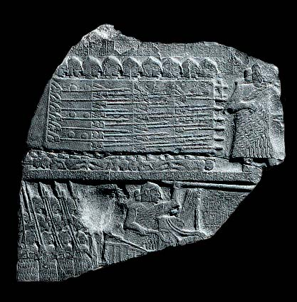
Stele of the Vultures, commemorating Eannatum
of Lagash’s defeat of Umma, 2525 B.C.

.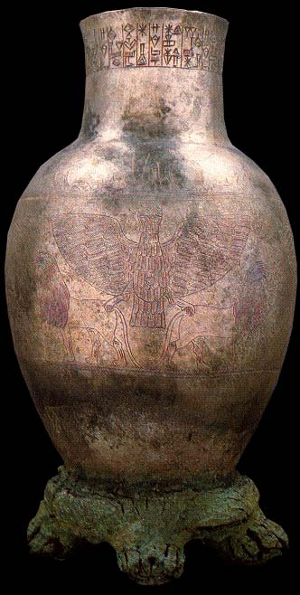
Entemena’s Anzu-styled vase, dedicated to Ningirsu (Ninurta)
Lagash, 2505-2375 B.C.

Unfortunately, the vassal ruler that Enannatum set up did not prove to be a loyal retainer. The third document tells how Ili drained the boundry canal and stole Lagash’s grain. When Eannatum declared hostility on him, the priest of Inanna flooded the fields, had the boundry canal of Ningirsu ruined, destroyed the stela of the vultures, and took control over the land. The resolution to this is enigmatically summed up as “Enlil and Ninhursag did not permit this to happen”. Apparently some compromise was made. The boundry line was restored to it’s old position and Eannatum had the canal restored. This may mean that a compromise had been set up involving the authorities of Nippur and Adab, the latter of which is just north of Umma. The text concludes with a prayer asking Enlil to destroy any trespasser, whether Ummaite or foreigner, and asking Ningirsu to hurl a net over the trespasser so that the people of the city can kill him a second time.
If Umma and Lagash fulfilled it’s purpose of explaining border line disputes and political upheavals of the Ur-Nanshe dynasty away as religious phenomenon, the heroics of Eannatum and his kindred did not inspire future generations of Lagash citizens to look past government corruption or accept gratuitous taxation by them. A social reform text has been found dating to the time of King Uru-Ka-Gina, who is said to have stopped the political corruption of the former dynasty. It is said that the inspectors of cattle, boats and fisheries often stole what they inspected and that taxes were levied on perfume, divorce, death, and wool that was white. The gods’ oxen were said to plow the king’s onion patch. Urukagina is recorded as having put a stop to all of this and also to have promulgated the oldest surviving law codes to date, which where uncharacteristically humane compared to later law codes, rarely resorting to the death penalty. But the laws would not benefit the city long because within 10 years the bitter hatred of Umma would come to haunt them again when the priest-king Lugal-Zagesi invaded Lagash with forces from Umma and razed the city, carrying off the temple’s statue of Ningirsu. The chroniclers of Lagash cursed him, writing, “The men of Umma, by the despoiling of Lagash, have committed a sin against the god Ningirsu.... As for Lugal-Zagesi, priest-king of Umma, may his goddess Nidaba make him bear his mortal sin upon his head!”.
Lugal-Zagesi went on to conquer Ur an Uruk under the name of Enlil, making Uruk his capital, cementing an alliance there. He claims to have then unifed all Sumer and to have taken control of the trade routes from the Mediterranean to the Persian Gulf. But he would never reunify the lands of Akkad, Elam and the Levant, and his 24 year rule would mark the end of the Sumerian kingdom. All this because of a cup bearer who came to his castle as a messenger.
There is a damaged text with a missing conclusion called the Sargon Legend, made up of three segments, which tells about Sargon’s days as a humble servant. In the first segment, Kish is said to have become a ghost-town, and that by the holy command of An and Enlil Ur-Zababa’s reign had been altered and the prosperity of his palace removed. Although other sources say Sargon didn’t know his father, this text identifies him as La’ibum. There is more text regarding the circumstances surrounding Sargon’s birth but the rest of this segment is missing.
The second segment says that while Sargon was making a delivery to Ur-Zababa’s palace, he somehow felt what the king was dreaming about but didn’t tell anyone. When Ur-Zababa awoke and received Sargon’s deliveries, he made him cup bearer and put him in charge of the drink cupboard. It is said that holy Inanna did not cease to stand by him. Five or ten days passed and the king began to grow sick and develop a bladder control problem, even discharging blood and pus. Sargon then ’laid down not to sleep but to dream’ and had a premonition of Inanna drowning the king in a sea of blood. Ur-Zababa heard the groans he made in his sleep and asked him what he had been dreaming and Sargon told him. The king grew even more afraid and began biting his lip. He decided that Inanna would change her mind and take Sargon’s life instead if he just helped it along, so he ordered his smith Belishtikal to wait for Sargon in the E-sikil, ’the fated house’, and then throw both him and his package (which might have been a bronze mirror) into the mould like a statue. The king sent Sargon there with the package, but Inanna stopped Sargon before he entered and told him that he could not enter the E-sikil while unpurified by blood, so Sargon instead made the chief smith come out to him and gave him the mirror at the gate, avoiding assassination. Knowing that he is fated to become king, Sargon becomes ‘founded like a mountain’ and Ur-Zababa begins to fear his presence, though he never said anything about it. Ur-Zababa then sent Sargon on an errand to carry a clay tablet to his most powerful rival, Lugal-Zagesi, and the text informs us that this was a historic moment:

In those days, although writing words on tablets existed, putting tablets into envelopes did not yet exist. King Ur-Zababa dispatched Sargon, the creature of the gods, to Lugal-Zagesi in Uruk with a message written on clay, which was about murdering Sharru-Kin.

Just as the story gets interesting, the rest is of the text is destroyed. There is something about Lugal-Zagesi’s wife’s femininity being a shelter in the third segment and something about Lugal-Zagesi not talking to an envoy for a time but when he did, he despaired and sat in the dust, and told the envoy that Sargon would not submit. It has been conjectured that Lugal-Zagesi helped Sargon overthrow Ur-Zababa to force an alliance with Nippur and Kish. One thing that’s known for sure is Ur-Zababa was out of the picture before long. One of the prayers written by Lugal-Zagesi during the time of his military dominance reads:

May the lands lie peacefully in the meadows. May all mankind thrive like plants and herbs; may the sheepfolds of An increase; may the people of the Land look upon a fair earth; the good fortune which the gods have decreed for me, may they never alter; and unto eternity may I be the foremost shepherd.

Another inscription found in Nippur reveals what fortunes were in store for the great conquerer:

Sharru-Kin, the king of Agade, the King of the Land, laid waste the city Uruk, destroyed its wall; fought with the men of Uruk, conquered them; fought with Lugal-Zagesi, the king of Uruk, took him prisoner and brought him in a neck stock to [Nippur/Kish].

Lugal-Zagesi was then chained by the neck to the “Gate of the Enlil“, after which he was never heard from again.

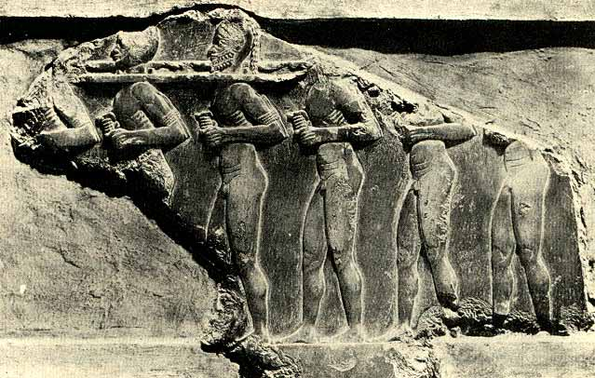
Stele of Sargon the Great

Sargon’s real name is not actually known. The name of a later Assyrian king who bore his name was translated in the book of Yesha-Yahu (Isaiah) as Sargon, but the name is actually Sharru-Kin, meaning “Legitimate-King”. The reason for the original Sharru-Kin taking a name like that leads to the presumption that he was the exact opposite.
The House of Lugal-Zagesi had 50 ensis (governors) at their command, but they were all defeated when Sharru-Kin launched his surprise attack. After consolidating his power in the northern territories of Akkad, he went down the Tigris conquering Umma, Lagash and Ur and then “stopped at the lower sea [Persian Gulf] to wash their weapons“. Although he was already King of Kish, he built a new capital with double fortifications and called it Agade, which gave Akkad it’s name. He also built a huge temple to Ishtar (Inanna) and another for the warrior god of Kish, Zababa, perhaps in Ur-Zababa’s memory. The now lost city of Agade’s location is said to have been on the Euphrates and is believed to be very close to later-day Babylon, if not within the city’s borders itself. With the rise of Akkadian power, their Semitic tounge replaced Sumerian as the official language and Akkadian governors were appointed in all the major cities. Following Sumerian religious traditions, Sargon appointed himself the anointed priest of Anu and the great governor of Enlil and gave his daughter Enheduanna the position of high priestess of Suen (Nanna) in Ur. He traveled to the east and conquered Elam and Barhashe. It is said he then went northwest and prostrated himself in front of Dagan, who gave him the cities of Mari, Iarmuti, and Ebla, all the way to the Cedar Forest (Lebanon) and the Silver (Taurus) Mountains. He is even quoted as conquering the Sumerian Eden. Sharru-Kin is believed to be the first person to unify the many different cultures of Mesopotamia under one nation, the Akkadian Empire, which was formed sometime between 2334 and 2371 B.C. Later documents say that Sargon ruled over 65 cities and boasted that trading vessels from Meluhha (Northwestern India), Magan (near the Gulf of Oman), and Dilmun (Eden) came to his capital. His former status of cup bearer is said to be some type of treasurer, but another text written in his name has Sargon claiming to be a former gardener. This text, named similarly to the last one, is the Legend of Sargon, which gives a short background of his life in first person:

Sharru-Kin, the mighty king, king of Agade, am I.
MY mother was a changling, my father I knew not.
The brother(s) of my father loved the hills.
My city is Azupiranu, which is situated on the banks of the Euphrates.
My changeling mother conceived me, in secret she bore me.
She set me in a basket of rushes, with bitumen [tar and pitch] she sealed my lid.
She cast me into the river which rose not over me,
The river bore me up and carried me to Akki, the drawer of water.
Akki, the drawer of water, lifted me out as he dipped his pot.
Akki, the drawer of water, [took me] as his son and reared me.
Akki, the drawer of water, appointed me as his gardener,
While I was a gardener, Ishtar granted me her love,
And for four and ... years I exercised kingship,
The black-headed [people] I ruled, I gov[erned];
Mighty [moun]tains with chip-axes of bronze I conquered,
The upper ranges I scaled,
The lower ranges I [trav]ersed,
The sea [lan]ds three times I circled.
Dilmun my [hand] cap[tured],
[To] the great Der I [went up], I ...,
... I altered and ...
Whatever king may come up after me,
...
Let him r[ule, let him govern the black-headed [peo]ple;
[Let him conquer] mighty [mountains] with chip-axe[s of bronze],
[Let] him scale the upper ranges,
[Let him traverse the lower ranges],
Let him circle the sea [lan]ds three times!
[Dilmun let his hand capture],
Let him go up [to] the great Der and ... !
... from my city, Aga[de] ...
The meaning of his mother being a changeling is unknown, but it has been suggested that it means he was the illegitimate child of a temple prostitute.
The sending of Sargon down the river in a tar pitch basket is reminiscent of the later Moses story:

“Now a man of the house of Levi married a Levite woman and she became pregnant and gave birth to a son. When she saw that he was a fine child, she hid him for three months. But when she could hide him no longer, she got a papyrus basket and coated it with tar and pitch. Then she placed the child in it and put it among the reeds along the bank of the Nile.” -Exodus 2:1-3

Like Sargon and Moses, the legendary founder of Rome, Romulus, is also said to have been set down the river in a similar legend. All three of these men were legendary founders of great nations. There is a good possibility that Sharru-Kin is also the Biblical king Nimrod:

“Kush was the forebear of Nimrod, who grew up to be a mighty warrior on the earth. He was a mighty hunter before Yahweh; that is why it is said, ‘Like Nimrod, the mighty hunter before Yahweh.’ The first centers of his kingdom were Babylon, Erech [Uruk], Akkad, and Calneh(?) in Shinar [Babylonia]. From that land he built Nineveh, Rehoboth, Ir, Calah and Resen, which is between Nineveh and Calah; that is a great city.” -Genesis 10:8-12

Sharru-Kin ruled over all these lands and became the legitimacy from which New Kingdom emperors of Babylonia and Assyria based their authority to conquer neighboring countries. It is from the texts of these later empires that everything about Sharru-Kin is known. The later Assyrian king who took his name (721-705 BC) made Ninevah his capital. The only likeliness we have of Sargon the Great was excavated from that city as well. His dominion of Uruk is one of his most famous endeavors and he is the only person who could have been said to have founded Akkad. Nimrod literally means “Let us revolt”, and Sharru-Kin’s standing as an usurper is certainly pervasive today. Regarding Nimrod’s reputation as a mighty hunter, one of the advantages attributed to Sharru-Kin’s success in battle was the invention of the composite bow, seen drawn for the first time in depictions of his army. The city of Calah, now called Nimrud, was a village of no importance until the Assyrian king Assurnasirpal II (883-859 BC) made it his capital, but he lived far too late for the Genesis times.

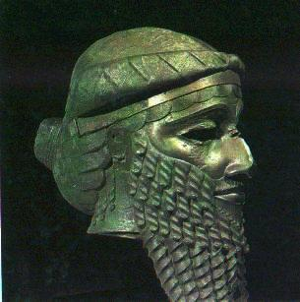
Bronze head of Sharru-Kin [Sargon] from Nineveh

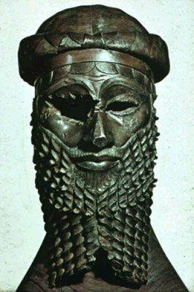
Frontal View

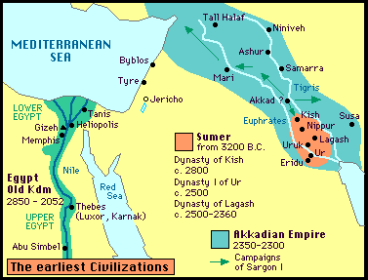

Sharru-Kin’s daughter, the high priestess of Ur, was Enheduanna. The En prefix is a title denoting her priesthood. The second half of her name, Hedu-Ana, means “Ornament of Heaven“. She is the first author known by name whose works still survive to this day. Although her father changed the official language of the lands to Akkadian, her name and her poetry is Sumerian. There are six poems associated with Enheduanna, which are sometimes referred to in the tradition of calling it by the manuscript’s first words: Nin-me-sar-ra (“Lady of Infinite Arts”), In-nin Sag-gur-ra (“Stout-hearted Lady”), In-nin Me-hus-a (“Inanna and Mt. Ebih”), E-u-nir (“House of the Ziggurat“), E-u-gim E-a (Hymn to Ereshkigal and Nanna for En-ship Assumption), and a hymn in praise to herself. The title of this last work was broken off and is lost to history due to divine retribution for self indulgence.

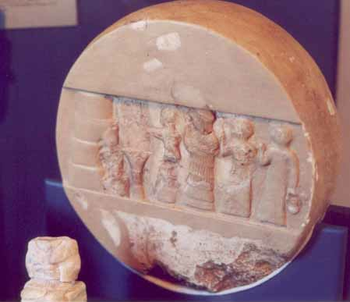
Enheduana with a priest and two priestesses
Limestone Disk from Ur

The poem Nin-me-sar-ra (“Lady of Infinite Arts“), also known as The Exhaltation of Inanna, consists mostly of glorifications to Inanna as guardian of the me, or sacred arts. An earlier Sumerian myth, Inanna and Enki, tells how Inanna got Enki drunk and was able to convince him to let her sail the 94 sacred arts from his underwater temple to the city of Uruk. These “arts” included offices of priesthood, articles of clothing, attributes, emotions, different forms of speaking, music, stages of intimacy, and prostitution. Beer is in there too. Enki sends out his messenger Isimud to stop Inanna from delivering these secret arts to the people of Uruk. Isimud catches up to her and Inanna becomes outraged that Enki would change his mind after he promised to let her take them. They get into a repeating argument as the minister tries to humbly convince Inanna to return. Although the ending is fragmented, we can tell something must have been worked out as there is mention of a festival. The text seems to insinuate that Uruk learned the arts of civilization from Eridu and that Eridu at first resented this. Besides honoring her role as guardian of these arts, Enheduanna’s Exaltation of Inanna also goes into great detail as to the devastation Inanna will bring to those who refuse to bow down to her. In her venerations to Inanna, she says that the goddess is even greater than her mother (Ningal). The focus then turns to the priestess herself, recounting how she went into her special fortune room in Ur named Gipar:

Into my fate-determining Gipar, I had entered for you.
I, the en-priestess, I, En-Hedu-Anna.
While I carried the basket, I struck up the song of jubilation,
Have I not lived there?
They offered me the death [?] sacrifice.
I came close to the light,
there the light became scorching to me.
I came close to the shadow,
there it was veiled by a storm.
My sweet mouth became bitter.
That with which I gave delight, turned to dust.
She writes of a situation she is having with Lugal-Anne, which is a generic name given to local rulers. She asks that Inanna report her fate with Suen (Nanna) and Lugal-Anne to An so that he would resolve the situation. She eventually reveals that Lugal-Anne has incited a rebellion within Ur and after he stood in triumph she was expelled from the temple and forced to “fly like a swallow from the window”. She takes this Sumerian revolt to mean that the moon god Suen has abandoned her and no longer cares for her, adding an insinuation that it did not matter what Suen decreed. She prays to Inanna, shedding tears “like sweet beer”, asking Inanna not to concern herself with Suen, since by changing the purification rites that An had set out, the moon god had not shown proper respect for An’s authority. She asks An to strike down the rebellious territory and for Enlil to curse the land. She prays that Inanna’s ship of wailing will be left in the enemy lands and repeats the passages regarding her flight from the temple and the inconsequence of whether Suen decreed the uprising or not. She laments how her rightful crown had stolen off her head but then turns her focus back to Inanna, saying that although she had been born a minor goddess, she had now risen above the Anuna gods. In this, she seems to reconcile Suen’s inability to help her as proof of Inanna’s ascension over her father and the other gods:

That Nanna has not proclaimed [the decree],
that he has said, "It is yours",
My Queen- it has made you greater,
you have become the greatest!

She then says that she has prepared the purification rites and asks that Inanna calm down for her, saying that because Inanna’s heart was so full, she would give birth for her. She promises that this song, normally sung at midnight, would be repeated in the middle of the day as well:

"Because of your captive spouse,
because of your captive protégé,
your anger has grown large,
your heart has not calmed down."

This chorus seems to indicate that Inanna’s wrathful heart comes from the memory of Dumuzi‘s death. Enheduanna’s poem ends saying that Inanna accepted the prayer and sacrifice, then became draped in enchanted moonlight and was blessed by her mother Ningal. It is believed that the rhetoric of this “Jewish princess” was copied and publicized to serve as propaganda for Shurru-Kin’s regime, though the lesson seems to be that Enheduanna‘s personal goddess grew vastly more powerful due to the author’s discredit. The concept of Inanna as a war goddess as well as being the chief matron of love and fertility is prevalent in later Babylonian stories as well.
In-nin Sagura (“Stout Hearted Lady”), also called A Hymn to Inanna, is the longest of Enheduanna’s poems but is far less complete. Like the previous text, it starts off praising Inanna in the third person and then moves to Enheduanna addressing the goddess in second person, telling how all the other gods trembled at Inanna’s greatness. It is said that An could make no decisions and Enlil could not set out those chosen destinies without the help of Inanna. Vibrant imagery is used in the poetry, including scenes of Inanna singing from her joyful heart a song of death on the battlefield as she washed her weapons of blood and gore and of Inanna riding seven great beasts as she came forth from heaven. Then, reminiscent of Inanna and Enki, Enheduanna goes through a long list of me-arts that Inanna guarded over. The text then breaks off right at the point where Enheduanna steps up and when the text is legible again, Enheduanna is telling a god that her body had suffered enough from the great punishment that had been sent on her, perhaps referring to a disease. The text ends with more glorifications for Inanna, once again asking who could possibly rival her, and Enheduanna prays that she and the great gods may be able to calm her mood.
E-u-nir (“House of the Ziggurat“), also known as The Temple Hymns, consists of 42 hymns of various length, each one dedicated to a particular god or city. The first praises go to Eridu for being the first city to be built. These hymns became dedicated to Babylon and although it was said to have been compiled by Enheduanna, at least some of them could not have been written by her as some were of the temples honored were not even built during Enheduanna‘s lifetime.
Sargon reigned 56 years (according to the king lists) and died at a very old age. He was succeeded by his son Rimush, who continued to expand his father’s empire further east. Inscriptions done by Rimush say that battles were fought in Sumer and Elam, presumably by revolts, and that 54,016 men were captured or killed in the battles. Even the Akkadian city of Kazallu rebelled and 12,000 were said to have been killed in that uprising alone. However, being the son of Sharru-Kin did not protect him from palace intrigues and after ruling nine years he was “killed by the administrator’s tablets”. He was succeeded by his brother Manishtusu, who may have been his twin. Manishtusu sent an expedition into the Persian Gulf to subjugate 32 cities at Onan and boasted that he had set up silver and diorite mines in Elam. Around this time, control of the Levant and the Mediterranean Sea was regained by the Eblaites. After a 15 year reign, Manishtusu too was killed by members of his own court and was succeeded by his son Naram-Suen (better known as Naram-Sin).
Naram-Suen (“Lover of Suen”) led an active military career and like Sargon, he appointed his daughter Enmenanna to be Priestess of Ur. He fought battles as close as in Kish and Uruk and as far away as Ebla, Lebanon, and against the Lullabi. A victory stele of Naram-Suen over the Lullabi was found in the Elamite capital of Susa. Alabaster jars from his reign with the words ‘booty of Magan’, a city far to the south, implied that he controlled the whole of the Persian Gulf. Other steles found in Turkey and the Kurdish mountains commemorates his far-reaching campaigns to those regions. Castles were also built for him in Nineveh and Eastern Syria. He also allied himself with the Elamites and had it’s governor Puzur-Inshushinak fight battles against the southern tribes of the Zagros Mountains. His inscriptions also tell of a general rebellion throughout the lands of both Sumer and Akkad. Even though his dynasty would give the Akkadians their name, it didn’t mean that they particularly liked him.

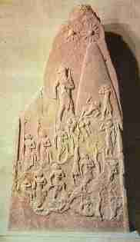
Naram-Suen’s Victory Over the Lullubi, found in Susa

The Akkadian Empire reached it’s peak during this time and Naram-Suen (2291-2255 BC) aggrandized his kingly titles accordingly, calling himself King of the Universe as well as the new title: King of the Four Regions. His name, both contemporary and subsequent to his reign, was prefixed with a star, denoting that he was a god. But despite his numerous military victories, he was unable to repel an invasion from the city of Guti, on the far north side of the Zagros mountains.
A later text, The Cursing of Agade, accuses Naram-Suen of destroying Enlil’s temple in Nippur and evidence excavated from Nippur confirms that the temple E-Kur was destroyed at the time: a door socket found in Nippur commemorating the rebuilding of the temple by Naram-Suen’s son, Shar-Kali-Sharri, who became the next god-king of Agade after Naram-Suen died. During Shar-Kali-Sharri’s reign there were more revolts in Sumer and about this time Puzur-Enshushinak of Susa declared himself King of the Universe and achieved independence from Agade. As his empire was crumbling around him, Shar-Kali-Sharri stopped using the god prefix in his declarations. After 25 years of rule, he was overthrown in a palace revolt around 2180 BC. The Lullibi, who inhabited the Sherizor plain in the Zagros Mountains of western Elam (Iran) regained their independence since their defeat by Naram-Suen, who commemorated the victory with a stele. Then another Elamite tribe, the Guitians, invaded and sacked Agade.
In The Cursing of Agade, the Gutian invasion is blamed on Naram-Suen sacking E-Kur, Enlil’s temple in Nippur. It starts off telling of Agade’s greatness, including how elephants, monkeys, lions, water buffalo and other exotic animals jostled in Agade’s public squares. Inanna made sure that Agade’s stores were always filled with enough food and gold, that she endowed the men and women on their council with great eloquence, that the foreign lands rested contently and the people were happy. Their monthly and New Years offerings were even supplied to them by the Gutians. After having the temple sacked, Naram-Suen had a vision that Enlil would curse the remaining years of his reign, and it said that the king buried his head in his hands for 7 years. He tried to perform some incantations to change Enlil’s pronouncement, but to no avail. The text goes on to say that Naram-Suen went on a path of destruction, ripping out drain pipes, he diverted grain from the gate from which grain should never be diverted, and struck down the Gate of Peace with a pickaxe causing peace and well-being to broken throughout the lands.
Looking for a people to enact revenge on Naram-Suen, Enlil enlisted the Gutians, who were said to have the features of a monkey, the intelligence of a man and the instincts of a canine. The Gutians came down upon Agade and the city erupted into chaos and starvation became rampant. It is said that “Honest people were confounded with traitors, heroes lay dead on top of heroes, the blood of traitors ran upon the blood of honest men.” No less than eight of the major gods come to Enlil and tell him:

“Enlil, may the city that destroyed your city, be treated as your city has been treated! May the one that defiled your giguna, be treated as Nibru! In this city, may heads fill the wells! May no one find his acquaintances there, may brother not recognize brother! May its young woman be cruelly killed in her woman's domain, may its old man cry in distress for his slain wife! May its pigeons moan on their window ledges, may its small birds be smitten in their nooks, may it live in constant anxiety like a timid pigeon!"

The Sumerian text ends praising Inanna for the destruction of Agade.
The Akkadian Empire fell around 2200 BC, the same time as the decline of the Old Kingdom of Egypt, the Indus Valley in Pakistan, and the Early Bronze civilizations of Palestine, Greece and Crete. Since 1993 it has been estimated that a severe drought had been responsible for the decline of these civilizations, and just recently new evidence from the Gulf of Oman (1800 km from the Akkadian Empire) has surfaced that it had the worst dry spell in 10,000 years and that it lasted for 300 years.¹⁶ Although there is still no proof that it was the direct cause of the empire’s fall, there’s a good chance it was a litigating factor. The king lists put the end of the empire this way:

157 are the years of the dynasty of Sharru-Kin. Then who was king? Who was not king? Irgigi was king, Imi was king, Nanûm was king, Ilulu was king, and the 4 of them ruled for only 3 years. 9 kings; they ruled for 161 years. Then Agade was defeated and kingship was taken to Uruk.

Empire of the Moon

The Gutians were the real beneficiaries of the Akkadian Empire’s downfall, although Uruk held out for another 30 years or so before it was the next to fall beneath Gutian rule. The king lists say that at first there were no Gutian kings who were famous and they “just ruled over themselves” for 3-7 years. It has been suggested that this means they were tribal chiefs who held office in rotation. Later traditions from the Babylonians saw this as a time of chaos and barbarity, when the temples of the gods were looted and women and children of the land were slaughtered, especially in Akkadian lands. There are indications that the Gutians became assimilated into Akkadian culture. Dedication inscriptions show that they adopted their gods and some of the later Gutian kings even have Semitic names.
Unmentioned by the king lists, Lagash began to gain some power during this time. It’s fourth king, Gudea, claimed to have taken control of Uruk and Nippur, and even conducted a campaign against the Anshan, in southwest Elam. His inscriptions makes references to trading expeditions and to temples being built for the gods. The money gained through tribute and trade helped to reinvigorate the city-states of Sumer and one by one they began to regain their independence.⁶

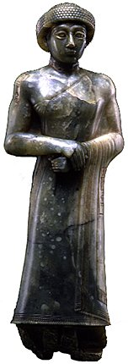
Gudea of Lagash, 2141-2122 B.C.

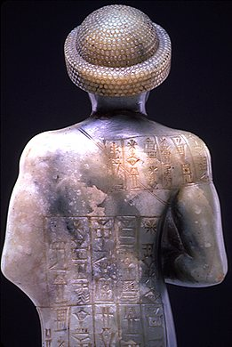
Gudea, Back view

Twenty-one kings and 124 years after Akkad was lost to the Gutians, the foreign barbarians were defeated and kingship was once again taken to Uruk by a king named Utu-Hegal (“Utu is Pleased“).
The Poem of Utu-Hegal tells how the king, with the help of the gods, went up against the Tirigan, the king of the Gutians. He occupied both sides of the Tigris, blocked the water’s path to the irrigation fields, and closed the roads, causing the grass on the highways of the land to grow over.

But the king, endowed with power by Enlil, chosen by Inanna with her heart -- Utu-Hegal, the mighty man, came out from Uruk to face him and set up camp(?) at the temple of Ishkur. He addressed a speech to the citizens of his city: "Enlil has given Gutium to me and my lady Inanna will be my help! Dumuzi, Mother-Dragon-of- Heaven has declared "It is a matter for me!" and assigned Gilgamesh, the son of Ninsun to me as a constable!" The citizens of Uruk and Kulaba rejoiced and followed him with one accord. He lined up his élite troops.

On the way to Karkara he captured two of Tirigan’s generals and there he prayed to Ishkur, asking for his help since Enlil had given the Gutians to him. There he laid a trap and when the Gutian army attacked, they were routed and Tirigan ran away on foot. Tirigan thought he would be safe in Dabrum but was captured by the citizens and kept until Utu-Hegal came and arrested him and his family. He blindfolded and tied their hands, made him lay down and then stepped down on his neck. Then he “made the Gutians, the fanged(?) snake of the mountains, drink again from the crevices.” The poem ends with kingship returned to Sumer.
When Utu-Hegal overthrew the last of the Gutian rulers, he was recognized in Nippur as “King of the Four Regions”.⁶ Utu-Hegal of Uruk also had a victory inscription for his defeat of the Gutians dedicated to himself. Some king lists say Utu-Hegal reigned 427 years, while others list a more realistic 7 or 26 year period, and then kingship was taken to Ur.
The first king of the Third Dynasty of Ur was a governor during Utu-Hegal’s rulership. To this new king is credited the Code of Ur-Nammu, the first of a genre of legal regulations consisting of a prologue and 7 laws. Ur-Nammu (“City of Nammu”) also standardized the mina and it’s weight relation to the silver shekel. He reduced the status of the ensi to that of an appointed governor. He promoted extensive temple and canal building. The first great pyramidal temples, the ziggurats, were built in Ur, Uruk, Nippur, Eridu and other cities during his reign. The ziggurat in Ur was rebuilt by later kings and rediscovered by Sir Leonard Woolley. Of the one built in Nippur it is said:

The shepherd Ur-Nammu made the lofty E-Kur grow high in Duranki. He made it to be wondered by the multitude of people. He made glittering the eyebrow-shaped arches of the Lofty Gate, the Great Gate, the Gate of Peace, the Artfully Built Mountain and the Gate of Perpetual Grain Supplies, by covering them with refined silver. The Anzu bird runs there and an eagle seizes enemies in its claws(?). Its doors are lofty; he filled them with joy. The temple is lofty, it is surrounded with fearsome radiance. It is spread wide, it awakes great awesomeness. Within it, he made the Artfully Built Mountain, the raised temple(?), the holy dwelling stand fast for the Great Mountain like a lofty tower(?).
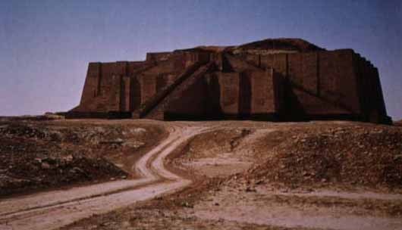
Nanna Ziggurat

Discovered by J.E. Taylor, British Consulate, as directed by the Foreign Office, 1854.
Excavated by Sir Leonard Woolley with joint American-British team, 1923. ¹⁶

In his law codes Ur-Nammu was said to have established "equity in the land and banished malediction, violence, and strife", although equal rights based on gender was not one of it’s strong points:

4. If the wife of a man followed after another man and he slept with her,
they shall slay that woman, but that male shall be set free.
5. If a man proceeded by force, and deflowered the virgin slave woman
of another man, that man must pay five shekels of silver.

Another of his promotional poems reads:

I am Ur-Nammu, king of Ur, the protecting genius of my city. I strike against those guilty of capital offences, and make them tremble. The fear I cause ....... My judgments make Sumer and Akkad follow a single path. I place my foot on the necks of thieves and criminals. I clamp down on evildoers, who will be caught like snakes. I ...... fugitives, and their intentions will be set right. I make justice apparent; I defeat wickedness. As if I were fire, even my frowning is enough to create peace.

He says that since he has become king no one has added extra taxes to abundant crops, he has released water into the canals for the trees to grow, lifted the yoke off the male prostitutes of the city, and brought the savage Gutians under control.
This is a time period marked as being an era of Sumerian revival, the golden age of the Sumerian era. Most texts of this era are poetic laments over fallen cities turned into long-winded praises of how awesome their god-kings were. German excavations led by Professor Koldeway done at the beginning of this century into the time of Nebuchadnezzar the Great found nothing but simple mud brick erections, one story high with about three or four rooms surrounding an open court yard. That was in the much admired Chaldean metropolis at the peak of the empire’s power, yet excavations done by Sir Leonard Woolley in Ur found large two-storied villas with 13 or 14 rooms, including an inner court, a reception room and a domestic chapel. The floor was solidly built of burnt brick; the upper floor with mud brick, and the walls were neatly coated with plaster and whitewashed. ¹⁶
Because the people living in Sumer by this time had inherited some Akkadian characteristics, these people are sometimes referred to as Neo-Sumerians. Ur-Nammu’s empire was smaller than Sharru-Kin’s; it only reached up to the cities of Ashur and Shusharra, but it had branched out slightly more to the east and west. The Third Dynasty of Ur was more united than the Akkadian one, and far more bureaucratic. Well over a hundred thousand documents from this dynasty have been excavated but most have gone unpublished. Everything was documented from how many fish were given to the temple dogs to how many sheep died of natural causes to documents recording that there was nothing to record.⁶
The popular acclaim that Ur-Nammu achieved was only matched by the huge disappointment his premature death caused. With the king slain on the battlefield, his administrative poets felt cheated by the gods. The Death of Ur-Nammu is a lament that is deeply fatalistic and almost sacrilegious on tone. For all the talk in prior texts of An and Enlil’s unalterable words, this text bewails how An and went back on his word and Enlil changed his appointed fate. It tells how everyone in the land went silent in heartfelt sorrow over the death of the king. The Anuna gods refused gifts and sacrifices went unaccepted. The text then follows Ur-Nammu on his desolate road to the netherworld. Because a king was crossing, the chariots were covered over and the people of the dead were forced to part away in disorder to make room for him. The king presented gifts to the chief porters of the netherworld. They announced the king to the netherworld travelers and they all cheered for him. The king then slaughtered some bulls and sheep and presented them at a banquet. But the food of the netherworld was bitter and the drink was salty. He then presented the gifts: To Nergal, “The Enlil of the netherworld.”, he gave a mace, a bow with a quiver of arrows, a dagger and a bag. He presented similar weapons and equipment to the “King of the Netherworld” Gilgamesh, and to Ereshkigal, Dumuzi, and to four other gods associated with the netherworld. Like Gilgamesh, he was given the position as a netherworld judge. But after ten days, his longing for Ur overwhelmed him and “his heart became full of tears.” In agony he lamented:

"I, who have been treated like this, served the gods well, set up chapels for them. I have created evident abundance for the Anunna gods. I have laid treasures on their beds strewn with fresh herbs. Yet no god stood by me and soothed my heart. Because of them, anything that could have been a favorable portent for me was as far away from me as the heavens, the ....... What is my reward for my eagerness to serve during the days? My days have been finished for serving them sleeplessly during the night! Now, just as the rain pouring down from heaven cannot turn back, alas, nor can I turn back to brick-built Ur.”

Although she did not stand up for him, Inanna was not happy at An and Enlil’s change of plans, and in a fierce storm destroyed cattle-pins and sheepfolds, wanting to hurl insults at An. She then said she would not enter her temple if her shepherd king wouldn’t be there for her. Among the tears and laments of the people, another fate was decreed: that Ur-Nammu’s name would live on, that people would admire the canals he dug, the reed-beds he drained, the barley fields he harvested and the fortresses and settlements he founded. His name would also be used in order to drive away evil spirits.
Ur-Nammu was succeeded by his son Shulgi (2095-2048 BC), and the hymns of praise written by him are no less self-exalting as those written by his father, growing to ludicrous proportions. Throwing weapons at lions was too sissified for Shugi, so he fought them face to face. He claimed to have run from Nippur to Ur and back in one day during a storm, breaking the four minute mile 200 times consecutively. He claimed to have been able to read omens, been a great musician, and able to speak many different languages, even correcting the foreign Ammorites’ grammar in their own language! He also said that he had never demolished a city or committed an act of violence to another king, whether he was Akkadian or a son of Sumer. He then ensures that all the praises given to him are completely verified:

Why should a singer put them in hymns? An eminent example deserves eternal fame. What is the use of writing lies without truth? For me, the king, the singer has recorded my exploits in songs about the strength of the protective deity of my power; my songs are unforgettable, and my words shall not fall into oblivion. I am the best king of the Land. From the very first origins until the full flourishing of mankind, there will never be any king who can measure himself against my achievements whom An will let wear his crown or wield his scepter from a royal throne.

After continuing with more self-praises for his power, insight and wisdom, he describes himself as a weapon for downfall of the rebel lands. He then makes this vow:

Now, I swear by Utu on this very day -- and my younger brothers shall be witnesses of it in foreign lands where the sons of Sumer are not known, where people do not have the use of paved(?) roads, where they have no access to the written word -- that the firstborn son is a fashioner of words, a composer of songs, a composer of words, and that they will recite my songs as heavenly writings, and that they will bow down before my words as a ......

Shulgi also wrote bedtime lullabies for his son, wishing him a good future wife. Another song dedicated to Shulgi lists all the major cities of Sumer and Akkad that he traveled to. Another text, The Blessing of Shulgi, tells how the “good shepherd” rang in the new year by taking a boat ride to Uruk, where he visited the temple E-anna. He wore a special robe and crown for the occasion and entered the temple leading a sheep and holding a kid goat to his breast. Delighted by Shulgi’s visit, Inanna “spontaneously struck up a song”:

"When I have bathed for the king, for the lord, when I have bathed for the shepherd Dumuzi, when I have adorned my flanks (?) with ointment (?), when I have anointed my mouth with balsamic oil, when I have painted my eyes with kohl, when he has ...... my hips with his fair hands, when the lord who lies down beside holy Inanna, the shepherd Dumuzi, has ...... on his lap, when he has relaxed (?) ...... in my pure (?) arms, when he has intercourse (?) with me ...... like choice beer, when he ruffles my pubic hair for me, when he plays with the hair of my head, when he lays his hands on my holy genitals, when he lies down in the ...... of my sweet womb….

Two more lines of Inanna’s song are unclear, but she ends it saying that if he treats her tenderly in bed, she will do the same. As a ritual of the Sacred Marriage Rite, Shulgi took on the incarnation of Dumuzi and facilitated the god’s husbandly duties in order to ensure the fertility of the empire for the coming year. After practicing the fertility rite the goddess Inanna “decreed a fate“, imitating Inanna’s pledge to Dumuzi in the Courtship of Dumuzi and Inanna, promising to be his leader, armor-bearer, advocate and encourager. Utu then greets him and invites him to his own temple E-Babbar (“House of White”) in Larsa, where we was decreed another good fate and then sent to Ninazu’s temple in the town of Enegir. There Ninazu kept the heaps of rhetoric piling in, asking Shulgi questions like who could stand up to him when he shrieked like an Anzu bird? He was then sent to Suen’s temple of E-Temen-Ni-Guru, where the moon god decreed another good fate to him for accomplishing his mission of reducing the houses of the rebel lands to ruins. The story comes to a finish with Shulgi taking his seat on the holy dais in his lofty palace Ninegala, decreeing judgments so that the strong do not abuse the weak, so that the mother would speak tenderly to the child and the child answer truthfully to his father.
The Third Dynasty of Ur came to operate large factories, workshops, and trading posts, and oversaw thousands of laborers in agriculture, industry, public works, civil service, and police. In one hymn Shulgi boasts to have worked out the mileages of the trade routes, built official posts at set distances, and hired experienced men to guard the highways from bandits. Workers were either freemen who paid taxes in corvées and military service, lesser paid serfs under the king's protection, or slaves. Officials received free meat, beer, and clothes and could own houses, fields, asses, and slaves. Governors and generals who were paid by taxes could be quite wealthy. In a middle class between these two extremes were some merchants and small land owners who farmed by borrowing at one-fifth to one-third interest rates. ⁶
A letter sent by Shulgi to his foreign administrator Ishbi-Irra was dedicated towards congratulating him for an important purchase of grain from Mari. For this Shulgi bestowed Ishbi-Irra with a great honor:

You are to receive the gold and silver from him, and purchase grain everywhere according to (?) whatever exchange rate they will take from you. May your .... nothing at all. From today (?), you are my son who makes me happy. The cities of (?) the province (?), the land of the Martu, Elam -- all of them I have placed before you: you are just as important as I am. So sit before them on a throne on a golden dais ....! Let their messengers prostrate themselves in front of you!

He then gives Ishbi-Irra the authority to appoint and remove governors, commanders, and captains and to blind any murderers that are caught. Ishbi-Irra would continue to be a major official in the Ur III government after Shulgi‘s rule as well.
Another letter addressed to Shulgi, tells the plight of the governor Sharrum-bani in his reply to an order of Shulgi’s to build a fortification between the mountains of Ebih to keep out the barbaric Martu (Amorites):

If my lord agrees, may he provide me with additional workmen and set the wages (?) for me. ...... did not succeed ...... tribute of the provinces (?).
I sent a messenger to the province of Murub: the attitude (?) of the province has altered. I will not neglect to build the fortification -- in fact I am building and engaging in military action at the same time. After all, as 'Sage of the Assembly' I descend (?) from a great lineage! I have been advised that the attitude (?) of the province has not altered.
At the time I sent my messenger to you, I sent another messenger, after him, to Lu-Nanna [Lu-Enki?], the ruler of the province of Zimudar. He has sent you 7,200 workers.
Basket men are available; however, men fit to engage in military action are limited. If my lord should arrange the dismissal of the workers ready to work, let me pursue military action together with them, when I have removed (?) them.
The dignitaries of your provinces are sending a man to them. They have presented themselves before me, announcing: "As far as we are concerned, we are unable to guard all the cities. But how exactly will any troops be given to you?" My messenger has been sent to them (?).
Once my lord has given me instructions, I will repeatedly return to (?) work at nightfall and at midnight, as well as engaging in military action. I stand at the disposal of the fame and word of my lord, and so I (?) will bring weapons to bear. No strength has yet been displayed (?), nor any firmness shown (?) by means of weapons. Let the storm cover (?) all the lands! May my lord know!

Shulgi reigned for 47 years and then died, leaving his throne to his son Amar-Suena. A single text from this time records that the people turned against this king and the lands were invaded by foreign lands, causing Enki’s temple, E-Engur (also called E-A or E-Abzu) to be laid waste. The text laments that it took nine whole years to finally rebuild the temple, due to a long list of excuses the king kept coming up with. Amar-Suena’s idleness was duly punished by the destruction of his own palace, although the text is too fragmented to determine the circumstances.
According to the king lists, those nine years made up the full length of his reign, and then his son Shu-Suen became king. One of his praise poems refers to Shu-Suen as the son of Shulgi, making him Amar-Suena’s brother, but this may just refer to ancestry. Shu-Suen came into conflict with the Amarru tribe (Martu; Amorites), who were contemptuously described as not knowing anything about cooking, agriculture or even burial. 2034 BC he built ’the Amorite wall’ in order to keep the city safe from barbarian attacks. During his reign, quite a few love songs were written for him during his reign:

Man, you have become attracted to me. Speak to my mother and I will give myself to you; speak to my father and he will make a gift of me. I know where to give physical pleasure to your body -- sleep, man, in our house till morning. I know how to bring heart's delight to your heart -- sleep, lad, in our house till morning.

Another praise text sings of the power of the warrior Ninurta, comparing his ability to torch the rebel lands to that of a fire-breathing dragon and asking Shu-Suen to trust in Ninurta’s strength.
Shu-Suen ruled another 9 years before his young son Ibbi-Suen became king. The poems written for Ibbi-Suen suck up to him as much as the rest of the propaganda reminiscent of the Ur III. Records indicate Ibbi-Suen had a very hard time keeping the empire together. One city after another soon began to withdraw their recognition of the emperor. In the 6th year of his reign, defensive walls were repaired at the cities of Ur and Nippur. That same year offerings to Nanna stopped in Ur. Invading Amorites took control of the roads and food became scarce. The honored Ishbi-Irra of Mari wrote to Ibbi-Suen informing him that he successfully purchased the grain just before the price doubled, but to no avail since to Amorite forces had taken over the country‘s fortresses one by one, making it impossible for him to get it back to him. Ibbi-Suen wrote back to him saying:

As long as Enlil was my lord (?), what course were you following? And is this how you alter your word? Today Enlil detests me, he detests his son Suen, and is handing Ur over to the enemy. Its central part (?) is gone, the enemy has risen up, and all the lands are thrown into disarray. But on the day when Enlil turns again towards his son Suen, you and your word will be marked out!
You have received 20 talents of silver to purchase grain. You purchase it at the price of one shekel of silver per 2 gur of grain, but in dealing with me, you fix the price at one shekel of silver per 1 gur of grain!
How could you allow Puzur-Numushda, the commander of the fortress Igi-hursaga, to let the hostile Martu penetrate into my Land? Until now (?) he has not (?) sent to you word (?) about engaging in battle. There are puny men in the Land! Why has he not (?) faced the Martu?

Desperation set in and massive inflation took over. In the 7th year of his reign, barley and fish sold for 50 to 60 times their normal price.⁶ Rebellion and uprisings became rampant. The city of Nippur withdrew it’s recognition and Ur III soon came to an end. The empire lasted about 100 years.
In the 12th year of Ibbi-Suen’s rule, Ishbi-Irra successfully repelled an army of Elamites from Isin and Nippur. Soon after this success, he withdrew his own allegiance to Ur and declared himself King of Isin. He then began to carve out a kingdom for himself at Ibbi-Suen’s expense. The governor of Kazallu sent this letter to the Emperor of Ur:

A messenger of Ishbi-Irra came to me. He presented himself before me announcing: "Ishbi-Irra, my lord, sends you a message:
'Enlil, my lord, has ...... the shepherdship of the land. Enlil has told me to bring before Ninisina the cities, deities and troops of the region of the Tigris, Euphrates, Ab-gal and Me-Enlila watercourses, from the province of Hamazi to the sea of Magan, so as to make Isin the storehouse of Enlil, to make it famous, and to make those regions its spoils of war and to make Isin's citizens occupy their cities as spoils of war.
Why do you oppose (?) me? I swear by the name of my lord Enlil and by Dagan, my personal god, that I will indeed get hold of Kazallu!
The cities and the province which Enlil has promised me I want to build up within Isin in their ....... I want to perform at their eshesh festivals. I want to install my statues, my emblems, my en priests and nindigir priestesses in their jipar shrines. Before Enlil, within the E-Kur, before Nanna, within the E-Kishnugal, the ...... shall speak their prayers.
And as for you, I want to remove from within his country the man in whom you placed your trust! I want to rebuild the fortification of Isin and name it Idil-pacunu!’

The letter then reports that Ishbi-Irra took control of the area and did everything he said he would. The letter ends saying:

Now Ishbi-Irra is looking in my direction. I have no ally, nobody with whom I can align myself. Since he has not yet been able to get me in his grasp, let me come to you when he falls upon me. My lord should know this!

To this pitiful cry for help, Ibbi-Suen gave this reply:

When I had chosen for you ...... from among the troops, they were at your disposal, as governor of Kazallu. But as in my own case, are not your troops proof (?) of your importance?
Why have you sent me somebody saying: "Ishbi-Irra has got his eyes upon me -- so let me come to you when he falls upon me"?
How come you did not know how long it would take to make Ishbi-Irra return to the mountain lands? Why have you and Girbubu, the governor of Jirikal, not confronted him with the troops which you had at hand? How could you allow (?) him to restore (?) ......?
Today (?) Enlil loathes Sumer and has elevated to the shepherdship of the Land an ape which has descended from those mountain lands. Now Enlil has given kingship to an idiot, a seller of spice -- to Ishbi-Irra, who is not of Sumerian origin.
See, the assembly where the gods are and Sumer itself have been dispersed! Father Enlil, whose words prevail (?), said: "Until the enemy has been expelled (?) from Ur, Ishbi-Irra, the man from Mari, will tear out Ur's foundations. He will indeed measure out Sumer like grain." He has spoken just so.
Even though you were installed as governors of the various ...... the others will defect to Ishbi-Irra, in accordance with Enlil's word. Should you hand over your city to the enemy like your companions, Ishbi-Irra will not recognize you as his faithful and agreeable servant.
May it now be brought about (?) that good words should be restored and treason extinguished. Let Ishbi-Irra (?) participate in the harvest among the people there; but you yourself, do not, and do not come to me! His grasp should not get hold of the city! This man from Mari, with the understanding of a dog, should not exercise lordship!
Now Enlil, my helper, has made the Martu rise from their mountain lands They will repel Elam and seize Ishbi-Irra. To regain the Land will indeed make our might known in all the foreign lands. It is urgent! Do not be neglectful!

Within the next two of three years, Ishbi-Irra was able to extend his authority to Nippur and Uruk to become the next official king of Sumer and Akkad.
About a decade later, the Elamites began to conduct raids against Sumer and in the 24th year of Ishbi-Irra’s reign (2006 B.C.), they finally to put forth a major offensive that put an end to Ibbi-Suen‘s rule. The walls of Ur were breached, the city was sacked, and the Elamites captured both the emperor and the statue of Suen. Ibbi-Suen was deported to Anshan, a rebel Elamite city he had once himself devastated. He would spend the rest of his life there.
It was about this time that the Biblical patriarch Avram (Abraham) is said to have left Ur to travel around the Syrian Desert to Canaan but instead settled in Haran, a city far up and to the east of the Euphrates (Gen. 11:31).

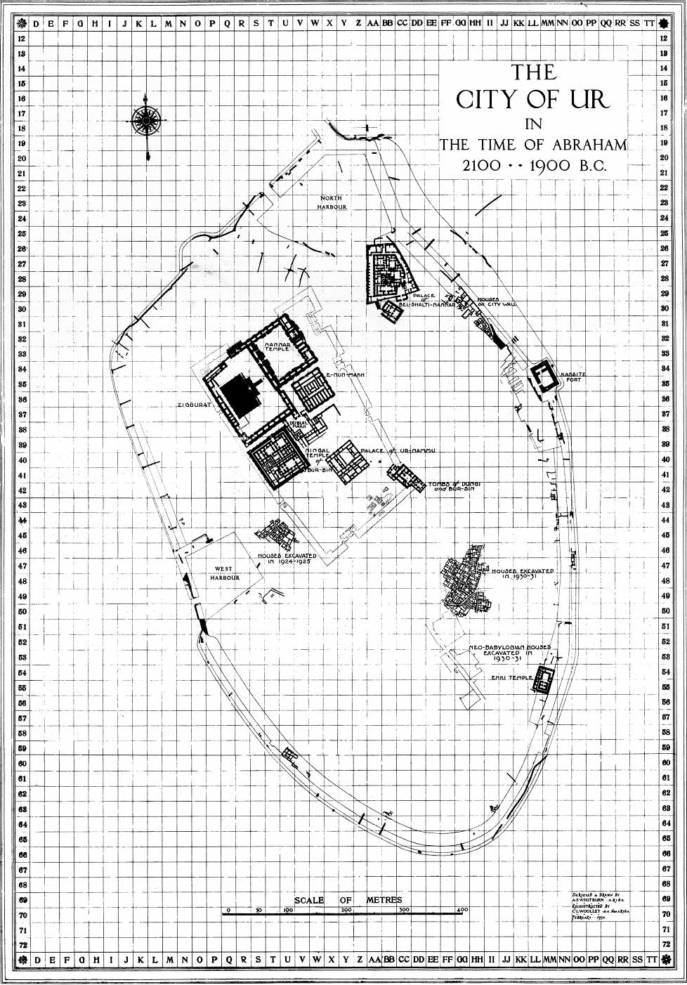
Drawn by Sir Leonard Woolley

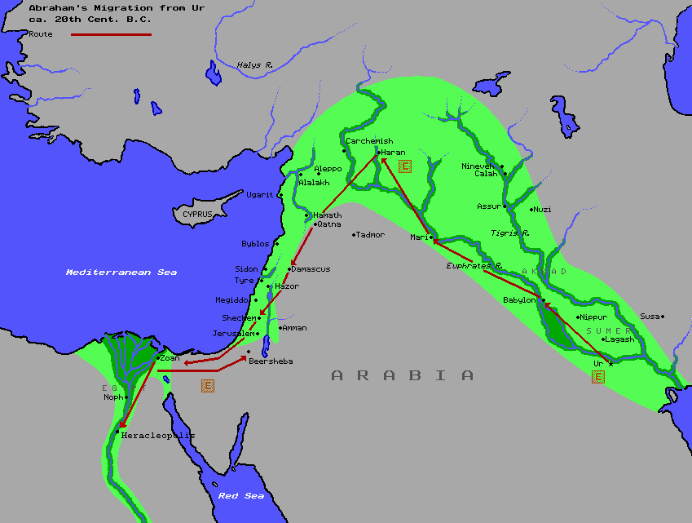
Abraham’s Migration from Ur

The Sumerian language, which had already been on the decline, was soon replaced once again by Akkadian. Amorites from the west began to immigrate into the lands in the masses. Ishbi-Irra, ruling from Isin, took on the title “King of Ur” to quickly gain the distinctions lost by his former king. It was he who inherited kingship from Ur III in the king lists. It is said that he restored civil order to the lands and restored foreign trade. He was succeeded by four descendants, carving out a dynasty that survived longer than Ur-Nammu‘s. His son Shu-Ilishu rebuilt much of Ur and invaded Elam to return with the statue of Suen.
The reign of Shu-Ilishu’s son, Iddin-Dagan was a peaceful one and his son Ishme-Dagan set about some social reforms to “set justice in the land”. The next son in line was Lipit-Ishtar, who propagated a new law code. Once again, the Amorites became a problem during his reign, and he was forced to allow the rival king of Larsa to peacefully annex the city of Ur in order to defend it from the Amorite invaders. The king of Isin’s daughters were even allowed to keep their priesthood. But the move cost Isin a lot of it’s prestige and as a consequence, Isin lost even more power. Lipit-Ishtar died that same year and his crown was usurped.
Gungunum of Larsa (1932-1906 B.C.) was the brother of the former king of Larsa, Zabaja, and was a sheik of the Amorites. After annexing Ur, he went on to conquer Lagash, Uruk and the Elamite capital of Susa, and then revived trade overseas with the kingdom of Dilmun. His son Abi-Sare invaded Isin, and killed Lipit-Ishtar’s usurper Ur-Ninurta. This did not stop Ur-Ninurta’s son Bur-Suen from taking the crown though.
Abi-Sare’s son Sumuel took the throne in 1895 B.C. and wrestled control of Nippur away from Isin. Sumuel ruled almost three decades before a he was overthrown by a commoner named Nur-Adad. Nur-Adad ruled for 16 years and then his son Suen-Iddinam took over. After him were three more kings who ruled no more than 5 years a piece: the last of which was Silli-Adad, who was killed in a battle with Babylon. His throne was usurped by a man named Kudurmabuk, who took control over the lands and installed his son Warad-Suen on the throne. Although Kudurmabuk is an Elamite name, he was probably an Amorite chieftain. After a short reign, Warad-Suen was succeeded by his brother Rim-Suen (1822-1763).
The last Sumerian king was the most adaptable monarch of them all. At 59 years, Rim-Suen had the longest authenticated reign in Mesopotamian history and was also the last monarch to claim divinity. He defeated Babylon in battle in 1794 B.C. and then conquered Isin, making himself the sole ruler of the greater half of southern Babylonia. In 1787 B.C. Khammurapi of Babylon invaded and conquered Isin, but failed to take Uruk. That was the last war between them until the end. In 1779 they signed a treaty in which he may have regained Isin. But the peace treaty was broken and his land conquered by Khammurapi (better known as Hammurabi). By this Khammurapi installed the beginnings of the Babylonian Empire and extinguished the last flowering bud of Sumerian culture.
What was to continue was a religious derivation built on top of the Sumerian and Akkadian traditions. The theology since the Early Dynastic Period built the right to kingship on the acceptance of a council in Nippur, acceptance that was given when the king brought about a military defeat on the present capital. Powerful families from each city would conserve money and resources for many generations before a king from a long and prestigious line would attempt a coup and have all the cities bring tribute to their hometown. But by holding on to these traditions, there was always the shadow of inevitable defeat. Some of these dynasty changes would set off chain reactions of battles, which would only better open the land up to foreign invasion. But ever since the Akkadian Empire, cities had been becoming more and more centralized, and the Babylonian Empire was the most centralized yet. The centralization was more than just political, it was also theological. A new god was brought into the pantheon, Marduk, the son of Ea (Enki). His common name Ba’al (“Lord” or “Husband”) is linked to the name of the devil in the New Testament. In many respects, he mirrored the legends of Ninurta. By slaying the dragon Tiamat (Nammu), the storm god was able to take the Tablets of Destiny for himself. Fulfilling their end of the bargain, the gods all gave their epithets over to him, making him the new king of the gods. Having given all their titles over to Marduk, the gods became incarnations of Marduk. Now, it was Marduk who had created the world by splitting Tiamat’s body, it was Marduk who created the Tigris and Euphrates out of Tiamat’s eyes, and it was Marduk who created man from out of the blood of god. The Assyrians took on many of the same traditions as Babylon but appeneded their own national deity, Ashur (Anshar) in place of Marduk’s. New ranks among the pantheon were formed as the patron city god system made way for the patron country god system.
With the new system, Babylon was able to usurp all of Nippur’s authority. In Babylonian writings, Enlil was designated to the same station as Anu: making decrees but never actually acting out a role in the story. His name almost always follows that of Anu, as if they have been merged into one god. Although Babylonian legends would of course never portray the antagonism the people of Nippur must have felt over this, it may not have been lost on those who traveled there. This may have been the source of conflict that the storm god had with his father in the Hurrian and Greek legends. Just as a younger god was able to become king over the pantheon by slaying the original mother of the universe, so to did the Amorites who inherited Sumero-Akkadian culture conquer those who taught it to them.
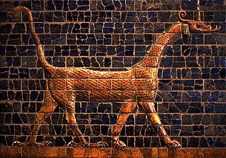
Dragon of Marduk

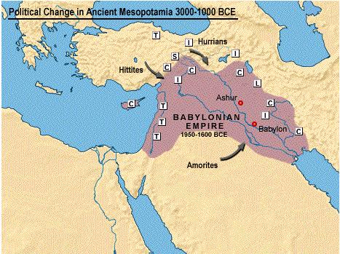

Glossary
Associations Key:
Pink: Akkadian/Babylonian
Red: Babylonian
Rose: Assyrian
Dark Blue: Hindu
Blue: Persian
Teal: Asia Minor
Violet: Canaanite
Yellow: Jewish/Israelite
Orange: Egyptian
Brown: Hurrian
Green: Greek
Gray: Roman
Turquoise: Norse
Periwinkle: Saxon

abzu: (“abyss”; Apsu) Underground sea of freshwater and home to Enki; in later Babylonian stories, it is personified as Apsu, the first husband of Tiamat
Adab: An important Sumerian city between Lagash and Nippur
Adad: See Ishkur, Hadad
Agade: Lost capital of the Akkadian Empire; founded by Sharru-Kin (Sargon the Great); probably in or near Babylon; laid to waste by the Gutians during the reign of Naram-Suen and was said to be cursed forever afterwards
Akkadians: Semitic speaking inhabitants of Northern Babylonia; derived from the name given in Genesis
Amarru: See Amorites
Amorites: (Amarru; Martu) A nomadic tribe that spoke a Semitic language; they eventually infiltrated all of Mesopotamia and founded the Babylonian and Assyrian Empires; the name is derived from 86 references in the Old Testament, sometimes equating them with Canaanites or the ancestors of the Canaanites
An: (“Heaven”; Anu; Uranus; Brahma) God of the Sky/Heaven; an enigmatic figure who makes decrees from his place in heaven but never ventures out
Anshan: An Elamite city-state in southwestern Iran
Anshar: (“Firmament”; “Sky arch”; Ashur) Babylonian god; husband to Kishar and father to Lahmu and Lahamu
Annunaki: (“Those who came from Heaven to Earth”; Anunna) General name for the Sumerian and Akkadian pantheon
Anu: See An
Anzu: (“Raven”; “Sky-Wisdom”; Imdugud; Pazuzu; Zeus) Giant storm bird; Lugalbanda meets one after being left in the Zagros mountains; Another one steals the Tablets of Destiny from Enlil; Enlil’s son Ninurta finds him and slays him, returning the tablets to his father
Apsu: (abzu; Nun; Oceanus) Babylonian god killed by Ea (Enki); personifies the primeval waters that encircle the world
Aratta: Another name for Susa (Susin).
Aruru: See Ninmah
Asag: A demon that Ninurta slew while in the netherworld; possibly another version of Anzu
Ba’al: (“Lord”; “Husband”; Marduk; Hadad) Common name used throughout Mesopotamia for the storm god
Ashur: (Anshar; Marduk) “Father of the gods“; national deity of the Assyrian Empire
Babylon: A city in northern Sumer which an Amorite dynasty turned into the capital of an empire; the official language spoken was Akkadian
Bad-Tibira: A city in southern Sumer; it’s temple to Dumuzi was called E-Mushkalamma or E-Mush
Black-headed ones: See Sumerians
Chaldean: Neo-Babylonian; a nomadic people who invaded Mesopotamia in the 1000s B.C. and inhabited the Babylonian territory
Cronus: (Enlil; Kumarbi) Greek god of time and the upper sky
Dagan: (Dagon) Semitic fish god of the west; represented on statues as having the tail of a fish
Dead Sea Scrolls: Old Testament scrolls written by Jewish Essenes in a male-only sect near Qumran sometime around 200-68 B.C.; they were stored in clay jars and hidden in caves in the Judean desert near the Dead Sea where a young Bedouin found them in 1947 while looking for a lost goat; the scrolls found were 1000 years older than the earliest existing copies
Dilmun: (Bahrain; Eden) The Sumerian and Babylonian island of paradise where no one can age or get hurt
diorite: Very hard green or gray volcanic rock
Dumuzi: (Tammuz; Tammuz; Mithras; Osiris; Serapis; Attis; Odin; Adonis; Dionysus; Apollo; Bacchus) Shepherd god who is hung on a stake in the netherworld as a substitute for Inanna but rises in the spring to be replaced by his sister Geshtinanna; often given the title “Mother-Dragon-of-Heaven”
Dumuzi the Fisherman: King of Uruk I; first ruler to wed the goddess Inanna in the Sacred Marriage Rite⁵
Dumuzi the Shepherd: King of Bad-Tibira before the Flood; first to be called Dumuzi
Ea: (“House of Water”) Babylonian name for Enki; taken from the name of his temple
E-Abzu: (E-A; E-Engur) Enki’s temple in Eridu
E-Anna: (“House of Heaven”) Inanna’s temple in Uruk.
E-Babbar: (“House of White”) Temple to Utu
E-Temen-Ni-Guru: Temple to Nanna (Suen)
Edubba: (“Tablet House”) Sumerian school
E-Kish-Nugal: Temple in Ur to the moon god Nanna (Suen)
E-Kur: (“House of the Mountains“) Enlil’s temple in Nippur
Elamites: (Iran) People living in the land east of Sumer and Akkad
Ellil: See Enlil
Elohim: (“Lords”) Common name for God used in the Old Testament; translated “God” in the Bible
Emesh: (“Summer”) Son of Enlil who argues with his brother Enten
E-Mush: (E-Mush-Kalamma) Temple to Dumuzi in Bad-Tibira
en: (“Lord”): High priest or priestess who resided in the gipar shrine where the Sacred Marriage Rite took place
En-Heduanna: Sharru-Kin’s daughter and high priestess of Ur; First known author
Enki: (“Lord-Earth”; Nudimmud; Ea; Azaz-El; Prometheus; Vishnu) God of wisdom and water, who along with Ninmah, fashions man from clay
Enkidu: (“Creation of Enki”) Gilgamesh’s slave and best friend who accompanies him on all of his adventures
Enlil: (“Lord-Air“; Ellil; El the Bull; Kumarbi; Min; Chronos; Saturn; Shiva) God of the space between the earth and the sky (heaven); he plays a very active role on earth, and is usually the one to execute decrees made by An
ensi: (ishakku) Sumerian word for ruler of a city
Enten: (“Winter”) Son of Enlil who argues with his brother Emesh
Erech: See Uruk
Ereshkigal: (Persephone; Proserpina; Hel) Queen of the netherworld
Eridu: First town and temple said to be built in Sumer; it’s temple to Enki was called E-Abzu (“House of the Abyss”) or E-A (“House of Water”)
galla: Little demon from the netherworld
Geshtinanna: (Artemis) Dumuzi’s self-sacrificing sister who undergoes torture so as not to reveal Dumuzi’s location to the demons that are chasing him
Gilgamesh: (“Gilga the Hero”) A Hercules-like hero goes on many adventures; he ruled Uruk I around 2650 B.C. and was said to have become one of the judges in the netherworld after he died
gipar: Shrine where the Sacred Marriage Rite took place
Gugalanna: See Nergal
Gutians: Barbarous mountain people to the east who overwhelmed Sumer towards the end of the of the second millenium B.C.
Hadad: (Adad; Hadad-Rimmon) Canaanite storm god referred to as Ba’al; son of Dagan.
Hammurabi: Babylonian king who united all of Babylonia into an empire; famous for his law code that includes the “Eye for an eye” law.
Hittites: People who lived in northern Turkey near the Black Sea; they had two official languages: Arzawan (an language related to Indo-European) and Akkadian
huluppu tree: (Tree of Wisdom; Yggdrasil) A tree (possibly a willow) cut down by Gilgamesh in order to make a bed and chair 0for Inanna; Inanna then uses the wood to make a pikku and mukku
Hurrians: A people who lived in Northern Syria and were eventually conquered by the Hittites
Hursag: (“Highland”) Mountainous region east of Sumer, named by the god Ninurta; also associated with Nin-Hursag (Ninmah).
Huwawa: (Humbaba) A monster who lives in the “Land of the Living” or “Land of Life” (Lebanon); Killed by Gilgamesh and Enkidu.
Imdugud: See Anzu
Inanna: (“Queen of Heaven”; Ishtar; Mylitta; Asherah; Astarte; Ashtoreth; Hathor; Eostre; Ostara; Aphrodite; Venus; Diana) Goddess of the morning star and Utu’s twin sister; goddess of love and fertility as well as the goddess of war; she and Dumuzi are the principle deities involved in the Sacred Marriage Rite.
ishakku: (ensi) Akkadian word for ruler of a city
Ishkur: (Adad; Hadad; Rimmon; Hadad-Rimmon) Sumerian storm god
Ishtar: See Inanna
Isimud: Enki’s vizier
Kalatur: (Kalaturru) Sexless creature created by Enki to save Inanna from the netherworld
Ki: (Gaea; Terra) Mother Earth; unless Ninmah is an incarnation of her, she takes no personal role other than giving birth to the gods.
Kur: (“Mountain”; “Land”; Kurnugia; Ganzir; Amenti; She‘ol; Hades; Tartarus) The nether world where dead souls descend to.
Kullab: Twin city of Uruk
Kumarbi
lahama: Sea monster
lapus luzuli: A dense semi-precious blue gemstone
Lilith: (Lilitu) A female wind demon or succubus who causes children to die suddenly; Adam’s first wife in Jewish legend
lukur: An Inanna priestess who probably represented the goddess in the Sacred Marriage Rite
lumah: A type of priest
mah: A type of priest
Marduk: (Ninurta; Ashur) Storm god; often called Ba‘al (“Husband“); national deity of Babylon
Martu: See Amorites
Masoretic: The Hebrew Old Testament that Jews use today; the King James Old Testament is based on the Greek Septuagint; there is also a third Samaritan text.
mashmash: An exorcist
me: Divine arts, rules, and regulations that keeps the universe operating
mina: A measure of weight; about a pound
mukku: An unidentified object that Enkidu went into the netherworld to get; perhaps a musical instrument
mushhush: Serpent or dragon
Nammu: (Tiamat; Neith) Goddess of the primeval sea which surrounds heaven with saltwater; she gives birth to the first humans
Namtar: (“Fate” or “Death”) A netherworld demon
Nanna: (Suen) Moon god of Ur
Nebuchadnezzar: Chaldean (Neo-Babylonian) king who ruled over Babylon (Sumer and Akkad) in the 700s B.C.; he laid siege to Jerusalem and destroyed the First Temple, built by Schlomo (Solomon); he then enslaved the people of Judah and took them back with him to Babylon (2 Kings 25)
Nephilim: Translated “giants” in most Bibles; the Book of 1 Enoch describes them as being the offspring of the “Watchers”, or angels; it is said that 200 of the Watchers made a pact and came down to the earth, impregnated human women, and taught their children the corruptions of the world such as warfare, makeup, and magic
Nergal: (Meslamtaea; Gugalanna; Hades) Ereshkigal’s husband; called the “Great Bull of Heaven”
Nimrod: (Sharru-Kin) Biblical emperor in Genesis 10:8-12; “A mighty hunter before Yahweh”
Ninazu: A god of the netherworld
Ningal: Wife of the moon god Nanna
Ningishzida: (Typhoeus; Hermes) God of the dawn whose symbol was the caduceus; associated with Dumuzi and the Sacred Marriage Rite.
Ninhursag: See Ninmah
Ninmah: (“Noble Queen”; Aruru; Ninhursag; Nintu; Nisaba) Mother goddess who helps Enki shape man from clay; Mother to Ninurta
Ninlil: (“Lady of Air”; Mullitu; Mylitta) Wife of Enlil; after being raped in Uruk by Enlil, she follows him into the underworld and gives birth to three gods to replace Suen so that he can return
Nisaba: See Ninmah
Ninshubur: Inanna’s vizier
Ninsun: (Sirtur) Wife of Lugal-Banda and divine mother of the Ur III rulers
Ninti: (“Lady of Life; Lady of the Rib”) Goddess that Ninmah gives birth to in order to heal Enki
Nintu: See Ninmah
Ninurta: (Ningirsu; Marduk; Teshub; Zeus) Warlike storm god in charge of the South Wind; son of Enlil and principle deity of Lagash; also called “Farmer of Enlil”
Nippur: City of Enlil; holiest city in Sumer and Akkad, holding the largest library of texts in the country
Nusku: Enlil’s vizier
pazuzu: (Anzu; Imdugud; Zeus) Assyrian sphinx-like demon with a lion’s head, large wings, and small goat horns ;they rise from beneath the stagnant waters of Kur and can possess bodies and must be exorcised
pikku: An unidentified object that Enkidu went into the netherworld to get; perhaps a musical instrument
Sagburru: Old crone that outwitted the Mashmash exorcist
Saggiga: (“Black-headed ones”) See Sumerians
Sargon the Great: See Sharru-Kin
Sargon II: See Sharru-Kin II
Semitic: Designating a major subfamily of the Afro-Asiatic family of languages which include: Northeastern (Akkadian), Northwestern (Hebrew, Phoenician, Aramaic, etc.), and Southwestern (Arabic, Ethiopic, etc.); derived from Noah’s son Shem (“Name”), who was said to be father of the Hebrews, Elamites, Assyrians and Arabians; commonly refers to the Jewish race
Shamayim: (An) Hebrew word for the sky and the heavens
Sharru-Kin: (“Legitimate-King”; Sargon; Nimrod) A former cup bearer to Ur-Zababa of Kish; he defeated Lugal-Zagesi to take over a unified Sumer and Akkad; founded the Akkadian Empire, centered in the lost city of Agade
Sharru-Kin II: (721-705 B.C.) An Assyrian king who made Ninevah his capital; derived from a translation in the book of Isaiah
Sharur: Ninurta’s personified weapon
shekel: 1/60 of a mina
She’ol: (Kur; Amenti; Hades; Tartarus) Hebrew term for the netherworld, although some scholars dispute this perception; listed as one of the names for Hell in the New Advent Catholic Encyclopedia; translated as “grave” in most Bibles
Shubur-Hamazi: Lands to the north and northeast of Sumer
shugurra: A turban-like crown worn by Inanna
Shuruppuk: A city in south-central Sumer; home of the Ziusudra, the Sumerian Noah
Sirtur: (Ninsun) Dumuzi’s mother; possibly a sheep goddess
Su: A people who helped the Elamites put an end to Ur
Suen: See Nanna
Sumerians: The first known civilization; established in Southern Babylonia in Iraq by 3500 B.C.
Susa: (Susin; Aratta) Elamite capital in western Iran
Susin: See Susa
Tammuz: See Dumuzi
tehom: Hebrew word for the primeval ocean; translated “deep” in the Bible
Teshub: (Ninurta; Marduk; Zeus) The Hurrian storm god; fights against his father Kumarbi and his brother Ullikummi
Tiamat: (Nammu; Yahm-Nahar; tehom; Leviathan; Rehab; Typhoeus; Illugankas) A multi-headed dragon that is killed by Marduk (or Ashur) to save the gods and man kind
Tidnum: Semitic land west of Sumer
tohu: (tehom) Hebrew word for formless
Torah: The first five books of the Bible: Beresheet (“In the Beginning”; Genesis), Shemot (Exodus), Va-Yikra (“And He Called”; Leviticus), Bamidbar (“In the Desert”; Numbers), and Devarim (“Words”; Deuteronomy); traditionally believed to have been dictated directly to Moshe (Moses) by God
Typhoeus: (Ningishzida; Typhon; Tiamat) Son of Tartarus and Gaea who fights with Zeus at Mt. Casius; has two snakes growing out of his shoulders
Ugarit: City state near the Mediterranean coast where tablets of alphabetic cuneiform have been excavated by a French expedition
Ullikummi: A diorite man conceived in order to kill the Hurrian storm god Teshub; he fights Teshub and the others gods at Mt. Casius
Umma: A city-state neighboring Lagash that was constantly at war with it
ummia: Sage or principal of the Sumerian edubba school
Ur: City of the moon god Nanna; capital of the Ur III empire
Uruk: (Unug; Erech) City of the Sky god Anu; The white temple in Kulaba is dedicated to Anu while the E-Anna (“House of Heaven”) sanctuary was dedicated to Inanna
ururu: a type of chant
Usaw: God of dusk
Utu: (Shamash; Apollo; Sol) The sun god and Inanna’s twin brother; he who had temples in Larsa and Sippar
Yahweh: (“I am that I am”) Proper name of the God of Israel and Judah; mistranslated by Christians as “Jehovah”; translated “the LORD” in the Bible; Jews use the word “Adonai” (“Lord”) instead when reading scripture aloud so as not to take the name in vain; Many Jews will not even write the words “Yahweh” or “God” on paper in case it is thrown away or otherwise destroyed
Yggdrasil (haluppu tree; Tree of Wisdom): Norse World Tree; a great ash tree that makes up the axis of the universe and whose roots spread out to nine worlds and are gnawed on by the serpent Nidhog; Odin hung on it for nine days and went through a spiritual death and rebirth
ziggurat: A pyramidal stage-tower temple; the one in Babylon is the Tower of Babel

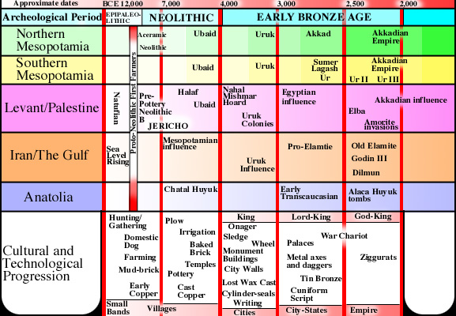

Timeline

There is about a 70 year discrepancy of opinion for some of the early dates.

Pliocene Epoch (5,000,000 - 1,800,000 years ago)
3,600,000 Bipedal hominid living in Tanzania, Africa
3,500,000 Australopithecus afarensis “Lucy” living in Hadar, Ethiopia
2,400,000 Stone tools used in Hadar
1,800,000 Homo erectus in Southeast Asia

Pleistocene Epoch (1,800,000 - 11,000 years ago)
1,600,000 Fire used in Chesowanja, Kenya and Swartkrans (S. Africa)
1,000,000 Beginning of the modern Pleistocene Ice Age
Homo erectus in Europe and Asia
400,000 Wooden spear used in Schoningen, Germany
300,000 A hut is used in Amata, France
150,000 Homo sapien neanderthalensis in Europe and Asia
135,000 Homo sapien sapien in Omo, Ethiopia
90,000 Homo sapien sapien in Qafzeh, Israel
45,000 A flute is played in north Africa
40,000 Modern humans and Neanderthals in Europe
35,000 Australian aboriginal hunter-gatherer traditions emerge
32,000 Cave art in Europe
28,000 The last Neanderthals in southern Spain become extinct
25,000 “Willendorf Venus” carved in Germany
23,000 Mammoth tusk Boomerang in Poland
18,000 Height of the Pleistocene Ice Age
11,500 Clovis culture begins in North America

Holocene Epoch (11,000 years ago to Today)
11,000 Domesticated dogs in the Middle East
Humans in South America
10,500 Pottery in Japan
10,000 Agriculture in the Middle East
9,000 Mammoths become extinct
Farming in the Middle East
Sheep herding in the Zagros mountains, Iraq

Proto-Neolithic Age (“Old Stone Age”) (8500-7500 B.C.)
8500 Jericho first city
8000 End of the Pleistocene Ice Age
Large-scale Agriculture in the Middle East
7700 Wheat and barley in the Middle East

Neolithic Age (“New Stone Age”) (7500-3800 B.C.)
6700 Chatal Hyuk, Turkey settlement
6500 Hussuna culture begins
6200 Copper smelting in Turkey
6000 Cattle domesticated in the Middle East
Halafian and Samarran cultures replace Hussuna
Farming spreads to southern Europe
Bahrain island (Dilmun) breaks away from the Arabian mainland
5900 Ubaid culture begins
5500 Samarran cultures ends
Black Sea Flood
5400 Halafian culture ends
Farming used in central Europe
5000 First towns and temples are built
Irrigation begins in Mesopotamia
4500 Plow, sail, potter wheel used

Uruk Period (4300-3100 B.C.)
4300 Copper working practiced in Sumer
Ubaid culture ends
4004 Victorian date for Adam and Chavah

Early Bronze Age (3800-2000 B.C.)
3800 Bronze produced in Elam (Iran)
3500 First cities develop in Mesopotamia
Writing used on Indus Valley pottery
3474 Victorian date for Adam’s death
3400 Pictographs used in Sumer
Priests take a governmental role in Sumer
3300 Writing used in Egypt’s tomb of the Scorpion King

Jemdet Nasr Period (3100-2900 B.C.)
3100 Extensive irrigation used in Sumer
3000 Military rivalry between cities in Sumer
2948 Victorian date for Noach’s birth

Early Dynastic Period (2900-2334 B.C.)
2900 Euphrates river floods Shurrupuk
Defensive walls built around cities; Tin bronze is used
Development of cuneiform script
2780 First pyramid built by Imhotep in Egypt
2750 Secular rulers achieve increasing importance in Sumer
2680 Great Pyramid of Giza built by King Khufu
2650 Dumuzi the Fisherman rules Uruk
2625 King Gilgamesh rules Uruk
2600 Mass suicide burials take place in Ur’s “Royal Cemetery”
2400 Four-wheeled war wagons used
2350 Urukagina of Lagash promulgates law code
Lugal-Zagesi unites Sumer and Akkad
2348 Victorian date for Noach’s Flood

Akkadian Period (2334-2000 B.C.)
2334 Sharru-Kin (Sargon) conquers Mesopotamia
2193 Gutians invade and the Akkadian Empire falls
2112 Ur-Nammu founds Ur III
2100 Ur-Nammu builds ziggurats in Ur, Eridu, Uruk, and Nippur
2034 Amorites begin to infiltrate Mesopotamia
2004 Elamites sack Ur

Middle Bronze Age (2000-1600 B.C.)
1998 Victorian date for Noach’s death
1996 Victorian date for Avram’s birth
1921 Victorian date for Avram leaving Ur
1896 Victorian date for Yitchak’s (Isaac‘s) birth
1894 Amorite dynasty established in Babylon
1836 Victorian date for Yah-Akov’s (Jacob’s) birth
1821 Victorian date for Avraham’s death
1813 Shamshi-Adad ruler of Assyria
1800 Semitic alphabet in Egypt
1787 Hammurabi conquers Uruk and Isin
1757 Hammurabi destroys Mari
1763 Rim-Suen of Larsa is defeated by Hammurabi
1760 Yah-Akov (Jacob) takes the Israelites into Egypt
1750 Indus Valley civilization collapses
1745 Victorian date for Yosef’s (Joseph’s) birth
1700 Horse drawn chariots are used
1680 Hurrians occupy Assyria
1635 Victorian date for Yosef’s death
1600 Canaanites use alphabetic script
1595 King Mursilis of the Hittites sacks Babylon

Sumerian King Lists
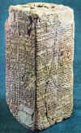

KEYS
* Son of the previous king
Colored: Variant source
Italic: Not recorded in any king lists
Bold: City listed as built by that king

# King Reign (yrs) Dynasty
==============================================
1 Alulim 28,000 Eridu
2 Alalgar 36,000 Eridu
1 Enmenluanna 43,200 Bad-Tibira
2 Enmengalana 28,800 Bad-Tibira
3 Dumuzi the Shepherd 36,000 Bad-Tibira
1 Ensipadzidana 28,800 Larag
1 Enmendurana 21,000 Zimbir
1 Ubara-Tutu 18,600 Shurrupuk
2 Ziusudra* 36,000 Shurrupuk
TOTAL: 241,200

Flood Sweeps Over

1 Jugur 1,200 Kish [First Akkadian King]
2 Kullassina-Bel 960 (900) Kish
3 Nangishlishma 670 Kish
4 Entarahanna 420 Kish
5 Babum 300 Kish
6 Puannum 840 (240) Kish
7 Kalibum 960 (900) Kish
8 Kalumum 840 (900) Kish
9 Zuqaqip 900 (600) Kish
8 Aba (Atab) 600 Kish
9 Mashda 840 Kish
10 Atab 600 Kish
11 Mashda* 840 (720) Kish
12 Arwium* 720 Kish
13 Etana the Shepherd 1,500 (635) Kish (Ascended to Heaven)
(Conquered the foreign lands)
14 Balih* 400 (410) Kish
15 Enmenunna 660 (621) Kish
16 Melem-Kish* 900 (1560) Kish
17 Barsal-Nuna 1,200 Kish (Brother of Melem-Kish)
18 Zamug* 140 Kish
19 Tizqar* 305 (1620+) Kish
20 Ilku 900 Kish
21 Iltasadum 1,200 Kish
22 Enmebaragesi 900 Kish (Made Elam submit)
23 Agga* 625 Kish (1525 yrs of Enmenbaragesi)
TOTAL 24,510 [2900? - 2680 B.C. ; 220 yrs?]

1 Meshkiagasher, Son of Utu 324 (325) E-anna (King disappeared into sea)
2 Enmerkar* 420 (900) Uruk (745 yrs of Meshkiagasher)
3 Lugalbanda the Shepherd 1200 Uruk
4 Dumuzi the Fisherman 100 (110) Uruk (Kuara; Beat Enmenbaragesi)
5 Gilgamesh, Lord of Kulaba 126 Uruk (Father was a phantom[?])
6 Ur-Nungal* 30 Uruk
7 Udul-Kalama* 15 Uruk (Son of Ur-Lugal)
8 Laba'shum 9 Uruk
9 Ennuntarahanna 8 Uruk
10 Meshe 36 Uruk
11 Melemanna 6 Uruk
11 Tilkug 900+ Uruk
12 Lugal-Kitun 36 (420) Uruk
TOTAL 2310 (3588) [2800?-2540? B.C. ; 260 yrs?]

1 Meshanepada 80 Ur
2 Meshkiagn[a/u]nna* 36 (30) Ur
3 Elulu 25 Ur
4 Balulu 36 Ur
TOTAL 171 [2560-2440 B.C. ; 120 yrs]

1 ??? ? Awan
2 ??? ? Awan
3 ??? 36 Awan
TOTAL 356 [2460-2420 B.C. ; 40 yrs]

1 Susuda the Fuller 201+ Kish II
2 Dadasig 81 Kish II
3 Mamagal the Boatman 360 (420) Kish II
4 Kalbum* 195 (132) Kish II
5 Tuge 360 Kish II
6 Mennuna* 180 Kish II
7 (8) ??? 290 Kish II
8 (7) Lugal-Gu 360 (420) Kish II
TOTAL 3,195 (3,792) [2500-2430 B.C. ; 70 yrs]

1 Hadanish 360 Hamazi [2450-2430 B.C.; 20 yrs]

1 Enshakanshanna 60 Uruk II
2 Lugal-Ure(Lugal-Kinishedudu)120 Uruk II
3 Argandea 7 Uruk II
TOTAL: 187 [2432-2340 B.C. ; 92 yrs]

1 Nani 120+ (54+) Ur II (Ur II proceeds Uruk II)
2 Meshkiagnanna 48 Ur II
3 ??? 2 Ur II (Omitted)
TOTAL: 582 (578) [2430-2340 B.C.; 90 yrs]

1 Lugal-Anemundu 90 (90) Adab [2500 B.C.]

1 Anbu 30 (90) Mari
2 Anba* 17 (7) Mari
3 Bazi the Leatherworker 30 Mari
4 Zizi the Fuller 20 Mari
5 Limer the Gudu-Priest 30 Mari
6 Sharrumiter 9 (7) Mari
TOTAL: 136 (184) [2500-2334 B.C. ; 166 yrs]

1 Kubau the Tavern Keeper 100 Kish III [Queen ; 2400 B.C.]
1 Unzi 30 Akshak
2 Undalulu 6 (12) Akshak
3 Urur 6 Akshak
4 Puzur-Nirah 20 Akshak
5 Ishu-Il 24 (24) (24) Akshak
6 Shu-Suen* 7 (7) (7) (24) Akshak [2450-2360 B.C. ; 90 yrs]
TOTAL: 99 (116) (5 kings ruled 87 yrs)

1 (2) Puzur-Suen, Son of Kubau 25 Kish IV (Kish III)
2 (3) Ur-Zababa 400 (6) (4+) Kish IV (Kish III) (131 yrs of Kubau)
3 (4) Zimudar (Ziguiake) 30+ Kish IV (Kish III)
4 (5) Ubni-Watar* 7 (6) Kish IV (Kish III)
5 (6) Ectar-Muti 11 (17) Kish IV (Kish III)
6 (7) Ishma-Shamash 11 Kish IV (Kish III)
? Shu-Ilishu 15 Kish III
? Zimudar 7 Kish III
7 (8) Nanniya the Jeweler 7 (3) Kish IV (Kish III) (Omitted)
TOTAL: 491 (485) (8 kings ruled 586 yrs)
[2360 - 2340 B.C.; 20 yrs]

1 En-Hegal 20? Lagash
2 Lugal-Sha-Engur 55? Lagash
3 Ur-Nanshe 30 Lagash
4 Akurgal 10 Lagash
5 E-Ana-Tum 30 Lagash [2455 B.C.]
6 En-Ana-Tum I 20 Lagash (Brother of Eanatum)
7 En-Temena* 30 Lagash
8 En-Ana-Tum II 10 Lagash [2375 B.C.]
9 En-Entar-Zi 5 Lagash
10 Lugal-Anda 5 Lagash
11 Uru-Ka-Gina 10 Lagash
TOTAL: 225 [2570-2345 B.C.]

1 Lugal-Zagesi 25 (34) Uruk III (Omit) [2345-2316; 29yrs]

1 Sharru-Kin, Gardener’s Son 56 (55) (54) Agade (Cupbearer of Ur-Zababa)
2 Rimush* 9 (7) (15) Agade
3 Manishtishu 15 (7) Agade (Older brother of Rimush)
4 Naram-Suen* 56 (56) Agade
5 Shar-Kali-Sharri* 25 (25) (24) Agade (157 yrs of Sharru-Kin)

Dynasty of Sharru-Kin [Sargon] Ends
“Who was king? Who was not king?”

6 Irgigi 0-1 Agade
7 (8) Imi 0-1 Agade
8 (7) Nanum 0-1 Agade
9 Ilulu 0-1 Agade (Total: 3 Years)
10 Dudu 21 Agade (Omitted)
11 Shu-Durul* 15 (18) Agade (Omit) [2371-2230;141 yrs]
TOTAL: 181 (12 kings ruled 197 yrs) (9 kings ruled 161 yrs)

1 Ur-Nigin 7 (3)(15)(30) Uruk IV (Uruk III)
2 Ur-Gigir* 6 (7)(15)(7) Uruk IV (Uruk III)
3 Kuda 6 Uruk IV (Uruk III) (Omitted)
4 Puzur-Eli 5 (20) Uruk IV (Uruk III) (Omitted)
5 (3) Ur-Utu , son of Ur-Gigir 6 (25) Uruk IV (Uruk III)
5 Lugalmelem, son of Ur-Gigir 7 Uruk IV
TOTAL: 30 (43) (26) (3 kings ruled 47 years)

Nobody 3 (5) Guti [Northern Elamites]
1 Inkishush 6 (7) Guti
2 Zarlagab 6 Guti
3 Shulmi (Yarlagash) 6 Guti
4 Silulumesh (Silulu) 6 (7) Guti
5 Inimabakesh 5 Guti
5 Duga 6 Guti
6 Ilu-An 3 Guti
6 Igeshaush 6 Guti
7 Yarlagab 15 (5) Guti
8 Yarla (Yarlangab) 3 Guti
9 Kulum 1 (3) Guti
10 Apil-Kin 3 Guti
11 Laerabum (?) 2 Guti
12 Irarum 2 Guti
13 Ibranum 1 Guti
14 Hablum 2 Guti
15 Puzur-Suen* 7 Guti
16 Yarlaganda 7 Guti
<<…Text Broken…>>
20 ??? 7 Guti
21 Tiriga (?) 40 days Guti
TOTAL: 124 (25) [2193-2123 B.C.; 70 yrs]

4 Gudea 20 Lagash [2141-2122 B.C.]

1 Utu-Hegal 427 (7)(7)(26) Uruk

1 Ur-Nammu 18 Ur III
2 Shulgi* 46(48)(48)(58)Ur III
3 Amar-Suena* 9 (25) Ur III
4 Shu-Suen* 9 (7)(16)(20+) Ur III
5 Ibbi-Suen* 24(15)(25)(25)Ur III [2112-2004 B.C. ; 108 yrs]
TOTAL: 108 (117)(117)(120+)(123)

1 Ishbi-Irra 33 (32) Isin
2 Shu-Ilishu* 20 (10) (15) Isin
3 Iddin-Dagon* 21 (25) Isin
4 Ishme-Dagon* 20 (18) Isin
5 Lipit-Ishtar* 11 (11) (11) Isin (Son of Iddin-Dagon)
6 Ur-Ninurta, Son of Ishkur 28 Isin (Abundant reign and a sweet life)
7 Bur-Suen* 21 Isin
8 Lipit-Enlil* 5 Isin
9 Erra-Imitti 8 (7) (7) Isin
? ??? 1/2 Isin
10 Enlil-Bani 24 Isin
11 Zambiya 3 Isin
12 Iterpica 4 Isin
13 Urdulkuga 4 Isin
14 Suen-Magir 11 Isin
? Damaqilishu* 23 Isin
TOTAL: 203 (225) [2004-1763 B.C. ; 241 yrs]

1 Naplanum 20 Larsa (Vassal to Isin)
2 Emisum 28 Larsa (Vassal to Isin)
3 Samium 35 Larsa (Vassal to Isin)
4 Zabaja 9 Larsa (Vassal to Isin)
5 Gungunum 27 Larsa (Zabaja‘s brother; King of Ur)
6 Abi-Sare 11 Larsa (Killed Ur-Ninurta of Isin)
7 Sumuel 29 Larsa (Took Nippur from Isin)
8 Nur-Adad 16 Larsa
9 Suen-Iddinam* 7 Larsa
10 Suen-Eribam 2 Larsa
11 Suen-Iqisham 5 Larsa
12 Silli-Adad 1 Larsa (Killed by Kutur-Mabuk)
13 Warad-Suen 12 Larsa (Son of Kutur-Mabuk)
14 Rim-Suen 59 Larsa (Defeated Babylon in battle)
(Conquered Isin; Defeated by Hammurabi)
TOTAL: 261 [2026-1763 B.C.]

KEYS
* Son of the previous king
Italic: Not recorded in king lists
Bold: City listed as built by that king

King List Versions:
Black: WB
Pale Blue: P2 + L2
Turquoise: L1 + N1
Rose: P3 + BT14
Blue: P2 + L2, L1 + N1, P3 + BT14
Red:: Su1
Dark Blue: P2 + L2, Su1
Violet: Su2
Yellow: Su1 + P3 + BT14
Green: P2 + L2, P3 + BT14, P5
Gray: TL
Medium Blue: L1 + N1, Su3 + Su4
Periwinkle: vD
Tan: S
Orange: L1 + N1, S
Pink: Su3 + Su4
Light Orange: Su1, Su3 + Su4
Dark Yellow: IB + S
Brown: IB, S, Su1, Su3 + Su4
Teal: IB
Bright Green: Mi
Lime: G
Dark Violet: J
Dark Red: P5
(Supposedly, + signs indicate combinations of broken texts)

Bibliography

The Oxford Electronic Text Corpus of Sumerian Literature
Piney Babylonia and Ancient Near East Texts
Gary’s Ancient Mesopotamia and the Near East Page
Earth’s Ancient History: A Theory About Ancient Times
Hebrew Names Version of the New English Bible

1. Cultural Atlas of Mesopotamia and the Ancient Near East, by Michael Roaf. Equinox Ltd., Musterlin House, Oxford, England, 1990.
2. Cultural Atlas of Mesopotamia and the Ancient Near East. p. 32.
3. Historical Atlas of the Ancient World: 4,000,000 - 500 B.C., by John Haywood. Barnes and Noble Books, New York, 1998.
4. History of the World, by J.M. Roberts. Hutchinson Publishing, Great Britain, 1976.
5. History Begins at Sumer, by Samuel Noah Kramer. 3rd Edition. University of Pennsylvania Press, Philadelphia, 1956.
6. The Babylonians, by H. W. G. Saggs. 3rd Edition. The Folio Society, London, 1962. Previously titled: The Greatness That Was Babylon.
7. “Earliest Writing” Found, editorial by Editor Dr David Whitehouse
8. Gunter Dreyer, German Institute of Archaeology; The Write Stuff, editorial by Terry Devitt
9. Noah’s Flood, by William Ryan and Walter Pitman. Simon and Schuster, New York, 1998.
10. The Bible Unearthed, by Israel Finkelstein and Neil Asher Silberman, The Free Press, New York, 2001.
11. Symbols, Snakes and Healing by Clarke Johnson DDS, PhD, Oral Biology and the Department of Orthodontics UIC College of Dentistry.
12. The Jesus Mysteries, by Timothy Freke and Peter Ganday, Three Rivers Press, New York, 1999.
13. The Columbia Encyclopedia, 6th Edition. 2001.
14. The Encyclopedia of World Mythology, edited by Arthur Cotterell, Barnes and Noble Books, New York, 1999.
15. Harvey Weiss, Yale; Paleoceanographers Heidi Cullen and Peter deMenocal of Lamont-Doherty Earth Observatory in Palisades, New York; Tell Leilan Weiss.
16. The Bible As History, 2nd Rev. Ed., by Werner Keller. Bantam Books, New York, 1974, 1982.

Other Sites:
Odin’s Castle of Dreams & Legends
The Forgotten Books of Eden
On-Line Primary Literature
The Lost Book of Jasher
The Nag Hammadi Library
The Writings of Flavius Josephus
The Noble Qu’ran
A Hebrew-English Bible
The Jefferson Bible
Internet Ancient History Sourcebook
Easton’s Bible Dictionary
Mythical Monsters
Ancient Near Eastern Warfare Gallery
Probert’s Encyclopedia of Mythology
Witcombe Prehistoric Art
Maelstorm Prehistoric Art
Venus Figurines from France, Germany, Austria and Italy
Oldest Alphabet Found in Egypt
Iraq__Novels
The Cat Shaman: Sumerian Heritage
The Enheduana Research Pages
Anthropology and the Bible
The New Geneva Center: World-Views of Ancient Times
Bible Origins
Holy Land Maps
Ethics of Civilization Chronology
Myths & Legends
Lexiline’s Musical Sumerian Page
The Life and Times of the Babylonians
Crystalinks: Mesopotamia
Akkadian Cuneiform
Washington State University World Cultures
University of Wisconsin-Madison History of Mesopotamia
History on the Internet: Ancient Near East
A Dictionary Of Gods and Men
The Skeptic’s Dictionary
Name Your Demon
Mary Forrest Mythology Notes
Table of Middle Eastern Deities
Who’s Who in Egypt
Mysteries of the Bible
The Hodge & Braddock Homepage
Treasures from the Royal Tombs of Ur
Lawbuzz: Hammurabi
The Code of Hammurabi
Realm of the Holy Grail
Gateways to Babylon
The Secret Gospel of Mark
Has the Garden of Eden Been Located at Last?
Mark McDonald’s Near East Photo Loft
Ziggurat List
Nippur: Sacred City of Enlil
Egyptian Archaeological Sites
Canaanite Writing System
Phoenician Religion
Gryffon’s Eyrie
Silken Fairy’s Dragon Realm
History of the Shepherd’s Crook Staff
Jewish Revolt on Rome
The Jesus Puzzle
The Bible and Christianity: The Historical Origins
She’ol and Hades
Mithras and Heathen Religions
Endtime Prophecies of Early Christians
Martin Luther On the Jews, Excerpts
Wars of the 20th Century
Sigmund Freud on Moses
Albert Einstein on Religion, Childhood
The Einstein-Freud Correspondence
Take Our Word for It Etymology Page
Bahumuth’s Fantasy Page

