How to Use the Behcet’s Chat Room

Welcome to the Behcet’s Chat room. In order to help make your first Behcet's (BD) chat room visit enjoyable, we offer a visual description on how to use our chat room. See the pictured examples of the BD chat room below.

How To Join The Behcet's Chat Room
- Visit the Behcet's Chat Room webpage at http://www.bdchatroom.com.
- Select the "Enter Chat Room Here" button.

Enter Chat Name Window will to be displayed in a few minutes (see below). Please enter an unique name for your chat session and then select the Connect button. If your name is being used by another chatter, please Cancel and try another unique name. Please do not register.

.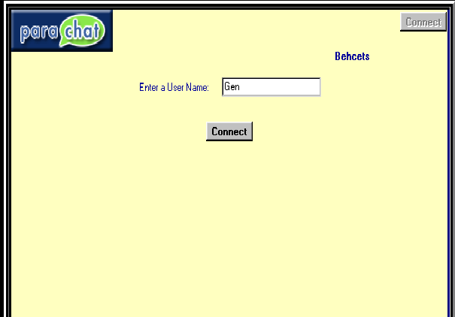

The Behcet's Chat Window

Behcet’s Chat Room Window
NOTE: In this example there are 3 chatters displayed in the room under User Info window. Each button is displayed and explained later, below the example picture.

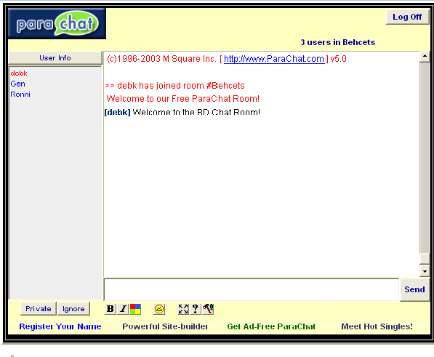

Individual Button Descriptions

Text entry window: Select this window with your mouse and type your chat message. Use your Return key or Send button to display your message in the chat window.
Private/Ignore Buttons: Selecting a chatter name (listed under the User Info Window) and then selecting the Private button, allows you to enter into a private chat with that individual. If you select a chatter name and then select the Ignore button, you will not see anything typed by that chatter unless you accept them again into your chat session.

Text Buttons:
The above 3 buttons change the look of your text.
  - Bolds your text
  - Italic your text
  - color window – opens the window below.

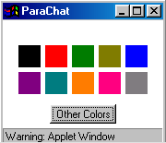

Allows you to rapidly change the color of your visible text.

Facial Expression Button:

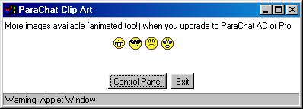
The face button opens the above window with a small selection of facial expressions. If you select any face or expression, it will attached special code to the end of your text in your text entry window. The face will be converted and displayed to other chatters if you either hit the return key or send button.

Floating Chat Button, Help Button, and Control Panel Button

- Floating Chat Button: The first button with the multi directional arrows allows you to open a floating chat window. This is a wonderful feature that allows you to move your chat window any place on the screen.. It makes the chat room self contained and completely visible. You do not have to scroll up and down to view chatter information.
- Help Button: The second button is the help button, which does not appear to work. For help visit http://www.parachat.com/help/
- Control Panel Button: The last button opens the control panel window. All your features and user settings are available in this one window. To show all the tab menus (Color, Face, Font and Settings), I had to display 4 different pictures of the control panel. The control panel allows you to select sounds for any chatter action, change font sizes, etc depending on the tab you select. All the features are available in the control panel. I normally open a floating chat window and move it in the upper left corner of my screen. Then I open the control panel window. I move or even resize the control panel window below and to the right of the floating chat window. This way it is easily visible and accessible while chatting.

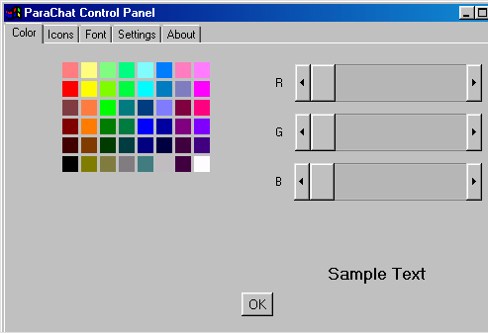

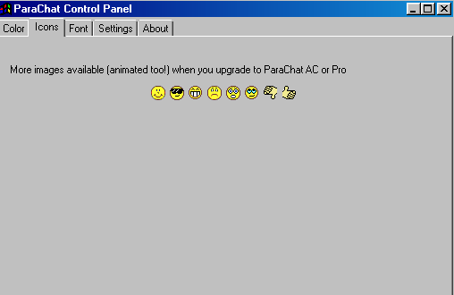

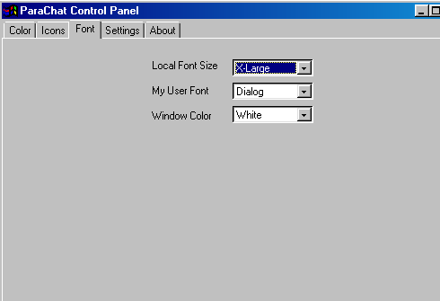

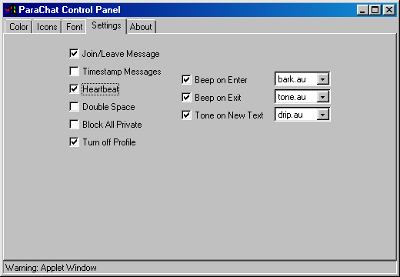

Ready To Chat
Now that you know how to use our BD chat room, please visit the Behcet's Chat Room Webpage at: http://www.bdchatroom.com. Select the “Enter The Chat Room Here” button.

Need help

The Behcet’s chat room requires a Java enabled browser. If you have any Java problems associated with your browser, please visit http://www.parachat.com/faq/java.html

For more detailed help using ParaChat, visit: http://www.parachat.com/help/

Happy Chatting,
Gen, Dot, Deb, Carol, Maria Pia, Anne, Kelli and Ronni

