October 2, 2001

Experiment: Reaction of Alkaline Earth Metals with Water

Purpose: To observe the reactivity of alkaline earth metals with water and to predict the metal reactivity trend within the Periodic Table.

Apparatus: test tubes, beaker, test tube holder, Bunsen burner, striker, indicators, retort stand, calcium metal, and magnesium.

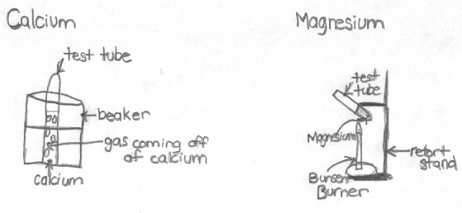
Method:
- Half fill a 400ml beaker with water and invert test tube filled with water into the beaker. Add two drops of phenolphthalein to the water.
- Add a piece of calcium metal to the water and observe the reaction.
- Place about 4 cm of water into a test tube. Heat until the water boils. Add two drops of phenolphthalein to the water, and then add a piece of magnesium. Observe.

Observations:

 | Calcium | Magnesium
Physical Properties | - shiny, silver, solid | - shiny, silver, solid
Reaction with Water | - water turned purple  - bubbles formed  - water in test tube decreased as gas level increased | - didn’t dissolve  - few bubbles formed  - not very reactive  - made hissing noise

Conclusions:

- The pattern of metal reactivity within the alkaline earth metals is as you go down the group they get more reactive.
- The pattern between the reactivity of the Alkali and alkaline metals is that they are both the same. They both get more reactive as you go down the group.
- With the tests we’ve done, I would expect that all the metals on the Periodic Table would increase in reactivity the further down they were in their group.

- a)
Elements | Predicted Reactivity
Li and Be | Lithium would be stronger
Ca and Ba | Barium would be stronger
Cs and Be | Cesium would be stronger

b) If Beryllium were to be added to water I would expect a few bubbles maybe to form, but for the most part, not a huge reaction because it is at the top of the alkaline metals column.

5.
calcium + oxygen -> calcium oxide
calcium + water -> calcium hydroxide + hydrogen
calcium oxide + water -> calcium hydroxide

magnesium + oxygen -> magnesium oxide
magnesium + water -> magnesium hydroxide + hydrogen
magnesium oxide + water -> magnesium hydroxide

6. The factor for the alkali metals being more reactive than the alkaline earth metals is they are in the first group on the Periodic Table and are more stable than the metals in the alkaline earth metal group.

Maria Acimovic

