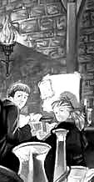 | .  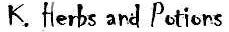
Review the herbs and potions used in the novel and the potions listed on the following site:
http://www.geocities.com/hogwarts_online_school/herb_fungi.html
Design your own potion. Make up the ingredients and instructions for how to brew the potion.
What is your potion used for and how should it be taken or applied?

1) Who is the student that was expelled from Hogwarts?
2) What is Harry’s father called?
3) Who is the Dursley’s nephew?
4) What type of feather do Voldermort and Harry have in their wand?
5) What type of animal is Scabbers?
6) What is Harry’s animal called?
7) Who did Harry first meet, Ron Weasley or Draco Malfoy?
8) What is the game that is played in the wizard world?
9) What broom does Harry have sent to him?
10) Who is the ‘Defence of the Dark Arts’ teacher?
11) What House is Hermione Granger in?
12) What House is Draco Malfoy in?
13) Who is the Potions Master?
14) What gift does Neville receive?
15) What does Harry take to tea with him when he is invited by Hagrid?
16) What is Aunt Petunia’s sister called?
17) Hagrid buy’s Harry a present for his birthday, what is it?
18) Who is the Headmaster of Hogwarts?
http://www.teachit.co.uk
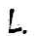
Design your own small handbook on how to play Quidditch. Include illustrations.

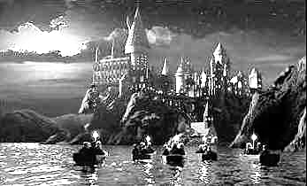 |   To really understand a character’s role in a story, it helps to look at the character from several angles. When you’re asked to describe or analyse a character, think SADDR, which stands for a certain way of looking at a character.
Speech: What does the character say? What does this tell you about the character? For instance, Vernon Dursley “yelled at five people” at work. This is a clue that he can be unfriendly and that he doesn’t really care about other people’s feelings. On the other hand, Professor Dumbledore said many things that showed he was kind and understanding of different people. What are two examples of things he said?
Dudley starts in Chapter One with prodding and poking at Harry. What are two other things he does that show what kind of person he is?
Action: What does the character do? What does this tell you about the character?
For instance, Hagrid brings Harry to Professor Dumbledore on a flying motorcycle. This is a clue that he is a little bit wild.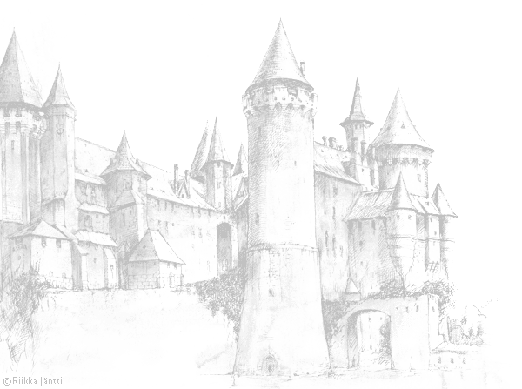
Description: What does the author say about the character? What does that description tell you about the character?
Example: Albus Dumbledore is described as “tall, thin and very old.” He also rummages through his cloak and laughs softly when he sees the cat (who is Professor McGonagall). This tells you that he has a sense of humour and might be a bit absent-minded.
Your turn: Professor McGonagall is described rather differently, as a “rather severe-looking woman” whose “black hair was drawn into a tight bun,” who Albus Dumbledore thought sat “so stiffly.” What kind of teacher do you think she would be?
Drawing: Imagine what the character looks like and make a sketch of it. Professor McGonagall’s neat hair and trim appearance are clues that she is a fastidious, neat and organized person. What does Albus Dumbledore’s appearance tell you about his character?
Reactions of others: How do other characters in the story react to this character?
For instance, Professor McGonagall asks Albus Dumbledore a lot of questions about what has happened. She clearly thinks he knows a lot, and when Professor Dumbledore asks her to, she uses Voldemort's name, even though she doesn't really want to, showing that Professor Dumbledore is a well-respected person. How does Professor McGonagall react to Hagrid? What does this tell you about him?
Apply the SADDR method of character analysis to Hermione.
From: http://www.resourceroom.net/comprehension/literature/Harrypottercomp.asp

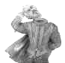 | 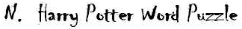  Right mouse click this puzzle and copy and paste it onto a Word document. Then print it out so  you can fill in the answers.  Then paste the completed puzzle in your book.
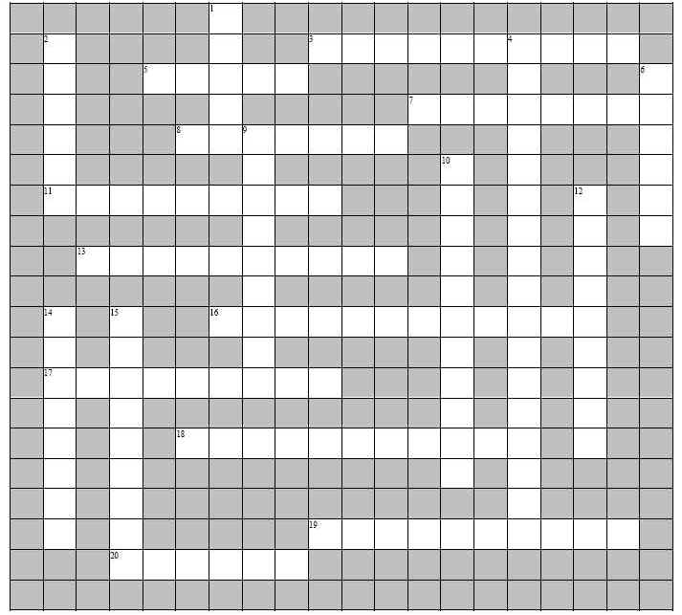
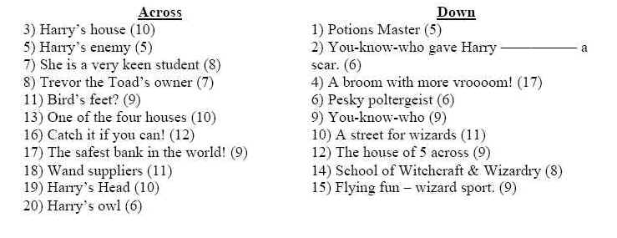
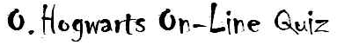
Complete this on-line quiz. Record in your book the level you selected and how long it took you to complete it.
http://www.factmonster.com/quizzes/hogwarts2/1.html

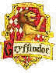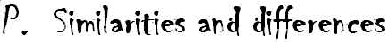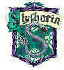
To understand things around us, it helps to think about how they are alike, and how they are different. This is called “comparing and contrasting.” One way to show this visually is with a chart which shows how two things “have some things in common”— they share some characteristics or ways they are alike — but also have differences.
Examples:
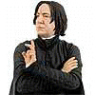
Snape and McGonagall
Gryffindor and Slytherin
Peeves and Nearly Headless Nick
History of Magic class and Potions class
Select one of the above pairs. After thinking about their similarities and differences, on a new page make a Venn diagram, where two circles overlap. The similarities are listed in the overlapping section, while the differences are written in the outside parts. This type of diagram is a simple visual way of showing their relationship.
http://www.resourceroom.net/Comprehension/literature/HPCompendium/simndif.pd


.
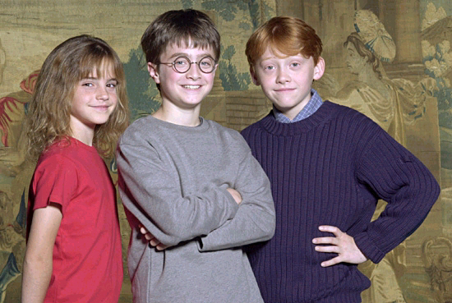
1) List the changes to the plot of Harry Potter from the novel to the film .
2) Explain why the omissions (bits left out) and changes might have were made .
3) Name the above three actors, and discuss how suitable you think their choice was for
playing the three main roles in the Movie 'Harry Potter and the Philosopher's Stone'.
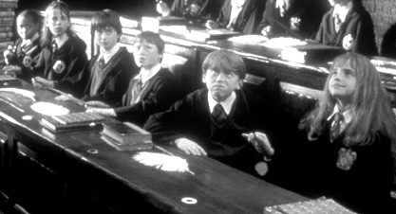
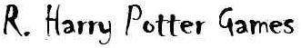
1) Hangman Game http://www.factmonster.com/games/hangman/harrypotter.html
2) Puzzle http://www.veritaserum.com/flashgames/jp/puzzledharry/puzzled-harry.swf
3) Broomsticks Game: http://brighton.ncsa.uiuc.edu/~prajlich/broomsticks/

(For the on-line study-guide, see www.interactive-learnng.com.au - ENGLISH / Reading / Harry Potter Unit )

