The American War of Independence – Questions Checklist
See the on-line web lessons for the Sources, video links and information....
.
Unit 1 - The Background Causes
1. As an introduction to this topic, watch the following slide presentation twice(see site). The second time you watch it, frequently pause the slides, and discuss and record in your work book the key facts covered in the slides.
2. Print off, paste in and lightly colour this map of the 13 Colonies.
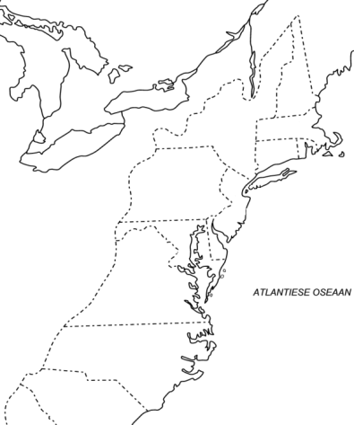
On the map, mark in and label the cities of Boston, New York, Philadelphia and Washington.
Then write in the names of the 13 colonies that became the first 13 States of the United States of America.
3. A popular slogan in the colonies at the time was: "No Taxation Without Representation!"
Explain what this slogan means, and why the tax laws being passed in Britain greatly angered many of the colonists.
4. Use the above information(see site) and the following site, to make brief notes on all of the background issues and events, that together caused the American war of Independence:
http://www.docstoc.com/docs/73530967/Causes-of-the-American-Revolutionary-War (click full screen)
Write your notes as a mind map or design a Glogster poster that explains the causes of the American War of Independence. (Year 7 examples of Glogster Posters)
Unit 2 - Overview of Key Events During the War
1. a) Watch the video and read the brief account of the Battle of Lexington at this site.
Explain what is meant by the saying that the first shot fired in this battle,
was the 'shot that was heard around the world'?
b) Copy and paste into your workbook, the map provided on this page, and complete the attached mapping activity.
2. Explore this Interactive Map, and
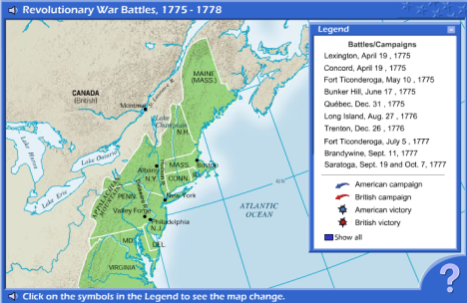
answer in your book in complete sentences, (using some of the key words from the question in your answer) the three questions on the site.
3. What are the main reasons presented in this short video, for why the revolutionary American colonists were able to defeat the British and gain their independence?
4. a) Briefly summarise the above information (see site)under the heading: The American Revolutionary War.
Pick out the main words/points and make point form notes. (..about one page of notes)
OR
b) Using the above information, design an interesting, original looking timeline of the American Revolutionary War. If you wish, you only need to use the dates of key events listed above, so your timeline is not too detailed and complicated.
.
Unit 3 - The Boston Massacre
a) List in your workbook, the criticisms that the writer makes about this above illustration, that was produced just after the 'massacre'.
b) Also add to your list, the criticisms made of the illustration on the following site:
http://www.historywiz.com/bostonmassacre.htm
c) Following your own research on this incident, do you think that this above engraving could be described as an early example of political propaganda?
Include a few brief quotes from different sources to support your view.
d) What motive would the American 'patriots' have for producing this engraving, and circulating it throughout the colonies?
e) How do the details or account of the event, as presented in the following video, compare with the details in the written accounts?
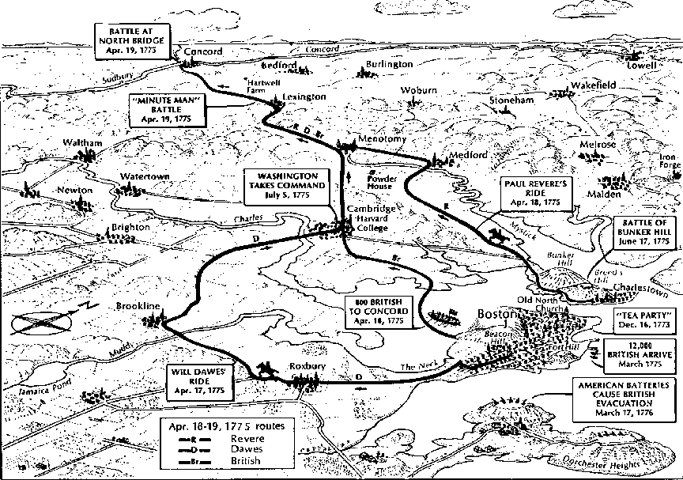
Unit 4 - The Boston Tea Party
1. As you read about the Boston Tea Party in the following links, keep in mind the creative writing/ 'historic fiction' activity you can enjoy doing in activity 3 below.
2. Print off this drawing.
Lightly colour it in and then paste it in your workbook or folder.
Also put a red X on your map at the site of the Boston Tea Party.
.
3. Pretend you were a young person standing in the excited crowd on the wharf. It is now evening, and by candle light in your room, you are writing a letter to your cousin.
Write the letter now, and in the letter describe what you saw at the docks that day, and explain who the people were wearing feathers in their hair.
Explain also what they were throwing into the harbour and what motivated them to do this. Try and make your letter look like it was really written in the1700s.
These Sources (on the site) will show you the style of writing that was common at the time.
Unit 5 - Battle of Bunker Hill
.
a) After reading more about the Battle of Bunker Hill, explain the different fighting methods or strategies used by both sides during the battle.
.
b) This link will show you a wide variety of illustrations of this famous battle (both primary source contemporary drawings and later artist’s impressions.) Draw and colour, or find, copy and paste, an illustration of each of the different uniforms worn by both sides in the conflict.
.
c) If the American forces were 'dug-in' on the high ground behind defensive earth embankments, why were the British able to defeat them? Write one or two paragraphs for your answer, and include in your argument a brief assessment of how important cannon fire was in the eventual British victory. (Note the sources or sites you use.)
.
As well of the sites you'll find through the above link, this map of the battle may help you in answering this question.
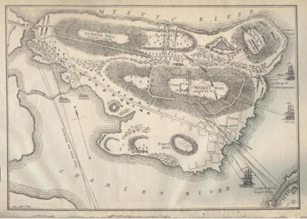
Also try these search words in Google's 'search/article' mode, and 'image' mode:
'british cannon used in the battle of bunker hill'.
Unit 6 - The Revolutionary War Battles - New York Focus
.
The Role of New York (the City and the State) in the American War of Independence.
.
1. Click to enlarge these three maps to study the location of the city of New York, it's environs and the borders of the later State of New York.
a) What large battle took place in what was later to be the State of New York, that is described as the "turning point in the war"?
b) Near what river did the battle take place?
.
2. Print off this map. As you read the following account, circle on the map any locations mentioned in the account.
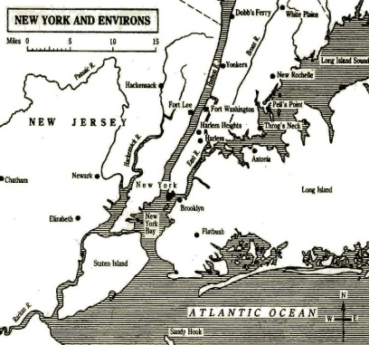
Where possible also label on the map the date and name given to different battles.
3. a) During the period in the war when the fighting took place in and around New York, what strategies did Washington use to avoid defeat and capture by the British forces?
b) What other characteristics did Washington display, that helped put him in the category of a great leader? Watch this video for some ideas.
.
4. Find a copy of an early print or drawing of Fort Washington and past it in your work book.
From your research, make about eight points about the British forces assault on the Fort and how it was eventually taken.
What role did Margaret Cochran play in the battle?
5. In your work books, under the heading: The Role of New York in the American War of Independence, write out five or six main points you can find in the following paragraphs.(see site)
6. OPTIONAL EXTRA
Watch the following documentary, until you think the narrator has explained what is different or unique about the history of New York City. What is unique about New York, compared to the history and development of other key settlement areas in the north eastern States of America?
http://topdocumentaryfilms.com/new-york-a-documentary-film/
a) Why and in what way were the reasons for people settling on the Island of Manhattan, different to the reasons that motivated other settlers to come to the new colonies? What was unique about why people settled in New York?
b) In what way was the composition of people who settled in New York, different to the people who settled in the other American colonies?
c) Why has New York grown to be such an important and influential city in America today?
What does this tell us about the value and importance, of accepting equally the wide range in the types of people, who can make up a city today? What does it tell us about the importance of being open, tolerant and accepting of different types of people, regardless of their different cultures, religions and backgrounds?
d) To what extent has the political, cultural and economic success of New York, been the product of this historical openness, tolerance and acceptance? Has this acceptance of all people, and giving them the same freedoms and rights, enabled them to fully use and focus their wide range of talents and skills?
Were there though any exceptions? Were any people not welcomed or included?
f) What lessons could be learned, from this unique historical 'experiment' seen in the story of New York. How could the history of New York be a valuable help for other cities in the world today, aspiring to also create a peaceful, thriving and prosperous society?
Unit 7 - The War of Independence - Research Options
The American War of Independence (1775–1783) - Research Activities
4 The Battle of Saratoga in 1777
1. Read about the main aspects of the Battle of Saratoga. Also this film starts with Saratoga
Why has the battle been described as the turning point in the war?
(Remember to list the sources you use in your research.)
2. Research the role played by Margaret Kemble Gage during the American war of Independence.
3. Find out about the story of Molly Pitcher. Record about eight key points about her background and actions in the battle and find a different illustration of her exploits and paste it in your workbook.
The Revolutionary War Weapons
4. a) Name, describe and provide illustrations for the most common weapons used during the American war of Independence.
b) What was the most commonly used rifle? What bullets were used? How were these made? How was the rifle loaded, and how did the firing mechanism work. Include a labelled diagram.
Watch the firing of the musket at the start of this video.
5. What parts did Native Americans play in the American Revolutionary Wars?
Medical treatments common during the Revolutionary war
6. Write two fictionalised diary entries that describe battle field medical treatments common during the Revolutionary war.
Include accurate historic details from information you can find by researching the common medical practices of this time.
7. a) After discussing this document (see site), describe what it was like for many young British soldiers living in the American colonies at that time; When the British soldiers were viewed by many Americans by then, as an unwelcome and foreign occupying army.
8. (Assessment/Grade Task)
You are a young colonist, and have been fighting in George Washington's army of patriots to throw off British rule.
Your favourite cousin in England though, has written to you, and is unhappy and shocked that you are fighting with these rebels who are killing British soldiers.
Write a letter back to your cousin, explaining why you have sided with Washington's revolutionary forces, and are fighting against the English soldiers and their allies. ( font: Blackadder ITC, size:36, background: google/image search 'parchment'- right click 'save picture as', select 'page layout'/'page colour'/'fill effect'/'picture'/'select picture 'from where you saved it.)
Before you begin, read through this brief page of discussion points.
In your letter, to help explain your point of view, and why you are fighting to gain your country's independence, also quote some words from the Declaration of Independence.
Notice in their Declaration of Independence, the list of complaints they made, about the way the colonists had been treated by the British and their King, George III.
These links will give you a detailed or simple overview, of what the colonist's leaders wrote in their Declaration of Independence from England.

