

Name:

www.interactive-learning.com.au Page 2
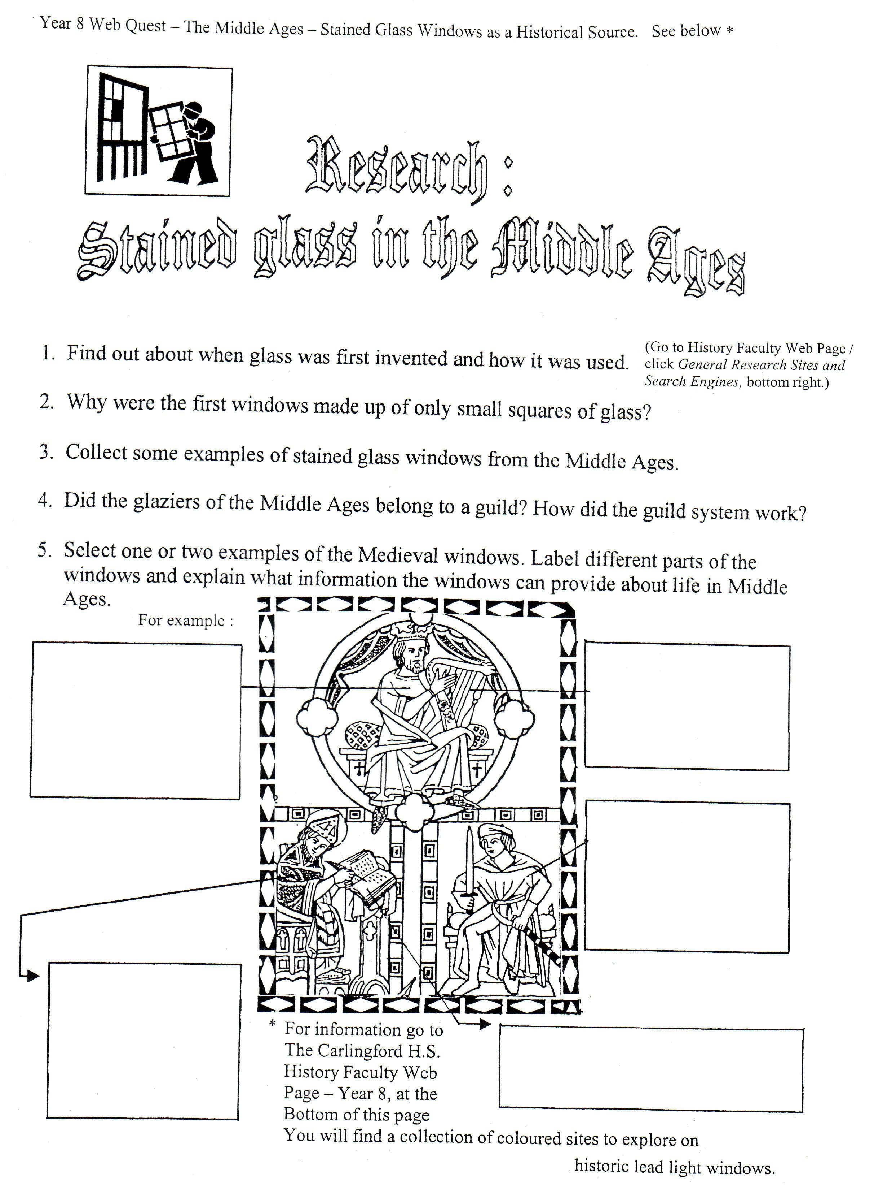
7. (Optional) Right mouse click and ‘cut’ the image of the window and paste it into
the Microsoft paint program. (It’s in Start/Multimedia Files/ Paint at school and Start/Programs/Accessories/Paint at your home.)Then colour some of the window with appropriate colours. Then lasso it with the square dotted line Paint tool, copy & paste it back on to your worksheet. Click Draw/Text Wrapping/Through, so you can drag the window up to position it properly.(You can also right mouse click to get the little dog, text wrapping tool.)

