Changing attitudes to Australia’s involvement in the Vietnam War

Internet research activity

- Make brief notes, from the given websites, to learn about and gain insight into the following:

  - The timeline, impact and nature of the protest movement within Australia.
  - Differing views of Australia’s involvement in the Vietnam War and the reasons why different groups within Australia opposed the war.
  - Impact of the war on the Vietnam veterans and their families.

- Create your notes in an interesting way. Google image search ‘mind map’ for ideas. Remember to use different colours and sub-headings.
- Alternative activity: Role-pay and video an argument between father and son, or mother and daughter – One for, and one against conscription and Australian involvement in the war.
Research first though! Be informed with relevant details facts and opinions from the time.
- Your notes will be collected on _ , during class. This will give you an opportunity to finish your research at home.

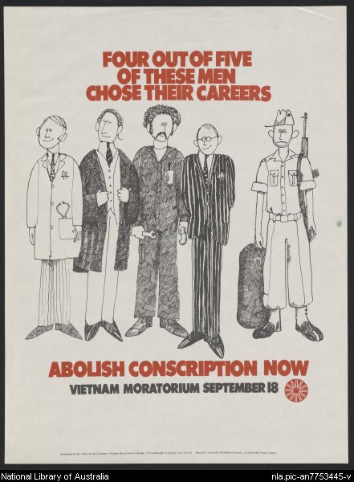
Internet research activity

websites

- The Protest Movement in Australia during the Vietnam War
http://en.wikipedia.org/wiki/Military_history_of_Australia_during_the_Vietnam_War#Protests_against_the_war

http://www.hotkey.net.au/~marshalle/Protest/protest.htm

http://www.theage.com.au/articles/2003/02/17/1045330536752.html

http://en.wikipedia.org/wiki/Conscription_in_Australia
Make brief notes on the section entitled, ‘National Service from the 1960s’.

http://australianscreen.com.au/titles/or-forever-hold-your-peace/clip2/
Watch the video clips of young high school students protesting.

http://www.milesago.com/Features/vietnam.htm

- Moratoriums
http://www.abc.net.au/ola/citizen/stories/trans/program1.htm

http://en.wikipedia.org/wiki/Moratorium_to_End_the_War_in_Vietnam

- Save Our Sons (S.O.S)
http://www.womenaustralia.info/biogs/AWE0099b.htm

http://www.milesago.com/Features/saveoursons.htm

- Impact of the protest movement in Australia
http://www.onlineopinion.com.au/view.asp?article=315

- Soldier’s Homecoming: impact of the war on the veterans
http://freepages.military.rootsweb.com/~bobw/home.htm

http://freepages.military.rootsweb.com/~bobw/after03.htm

http://www.theage.com.au/news/World/The-Vietnam-War-a-nightmare-still-vivid/2005/04/29/1114635749004.html

http://www.vvaa.org.au/experience.htm
Also make brief notes on the following sections for this website:
- ‘Difference between the Vietnam conflict and other wars’
- ‘Posttraumatic Stress Disorder (PTSD)’ – symptoms and effects

