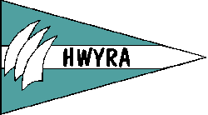 Makin’ Waves

November 2000
Next Meeting : November 16 6PM at Hawaii Yacht Club – Election of Officers

Commodore's Comments

From Summer to Fall we Sailed and Sailed: As I proof read this section, it sounds like the HWYRA members are golden girls with big money backing their sailing dreams. It is really surprising what our members have accomplished this summer on shoestring budgets. Here are some of our members accomplishments this year, so far…

Your Commodore Katie had the opportunity to skipper a 46 foot yacht in Tonga this summer with a group of friends (see article Tonga Charter.) Dr. Melinda Kohr took a much deserved sailing vacation in Tahiti - story goes, she was on the bow attaching a make-shift spinnaker pole to the roller furling jib, to improve boat speed dead downwind. Oh, those ex-J24 racers! They can't stand a sloppy jib, even on a cruising boat in Tahiti! Kim Devereaux was also on that 40 foot yacht in Tahiti, and confirms that story. Incidently, their yacht was skippered by Eedry Zey, my first female sailing mentor. Kim also made her maiden voyage on her own Nordic 44 this summer, which she has spent the last year and a half refitting. Marian Westley worked on her Doctoral oceanographic research project this summer aboard a 300 foot ship which departed Honolulu in
May and landed five weeks later in San Diego. After seeing the world (London, Rome, and Texas...pity, the life of a researcher!), she decided to come home to Hawaii and settle down, joining Kaneohe Yacht Club and buying a J-24.

Hey that reminds me; Liana Holmberg, is a part owner of a J-24, and although she has been very busy this year with graduate school, she made her first blue water crossing from Honolulu to Seattle this summer, delivering a 50 foot sailboat in 18 days. Liana joins veteran club members such as Lyn Silva, Sherry Vann and Lita Shelton by making an ocean crossing...But look, on the heels of Liana is Kim Devereaux, currently on her first long ocean passage delivering a 55 foot sailboat from a small island near Fiji to Hawaii.

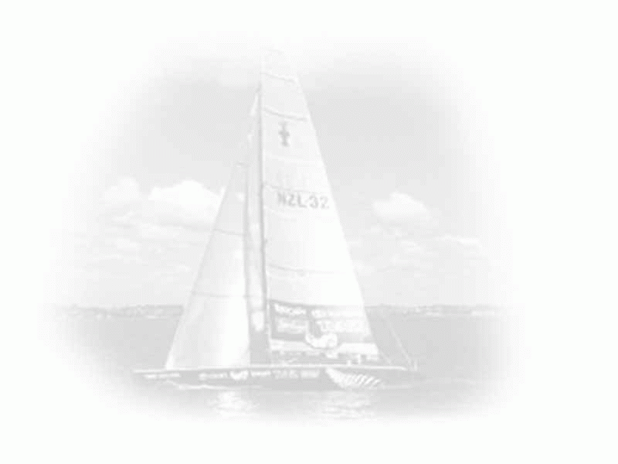
Lets not forget the small but mighty Carol Barkley who has become the queen of small boats, mastering the Rhodes 19's, El Toro's, and 420's. Look out Wahine Skipper of the Year competitors! Half of next years races are on small boats, so Carol and her friend Lynelle Torikai have the edge on us already! Of course we will all be struggling to keep up with Deniz Karacaoglu in the laser race, knowing her record in this years Laser Worlds.

While we were all out on oursailing adventures, Susan Harper was back home minding our Cal-20 Hot Flash,THANK YOU SUSAN! She has given us hints of a new boat in her future, and she is planing a busy schedule next year with HYRA events. Trish Gilbert went to the Big Boat series in San Francisco and has been actively managing the Wahine Sailors group this year. Nancy Mulford, Crispen Muligan, Lori Johannessen, Susan Harper, Marie Ann DiGennaro, Chimufi Nagai, and Nancy Hamel were all major contributors to the volunteer efforts at the Kenwood Cup along with Melinda Kohr, Kim Devereaux, and Mary O'Leary, and Debbie Gleason as helpers.

New Members Update

Debbie Gleason has been sailing Friday Night races on Urban Renewal and I hear they beat Desperado last Friday night. Debbie is a canvas cover and sail maker and has offered to supply services and possibly sails if we get another boat in the future. Rachel Shackelford, AKA Velcro Woman for her ability to hang on to the bow in ruff seas. Rachel did foredeck for HWYRA, during Lipton II and did a fabulous job!. (What blew us away though, was that on the early morning of the second day of heavy sailing, she managed to fit it an 18 mile fun run!) The crew from Maui were impressed and wanted to pose in pictures with her..was it the strong legs or the beautiful long blonde hair they wanted to remember?

Bridget Andrew raced on Margaret Haig's big boat Bondi Tram this summer. Wow girl, zero to 60 in a single year. I remember earlier this year when we flipped the FJ together in Keehi Lagoon. Bridget races regularly on Uina Mara.

Jennifer Scott is our youngest and newest member. She is 13 and she recently won an award in San Francisco for the First Quailifing girl to race in the Gold Fleet at the El Toro North Americans. During this summer regatta she ended up finishing 12th of 30 plus entries skippered by both boys and girls and she was the first girl to cross the line. During the Greenhow regatta Jenny tied for second but due to having less firsts, came in third. On Oct. 31 Jenny and Kate raced our Cal-20 Hot Flash in Kaneohe. With Jenny driving they came in 2nd over the finish line in the POURING rain. If Jenny gets her sailing Grandmother to join HWYRA, we will have our first multi-generational memberships! Deniz Karacaoglu is our all-star Laser sailor. Just having her around keeps us inspired. Deniz flew to Istanbul Turkey this summer to race lasers for her country and then the Laser Worlds. By coming in First for her country (Turkey) and Fifth in the Laser Worlds...I think we all have our work cut out for us and we better start doing our sit ups now if we expect to hike-out for several hours on race day. Deniz skippered the J-24 Blue Jay in Kaneohe on Oct 29th in the Perfect Storm. Sami Goldberg: where are you? Lets find this new member and get her sailing!

Tonga Charter

Being the Captain of a fabulous boat in a fabulous place does me wonders. I call the Vava'u group in Tonga - Sailing Disneyland - because it is so colorful, easy, and fun. Five of my friends and I rented a 46 foot boot from a charter company. The boat was well maintained, and had the most useful conveniences, such as, an electric toe driven anchor windless, which I feel in love with. With 10 knots of wind, flat seas, line of sight navigation, and 30ft water visibility, abundant tropical fish, living coral and beautiful sunsets...it is THE dream cruising site. I happened upon a friend, a famous solo circumnavigator, Brian Caldwell in Vava'u. He was sailing from New Zealand home to Hawaii on his new boat Stray Bit. It is a small cruising world!

Lipton II

On Oct 21 and 22 our HWYRA team went up against the best in the Lipton II race. The event was held on beautiful Kaneohe Bay with flat seas and 15 knots of wind. With seven clubs competing for the cup and six boats in the race we each sat out a turn (BYE), to create a fair Round Robin race. There were many spectator boats and it was fabulous close and competitive racing. It was Marian's vision that we race, and we did it. Participants: Kate Thompson-Skipper; Marian Westley-Pit/Halyards; Rachel Shackelford-Foredeck; Carol Barkly-Main Trim; Lori Johannessen-Jib and Spin Trim; Melinda Kohr-Jib and Spin Trim (Sat); Trish Gilbert-Jib and Spin Trim (Sun). The crew worked very well together. We had three practice sessions but never the same crew all three times. Kim Devereaux helped by driving the delivery crew, filling in as main trimmer on a practice, and dog sitting on race day! Charlas Barkley was a great supporter on the race days and Tom Pochereva of the race committee proved to be a supporter too. Although, we came in last in every race except one...we were in the pack and did rather well. When things were not looking that good, Lori set our sights for beating one boat...AND WE DID IT...you should have heard us as we crossed the finish line in front of Pearl Harbor Yacht Club.

Replacement Therapy

for HOT FLASH

There comes a time when a Hot Flash, is too much and the best remedy is replacement. Yes, after much discussion, networking, and good ideas we are planning to release our Cal-20 Hot Flash by selling her. It is officially on the market with the asking price of $2,500.

Wahine J-24 race

A week before the September J-24 race at Waikiki Yacht Club, only one boat was ready to get to the starting line. Rather than cancel the race, we decided to postpone it and move it to Kaneohe, where, rumor has it, the J-fleet is alive and well. With Leslie Johnson pulling some strings and Katie Thompson wielding her all-powerful cellular phone, word got out and the Js prepared for battle. Leslie Johnson packed Flash with young hotshots, Leslie Foster crossed the Pali with a formidable Waikiki crew, and the Kaneohe Frans (Vaughan and Haas) pulled together a venerable home team. The newcomer was Brett Phillips' J-Bird, skippered by laser sailor Deniz Karacaoglu.The boats sailed out in light and humid air, with crews complaining about the heat and muggy weather. Race 1 went off without a hitch: J-Bird won the start but Flash split from the pack, found better wind on the far right side of the course, and had the race in the bag by the first mark. Race 2 began in freshening wind. Half way up the beat to the windward mark, it started to rain. The fleet rounded the mark in increasing gusts and driving rain, and started genoa-reaching to the second mark. J-Bird and Flash both went for their spinnakers. Within seconds, the storm worsened. Lightening cracked, thunder roared and the bay disappeared behind white sheets of rain and spray which blotted out the marks and the finish. And, of course, all the reefs, not to mention islands and other keel-unfriendly protruberances. J-Bird and Mai Lan, who were leading the second race, never found the finish, and enjoyed the surreal experience of careening around the bay at top speed in almost zero visibility. The two Leslies made it around the course somehow, minus one spinnaker which was shredded beyond repair. Eventually, all the boats made it back to the yacht club in one piece. The crews raced for the shelter of the club where they thanked their lucky stars and soothed their nerves with hot buttered rum. A big mahalo to Eileen Phillips and Tom Pochereva, our soggy but intrepid race committee, and Leslie Johnson for helping us keep the regatta alive. She won, with Leslie Foster in second, Deniz Karacaoglu in the third and Fran Vaughan in fourth. Apart from the storm, the day was a huge success for women's sailing and generated enthusiasm for racing among old-timers
and newcomers alike.

Outlook for 2001

Based on our experience this year, we have made some changes to the race schedule for 2001. We have spread the races out over the calendar with HYC in January, PYC in April, Greenhow in June, KYC Cal-20s in July, WYC in September and KYC J-24s in October. We will be seeking opportunities to add dinghy fleets to several regattas to make it easier for non-boat owners and the not-quite-so-well-connected to participate and to hopefully bring in some new blood. And we will be working hard, with your help, to make sure that the races we have fought for in the scheduling meetings actually happen.

Nominations for 2001 HWYRA Board

Commodore – Katie Thompson
Vice Commodore – Melinda Kohr
Rear Commodore – Marian Wesley
Local/National sail coor.-Trish Gilbert
Secretary – Carol Nakahara
Treasurer - Kim Devereaux
Education - OPEN
Membership - Debbie Gleason
Newsletter- Sue Roach
Website-Deniz Karacaoglu

Proposed 2001 Racing Schedule

January 20: HYC/Wahine#1:
big boats plus a dinghy start (maybe)
April 21: PYC/Wahine#2: Rhodes 19s
June 17 PHYC/HWYRA Greenhow Regatta Wahine#3: Rhodes 19s
July 7: KYC Wahine#4 Cal-20s
September 29: WYC/Wahine#5: Boat TBD
October 27: KYC/Wahine#6:J-24s

Cyber Sailing

LADIES' ROOM
http://www.ussailing.org/calendar/results.asp?week=ON
Check out this week's events listed on the US SAILING events calendar. You can also do a search on the calendar to find out more about the Rolex 2000 ISAF Women's World Match Racing Championship, to be held November 25 December 2000, at the St. Petersburg Sailing Center, St Petersburg, FL. You can also find out about the SYCA Women's Sailing Convention, scheduled for February 3, 2001 at the Bahia Corinthian YC in Corona del Mar, CA.

Hawaii Women’s Yacht Racing Association
P.O. Box 75505
Honolulu, HI 96836

ADDRESS CORRECTION REQUESTED

