T | W | A | R | E
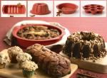  MAGIC BAKING FORMS | 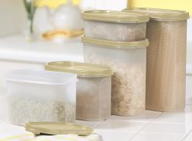  MODULAR MATES | 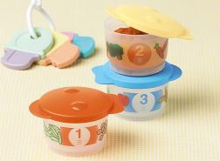  YUMMY TUMMY FIRST MEAL | 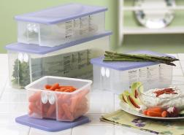FRIDGE SMART | 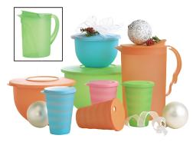  IMPRESSIONS
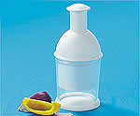  THE CHOPPER MACHINE | 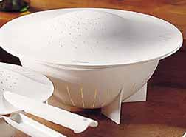  LARGE DOUBLE COLANDER | 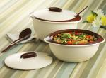  INSULATED OVAL SERVER | 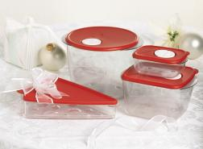  PIZZA, PASTA & MORE SET | 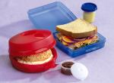  SANDWICH KEEPER SET
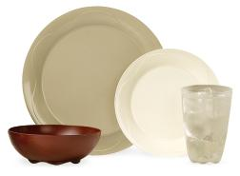 OPEN HOUSE COLLECTION | 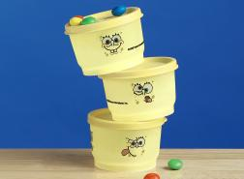  SPONGEBOB SNACK CUPS | FREE  LIFETIME  WARRANTY | 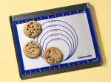  SILICONE WONDER MAT | 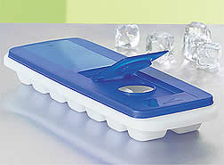  FRESH & PURE ICE TRAY
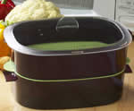  OVAL MICROWAVE COOKER | 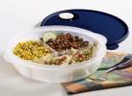  CRYSTAL WAVE DIVIDED DISH | 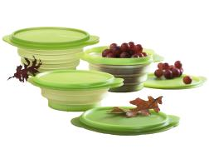  FLAT OUT CONTAINERS | 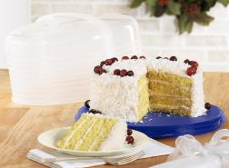  ROUND CAKE TAKER | 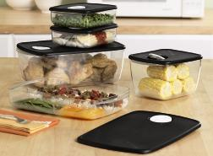  ROCK ‘N SERVE
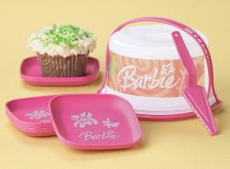  BARBIE MINI SWEET SET | 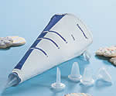  DECORATING BAG W/ TIPS | 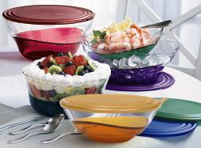  SHEERLY ELEGANT | 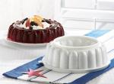  JEL-RING MOLD | 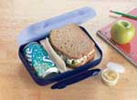AT LUNCH BOX
T | W | A | R | E
SILICONE WONDER MAT | INSULATED OVAL SERVER | SHEERLY ELEGANT | DECORATING BAG W/ TIPS | YUMMY TUMMY FIRST MEAL
ROCK ‘N SERVE | PIZZA, PASTA & MORE SETN | JEL-RING MOLD | AT LUNCH BOX | OPEN HOUSE COLLECTION
FRIDGE SMART | SANDWICH KEEPER SET | FREE  LIFETIME  WARRANTY | MAGIC BAKING FORMS | LARGE DOUBLE COLANDER
IMPRESSIONS | THE CHOPPER MACHINE | SPONGEBOB SNACK CUPS | FLAT OUT CONTAINERS | CRYSTAL WAVE DIVIDED DISH
ROUND CAKE TAKER | MODULAR MATES | FRESH & PURE ICE TRAY | OVAL MICROWAVE COOKER | BARBIE MINI SWEET SET

