T | W | A | R | E
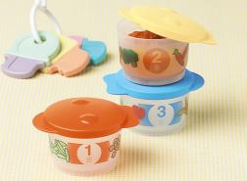BI YUMMY TUMMY FIRST MEAL | 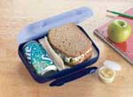AT LUNCH BOX | 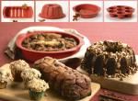  MAGIC BAKING FORMS | 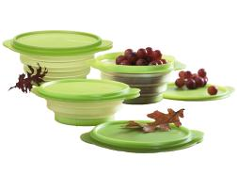FLAT OUT CONTAINERS | 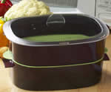  OVAL MICROWAVE COOKER
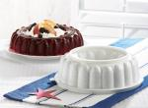  JEL-RING MOLD | 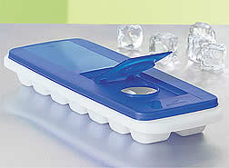  FRESH & PURE ICE TRAY | 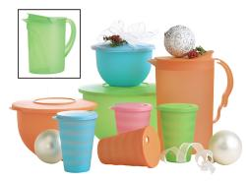  IMPRESSIONS | 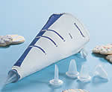  DECORATING BAG W/ TIPS | 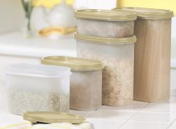  MODULAR MATES
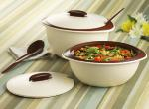  INSULATED OVAL SERVER | 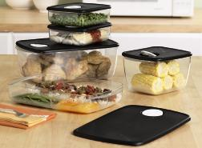  ROCK ‘N SERVE | FREE  LIFETIME  WARRANTY | 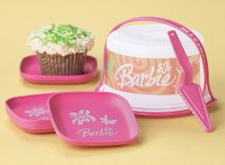  BARBIE MINI SWEET SET | 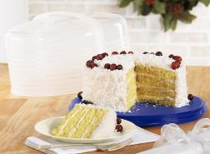  ROUND CAKE TAKER
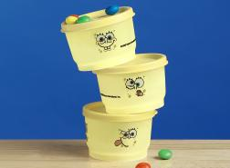  SPONGEBOB SNACK CUPS | 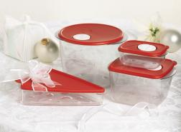  PIZZA, PASTA & MORE SET | 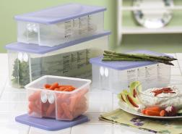  FRIDGE SMART | 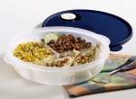  CRYSTAL WAVE DIVIDED DISH | 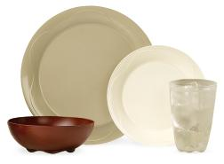  OPEN HOUSE COLLECTION
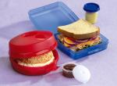  SANDWICH KEEPER SET | 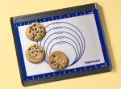  SILICONE WONDER MAT | 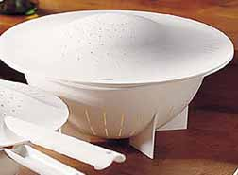  LARGE DOUBLE COLANDER | 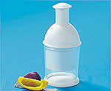  THE CHOPPER MACHINE | 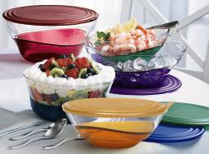SHEERLY ELEGANT

T | W | A | R | E
FRIDGE SMART | SPONGEBOB SNACK CUPS | ROCK ‘N SERVE | AT LUNCH BOX | FLAT OUT CONTAINERS
MODULAR MATES | DECORATING BAG W/ TIPS | CRYSTAL WAVE DIVIDED DISH | MAGIC BAKING FORMS | BARBIE MINI SWEET SET
THE CHOPPER MACHINE | JEL-RING MOLD | FREE  LIFETIME  WARRANTY | YUMMY TUMMY FIRST MEAL | LARGE DOUBLE COLANDER
SILICONE WONDER MAT | PIZZA, PASTA & MORE SET | OVAL MICROWAVE COOKER | OPEN HOUSE COLLECTION | SANDWICH KEEPER SET
SHEERLY ELEGANT | ROUND CAKE TAKER | IMPRESSIONS | INSULATED OVAL SERVER | FRESH & PURE ICE TRAY

