T | W | A | R | E
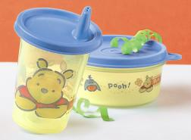  POOH MINI MEAL SET | 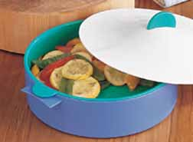  MICROSTEAMER |   FORGET ME NOT | 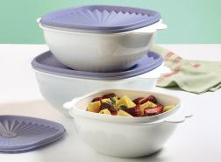3-PC SERVING BOWL SET | 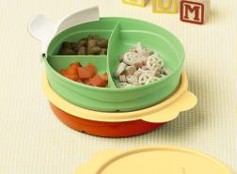  DIVIDED DISH SET
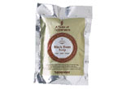  TASTE OF TW SOUP MIX | 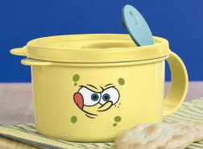  SPONGEBOB SOUP MUG | 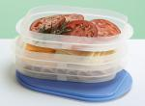  FRIDGE STACKABLES | 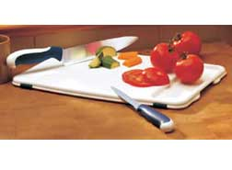  EASY LIFT CUTTING BOARD | 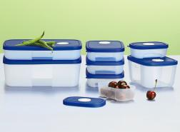  FREEZE SMART
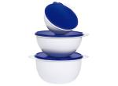  THATSA BOWL | 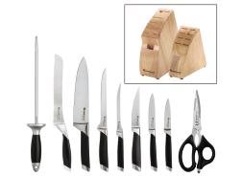CHEF SERIES KNIVES | FREE  LIFETIME  WARRANTY | 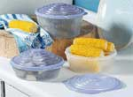  STUFFABLES CONTAINERS | 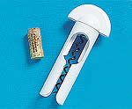  UPLIFTER CORKSCREW
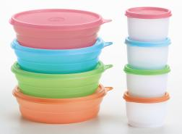  MICROWAVE CEREAL BOWL | 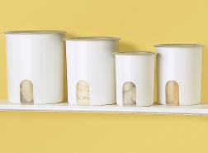  ONE TOUCH CANISTER |   16 OZ. TUMBLER | 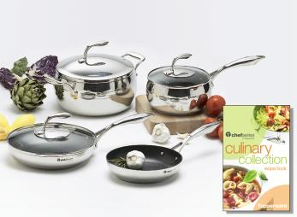  CHEF SERIES COOKWARE | 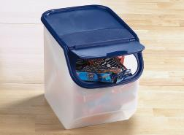  ACCESS MATES
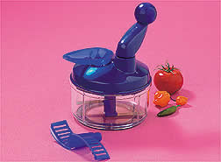  QUICK CHEF | 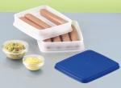  DOG HOUSE SET | 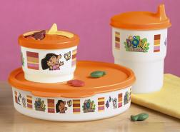  DORA THE EXPLORER | 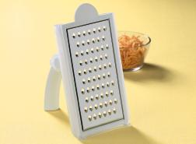  GRATE ‘N MEASURE GRATER | 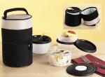MEAL SOLUTIONS TO GO PACK
T | W | A | R | E
ONE TOUCH CANISTER | 16 OZ. TUMBLER | DOG HOUSE SET | 3-PC SERVING BOWL SET | FREEZE SMART
QUICK CHEF | EASY LIFT CUTTING BOARD | CHEF SERIES COOKWARE | DIVIDED DISH SET | TASTE OF TW SOUP MIX
MICROSTEAMER | POOH MINI MEAL SET | FREE  LIFETIME  WARRANTY | THATSA BOWL | FORGET ME NOT
STUFFABLES CONTAINERS | MICROWAVE CEREAL BOWL | FRIDGE STACABLES | MEAL SOLUTIONS TO GO PACK | DORA THE EXPLORER
ACCESS MATES | UPLIFTER CORKSCREW | SPONGEBOB SOUP MUG | CHEF SERIES KNIVES | GRATE ‘N MEASURE GRATER

