November 14, 2005

Hi Everyone

Thank you to everyone that came by and joined in our birthday celebration for Matt. When going back to my list on Sunday and counting everyone that came by there were over 60 friends and family that came to share in the wonderful day. Lots of food, drink and fellowship and a day I will never forget. I hope everyone enjoyed the days events I know that Matt was with us and was very happy to see our love for him and each other.

Jimmy and Travis are looking at the Hawk that graced us with his present prior to sending off Matt's balloons. Most of you know the significance of the HAWK to our family so it was very special and appropriate that he was there.

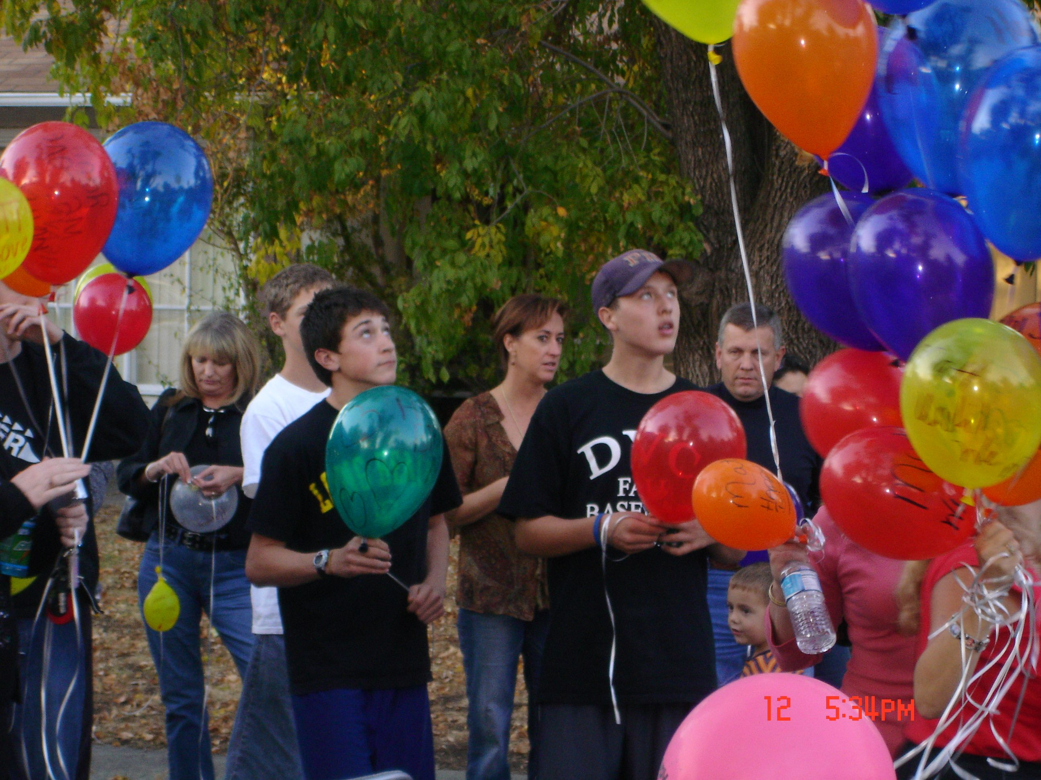

It was amazing to see the balloons leave our hands separately but as they flew higher and higher into the sky they joined together as one. It was an incredibly touching experience for everyone.

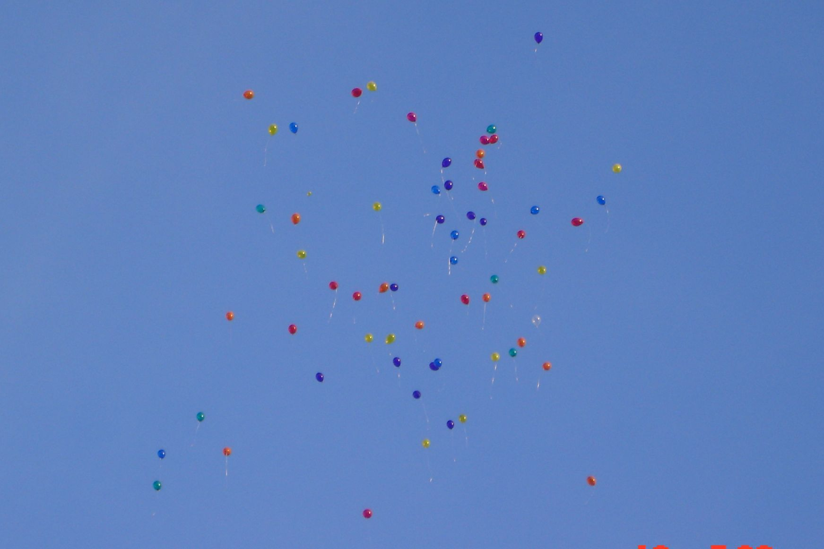

I am not going to do any anti hazing preaching today because I just want everyone to remember the wonderful time we shared together and to those that were unable to be with us our thoughts and love were with you all day.

FYI:

National Public Radio will be airing their 9-minute Matt segment this afternoon sometime between 5pm and 5:30pm and again between 12am and 12:30am on KQED 88.5 FM. Once it has aired you will be able to find the audio and the transcript at NPR.org NPR : A Fraternity Hazing Gone Wrong

I did find out that Inside Edition is still working on their segment and it is supposed to air within a week or two, I will let you know when I hear something.

As far as I know about DATELINE (very important) they are still waiting for the two misdemeanors to be through before they will be airing their segment.

As always thank you for your support. Hug your children and tell them you love them everyday.

Love,
Debbie, MM
www.wemissyoumatt.com

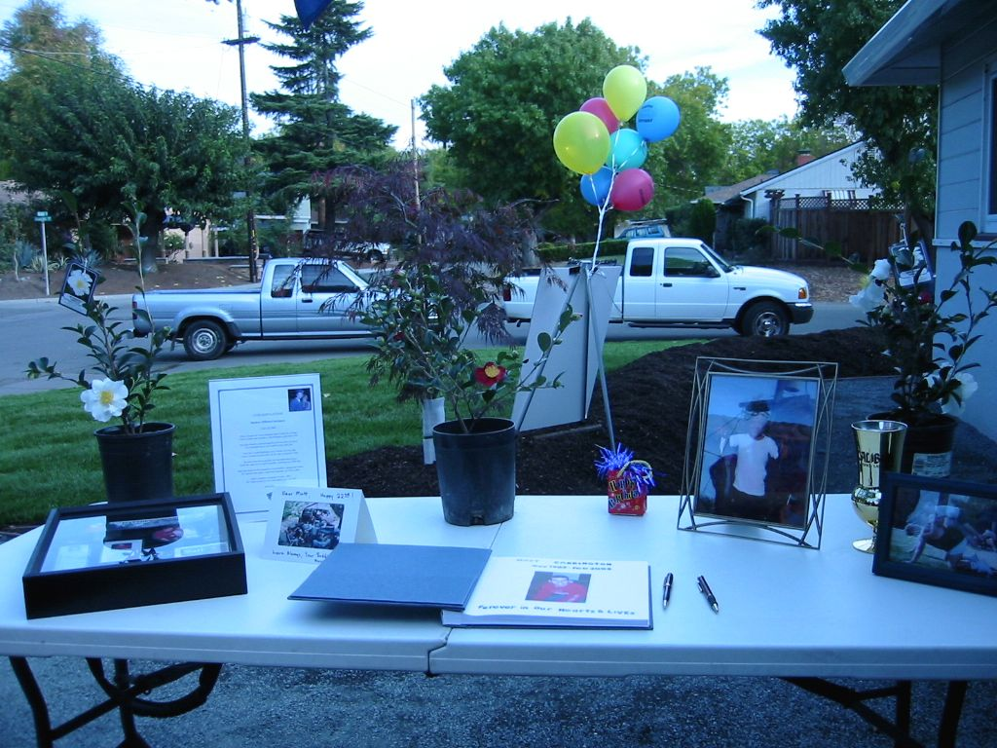

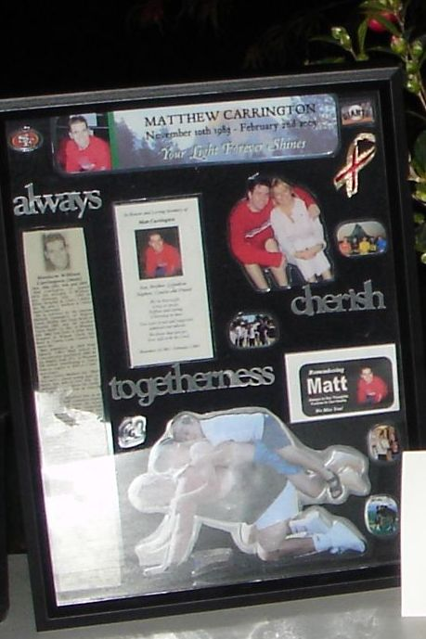 This is a very sweet gift from Jessica given to me on Matt’s birthday November 10th.

