D20 STAR WARS LITE
(The D20 System Rules are Required in order to use these Rules)

Race Selection
Human - No Modifier
Medium-size: Base speed 10 meters
4 extra skill points at 1st level and 1 extra skill point at each aditional level
1 extra feat at 1st level
Automatic Language: Read/Write Basic, Speak Basic

Bothan - +2 Dex, +2 Int, -2 Con
Medium size: Base speed 10 meters
+2 species bonus on Gather Information and Spot checks
+2 species bonus on Computer Use
Low-light vision
Bonus Technology related Feat at Level 1
Automatic Languages: Speak and Read/Write Bothese and Basic
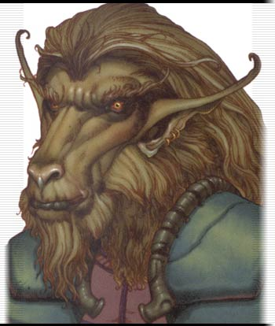
Duros - +2 Dex, +2 Int, -2 Str, -2 Con
Medium size: Base speed 10 meters
Low-light vision
+4 species bonus on craft checks
Duros receive the Spacer feat as a bonus feat at 1st level.
Automatic Languages: Speak and Read/Write Durese and Basic
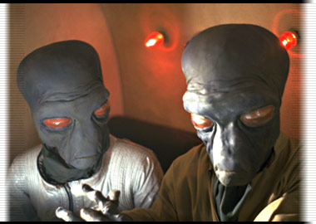
Gamorrean - +6 Str, -6 Int
Medium Size: Base Speed 10 meters
Primitive: A gamorrean receives the bonus feat Weapon Group Proficiency(primitive weapons) and
Weapon Group Proficiency(simple weapons) at 1st level.
+2 species bonus on Fortitude saves
Bonus Feat: Power Attack at 1st level.
Automatic Language: Speak Gamorrean
*Gamorreans are an incredibly un-intelligent species... They have no capabilities of speaking basic, and also cannot read or write.
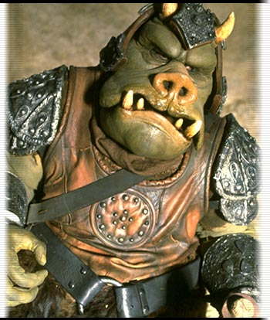
Ithorian - +2 Wis, +2 Cha, -2 Dex
Medium size: Base speed 10 meters
+2 species bonus on Knowledge(wilderness lore) checks
+4 species bonus on Survival checks
+1 species bonus on Will saves
Bonus Feat: Rugged at 1st level
Automatic Languages: Speak and Read/Write Ithorese and Basic
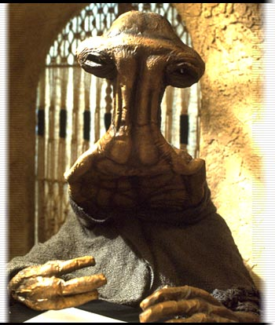
Jawa - +2 dex, -2 str
Small size: Base speed 6 meters
Small +1 to Armor and attack rolls
+4 to Hide checks
Darkvision - up to 20 feet, although the Jawa can only see black and white in the dark.
+2 bonus on Bluff and Handle Animal checks
Bonus Feat at 1st level: Persuasive
Automatic Languages: Speak and Read/Write Jawa and Basic
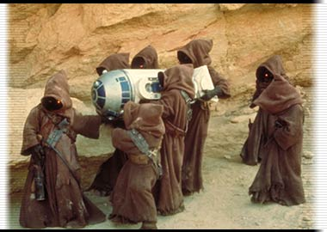
Mon Calamari - +2 Int, -2 Con
Medium size: Base speed 10 meters
Breathe Underwater
Low-light vision
+4 species bonus on Swim check
+4 species bonus on Craft checks(Player may select one craft skill)
+1 species bonus on Will saving throws in watery environments
-1 species penalty on Will saving throws in dry or arid environments
Automatic Languages: Speak and Read/Write Mon Calamarian and Basic

Quarren - +2 Con, -2 Wis
Medium size: Base speed 10 meters
Breathe Underwater
Low-light vision
+2 species bonus on Bluff checks
Automatic Languages: Speak and Read/Write Quarrenese and Basic
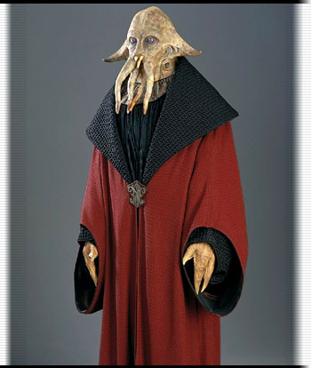
Rodian - +2 Dex, -2 Wis, -2 Cha
Medium size: Base speed 10 meters
Rodians receive the Track feat as a bonus feat at 1st level
+2 species bonus on Listen, Search, and Spot checks
Automatic Languages: Speak and Read/Write Rodese and Basic

Sullustan - +2 Dex, -2 Str
Medium size: Base speed 10 meters
Darkvision - up to 20 feet although Darkvision is in black and white only
+2 species bonus on Climb and Listen checks
Automatic Languages: Speak and Read/Write Sullustese and Basic

Trandoshan - +2 Str, -2 Dex
Medium size: Base speed 10 meters
+1 natural armor bonus to Defense
Darkvision - up to 20 feet although Darkvision is in black and white only
Bonus Feat: Track at 1st level
Automatic Languages: Speak and Read/Write Dosh and Basic

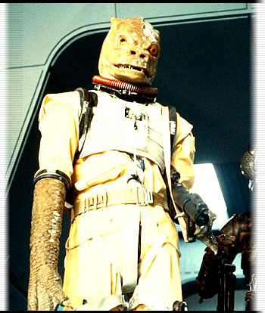
Twi'lek - +2 Cha, -2 Wis
Medium size: Base speed 10 meters
Low-Light Vision
+1 species bonus on Fortitude saves
+2 species bonus on Diplomacy checks
+4 species bonus on Entertain check (Female only)
Automatic Languages: Speak and Read/Write Ryl and Basic
Bonus Language: Lekku (the head-tail language)

Wookiee - +4 Str, -2 Dex, -2 Wis, -2 Cha
Medium size: Base speed 10 meters
+2 species bonus on Climb check
+4 species bonus on Intimidate checks
Wookiee Rage: When necessary the wookiee can fly into a frenzy.
The wookiee gains a temporary +4 strength, +2 vitality per level,
and a +2 rage bonus on Fortitude and Will saves, but suffers a -2 penalty to Defense.
While raging a wookiee cannot use skills that require patience and concentration-
Such as: Move Silently, Combat Expertise, or any Force-based skill.
A fit of rage lasts for 5 + the constitution modifier. At the end of the rage,
the wookiee loses the bonus vitality points gained from rage and is fatigued
and suffers -2 penalty to effective Str and Dex (can't run or charge) for a number of rounds equal to the rage duration.
Extraordinary Recuperation: A wookiee regains vitality and wound points at twice
the normal rate(2 vitality points per char. level per hour, 2 wound points per day of rest)
Favored Weapon: Wookiee's are capable of using Bowcasters without the Exotic Weapon Feat
Automatic Languages: Read/Write Shyrilwook and Basic, Speak Shyriiwook, understand Basic
*While Wookiee's are capable of understanding Basic, they are unable to speak it.


Specialty Races:
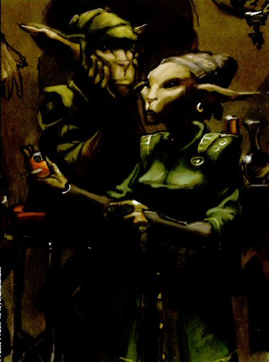
Bimm: -2 Str, +2 Int, +2 Cha
Small Size: Base speed is 6m
Bonus Feat at 1st Level
+2 racial bonus to all Charisma based skills
Automatic Languages: Bimm and Basic


Chiss - +2 Int, +2 Wis, -2 Str
Medium Size - Base Speed is 10m
Tactics: The Chiss have a martial society, and even those Chiss with no military background to speak of are trained in strategy appropriate to their skills. While using the "Tactics" ability Chiss are granted a +4 bonus to Charisma.
+4 racial bonus to Knowledge (Tactics)
Automatic Languages: Cheunh

Defel - +2 Wis, +2 Cha, -2 Dex, -2 Con
Small Size - Base speed is 6m
Invisibility: Defels absorb all light wavelengths except ultraviolet. In effect, they appear as patches of darkness, much like shadows; in areas of low light, they are effectively invisible. Unless the creature is under direct normal sunlight(or the artificial equivalent), the Defel gains a +2 Circumstance bonus to attacks, and its target loses all Dex bonuses to Defense. At the same time, attacks against a Defel in these circumstances confer a 50% miss chance. Under especially low-light conditions, the attacker must guess where the Defel actually is as well.
+2 racial bonus to Hide and move silently
Automatic Languages: Defel and Basic
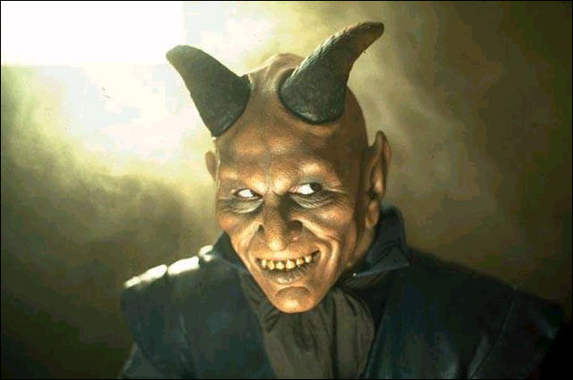
Devaronian(Male only) - +4 Dex, -2 Int, -2 Wis
Medium Size - Base speed is 10m
+2 racial bonus on Appraise and Bluff Checks
+2 racial bonus on Profession (Spacehand)
Automatic Languages: Devaronese and Basic

Faleen - +4 Cha, -2 Str
Medium Size - Base speed is 10m
Pheromones: The natural pheromones of Falleen affect the behavior of other beings in close proximity. Faleen gain a +1 species bonus on all Charisma-based checks(Except disguise), made against beings within 10 meters. The trait is continuous and cannot be "shut off."
Hold Breath: Many xenobiologists believe that the Falleen's reptilian ancestors were genetically close to amphibians. Faleen can hold their breath for a number of rounds equal to 25 times his/her Constitution score.
+2 Racial Bonus on Diplomacy, Bluff, and Gather Information checks
Automatic Languages: Faleen and Basic
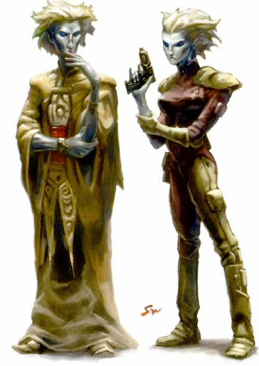
Omwati - +2 Int, +2 Wis, -2 Str
Medium Size - Base speed is 10m
Bonus Feat: Gearhead
-2 racial bonus to Pilot and Astrogate checks
+2 racial bonus to Diplomacy and Gather Information checks
Automatic Languages: Omwatese and Basic

Shistavanen - +2 Str, +2 Con, -2 Int, -2 Cha
Medium Size - Base speed is 10m
Bonus Feats: Alertness, Improved Initiative
+2 racial bonus to Listen, Search, and Spot checks
Automatic Languages: Shistavanen and Basic
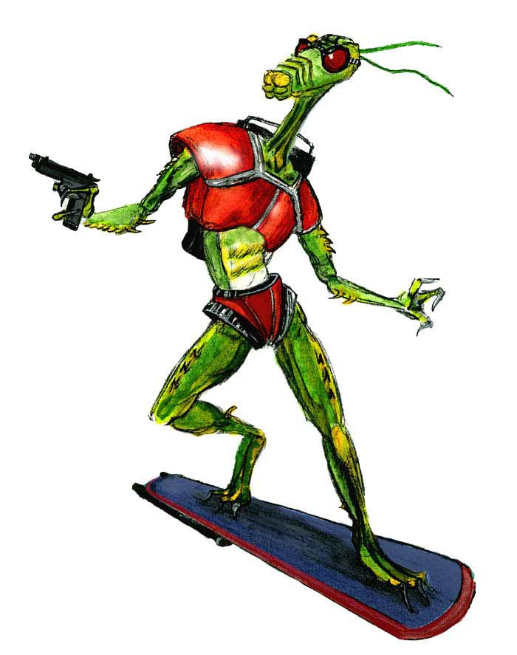
Verpine - +4 Int, +2 Dex, -2 Str
Medium Size - Base Speed is 10m
Organic Telecommunication: Verpine can send radio waves through their antennae, so they can communicate with other Verpine as well as specially tuned comlinks. The ability is limited for individuals(1 km), but when working together, a hive can broadcast up to 50km per Verpine for a great deal of distance.
Bonus Feat: Gearhead
+4 Racial Bonus on Repair Checks
+2 Racial Bonus on Disable Device Checks
Automatic Languages: Verpine and Basic
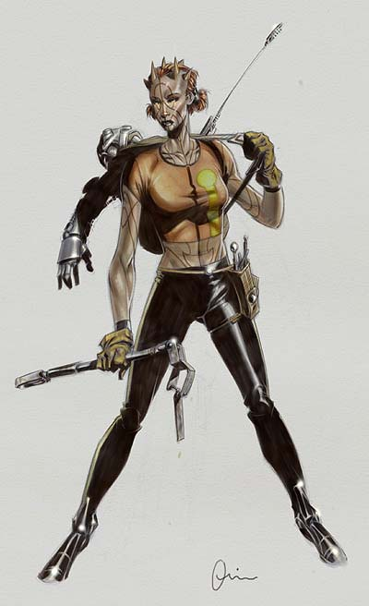
Zabrak - +2 Con
Medium Size - Base Speed is 10m
+2 Racial Bonus on Fortitude and Will Saving Throws
Bonus Feat at 1st level
Automatic Languages: Zabrak and Basic

Classes
Fringer: A Jack of all trades, with little formal education who picks up skills and tech. knowledge through life experience and improvisation.
Abilities: Dex, Wid, and Str are the most important for the Fringer class.
Bonus Feat/Class Skill at 1st level
Barter at 2nd Level
Jury-Rig+2 at 3rd Level
Bonus Class Skill at 4th Level
Class Skills: Climb, Craft, Gamble, Handle Animal, Hide, Jump, Knowledge, Listen, Pilot, Profession, Ride, Search, Spot, Survival, Swim.
Weapon Group Proficiency(Primitive weapons)
Weapon Group Proficiency(Simple weapons)
Noble: A master of bargaining and negotiation who inspires confidence and makes a great leader.
Abilities: Charisma is the most important, Wis and Int, are next in line.
Bonus class skill, favor +1 at 1st level
Inspire confidence at 2nd level
Favor +2, resource access at 3rd level
Coordinate +1 at 4th level
Class skills: Appraise, Computer Use, Craft, Diplomacy, Disguise, Entertain, Knowledge, Profession, Read/Write Language, Ride, Sense Motive, Speak Language.
Weapon Group Proficiency(Blaster pistols)
Weapon Group Proficiency(Simple weapons)
*Bonus skill at 1st level must be cross-class.
Members of the noble class use their intelligence and natural charisma to make their way in the galaxy. From true royalty to elected officials, military commanders to crime lords, traders, merchants, ambassadors, holovid stars, and influential corporate magnates, character types who appear in the noble class are varied and numerous. Some bring honor to the name. Others are sly, treacherous, and dishonorable to the core. With a winning smile, a golden tongue, a powerful message, or a knack for making compromises, the noble commands respect, makes friends, and inevitably influences people.
Exploits
Most nobles wind up in dangerous situations because of something they believe in or because their job calls for it. Others hope to use their negotiating talents to navigate a course through the troubles around them, or seek to find profit in the troubles of others. Whatever their initial motivations, nobles usually wind up taking to a cause and a goal that sustains them through the roughest missions. An adventuring noble might be a senator's aide, a free trader, a diplomat, a true prince or princess, or an outlaw's lieutenant. Nobles often feel responsible for others, though some consider themselves to be better than those around them.
Characteristics
The noble fosters feelings of good will and honesty, or at least the illusion of such, to succeed. Where other classes shoot first, the noble starts out asking questions and hopes to finish by negotiating a deal. The noble believes she can be more effective with words and deeds than with violence, though some draw a blaster when push comes to shove. The noble is more comfortable in civilized regions of space, where law and order have some meaning. Of all the classes, nobles have the best diplomatic and bargaining skills. They're good talkers, negotiators, and bluffers. They have a knack for inspiring others, and they make good leaders.
Background
Nobles come to their profession in a variety of ways. Altruistic nobles believe it is their duty and responsibility to serve and lead. More selfish nobles seek the fame, wealth, and power often associated with the positions they aspire to. Power-hungry nobles take advantage of the system and wind up helping others only to help themselves. The halls of power are calling. How the noble answers can make all the difference.
Examples of Nobles in Star Wars
Leia Organa, Padmé Amidala, Talon Karrde, the vile gangster Jabba the Hutt, Chancellor Valorum, Supreme Chancellor Palpatine.
Game Rule Information
Nobles have the following game statistics.
Abilities
Charisma is undoubtedly a noble's most important ability score, as the noble's skill at interacting with others and projecting a sense of confidence is crucial for his or her success. Wisdom and Intelligence form the basis of other important skills, so these ability scores are also significant.
Vitality
Nobles gain 1d6 vitality points per level. The character's Constitution modifier applies.
Class Skills
The noble's class skills, and the key ability for each, are as follows (see Chapter Four: Skills for skill descriptions).
Appraise (Int), Computer Use (Int), Craft* (Int), Diplomacy (Cha), Disguise (Cha), Entertain* (Cha), Knowledge* (Int), Profession* (Wis), Read/Write Language (none), Ride (Dex), Sense Motive (Wis), Speak Language (none).
* This skill actually encompasses a number of unrelated skills. Each time this skill is learned, a specific category must also be chosen. Examples include Craft (droids), Entertain (kloo horn), Knowledge (Jedi lore), and Profession (droid programmer).
- Skill Points at 1st Level: (6 + Int modifier) x 4.
- Skill Points at Each Additional Level: 6 + Int modifier.
Class Features
All of the following are class features of the noble.
Starting Feats
The noble begins play with the following feats:
Weapon Group Proficiency (blaster pistols)
Weapon Group Proficiency (simple weapons)
Bonus Class Skill
At 1st level, a noble may designate any one cross-class skill (except for a Force-related skill) as a class skill. This represents an area of expertise the noble picks up outside his or her normal training.
Favors
The noble has the ability to call in favors from those she knows. By making a favor check, the noble can call upon contacts to gain important information without going through the time and trouble of doing a lot of research. Favors can also be used to acquire the loan of equipment or documents from influential acquaintances.
To call in a favor, the noble makes a favor check. Roll a d20 and add the character's favor bonus (+1 at 1st level, +2 at 3rd level, and so on). The GM sets the DC based on the scope of the favor being requested. The DC ranges from 10 for a simple favor to as high as 25 for highly dangerous, expensive, or illegal favors. The noble can't take 10 or take 20 on this check, nor can she retry the check for the same (or virtually the same) favor. (See Chapter Four: Skills for information on taking 10 and taking 20.) Note that favors should help advance the plot of an adventure. A favor that would enable a character to circumvent an adventure should always be unavailable to the character, regardless of the results of a favor check.
A noble can try to call in a favor a number of times in a week of game time that's equal to half her noble levels, rounded up. So, as a 1st-level noble, Arani can attempt to call in a single favor, while as a 7th-level noble she can attempt to call in favors as many as four times from different contacts.
The GM should carefully monitor the noble's use of favors to ensure that this ability isn't abused. The success or failure of a mission shouldn't hinge on the use of a favor, and calling in favors shouldn't replace good roleplaying or the use of other skills. The GM may disallow any favor deemed to be disruptive to the game. See Chapter Twelve: Gamemastering for additional information on favors and contacts.
Inspire Confidence
Beginning at 2nd level, a noble can use oratory to inspire confidence in allies, bolstering them and improving their chances of success. An ally must listen to and observe the noble for a full round for the inspiration to take hold. The effect lasts for 5 rounds. The noble can inspire a number of allies equal to half her noble levels, rounded up. She can inspire confidence once per day for every four levels of noble she possesses (once per day from 1st to 4th level, twice per day from 5th to 8th level, and so on).
An ally inspired with confidence gains a +2 morale bonus on saving throws and a +1 morale bonus on attack and weapon damage rolls.
The noble can't inspire confidence in herself. The ability only aids her allies.
Resource Access
Beginning at 3rd level, a noble has access to an array of resources (usually from family, influential friends, or patrons). Once per game session, the noble can make a Charisma check to use those resources during the adventure.
The value of resources gained equals the noble's class level multiplied by the result of the Charisma check multiplied by 20. Thus, a 3rd-level noble who gets a result of 16 on her Charisma check would gain 960 credits' worth of resources to use in the adventure (3 x 16 x 20 = 960). Resource access can be used instead of, but not in addition to a Profession skill check, to generate money. (The difference being that a Profession check is done between adventures, while Resource Access would be used during adventures, and can be traced more easily.)
These resources can take almost any form the noble chooses (within reason) and are hers to do with as she pleases. She can keep them, use them, give them away, or sell them as she sees fit. The resources gained arrive in the noble's possession 1d8 hours after she makes the check. These resources must be reasonably available when and where she chooses to make the check. For instance, a noble trekking through the wilderness of Endor's forest moon won't have access to many resources.
Resource access tends to be monetary, whereas favors tend to be benefits that can't necessarily be measured in credits.
Coordinate
A noble has a knack for getting people to work together. When the noble can aid others and give directions, she provides a bonus to the task at hand by making an aid another check. This bonus is in addition to the normal aid another bonus (+2), and it increases as the noble gains levels. So, the noble provides a total +3 bonus at 4th level (+2 aid another bonus, +1 cooperation bonus), a +4 bonus at 8th level, etc.
This ability can't be used to assist in combat.
Bonus Feats At 6th, 9th, 14th, and 19th level, the noble gains a bonus feat. This feat must be selected from the following list, and the noble must meet any prerequisites: Fame, Frightful Presence, Influence, Mimic, Persuasive, Sharp-Eyed, Trustworthy.
Inspire Greatness
Beginning at 11th level, a noble can inspire greatness in an ally, granting extra fighting capability. This works similar to inspire confidence, except it affects but a single ally. An ally inspired with greatness gains +2d6 temporary vitality points, a +2 competence bonus on attacks, and a +2 morale bonus to saving throws. The effect lasts for 5 rounds. The noble can inspire greatness once per day. For every three noble levels attained beyond 11th level, the noble can inspire greatness in one additional ally.
The noble can't inspire greatness in herself. The ability only aids her allies.
Credits
A 1st-level noble starts play with 1d4 x 1,000 credits.
Table 3-3: The Noble
 | Base Attack | Fort | Ref | Will |  | Defense | Reputation
Level | Bonus | Save | Save | Save | Special | Bonus | Bonus
1st | +0 | +0 | +1 | +2 | Bonus class skill, favor +1 | +2 | +1
2nd | +1 | +0 | +2 | +3 | Inspire confidence | +3 | +1
3rd | +2 | +1 | +2 | +3 | Favor +2, resource access | +3 | +1
4th | +3 | +1 | +2 | +4 | Coordinate +1 | +3 | +2
5th | +3 | +1 | +3 | +4 |  | +4 | +2
6th | +4 | +2 | +3 | +5 | Bonus feat | +4 | +2
7th | +5 | +2 | +4 | +5 | Favor +3 | +5 | +2
8th | +6/+1 | +2 | +4 | +6 | Coordinate +2 | +5 | +3
9th | +6/+1 | +3 | +4 | +6 | Bonus feat | +5 | +3
10th | +7/+2 | +3 | +5 | +7 |  | +6 | +3
11th | +8/+3 | +3 | +5 | +7 | Inspire greatness | +6 | +3
12th | +9/+4 | +4 | +6 | +8 | Favor +4 | +7 | +4
13th | +9/+4 | +4 | +6 | +8 | Coordinate +3 | +7 | +4
14th | +10/+5 | +4 | +6 | +9 | Bonus feat | +7 | +4
15th | +11/+6/+1 | +5 | +7 | +9 |  | +8 | +4
16th | +12/+7/+2 | +5 | +7 | +10 | Favor +5 | +8 | +5
17th | +12/+7/+2 | +5 | +8 | +10 |  | +9 | +5
18th | +13/+8/+3 | +6 | +8 | +11 | Coordinate +4 | +9 | +5
19th | +14/+9/+4 | +6 | +8 | +11 | Bonus feat | +9 | +5
20th | +15/+10/+5 | +6 | +9 | +12 | Coordinate +5 | +10 | +6
Scoundrel: A tricky, skillful rogue who succeeds by stealth instead of brute force.
Abilities: Dex and Int are most important, followed by Cha. Wis is next in line after those 3.
Illicit Barter
Lucky(1/day)
Precise attack +1
Skill Emphasis
Class Skills: Appraise, Astrogate, Balance, Bluff, Computer Use, Craft, Demolitions, Disable Device, Disguise, Escape Artist, Forgery, Gamble,
Gather Information, Hide, Knowledge, Listen, Move Silently, Pilot, Profession, Repair, Search, Sleight of Hand, Spot, Tumble.
Weapon Group Proficiency(Blaster pistols)
Weapon Group Proficiency(Simple weapons)
Scout: A cunning, skilled explorer trained to operate in the vast wilderness of space and backwater worlds.
Abilities: Dex, Int, and Wis are most important for Scouts, Str is also useful.
Bonus feat at 1st level
Trailblazing at 2nd level
Heart +1 at 3rd level
Uncanny Dodge at 4th level
Class Skills: Astrogate, Climb, Computer Use, Craft, Demolition, Disguise, Hide, Jump, Knowledge, Listen, Move Silently, Pilot, Profession,
Read/Write Language, Repair, Ride, Search, Speak Language, Spot, Survival, Swim.
Weapon Group Proficiency(Blaster pistols)
Weapon Group Proficiency(Blaster rifles)
Weapon Group Proficiency(Simple weapons)
TABLE: The Scout
Base Fort Ref Will
Level Attack Bonus Save Save Save Special | Defense
----- ------------ ---- ---- ---- ------- | -------
1 +0 +1 +1 +1 Bonus Skill | +2
2 +1 +2 +2 +2 Trailblazing | +2
3 +2 +2 +2 +2 Heart +1 | +3
4 +3 +2 +2 +2 Uncanny Dodge  (Dex Bonus Only) | +3
5 +3 +3 +3 +3 Extreme Effort | +4
6 +5 +3 +3 +3 Evasion | +4
7 +6/+1 +3 +3 +3 Uncanny Dodge  (Full Feat) | +5
8 +6/+1 +4 +4 +4 Bonus Feat | +5
9 +7/+2 +4 +4 +4 | +6
10 +8/+3 +4 +4 +4 Skill Mastery | +6
11 +9/+4 +5 +5 +5 Heart +2 | +7
12 +9/+4 +5 +5 +5 Bonus Feat | +7
13 +10/+5 +5 +5 +5 | +8
14 +11/+6/+1 +6 +6 +6 Heart +3 | +8
15 +12/+7/+2 +6 +6 +6 Skill Mastery | +9
16 +12/+7/+2 +6 +6 +6 Bonus Feat | +9
17 +13/+8/+3 +7 +7 +7 | +10
18 +14/+9/+4 +7 +7 +7 Heart +4 | +10
19 +15/+10/+5 +7 +7 +7 | +11
20 +15/+10/+5 +8 +8 +8 Skill Mastery | +11
Heart: bonus to all dice rolls once per day
Skill Mastery: +5 to one skill
Soldier: A warrior with exceptional combat capability and unequaled skill with weapons.
Abilities: Dexterity is the soldier's most important ability score, followed closely by Con and Str.
Bonus Feats at 2nd, 3rd, and 4th level
Class Skills: Astrogate, Computer Use, Craft, Demolitions, Intimidate, Knowledge, Pilot, Profession, Repair, Treat Injury.
Armor Proficiency(Light)
Weapon Group Proficiency(Blaster pistols)
Weapon Group Proficiency(Blaster rifles)
Weapon Group Proficiency(Heavy weapons)
Weapon Group Proficiency(Simple weapons)
Weapon Group Proficiency(Vibro weapons)
Base Fort Ref Will
 | Defense
Level Attack Bonus Save Save Save Special
----- ------------ ---- ---- ---- -------
  -------
1 +1 +2 +0 +0 All Armor and Weapon Proficiencies | +3
2 +2 +3 +0 +0 Bonus feat | +3
3 +3 +3 +1 +1 Bonus feat | +4
4 +4 +4 +1 +1 Bonus feat | +4
5 +5 +4 +1 +1 | +5
6 +6/+1 +5 +2 +2 Bonus feat | +5
7 +7/+2 +5 +2 +2 | +6
8 +8/+3 +6 +2 +2 Bonus feat | +6
9 +9/+4 +6 +3 +3 | +7
10 +10/+5 +7 +3 +3 Bonus feat | +7
11 +11/+6/+1 +7 +3 +3 | +8
12 +12/+7/+2 +8 +4 +4 Bonus feat | +8
13 +13/+8/+3 +8 +4 +4 | +9
14 +14/+9/+4 +9 +4 +4 Bonus feat | +9
15 +15/+10/+5 +9 +5 +5 | +10
16 +16/+11/+6/+1 +10 +5 +5 Bonus feat | +10
17 +17/+12/+7/+2 +10 +5 +5 | +11
18 +18/+13/+8/+3 +11 +6 +6 Bonus feat | +11
19 +19/+14/+9/+4 +11 +6 +6 | +12
20 +20/+15/+10/+5 +12 +6 +6 Bonus feat | +12

Starship Ace: What a soldier is on the ground, a Starship ace is in a cockpit.
Abilities: Dexterity and Intelligence are by far the most important for the starship ace.
Starship Defense
Familiarity +1
Bonus Feat
Familiarity +3
Class Skills: Astrogate, Computer Use, Knowledge*, Pilot, Profession*, Repair, and Spot.
Weapon Group Proficiency (Blaster Pistols)
Tech Specialist: A skilled high-tech wizard who focuses on a specific application of technology, such as surgery, starship mechanics, or droid programming.
Abilities: Int is the most important ability for a tech specialist. Wis and Dex also help as secondary abilities.
Skill Emphasis
Research
Instant Mastery
Tech Specialty
Class Skills: Astrogate, Computer Use, Craft, Demolitions, Disable Device, Knowledge, Pilot, Profession, Read/Write Language, Repair, Search, Treat Injury
Weapon Group Proficiency(Simple weapons)
TABLE: The Tech Specialist
Base Fort Ref Will
Level Attack Bonus Save Save Save Special | Defense
----- ------------ ---- ---- ---- ------- | -------
1 +0 +0 +1 +1 Skill Emphasis | +2
2 +1 +1 +2 +2 Research | +2
3 +2 +1 +2 +2 Instant Mastery | +3
4 +3 +1 +2 +2 | +3
5 +3 +2 +3 +3 Tech Specialty | +4
(Computer, MasterCraft,
Medical, Science, etc)
6 +5 +2 +3 +4 Expert | +4
7 +6/+1 +2 +3 +4 | +5
8 +6/+1 +3 +4 +5 | +5
9 +7/+2 +3 +4 +5 Expert | +6
10 +8/+3 +3 +4 +6 Tech Specialty | +6
11 +9/+4 +4 +5 +6 | +7
12 +9/+4 +4 +5 +7 | +7
13 +10/+5 +4 +5 +7 | +8
14 +11/+6/+1 +5 +6 +8 Expert | +8
15 +12/+7/+2 +5 +6 +8 Tech Specialty | +9
16 +12/+7/+2 +5 +6 +9 | +9
17 +13/+8/+3 +6 +7 +9 | +10
18 +14/+9/+4 +6 +7 +10 Expert | +10
19 +15/+10/+5 +6 +7 +10 Master Tech | +11
20 +15/+10/+5 +7 +8 +11 Tech Specialty | +11

Skill Emphasis: +2 to two skills
Instant Mastery: 10 ranks to a skill not yet chosen
Expert: +5 to 1 skill
Jedi Guardian
Level | Base Attack Bonus | Fort Save | Ref Save | Will Save
 |  |  |  |  | Def
 |  |  |  |  |  | Abilities Gained
1st | +1 | +2 | +0 | +0 | +3 | Force Training, deflect (defense)
2nd | +2 | +3 | +0 | +0 | +3 | Bonus Feat
3rd | +3 | +3 | +1 | +1 | +4 | Force Training, deflect (attack)
4th | +4 | +4 | +1 | +1 | +4 | Force Training
5th | +5 | +4 | +1 | +1 | +5 | Light Saber Damage 3d8
6th | +6 / +1 | +5 | +2 | +2 | +5 | Deflect (extend defense & attack)
7th | +7 / +2 | +5 | +2 | +2 | +6 | --
8th | +8 / +3 | +6 | +2 | +2 | +6 | Bonus Feat
9th | +9 / +4 | +6 | +3 | +3 | +7 | Deflect (Defense), Block
10th | +10 / +5 | +7 | +3 | +3 | +7 | --
11th | +11 / +6 / +1 | +7 | +3 | +3 | +8 | Deflect (Attack)
12th | +12 / +7 / +2 | +8 | +4 | +4 | +8 | Bonus Feat
13th | +13 / +8 / +3 | +8 | +4 | +4 | +9 | Deflect (Defense)
14th | +14 / +9 / +4 | +9 | +4 | +4 | +9 | --
15th | +15 / +10 / +5 | +9 | +5 | +5 | +10 | --
16th | +16 / +11 / +6 / +1 | +10 | +5 | +5 | +10 | Deflect (attack)
17th | +17 / +12 / +7 / +2 | +10 | +5 | +5 | +11 | Deflect (defense)
18th | +18 / +13 / +8 / +3 | +11 | +6 | +6 | +11 | Bonus Feat
19th | +19 / +14 / +9 / +4 | +11 | +6 | +6 | +12 | Deflect (attack)
20th | +20 / +15 / +10 / +5 | +12 | +6 | +6 | +12 | --

Skills
Starting Skill Points
Fringer - 6 + Int Modifier x 4
Noble - 6 + Int Modifier x 4
Scoundrel - 8 + Int Modifier x 4
Scout - 6 + Int Modifier x 4
Soldier - 4 + Int Modifier x 4
Starship Ace - 4 + Int Modifier x 4
Tech Specialist - 4 + Int Modifier x 4
Jedi Guardian- 4+Int Modifier
Skill (Key Ability) | Use Untrained | Fringer | Noble | Scoundrel | Scout | Soldier | Tech Spec.
Appraise (Int) | Yes | X | C | C | X | X | X
Astrogate (Int) | No | X | X | C | C | C | C
Balance (Dex) | Yes | X | X | C | X | X | X
Bluff (Cha) | Yes | X | X | C | X | X | X
Climb (Str) | Yes | C | X | X | C | X | X
Computer Use (Int) | Yes | X | C | C | C | C | C
Craft (Int)* | Yes | C | C | C | C | C | C
Demolitions (Int) | No | X | X | C | C | C | C
Diplomacy (Cha) | Yes | X | C | X | X | X | X
Disable Device (Int) | No | X | X | C | X | X | C
Disguise (Cha) | Yes | X | C | C | C | X | X
Entertain (Cha) | Yes | X | C | X | X | X | X
Escape Artist (Dex) | Yes | X | X | C | X | X | X
Forgery (Int) | Yes | X | X | C | X | X | X
Gamble (Wis) | Yes | C | X | C | X | X | X
Gather Information (Cha) | Yes | X | X | C | X | X | X
Handle Animal (Cha) | No | C | X | X | X | X | X
Hide (Dex) | Yes | C | X | C | C | X | X
Intimidate (Cha) | Yes | X | X | X | X | C | X
Jump (Str) | Yes | C | X | X | C | X | X
Knowledge (Int)** | No | C | C | C | C | C | C
Listen (Wis) | Yes | C | X | C | C | X | X
Move Silently (Dex) | Yes | X | X | C | C | X | X
Pilot (Dex) | No | C | X | C | C | C | C
Profession (Wis)*** | No | C | C | C | C | C | C
Read/Write Language (None) | No | X | C | X | C | X | C
Repair (Int) | No | X | X | C | C | C | C
Ride (Dex) | Yes | C | C | X | C | X | X
Search (Int) | Yes | C | X | C | C | X | C
Sense Motive (Wis) | Yes | X | C | X | X | X | X
Sleight of Hand (Dex) | No | X | X | C | X | X | X
Speak Language (None) | No | X | C | X | C | X | X
Spot (Wis) | Yes | C | X | C | C | X | X
Survival (Wis) | Yes | C | X | X | C | X | X
Swim (Str) | Yes | C | X | X | C | X | X
Treat Injury (Wis) | Yes | X | X | X | X | C | C
Tumble (Dex) | No | X | X | C | X | X | X
C Class Skill. X Cross-class skill
*Craft Abilities: airspeeders, armor, blaster pistols/rifles, capital ships, computers, costumes, droids, electronic devices, exotic weapons, heavy weapons, holoart, hyperdrives, landspeeders, medpacs, repulsorlift engines, sculpture, simple/primitive weapons, slugthrowers, space transports, starfighters, starship weapons, sublight drives, tools, vibro weapons, walker vehicles, wheeled/tracked vehicles
**Knowledge Areas: Alien Species, Archaeology, Architecture, Astronomy, biology, beauracracy, business, chemistry, engineering, forensics, genetics, geography, history, jedi lore, medicine, physics, politics, streetwise, tactics, technology, wilderness lore, world lore.
***Professions: bartender, cook, moisture farmer, herbalist, spacehand, trader, doctor, slicer, engineer, mechanic, lawyer, law officer, computer programmer, droid programmer, military officer, gambler, entertainer
Feats
Feat | Prerequisite |  | Feat | Prerequisite
Acrobatic |  |  | Mimic
Alertness |  |  | Nimble
Ambidexterity | Dex 15 |  | Persuasive
Animal Affinity |  |  | Point Blank Shot
Armor Profiency (light) |  |  | Far Shot | Point Blank Shot
Armor Proficiency (medium) | Armor Proficiency (light) |  | Precise Shot | Point Blank Shot
Armor Proficiency (heavy) | Armor Proficiency (light)  Armor Proficiency (medium) |  | Rapid Shot | Dex 13, Point Blank Shot
Armor Proficiency (powered) | Armor Proficiency (light)  Armor Proficiency (medium) |  | Multishot | Dex 13, Point Blank Shot,  Rapid Shot
Athletic |  |  | Shot on the Run | Dex 13, Point Blank Shot,  Dodge, Mobility
Blind-Fight |  |  | Power Attack | Str 13
Cautious |  |  | Cleave | Str 13, Power Attack
Combat Expertise | Int 13 |  | Great Cleave | Str 13, Power Attack,  Cleave, base attack bonus +4
Improved Disarm | Int 13, Combat Expertise |  | Improved Bantha Rush | Str 13, Power Attack
Improved Trip | Int 13, Combat Expertiese |  | Sunder | Str 13, Power Attack
Whirlwind Attack | Dex 13, Int 13, Dodge, Mobility  Spring Attack, Combat Expertise,  base attack bonus +4 |  | Quick Draw | Base attack bonus +1
Combat Reflexes |  |  | Quickness
Dodge | Dex 13 |  | Rugged
Mobility | Dex 13, Dodge |  | Run
Spring Attack | Dex 13, Dodge, Mobility,  base attack bonus +4 |  | Skill Emphasis
Endurance |  |  | Sharp-Eyed
Exotic Weapon Proficiency | Base attack bonus +1 |  | Spacer
Fame |  |  | Stamina | Con 13
Force-Sensitive |  |  | Starship Dodge | Dex 13, Pilot 6 ranks, Starship  Operation
Frightful Presence | Cha 15, Intimidate 9 ranks |  | Starship Operation | Pilot 2 ranks
Gearhead |  |  | Steady
Great Fortitude |  |  | Stealthy
Headstrong |  |  | Surgery | Treat Injury 4 ranks
Heroic Surge |  |  | Toughness
Improved Critical | Proficient with weapon,  base attack bonus +8 |  | Track
Improved Initiative |  |  | Trick
Infamy |  |  | Trustworthy
Influence |  |  | Two-Weapon Fighting
Iron Will |  |  | Improved Two-Weapon  Fighting | Two-Weapon Fighting,  Ambidexterity,  Base attack bonus +9
Lightning Reflexes |  |  | Weapon Finesse | Proficient with weapon,  base attack bonus +1
Low Profile |  |  | Weapon Focus | Proficient with weapon,  base attack bonus +1
Martial Arts |  |  | Weapon Group Proficiency
Defensive Martial Arts | Martial Arts |  | Zero-G Training | Dex 13, Tumble 4 ranks
Improved Martial Arts | Martial Arts, base attack bonus +4
Advanced Martial Arts | Martial Arts, Improved Martial Arts,  base attack bonus +8

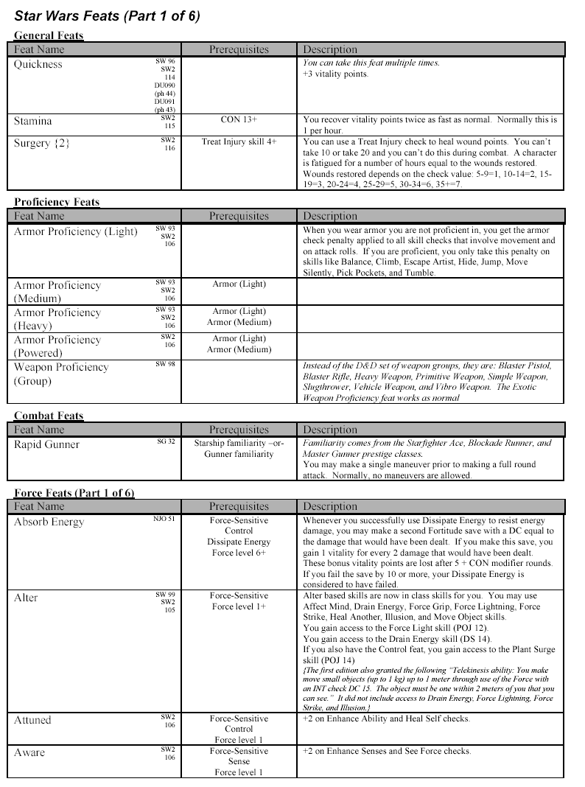
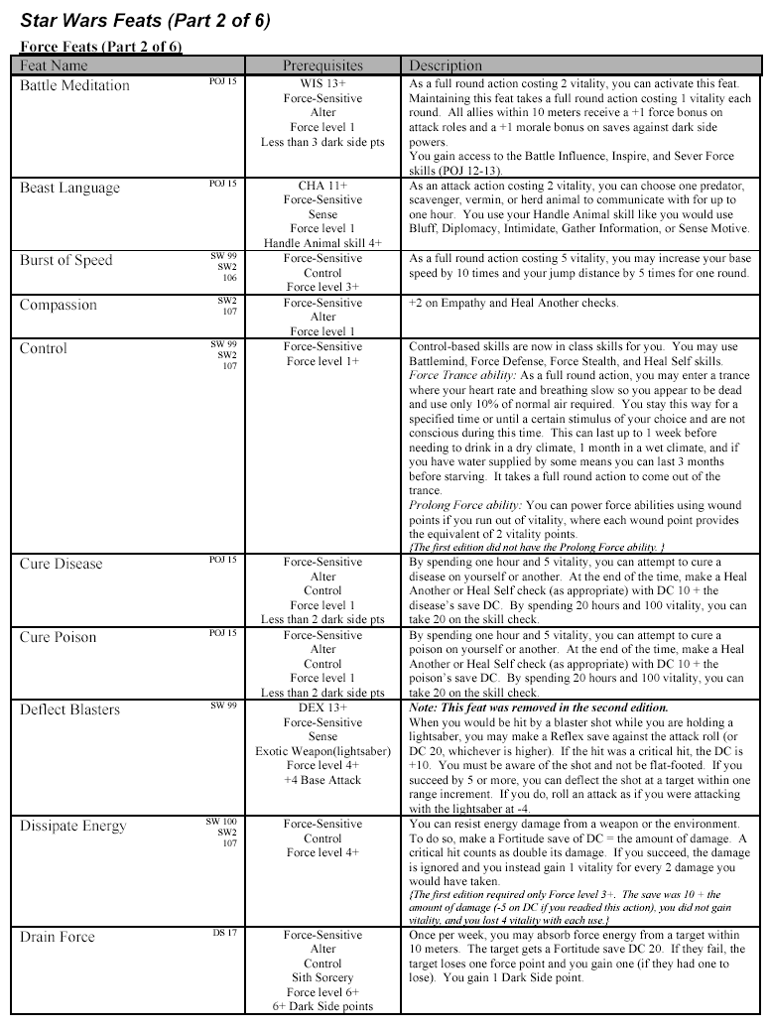
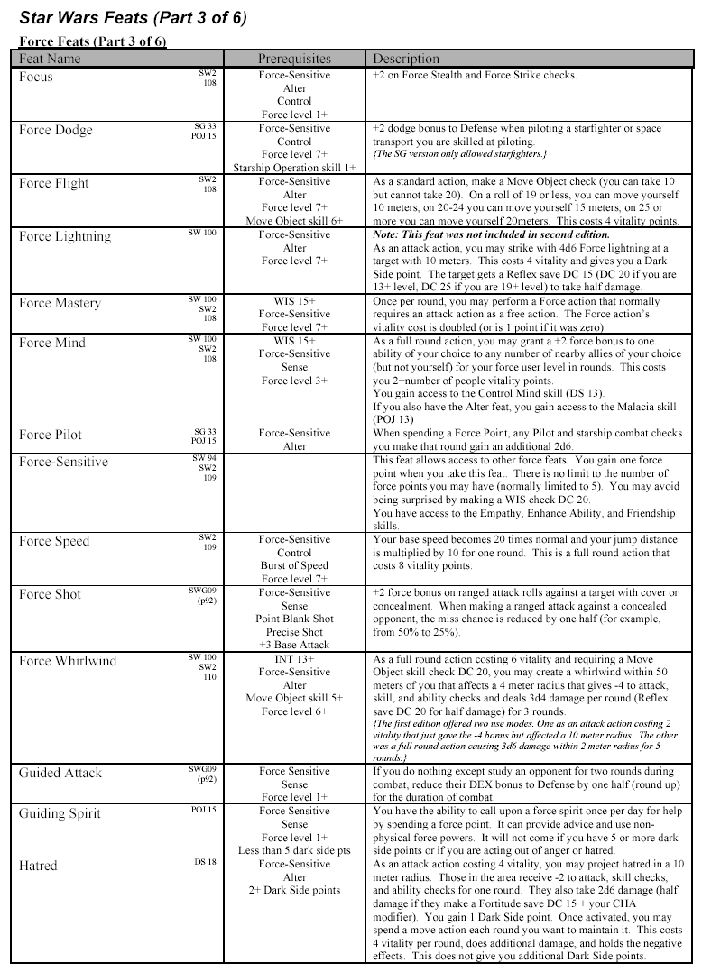
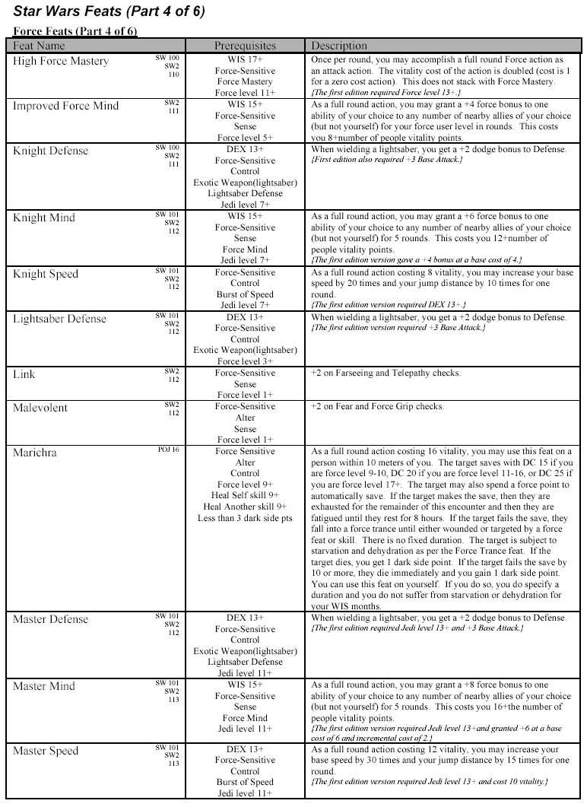
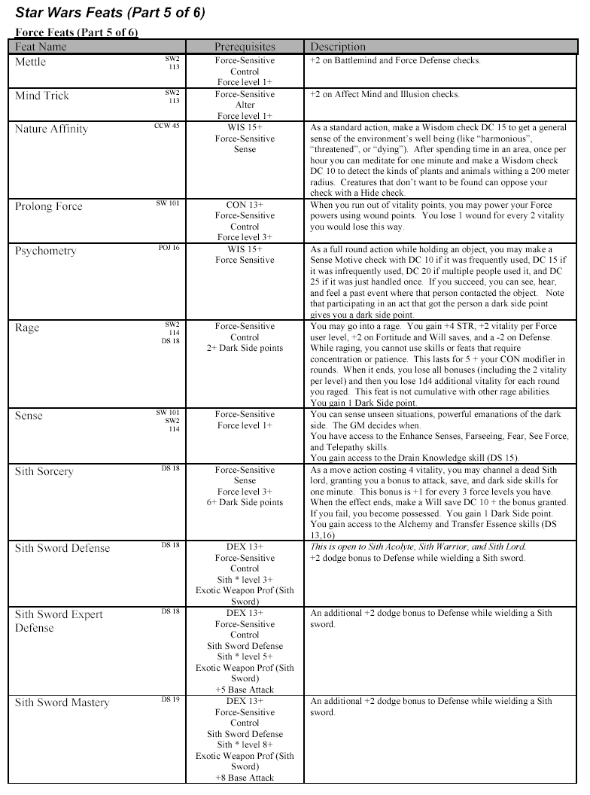
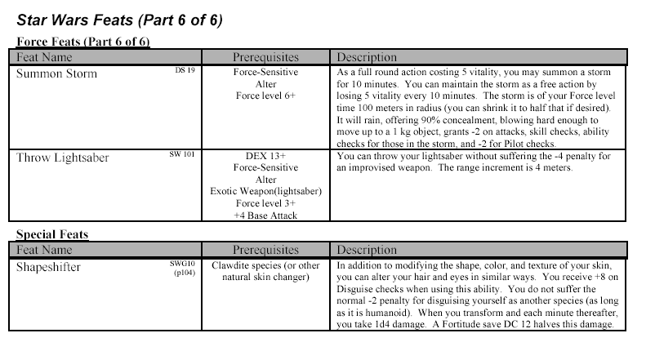
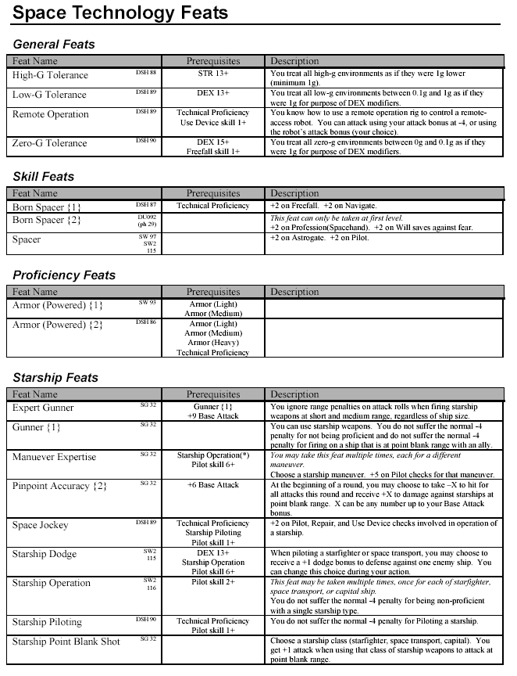
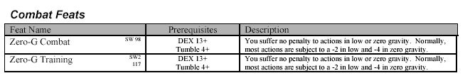

Equipment
Melee Weapons
Weapon | Cost | Damage | Critical | Range  Increment | Weight | Stun  Fort DC | Type | Size | Group
Unarmed | - | 1d3 |  | - | - | - | Bludgeoning | - | None
Club/Baton | 15 | 1d6 | 20 | 2 m | 1.5 kg |  | Bludgeoning | Medium | Simple
Combat Gloves | 200 | +2 |  | - | 1 kg |  | Bludgeoning | Medium | Simple
Force Pike | 500 | 2d8 | 20 | - | 1.8 kg | DC 15 | Slashing | Large | Vibro
Gaderffii | 50 | 1d8/1d6 | 20 | - | 2 kg |  | Slashing/Piercing | Large | Exotic
Knife | 25 | 1d4 | 20 | 2 m | 1 kg |  | Piercing | Small | Simple
Lightsaber | 50,000 | 2d8 | 19-20 |  | 1 kg |  | Energy | Medium | Exotic
Longsword | 150 | 1d8 | 20 |  | 2 kg |  | Slashing | Medium | Exotic
Mace, light | 50 | 1d6 | 20 |  | 2.5 kg |  | Bludgeoning | Small | Simple
Quarterstaff | 65 | 1d6/1d6 | 20 |  | 1.8 kg |  | Bludgeoning | Large | Simple
Spear | 60 | 1d8 | 20 | 4 m | 1.5 kg |  | Piercing | Medium | Primitive
Stun Baton | 500 | - | - | - | 1.8 kg | DC 15 | Bludgeoning | Medium | Simple
Vibro-ax | 500 | 2d10 | 20 |  | 2 kg |  | Slashing | Large | Vibro
Vibroblade | 250 | 2d6 | 20 |  | 1.8 kg |  | Slashing | Medium | Vibro
Vibrodagger | 200 | 2d4 | 20 |  | 1 kg |  | Slashing | Small | Vibro
Ranged Weapons
Weapon | Cost | Damage | Critical | Increment | Weight | Fort DC | Type | Autofire? | Size | Group
Blaster Pistol | 500 | 3d6 | 20 | 10 m | 1 kg | DC 15 | Energy | M | Small | Blaster pistols
Blaster, heavy | 750 | 3d8 | 20 | 8 m | 1.3 kg | DC 18 | Energy | M | Medium | Blaster pistols
Blaster, hold-out | 300 | 3d4 | 20 | 4 m | 0.5 kg | DC 10 | Energy |  | Tiny | Blaster pistols
Blaster, sporting | 300 | 3d4 | 20 | 8 m | 1 kg | DC 12 | Energy |  | Small | Blaster pistols
Ion gun pistol | 250 | 3d6 | 20 | 8 m | 1 kg | DC 15 | Energy |  | Small | Blaster pistols
Blaster carbine | 900 | 3d8 | 19-20 | 20 m | 2.2 kg | DC 15 | Energy | M | Medium | Blaster rifles
Blaster rifle | 1,000 | 3d8 | 19-20 | 30 m | 4.5 kg | DC 18 | Energy | M | Medium | Blaster rifles
Blaster rifle, sporting | 800 | 3d6 | 19-20 | 40 m | 4 kg | DC 15 | Energy |  | Medium | Blaster rifles
Blaster, light repeating | 2,000 | 3d8 | 19-20 | 40 m | 6 kg |  | Energy | M/A | Large | Blaster rifles
Ion gun rifle | 800 | 3d8 | 19-20 | 30 m | 3.1 kg | DC 18 | Energy |  | Medium | Blaster rifles
Grenade, frag | 500 | 4d6+1 | 20 | 4m(4m) | 0.5 kg |  | Slashing |  | Tiny | Simple
Grenade, stun | 600 |  |  | 4m(4m) | 0.5 kg | DC 15/12 | Energy |  | Tiny | Simple
Thermal Detonator | 2,000 | 8d6+6 | 20 | 4m(8m) | 0.5 kg |  | Energy |  | Tiny | Simple
Net | 25 |  |  | 2 m | 4.5 kg |  |  |  | Medium | Primitive
Electro-net | 300 |  |  | 2 m | 7 kg | DC 12 |  |  | Medium | Exotice
Sling | 35 | 1d4 | 20 | 6 m | 0.3 kg |  |  |  | Small | Primitive
Bullets(10) | 5 |  |  |  | 1 kg |  |  |  | Tiny | Primitive
Bow | 300 | 1d8 | 20 | 12 m | 1.4 kg |  | Piercing |  | Medium | Primitive
Arrows(10) | 20 |  |  |  | 0.8 kg |  |  |  | Medium | Primitive
Slugthrower, Pistol | 275 | 2d6 | 20 | 10 m | 1.4 kg |  | Piercing | M | Small | Slugthrower
Slugthrower, Rifle | 300 | 2d8 | 20 | 20 m | 4 kg |  | Piercing | M | Medium | Slugthrower
Bowcaster | 1,500 | 3d10 | 19-20 | 10 m | 8 kg |  | Energy |  | Large | Exotic
Quarrels(10) | 400 |  |  |  | 1 kg |  |  |  | Small | Exotic
Blaster cannon | 3,000 | 4d8 | 19-20 | 40 m | 18 kg |  | Energy |  | Large | Heavy
Blaster, Heavy Repeating | 4,000 | 4d8 | 19-20 | 30 m | 12 kg |  | Energy | M/A | Large | Heavy
Blaster, E-Web | 8,000 | 6d8 | 19-20 | 80 m | 38 kg |  | Energy | M/A | Large | Heavy
M= multifire, A= autofire
Armor
Armor | Cost | Damage Reduction | Maximum Dex Bonus | Armor Check Penalty | Speed  (10m) | Weight
Light Armor
Blast Helmet, Vest | 500 | 2 | +5 | -1 | 10 m | 3 kg
Combat Jumpsuit | 1,500 | 3 | +4 | -3 | 10 m | 8 kg
Padded Flight Suit | 800 | 2 | +4 | -2 | 10 m | 5 kg
Medium Armor
Armored Flight Suit | 4,000 | 4 | +3 | -4 | 8 m | 20 kg
Battle Armor, Padded | 2,000 | 4 | +3 | -4 | 8 m | 13 kg
Battle Armor, Medium | 6,000 | 5 | +2 | -5 | 8 m | 16 kg
Heavy Armor
Armored Spacesuit | 10,000 | 6 | +1 | -6 | 6 m | 45 kg
Battle Armor, Heavy | 12,000 | 7 | +0 | -7 | 6 m | 35 kg
Powered Armor
Corellian Powersuit | 10,000 | 4 | +0 | -4 | 8 m | 18 kg
Stormtrooper Armor* | 8,000 | 5 | +2 | -2 | 8 m | 16 kg
Battleframe | 12,000 | 3 | +0 | -8 | 6 m | 20 kg
*Stormtrooper armor is not available for sale to non-Imperials
Equipment
Item | Cost | Weight
All-temperature cloak | 100 | 1.5 kg
Aquata Breather | 350 | 0.2 kg
Bacta Tank | 100,000 | 500 kg
Bacta, 1 liter | 100 | 2 kg
Breath mask | 200 | 2 kg
Atmosphere canister/filter | 25 | 1 kg
Code Cylinder | 500 | 0.1 kg
Comlink | 200 | 0.1 kg
Encrypted Comlink | 1000 | 0.1 kg
Credit Chip | 100 | 0.1 kg
Datapad | 1,000 | 3 kg
Datacards, blank (10) | 10 | 0.2 kg
Datacard, 1 program | 300 | 0.1 kg
Datapad, mastercraft (+1) | 2,000 | 3 kg
Electrobinoculars | 1,000 | 1 kg
Energy Cell | 10 | -
Field kit | 1,000 | 10 kg
Flight Suit | 250 | 3 kg
Fusion lantern | 25 | 2 kg
Glow Rod | 10 | 1 kg
Grappling Spike Launcher | 50 | 0.3 kg
Holoprojector, Personal | 1,000 | 0.5 kg
Holorecorder | 3,000 | 1 kg
Liquid Cable Dispenser | 25 | 0.2 kg
Macrobinoculars | 600 | 0.8 kg
Medical kit | 25 | 1 kg
Medpac | 100 | 1 kg
Medpac, mastercraft (+1) | 200 | 1.2 kg
Power Pack | 25 | .1 kg
Recording Rod | 500 | 1 kg
Sensor Pack | 1,500 | 9 kg
Sensor Pack, mastercraft (+1) | 3,000 | 9 kg
Security Kit | 750 | 1 kg
Security Kit, Mastercraft (+1) | 1,500 | 1.2 kg
Surgery Kit | 1,000 | 1 kg
Tool Kit | 250 | 1 kg
*All items can be mastercrafted. For a +1 mastercraft item it is double the cost of the base item, for a +2 mastercraft item it is double the cost of the +1 mastercraft item.

