Name____________________________________

Our Tessellation WebQuest
Tessellation Project #1 Test Grade
(Each individual is responsible for answering all of the questions.)

To answer questions 1 – 6, you will need to use the pattern blocks in class or go to:
http://www.arcytech.org/java/patterns/patterns_j.shtml

or

http://nlvm.usu.edu/en/nav/vlibrary.html

You will find online pattern blocks at the above two websites.

Regular Polygon Tessellations

Make patterns with the pattern blocks, making certain that you leave no gaps or spaces.
1. Which shapes fit together easily? Trace shapes. Identify name of shapes.

2. Which shapes don't seem to fit together like the others? Trace shapes. Identify name of shapes.

3. Use one block at a time. Using the pattern blocks draw at least two different patterns that could be repeated over and over again in a plane that do tessellate (fit together). Draw an example showing shapes that do not fit to repeat over and over together. (Do not fit together, have gaps.)

4. Use one block at a time. Using the pattern blocks draw at least two different pattern examples showing shapes that do not fit to repeat over and over together and do not tessellate. (Do not fit together, have gaps.)

5. Now use two different pattern blocks. Which of the pattern block shapes will fit together making a repeated pattern using two blocks that are different?

Draw it here:

6. Now use three different pattern blocks. Which of the pattern block shapes will fit together making a repeated pattern using three blocks that are different?

Draw it here:

Name the shapes listed below.

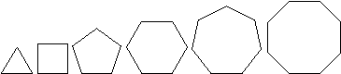

7. List the names of the regular polygons shown above? Define regular polygon? (Look regular polygon up in your book or notes to be sure that you know what it means.)

8. How many hexagons meet at one vertex? (If you do not recall what a vertex is, look it up). Circle each place where several hexagons meet at one vertex to give proof. (You will have seen this in the PowerPoint.)
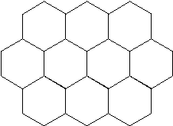
9. How many square tiles meet at one vertex? Circle where several squares meet at one vertex to give proof. (You will have seen this in the PowerPoint.)

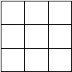

10. How many regular triangles meet at one vertex? Circle where several triangles meet at one vertex to give proof. (You will have seen this in the PowerPoint.)
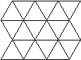

11. Are the pentagons tessellating? Explain why or why not.
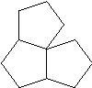

12. Complete the following chart. The polygon will tessellate if there is no remainder. (If there is a decimal or remainder, there would be a gap.)
Regular Polygon | Sum of the measures of all of the interior angles of the polygon | Measure of one  interior angle of the polygon  (sum ÷ how many sides) | 360 degrees ÷  by the measurement  of one interior angle | Will the polygon  tessellate using only  this polygon?
equilateral triangle | 180 | 180 ÷ 3 = 60 | 360 ÷ 60 = 6
square
regular pentagon
regular hexagon
regular heptagon
regular octagon

Use the chart above to answer fill in the blanks below.

13. In a tessellation the polygons used will fit together with their angles arranged around a point with no gaps or overlaps.

When using just one polygon (for example, only equilateral triangles), the interior measure of each angle will need to be a factor of _____ degrees (meaning that ____ degrees can be divided evenly by that angle measure).

14. The only regular polygons that will tessellate are the __________________, ___________________, and ___________________.

15. Choose a polygon other than the pentagon example that you have been given. Illustrate (by drawing) and then explain why it will not tessellate regularly.

16. What is a regular tessellation? (See your notes or look it up on WWW.)

Symmetry Commonly Found in Tessellations

17, Look for tessellations that you can find in your house? Look for more tessellations in your classroom, in nature or outdoors? These are all examples of tessellations that can be found in the real world.

Photograph them, scan pictures from books, print them from the internet, cut out pictures from magazines, or from newspaper color sale ads.

Turn in at three or more picture examples of real world tessellations that you found.
Attach them to this packet.
18. Define symmetry in your own words? (Even though we all understand and recognize symmetry intuitively, it is a little harder to really say just what it is.) Look up symmetry in your book and you will also find some links to information on symmetry on the main page of the WebQuest page.

19. Name and describe the different types of symmetry. Draw examples also.

M.C. Escher: Artist or Mathematician

Read Website or pay close attention to PowerPoint for correct answers.

20. Was M.C. Escher an artist or a mathematician? Can someone be more than one thing at a time?

Justify your answer by explaining why you feel the way that you do about Escher.

How did Escher feel about his work?

When you have completed the packet, you will be ready to try your hand at creating some tessellations. Have your packet checked before you start working on your poster paper.

Tessellation Pattern Guide – Escher Like Creations

Simple Translation Tessellation  Polygon should have opposite sides that are parallel and congruent.  - squares  - hexagons  - parallelograms | 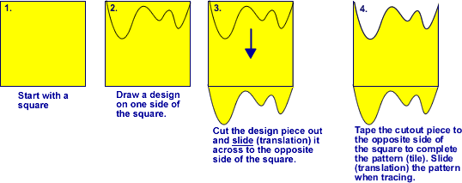
Glide Reflection Tessellation  Polygon should have opposite sides that are parallel and congruent.  - squares  - hexagons  - parallelograms | 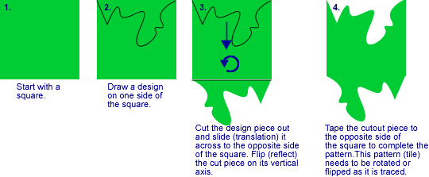
Rotational Tessellation  Adjacent sides must be congruent.  - squares  - triangles  - hexagons  - parallelograms | 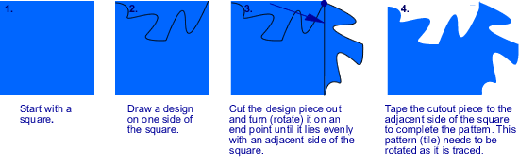
Midpoint  Rotations  - triangles  - squares  - quadrilaterals | 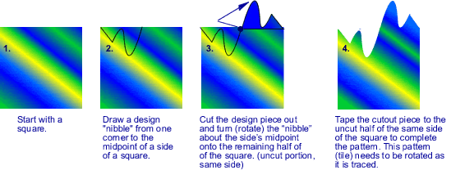
Note: More than one side may be altered for more challenging designs. Coloring one side of the pattern will help prevent accidental flipping during tracing. Adding color and features will enhance the artwork.

