Tessellation Pattern Guide

Simple Translation Tessellation  Polygon should have opposite sides that are parallel and congruent.  - squares  - hexagons  - parallelograms | 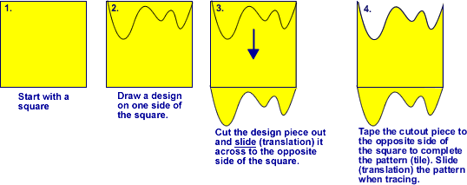
Glide Reflection Tessellation  Polygon should have opposite sides that are parallel and congruent.  - squares  - hexagons  - parallelograms | 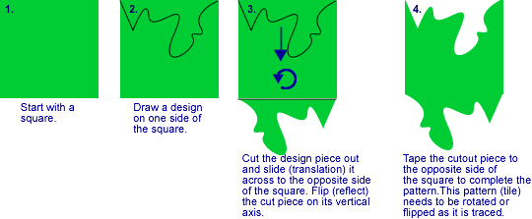
Rotational Tessellation  Adjacent sides must be congruent.  - squares  - triangles  - hexagons  - parallelograms | 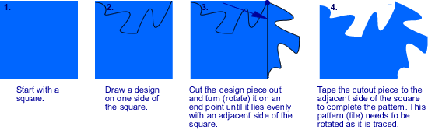
Midpoint  Rotations  - triangles  - squares  - quadrilaterals | 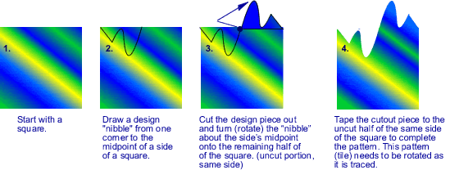
Note: More than one side may be altered for more challenging designs. Coloring one side of the pattern will help prevent accidental flipping during tracing. Adding colour and features will enhance the artwork.

