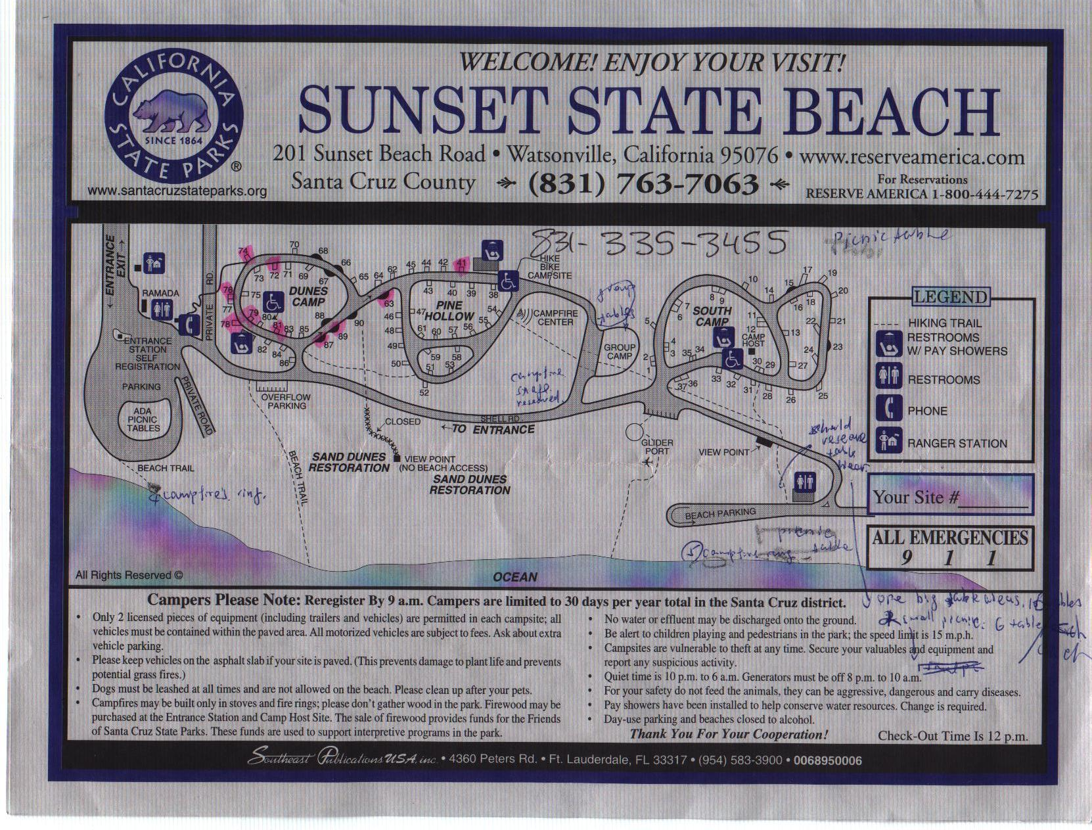
T453 Picnic Area
Hiking path
 | Campsite # | Campsite name
WeblosII | 76 | Dunes
WeblosI | 81 | Dunes
Bear | 78 | Dunes
New member | 79 | Dunes
Raven | 72 | Dunes
Dragon | 74 | Dunes
Falcon and  others | 63 and 41 | Pine Hollow
Cobra | 87 and 89 | Pine Hollow
Scout's own | at 79 | at 8:00am
Morning cooking | start at 6:30am | finish at 7:45am

T453 Campsite

