DEEJAY TIBETAN SPANIELS

PRESENTS
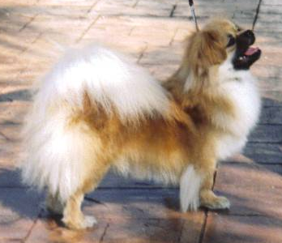

CH. DEEJAY’S SPIRIT SUN OF STAR
Owner handled and bred by
Diane Snowden

Spirit, who lives by his name, finished in 5 weekends to become a champion on his 1st birthday in the bred by class and is invited to show at Eukanuba for the next 2 years. Spirit is a charm, very sweet and wonderful dog to live with. I am very proud of his and will be showing him in the Best of Breed ring. He also took BOB at the Boca show on February 23rd.

