GAME DESIGNER EVALUATION PART I:
GENERAL QUESTIONS

Please answer the following questions:

- Describe the challenges and advantages associated with designing for both linear and non-linear gameplay.
  - What are the best ways to support each gameplay style?

What is considered Linear and what is not can vary greatly in opinion. For purposes of answering this question I am going to define in my terms what Linear and Non-linear game design means to me. The term Liner in game play terms usually describes a game where the player must follow a predetermined path. For example, In a three point Line ( Using A, B & C as the point Names ) in order to get to point C from point A the player must travel through point B. There is only one way to navigate from A to C. There are no alternate choices to be made by the player. If the player wants to get from point A to point C they must go through point B.
  - In a game such as a FPS, one advantage to using a linear type of design flow would be having the ability to anticipate the players movement and script events / triggers all around the player as he / she navigates through the game. This allows the game to be more controlled for a design standpoint.
  - One challenge of using a linear design would be only allowing the player access to only one puzzle or quest at a given time. In order to even attempt a second puzzle or part 2 of the quest, players must complete the first one. This can be frustrating for the player if they get stuck on a particular puzzle or unable to complete part one of the quest. In this case the player can do nothing else until that puzzle is solved or quest completed.

A Non-linear design would provide choices for the player to make, different paths they can take to get from point A to point B, from the games beginning to its end. A non-linear game will enable the player to come up with multiple or even his/her own solutions to the challenges/puzzles/quests the game presents.
  - Non-linear gameplay can provide for a great deal of replay ability. For example a player may have the choice to play different character classes and races. Playing from each different one can provide a unique gameplay experience.

- Based on your knowledge of games and your experience in the industry, in a broad sense - what are the three most important elements to designing and developing a fun game?
  - Describe two games (different genres) that you feel exemplify superior game design.

I’m going to have to say that there is no clear cut answer to this question and what might be fun to one person might not be fun to another. That being said I am going to use my opinion.
- The first and most important element to making a game fun is gameplay.
- The second would be to provide the player with interesting and well-paced variety of different decisions to make. I have the most fun when I can make my own decisions in game and the sense of accomplishment or reward when I make good decisions.
- The actual game world. I love unique, incredibly rich, deep, and detailed worlds.
  - World of World craft and Half-Life 2

- What game-design considerations need to be kept in mind when creating 3rd person action games like Resident Evil 4 and Gears of War?

  - How would your design/development approach for a third person action game differ from your design approach to other games?
  - What is unique about 3rd person action games, compared to other types?
3rd person action games focus on exploration and usually involve item gathering, simple puzzle solving, and combat from a third-person perspective of the character the player is controlling. This perspective gives the player a wider view of their surroundings as opposed to the limited viewpoint of first-person games.
One important consideration would be to take into account the camera in any indoor (and some outdoor) areas. The camera view in 3rd person action game can become obscured or blocked in some indoor areas. It is important to figure out how to handle the issues. A common solution is to have the player able to scroll the mouse wheel to zoom the camera in closer to the player when indoors to prevent any blocking issues.
Another important issue to consider is how the player is going to target the enemy. From a first person perspective it is easier to see what you are aiming at because it is right in front of you. On way to help the user target for a 3rd person game is to have the player select the target before shooting.

- Describe the elements that make up a good boss battle and what design considerations need to be kept in mind when creating one.
  - Should a game’s boss battle gameplay differ substantially from its regular gameplay? If so, how? If not, why?

A Good boss battle should take longer than the typical combat encounter in the game. A great element in some boss battles are puzzles or patterns the player can (or needs to) follow to help defeat the boss. For example, the boss may have 4 lesser minions guarding the boss and each minion (once killed) may drop an item that will be needed to defeat the boss. Say these 4 minions represent Earth, Wind, Fire and water and in order to vanquish the boss back to the abyss the player must place these 4 drops into a cauldron. Thus, the trick or puzzle in this situation would be to not kill the boss but to kill the 4 minions and place their essence in the cauldron.

The game play should not differ substantially from the games regular game play. During regular game play the player is learning the flow of how to use their abilities, weapons and the different advantages and disadvantages of each. In the boss battle this knowledge is put to use. If the game play varies too much the player may be forced into the boss battle without this prior knowledge and have no clue how to defeat the boss. This would be very frustrating as a player, to get all the way to the end and not be able to finish.
GAME DESIGNER EVALUATION PART II:
GAMEPLAY/LEVEL DESIGN TEST

Introduction
The following is a description of a generic game title imagined for the purpose of this test. You are to read the Overview and the Mission Briefing sections in order to create a level for the game (as directed in the “Test Requirements” section). Be as creative as you can within the limits placed on you.

Overview: Super Magic Fighting Man (working title, obviously)
Imagine a third person action game that utilizes a control scheme like that found in Gears of War or Resident Evil 4 in which the main character can use some magic-like powers. The setting is modern-day and the game features a cinematic but fairly realistic style. The game’s levels feature heavy action areas interspersed with atmospheric sequences (read: suspense and/or horror) intended to provide pacing. For the purposes of this test, the main character’s action set is severely limited.

The following are actions the main character can perform:
- Walk/run
- Shoot gun (pistol)
- Fire (throw a basketball-sized fireball)
- Lightning (shoot electricity from your fingertips. 16 foot range)
- Activate (flip a switch, push a button, pull a lever)
- Cause limited environmental damage (blasting a pillar to topple it, for example) by damaging it with his powers.

Stick to this action list as closely as possible. For instance, do not have areas where the player must crouch or hang from a ledge, as the character cannot perform those actions. The main character cannot climb ladders either, so to have any vertical movement in your level, you must rely on the player character using stairs or ramps.

Enemies will attack immediately when they see the player character. The player character can hide by standing behind objects. Enemies can attack at close range (melee weapons or fists) or from long range (guns).

The environment is fairly static, but as a level designer, you can specify certain environmental objects that break (when damaged or scripted) or can be moved (with your push object ability)

Mission Briefing
Super Magic Fighting Man’s mission is to infiltrate a chemical plant, steal a vial of a top-secret chemical and escape. There will be a combination of outside and inside areas. Here is a flowchart to outline the major areas and their physical relationship (gameplay flow):

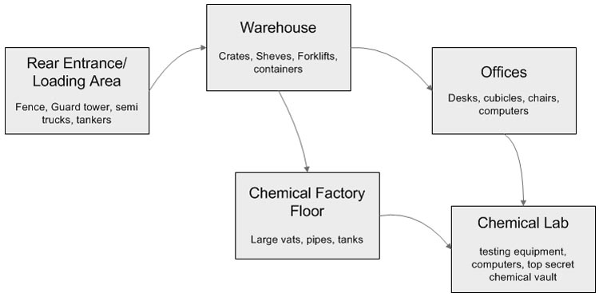

Enemies will include security guards and lab technicians. Security Guards attack with guns or melee weapons, and lab technicians will attempt to set of alarms to call security guards. Technicians will also attack with melee weapons, but only after physically threatened.

Test Requirements

- Describe your core game design taking into account the limited feature set described above. Be sure to explain what the gameplay focus will be, and justify how it will be fun for the player.

- Choose ONE of the level areas shown above (see flowchart). Create a short document that describes the area visually as well as all gameplay features that will be contained within it. Feel free to include any additional concept art or reference you feel will help present your ideas. If desired, additional game areas can be documented.

- Create an overhead map of the same area and a key describing all the major locations. Include where enemies will be placed and spawned, any “puzzle” elements, game paths and any other elements needed to explain your area’s gameplay design.

- If you feel the brief nature of the game design forced you to make any significant assumptions, explain them.

- The main character’s action set was purposefully abbreviated in order to test for your creativity in the face of confining limits. Give a few suggestions for additional character abilities that could lead to the creation of more entertaining levels and gameplay.

