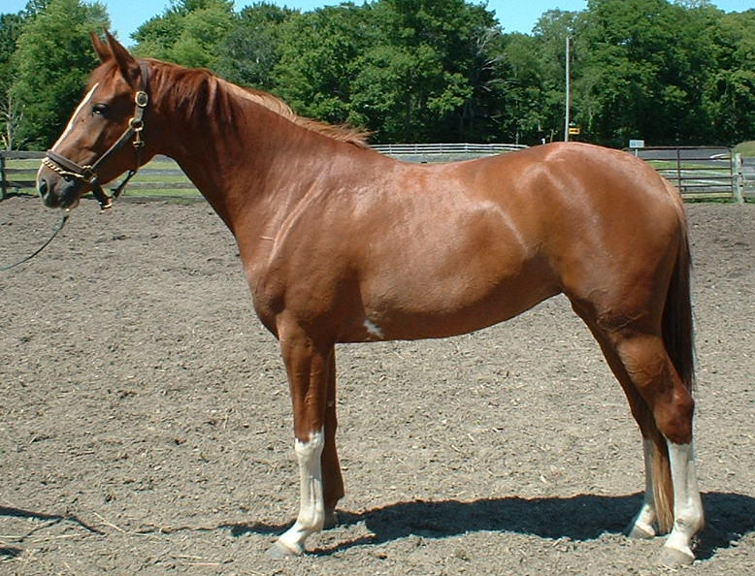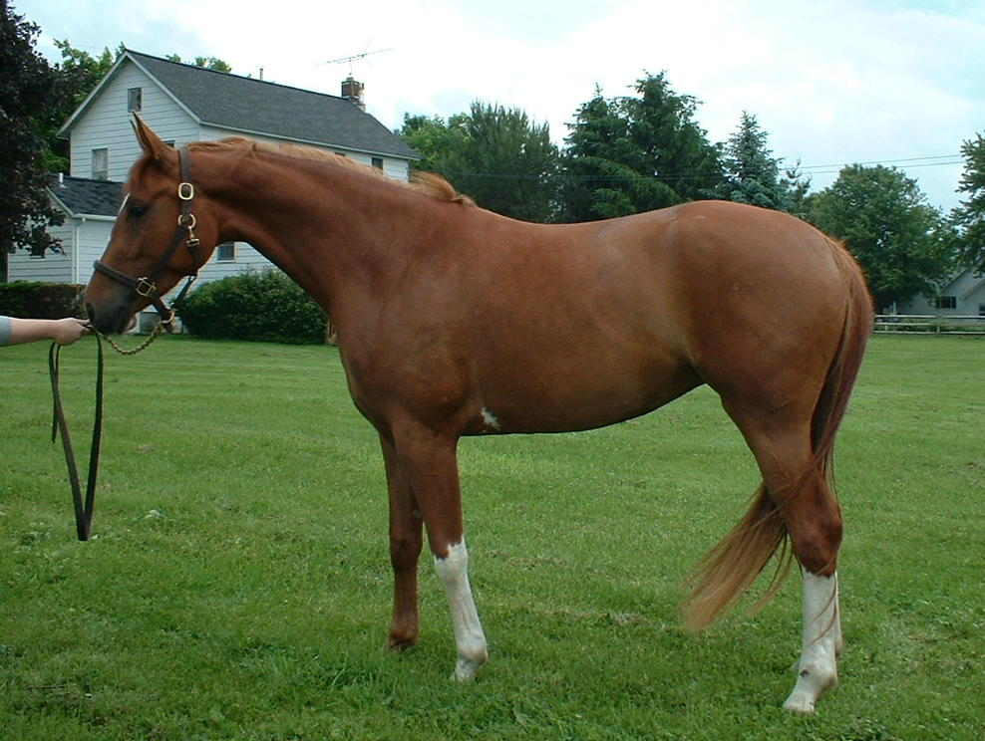
FOR SALE: 2001 Registered Branded Hanoverian Filly by Winterprinz
Absolutely stunning registered/branded 3 yr old Hanoverian filly by Winterprinz (www.yarrayarraranch.com) out of a Vienna Waltz/Woermann daughter. Gorgeous movement, beautiful topline, awesome bloodlines and a sweet personality. Should mature about 16.2+hh. Her sire was champion of his 100-day dressage testing in Germany where he received 9's by all three test riders. He was also USDF 4th level champion in 2003 and 4th level CDS horse of the year. This filly has a ton of potential. She has started lunging, but has not yet been backed. Asking $15,000 OBO. Will be sent to trainer in July and price will increase accordingly. Please email for more info or call 330-204-3863. efkahuf@hotmail.com
Whitesinvogue | ES Winterprinz | Warkant | World Cup I
Whitesinvogue |  |  | Grandel
Whitesinvogue |  | SPS Windrose | Weltmeyer
Whitesinvogue |  | SPS Windrose | SPS Sangrita
Whitesinvogue | Vienna Vanity | Vienna Waltz | Wienerwald
Whitesinvogue | Vienna Vanity | Vienna Waltz | Annelin
Whitesinvogue | Vienna Vanity | Woronica | Woermann
Whitesinvogue | Vienna Vanity | Woronica | Kokarde

