Robert Paarlberg. The Politics of Precaution: Genetically Modified Crops in Developing Countries. Baltimore: Johns Hopkins University Press, 2001.

http://www.nap.edu/issues/19.3/wheelis.htm
Thus there are two rather different questions:
Given that it is legal to develop and use these weapons for law enforcement purposes, is it wise?
Should is be allowed?
And how should prohibited military development be deterred?

Should non lethal chemical weapons be allowed?

Arguments :
NO
who are the good guys who are the bad. Is it possible to ever distinguish the too.
And suppose bans are placed against their usage is it completely viable that sides will listen and comply to those bans when fear of others able to amass weapons still a haunting thought.

http://microbiology.ucdavis.edu/faculty/mwheelis/BW_history.pdf
The legal regime prohibiting them [BW] is clear and in place, but it lacks effective mechanisms to verify compliance and to build confidence in the existing legal regime. Repairing that gap constitutes an urgent agenda for the international community in the next few years. The urgency is made greater by the rapid scientific progress…
http://www.nap.edu/issues/19.3/wheelis.htm
http://www.fas.org/bwc/papers/sirens_song.pdf

Information amassing :

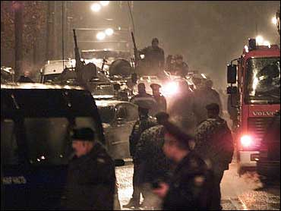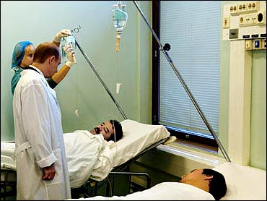Russian President Vladimir Putin visits victims of the theater siege at the Sklifisovski Emergency Institute, one of Moscow's clinics where freed hostages were hospitalized. The gas used by Russian troops can paralyze breathing, blood circulation, and cardiac and liver functioning, doctors said. More than 400 people, including nine children, remained in the hospital Monday. (Photo: CBS/AP)

http://www.cbsnews.com/stories/2002/10/26/world/main527052.shtml

Questions to ask :
In the abstract do you include the method of presentation ie. Use of powerpoint or movies. Etc. or focus strictly on the topic.
http://www.cnn.com/2002/WORLD/europe/10/29/moscow.whichgas/

Recommendation 1: The Protocol should require, on a legally-binding basis, that States Parties provide prompt and detailed reports on all unusual outbreaks of disease on their territories. Reports should be directed to the WHO, the OIE, the FAO or other appropriate international health organizations.
Other reconmmendations made for investigating cases where outbreaks occur. Protection of the party investigating… full access yadah yadah.

The Chemical weapons convention CWC
http://www.fas.harvard.edu/~hsp/chemical.html
purpose of the convention treaty…. Possible loopholes : The CWC not only bans the use of chemical weapons, but unlike the Geneva Protocol also bans their development, production, stockpiling and transfer and requires that all existing stocks of chemical weapons be destroyed within 10 years. Like the BWC, the CWC is also underpinned by a "general purpose criterion" which defines the substances to which its prohibitions apply. According to Article VI of the CWC, states parties must adopt measures to ensure that toxic chemicals and their precursors are only used for purposes not prohibited by the Convention. The general purpose criterion allows the Convention to keep up with technological change and, in the case of dual-use chemicals, to exempt application for peaceful purposes from its prohibitions. The Convention lists 43 chemicals and families of chemicals for the application of special procedures, but, by virtue of the general purpose criterion, the prohibitions of the treaty are not restricted to them.

http://microbiology.ucdavis.edu/faculty/mwheelis/
http://microbiology.ucdavis.edu/faculty/mwheelis/cbw.html

