RoamerV

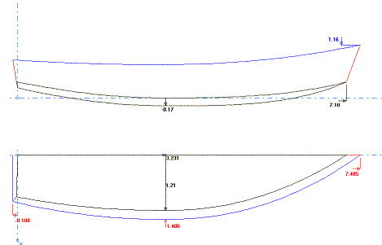
7 ½’ long, 30-35 lbs, Vee bottom skiff

RoamerV is the Vee bottom version of Roamer. It is made out of one sheet of ¼” ply and some 1x stock for the transom, seats, inner and outer rails. It will need a skeg on the bottom to help directional stability. It has a shallow Vee to increase displacement a little, and make it a little boatier looking but hopefully not affect stability too much. Construction is of Stitch and glue. Seating position is up to you, but a longitudinal seat comes to mind for this one. That way, rowing position can be adjusted back and forth.

Bottom Panel Half
Station | X | Y | X2 | Y2
1 | N/A | N/A | 0 | 11 5/8
2 | 5/16 | 5/8 | N/A | N/A
3 | 12 | 5/16 | 12 | 13 1/4
4 | 24 | 1/8 | 24 | 14 1/4
5 | 36 | 0 | 36 | 14 5/8
6 | 48 | 0 | 48 | 14 3/16
7 | 60 | 1/8 | 60 | 12 3/16
8 | 72 | 3/8 | 72 | 8 5/16
9 | 84 | 15/16 | 84 | 3 5/16
10 | 87 9/16 | 1 3/16 | 87 9/16 | 1 3/16
Side Panels
Station | X | Y | X2 | Y2
1 | N/A | N/A | 0 | 7 7/8
2 | 1 1/4 | 2 | N/A | N/A
3 | 12 | 1 | 12 | 8 3/16
4 | 24 | 3/16 | 24 | 8 5/8
5 | 36 | 0 | 36 | 9
6 | 48 | 5/16 | 48 | 9 1/2
7 | 60 | 1/2 | 60 | 9 15/16
8 | 72 | 13/16 | 72 | 10 7/16
9 | 84 | 1 7/16 | 84 | 11
10 | 91 1/4 | 2 | N/A | N/A
11 | N/A | N/A | 95 3/8 | 11 9/16
Transom Half
Station | X | Y
1 | 1 5/8 | 10 15/16
2 | 7 7/16 | 12 3/16
3

All measurements are in inches. The end points of the plotted lines are joined by a straight line.

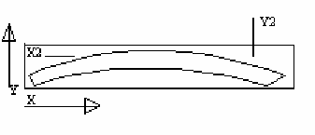
Example only. Not to scale. For informational purposes only.

This shows how the measurements are used to lay out the panels. X and Y are the bottom line of the panel and X2 and Y2 are the top line. All points are from the edge of the ply or a baseline. Any points which are N/A are not plotted. They may just be not on the panel or are not important to that line. The two end points are closed with a straight line.

For information on Stitch and Glue, please check the construction of fisher10. The hull was done entirely with stitch and glue, except for the transom/side panel joint, which was first attached with screws and then filleted on the inside and taped on the outside. There are also many good sites with Stitch and glue information. www.bateau.com has an excellent primer on the subject, so do most of the other major plans dealers, such as Glenn-L and Clark Craft.

