MiniMaxFlat
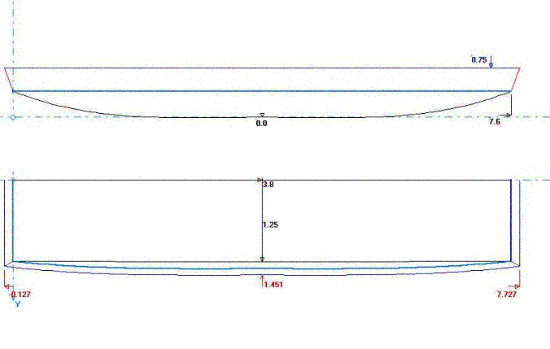

MiniMaxFlat is one of the boats that I designed to get the most displacement out of a single sheet of ply. This one will still have the transoms out of the water with a total weight of 350 lbs. With the boat weighing about 30 or so lbs (1/4” ply), this still leaves 320 lbs of people and “stuff”. Construction is Stitch and Glue, with scrap or 1x for the transoms. Seating arrangements are up to the builder, but I suggest a longitudinal seat for ease of seating while rowing.

Bottom Panel Half
Station | X | Y | X2 | Y2
1 | 0 | 0 | 0 | 10 13/16
2 | 12 | 0 | 12 | 12
3 | 24 | 0 | 24 | 12 3/4
4 | 36 | 0 | 36 | 12 15/16
5 | 48 | 0 | 48 | 13
6 | 60 | 0 | 60 | 12 15/16
7 | 72 | 0 | 72 | 12
8 | 84 | 0 | 84 | 11 15/16
9 | 93 15/16 | 0 | 93 15/16 | 10 13/16
Side Panel First Chine
Station | X | Y | X2 | Y2
1 | 0 | 6 | 0 | 9
2 | 12 | 2 5/8 | 12 | 9
3 | 24 | 5/8 | 24 | 9
4 | 36 | 1/16 | 36 | 9
5 | 48 | 0 | 48 | 9
6 | 60 | 1/16 | 60 | 9
7 | 72 | 5/8 | 72 | 9
8 | 84 | 2 5/8 | 84 | 9
9 | 96 | 6 | 96 | 9
Transom Half (front and rear)
Station | X | Y
1 | 0 | 10 13/16
2 | 5 1/8 | 10 13/16
3
4

All measurements are in inches. The end points of the plotted lines are joined by a straight line.

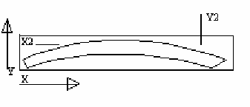
This shows how the measurements are used to lay out the panels. X and Y are the bottom line of the panel and X2 and Y2 are the top line. All points are from the edge of the ply or a baseline. Any points which are N/A are not plotted. They may just be not on the panel or are not important to that line. The two end points are closed with a straight line.

For information on Stitch and Glue, please check the construction of fisher10. The hull was done entirely with stitch and glue, except for the transom/side panel joint, which was first attached with screws and then filleted on the inside and taped on the outside. There are also many good sites with Stitch and glue information. www.bateau.com has an excellent primer on the subject, so do most of the other major plans dealers, such as Glenn-L and Clark Craft.

