MaxCapacityJonboat

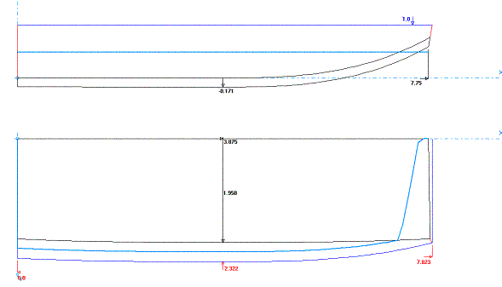
MaxCapacityJonboat is the most boat I could get out of one sheet of ply. The sides and transoms are of 1x lumber, with the whole sheet of ply for the bottom. The bottom is stitched and the rest is glue and screw. The waterline is at a displacement of about 935 lbs. Short and stubby, it can carry a serious load of cargo, but wouldn’t row very well. It really should be used with a motor. Note*….The offsets for the side panel (Below) should be plotted on some cardboard or paper and then used for a template. The program that I used to develop the boat does some peculiar things to this kind of shaped boat: it tilts the side panel as it develops it. The bottom rear of the boat is lifted by over 5 inches.

Bottom Panel Half
Station | X | Y | X2 | Y2
1 | 0 | 0 | 0 | 22 3/4
2 | 12 | 0 | 12 | 23 1/4
3 | 24 | 0 | 24 | 23 1/2
4 | 36 | 0 | 36 | 23 9/16
5 | 48 | 0 | 48 | 23 9/16
6 | 60 | 0 | 60 | 23 9/16
7 | 72 | 1/8 | 72 | 23 9/16
8 | 84 | 3/8 | 84 | 23 9/16
9 | 94 7/16 | 13/16 | N/A | N/A
10 | N/A | N/A | 94 7/8 | 23 9/16
Side Panel First Chine
Station | X | Y | X2 | Y2
1 | 0 | 5 1/16 | 1 3/16 | 17 13/16
2 | 12 | 4 1/8 | 12 | 16 15/16
3 | 24 | 3 1/8 | 24 | 15 15/16
4 | 36 | 2 | 36 | 14 13/16
5 | 48 | 15/16 | 48 | 13 3/4
6 | 60 | 1/8 | 60 | 12 5/8
7 | 72 | 0 | 72 | 11 1/4
8 | 84 | 5/16 | 84 | 9 11/16
9 | 94 1/16 | 2 3/16 | N/A | N/A
10 | N/A | N/A | 94 7/8 | 7 15/16
Rear Transom Half
Station | X | Y
1 | 2 | 22 11/16
2 | 14 | 27 1/16
Front Transom Half
Station | X | Y
1 | 2 1/4 | 22 5/8
2 | 5 1/16 | 23 9/16

All measurements are in inches. The end points of the plotted lines are joined by a straight line.
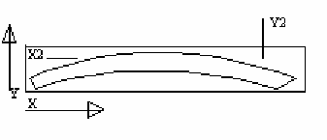
This shows how the measurements are used to lay out the panels. X and Y are the bottom line of the panel and X2 and Y2 are the top line. All points are from the edge of the ply or a baseline. Any points which are N/A are not plotted. They may just be not on the panel or are not important to that line. The two end points are closed with a straight line.

For information on Stitch and Glue, please check the construction of fisher10. The hull was done entirely with stitch and glue, except for the transom/side panel joint, which was first attached with screws and then filleted on the inside and taped on the outside. There are also many good sites with Stitch and glue information. www.bateau.com has an excellent primer on the subject, so do most of the other major plans dealers, such as Glenn-L and Clark Craft.

