CubCanu MkII and ScoutCanu
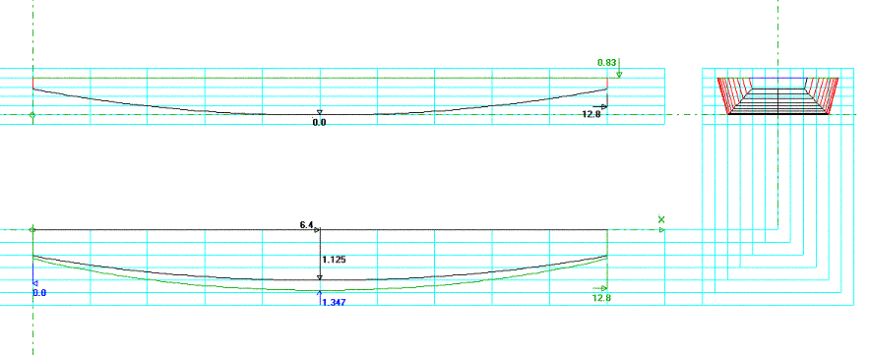

Here are the plans for the revised CubCanu and its bigger brother, the ScoutCanu.

I did the revision due to some feedback from another CubCanu builder. The boat is the same length, but the sides are lower and the bottom is wider.

ScoutCanu is a longer derivative of CubCanu, designed for older and heavier kids.

CubCanu MkII

Starting with a sheet of ¼”exterior grade ply, lay out the pieces. The sides will be 10” deep, so these will need to be ripped from the ply. Cut one from each side of the ply, so that there is a factory edge on each. Cut the ply so that the middle piece is a true 28”, leaving the sides around 9 15/16” or so.
To lay out the curves, take one of the side panels, put the lesser side up and locate the edge opposite the factory edge. Measure towards the factory edge 7 inches on each end and mark. Locate the center of length and mark. Draw straight lines from each end mark to the center mark. Locate the center of each diagonal line and mark. Take a batten (something that you can bend to make a curve with. I use a piece of 1x1/8” x8’ aluminum) and draw a nice, smooth curve between one end point and the center mark. Don’t make it too rounded though, remember: you have to bend the ply to this curve and the bottom takes the same curves, so the side will have to bend to it too. Once you have the curve drawn, measure from the center of the diagonal to the curve, at a 90° angle to the diagonal. Take this measurement and mark it on the other end of the ply and use the batten to draw that curve too. They should end up being equal.
Clamp the two side pieces together, with the good sides facing each other and the factory edges aligned. Take a circular saw and set the depth of cut to about 1/8” deeper than the doubled ply. Carefully cut the curves, perhaps leaving a little to sand to the lines. A jigsaw works Ok too, but can suffer from wobbles more than a circular saw. Sand to the lines if needed and take one of the sides and put the other out of the way.
Turning to the bottom piece, making sure the bad side is up, lay one of the side pieces on it and trace the curves along each side. This should leave you with a 14” width at each end and 28” in the middle. Cut the bottom and lay to one side.
Using the 1x10x10 , cut 2 chine logs from it, 1” wide. Glue and screw the logs to the curve on the rough side of the side panels, leaving about ¼” sticking out past the edge of the ply. Leave enough space at the ends for the transoms. Be sure to pre-drill the holes before screwing, as the wood will almost surely split. Set the side panels aside .

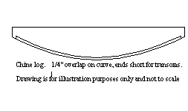
Using a 1x4 or some scrap ½” or ¾” ply, cut two 14” x 3 ½” pieces. Transfer the angle of the bottom curve at the ends of the side pieces to the bottom edge of the transom blanks. Bevel the bottoms to the angle. Transfer the angle of the ends of the bottom piece to the side ends of transoms and bevel the ends.

Time to assemble. Glue and screw the transoms to the side panels. Make a spreader that fits in the middle of the boat, right at the top of the side panels. This should make the sides spread out to about 32”. Make another that will fit between the chine logs, putting the middle of the boat at the exact width of the bottom panel. This piece needs to be even with the tops of the ply, about a ¼” below the edge of the chine logs, so that when the chine logs are beveled, the bottom will meet up with it without too much of a gap.
We need to get the chine logs down to the ply, at the correct angle for the bottom to lay flat, so we use a long board. This is a flat board with some coarse sand paper on it. It spans the 2 sides of the boat and allows us to sand both the logs at once and get them to the right angle. You can get the chine logs near with an electric plane or sander but finish with the long board. We are looking at a flat surface to screw the bottom to. Once the chine logs are right, center the bottom ply on the sides and glue and screw from the center to the ends, forming the sides to meet the bottom curve. Make a skeg out of the scraps from cutting the parts out, trimming the wider end at a slight angle, for looks (see picture). Glue 2 of the scrap pieces together to get a ½” thick piece. Cut a rub strip from the 1x10x10, 2” wide and cut a slot in one end to accept the skeg. Glue and screw the rub strip to the bottom and glue the skeg into the slot. Once the glue has cured, fillet and tape the skeg for added strength. I recommend taping and epoxying the outside joints and epoxying the bottom, but caulking the gaps and painting to waterproof will work too.
Turning the boat over we need to put the outside rails on. Rip the rails from the 1x10x10, 1 ¼” wide and glue and screw from the center to the ends. Trim to be even with the transoms. Cut a couple of pieces of ply 1’ wide and long enough to lay across the ends and trace the outline of the outside of the boat. Cut the panels and glue and screw them onto the boat for decks. Glue and screw a cross piece under the inside edge of the panels and one each on the floor of the boat, directly underneath. Cut and fit a panel to enclose each end. Caulk the joints, sand and paint the interior.

CubCanu can be made in the Stitch and Glue fashion also, with a savings of maybe 3 or 4lbs, and without the hassle of beveling the chine logs. It will end up more expensive thought as more epoxy will be used. It may also take a little more time, because of curing times. Fillets should be taped, as this adds significantly to the strength of the joint(s). If building with S&G, install the vertical sections of the deck chambers first, to allow for stitching and filleting to the sides. Once cured, install a piece of 1x to the top of the bulkhead and glue and screw the deck top on. The transoms can also be made from ¼” instead of the thicker material, as they will be stitched to the end of the boat instead of screwing. A piece of 1x will be needed to secure the deck though.

As all the panels of the boat are curved, this should end up as a very stiff, light little boat. Perfect for a young boy or girl or two to paddle around in, on a farm pond or still lake, near the shore. PFDs must always be used, along with flotation cushions for seats. The boat has a capacity of about 310 lbs total, with a weight of about 30-35 lbs. So it can carry a maximum of 275 lbs of kids ’n stuff.

Materials needed:
2 sheets ¼” exterior grade plywood. 1 sheet will do, if you have enough scraps for the decks and bulkheads.
1- 10’ 1x10” pine or fir for rub rails bottom skid, spreaders, chine logs and framing.
1- 4’ 1x4” or ½” or ¾” scrap for transoms.
Screws, epoxy, FG tape or cloth, sandpaper, primer, paint

ScoutCanu
A 12 foot version of CubCanu for bigger kids.

ScoutCanu is built using the same methods and measurements as CubCanu, except for the length of the boat. The curves will be gentler and some additional framing may be needed, but it should be as easy to build as a CubCanu. As CubCanu needs 2 sheets of ply to do properly, with a lot of excess, ScoutCanu can be built out of most of the same supplies, with a lot less excess. You will need a 14’ piece of 1x10 to cut the chine logs, rails and bottom rub strip out of , or a 14’ 1x6 for the rails and rub strip, if using S&G. You may be able to get by using some 1x2x8’ furring strips, by scarfing them together. Gluing the furring strips to the sides and themselves before assembling the boat may allow butted strips to bend into a smooth curve when the panels are bent. The plywood panels will be cut into 2 6’ lengths, so the joints are in the middle, and joined together with a fiberglass or butt joint. The butt joint is made by gluing a piece of wood across the joint at a 10 to 1 ratio. This means that with ¼” ply the butt needs to be at least 2 ½” wide, and of the same thickness. Leave about 1” unbutted on the bottom edge if stitching, to allow for a good fillet.
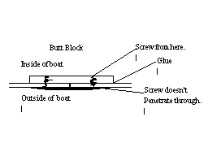
The outside of the joint is glassed with fiberglass tape and epoxy. A glass joint has glass on both sides. The joint is started the same, with a piece of wood joining the edges, but without the glue (the wood can be thicker, as the screws go through the butt and into the panels, but without exiting the other side). The butt is screwed to the ply with a sheet of waxed paper in between and the other side of the joint is glassed. Once it has cured , the panel is flipped, the butt and paper is removed and this side of the joint is glassed.
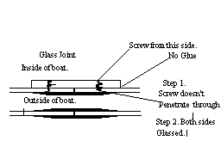
This makes for a neater joint, though it takes longer. Once you have a 12’ panel, layout and cut the same way as building the CubCanu. The decks will need to be 18” long instead of 12” to add a little extra flotation. Angling the bulkhead will make a good back rest. The build time should be about the same, once the panels are joined. All other dimensions are the same, as is the building. If framing is needed, 1x scraps or 1x2 furring strips, with triangular pieces of ply will suffice. Glue the strips to the sides and bottom and the triangular pieces to the strips. Use one spreader if the boats intended purpose is to have a single occupant, and 2 spreaders for 2 occupants. Put the spreaders about 33-36” apart centered on the boat. This allows the front person to have a backrest. A portaging yolk would be needed to carry the boat comfortably.
.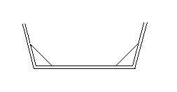
Frame (Not to scale, for info only)

ScoutCanu should run about 45-50lbs, with a maximum capacity of 450lbs for a 400lb payload of kids and gear. Use flotation cushions for seats and PFDs.

Materials needed:
2 sheets ¼” exterior grade plywood.
1- 14’ 1x10” pine or fir for rub rails bottom skid, spreaders, chine logs and framing.
1- 4’ 1x4” or ½” or ¾” scrap for transoms.
Screws, epoxy, FG tape or cloth, sandpaper, primer, paint.

ScoutYak

A 12’ single person Kayak, in the fashion of the ScoutCanu.

ScoutYak is a derivative of ScoutCanu, and is built in a similar fashion. The differences are in the width, the height of the sides and the additional decking. Instead of the bottom panel being 28” wide it is 20-22” wide and the sides are reduced to 8.5-9” in height. The boat has additional decking to make it more Kayaky, and keep the interior a little dryer. The bow and stern transoms will be really small, using the same 7” measurement for the rocker. The decks are screwed to the rails after the boat is built. A slight arching of the deck could be included, for water drain off. Seating position should be in the 55% region, from the front of the boat. This should lift the nose slightly but still keep the tail out of the water. The skeg would still be needed, unless you want to wiggle all over the place. Varying the size of the skeg should increase or decrease maneuverability. Another sheet of ply probably will be needed for the decks. Overall width should run about 27-29”. Good for one person, up to about 220 lbs.

