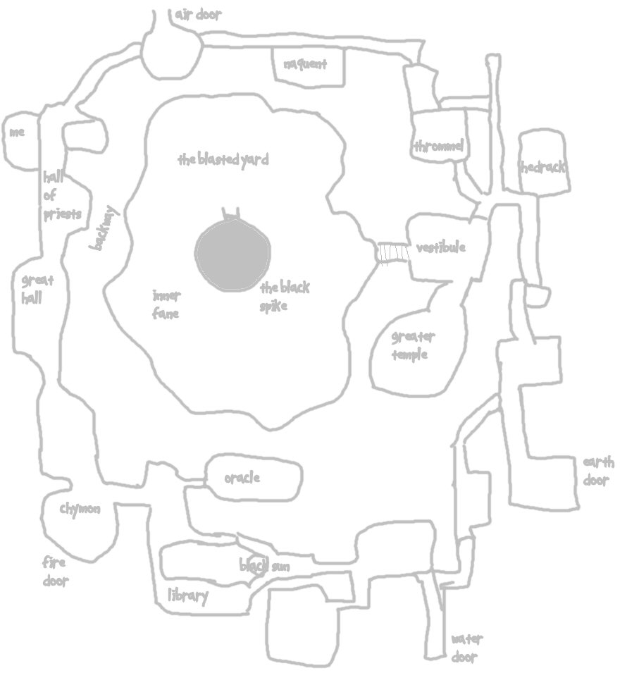
Friends,

My heart leaps with joy at your recent triumph against the strongest of the minor temples. Hedrack is busy with the champion – for I am sure that he is him – and fortunately, still views you as no more than a distraction. However, he is nothing if not prudent. He has alerted all of the forces in the fane, and provided them all with your descriptions and images, through the use of elaborate phantasms. They are aware of your coming and of your weaknesses, and are eager to find you, as much out of fear of his wrath as in anticipation of a reward. The lightning towers are on constant watch, and the spider eater riders are patrolling, ever vigilant. I recommend you wait until the morrow, as with the champion supposedly proven by that time, Hedrack will be too bothered to pay much attention to your coming.

Do beware, my friends! I can do little to help you further at this juncture, and my predicament is growing daily. It is my hope that the little sketch I have provided will be of some trifling assistance to you, in showing you the general layout of the outer fane. I beg your forgiveness, for I had to prepare this hastily, and thus it is not fully detailed.

In my quest for repentance, I have also included a few pages from my diary. I was, indeed, the one who wrote these terrible words. Oh, how exultant I was! Alas, my day of judgment shall come. For now, accept this confirmation of my identity as you have correctly deduced.

Praying for your success, Varachan

