Mid Northern Valleys Cat Club
Annual Championship Show
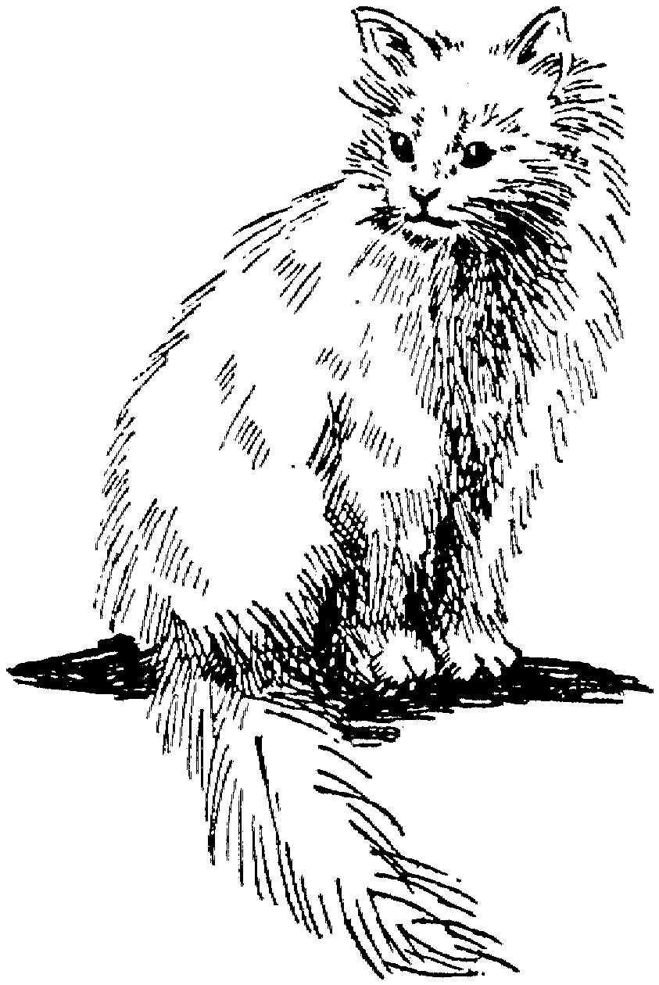
Sunday 27th March 2011

NAPPERBY MEMORIAL HALL, SCENIC DRIVE, NAPPERBY

(Turn off before Port Pirie. See Marilyn for a map.)
Judging panel
RING 1 | RING 2
GROUP 1  Anne Bourke FCCV | GROUP 1  Judith Russack GCCFSA
GROUP 2  Anne Bourke FCCV | GROUP 2  ENTIRES Judith Adams GCCFSA  NEUTERS & KITTENS Mathew Wood GCCFSA
GROUP 3  Anne Bourke FCCV | GROUP 3  Judith Russack GCCFSA
GROUP 4  Anne Bourke FCCV | GROUP 4  Rose Preston GCCFSA
DOMESTICS  Judith Adams GCCFSA | DOMESTICS  Rose Preston GCCFSA
Ring 2 Judges will judge Side Classes

Show Managers: Marilyn Larcombe & Susan Everett
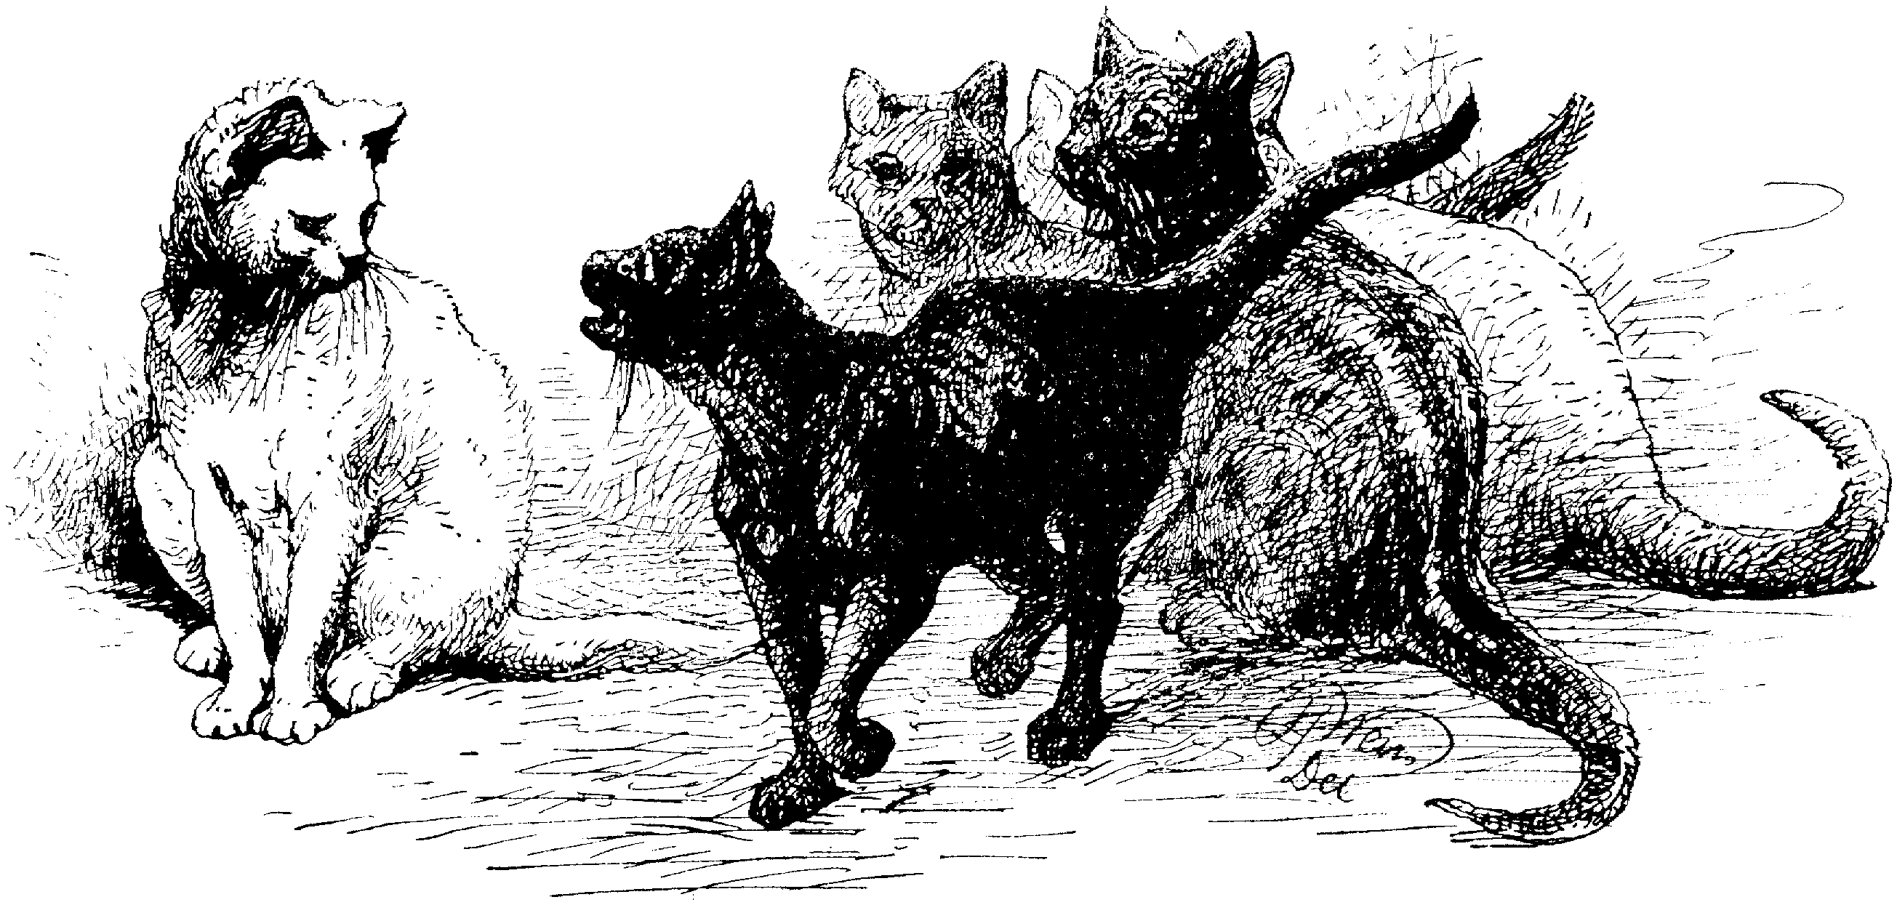

ENTRIES CLOSE: SUNDAY FEBRUARY 27TH 2011

Post Entries to: Marilyn Larcombe P.O. Box 84, Port Pirie SA 5540

Ph: 0409 690 492
Cheques payable to ‘Mid Northern Valleys Cat Club’. Please include all fees with entries.
Money orders MUST have your name and address on the back.
IN-LINE VETTING WILL APPLY AT THIS SHOW
CONDUCTED UNDER THE RULES AND REGULATIONS OF THE GOVERNING COUNCIL OF CAT FANCY OF SA INC
SHOW MANAGEMENT RESERVES THE RIGHT TO CHANGE JUDGING ASSIGNMENTS DEPENDING ON NUMBER OF ENTRIES.
PLEASE ADVISE UPGRADES AS EARLY AS POSSIBLE.
UPGRADES & CHANGES MUST BE NOTIFIED BY MONDAY 21st March 2011.
ENTRY FEES
ENTIRES & NEUTERS 13.00
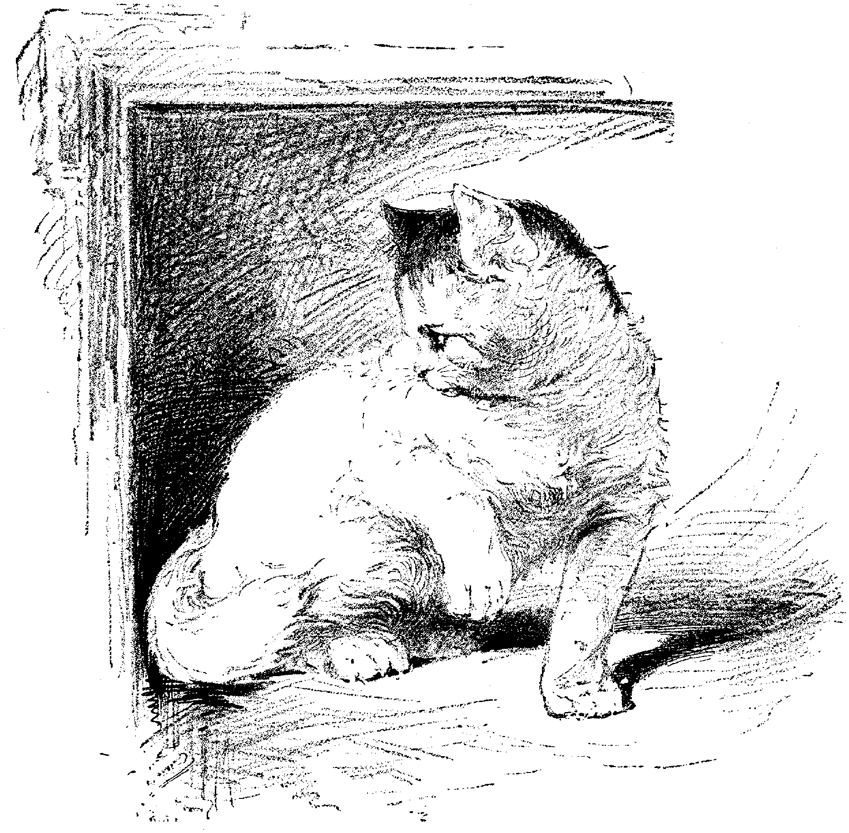
KITTENS, DOMESTICS & PT PEDIGREE 10.00
AGE, LITTER, PAIR, BRACE, TEAM ETC 5.00
SIDE CLASSES included in above price
GOLDEN AWARDS 4.00
CATALOGUE 6.00
ADVERTISING full page / half page 6.00 / 3.00
EXHIBITORS PASS & EXTRA PASSES 1.00 ea
DOUBLE CAGE 3.00
EXHIBITION CAGE 5.00

DONATIONS WILL BE GREATLY APPRECIATED.
This helps go towards ribbons and trophies and will be acknowledged in the catalogue.

TIMETABLE
SETTING UP SHOW – SATURDAY 26TH March 2011 1.00PM

VENUE OPEN SUNDAY 27th M arch 7.30AM – IN LINE VETTING APPLIES
CATS TO BE BENCHED BY 8.45AM OR WHEN VETTING IS FINISHED
JUDGING TO COMMENCE APPROX 8.45AM
MNVCC PRESENTATION 3.30 PM

SHOW CLOSE & DISMANTLING 4.30PM
Help with Setting Up and Dismantling of Show is greatly appreciated.

Please remember to bring your covered litter tray to avoid unnecessary odours in the hall.
Also bring water bowl and water with you for your cats.
If you have any advertising materials (brochures, photo boards etc) bring them along for the public to see.

PLEASE REMEMBER: No Exhibit shall be removed from the show prior to CLOSE OF SHOW without the prior permission of the Show Manager.

KITTEN CLASSES
KITTENS: Born on or between
26-06-10 and 27-08-10 M9 F9
26-08-10 and 27-10-10 M7 F7
26-10-10 and 27-12-10 M5 F5

RECORD OF CATS ENTERED
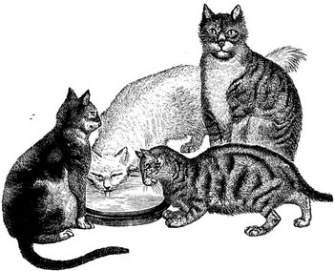
……………………………………………………………………………………………………..

……………………………………………………………………………………………………..

……………………………………………………………………………………………………..

……………………………………………………………………………………………………..

……………………………………………………………………………………………………..

MNVCC EXHIBITOR ETIQUETTE

Exhibitors should note the following in the interests of fair play and the enjoyment of all on the day:
- Please do not make comments on exhibits within the Judge’s hearing or challenge the Judge’s decision during judging.
- Please do not talk during judging and reserve your interaction with the Judge until completion of judging unless instigated by the Judge.
- Offenders will be asked to leave the area by the Judge or Show Manager. If the request is ignored the Judge or Show Manager has the right to disqualify the exhibitor’s cats.
- Please turn off your mobile phone while judging is underway.
PLEASE NOTE: No exhibit is to be removed from the show prior to CLOSE OF SHOW without the permission of the Show Manager (Show Rule 13.9)

Gov. Council Golden Award

The Golden Awards will be held annually for GCCFSA registered Longhairs, Siamese, Foreign Shorthairs and British Shorthairs with separate classes for Entire Cats and Neuters. All exhibits must be nine (9) months of age or over.
QUALIFYING HEATS may take place at any approved show except the show at which the FINALS take place.
The FINALS may take place at a Governing Council Show or any show nominated by the Governing Council.
The entry fee for the QUALIFYING HEATS is to be $4.00; $3.00 of which is to go to the Governing Council. There will be no entry fee for the FINALS, but cats concerned must enter a Challenge or Award of Merit class.
If there are up to nine (9) entries in a Qualifying class, the judge may award two Qualifiers and a Reserve. If there are ten to fourteen entries, the judge may award three Qualifiers and a Reserve. If there are fifteen to nineteen entries, there may be four Qualifiers and a Reserve. For each additional five entries, there may be one additional Qualifier. There will be no minimum entries required for the class to be held.For heats qualifiers do not need to place in top ten.
Qualifiers are eligible to enter the FINALS but may not enter any more Qualifying Heats during the current Golden Award Year. Reserves are eligible to enter the Finals if any of the Qualifiers from their Heat are not benched. Reserves may attempt to Qualify in their own right at other shows in the same Golden Award Year, and if successful, are then Qualifiers.
Judges may withhold any placings if they do not consider that there are entries of sufficient merit. Exhibits who Qualify after the closing of entries for the Finals carry over into the Finals of the next Golden Award Year.
Governing Council will make available to shows holding Qualifying Heats, a suitable prize card.
For the Finals, Council will provide a prize card, a sash or rosette, and the following prize monies:
All Entire & Neuter Sections:
First - $50.00
Second - $30.00
Third - $20.00

Guidelines for ACF Award

- All adult cats are eligible.
- Cats must be entered in the class by the Show Secretary. The class is to be a FREE CLASS.
- Maximum Certificates to be awarded per show:
One certificate per SEX per GROUP
Ie no more than six (6) certificates to be awarded per show for entires
No more than six (6) certificates to be awarded per show for desexed.
- In the case of a "multiple ring" show, each ring to be considered as a "separate show" and certificates to be awarded accordingly.
- Record of certificates issued to be sent to affiliate control after each show. (Used to check certificates.)
- For each level, applications for ACF Award of Excellence must be made on the appropriate form.
- Applications must be made THROUGH the affiliate control.
- For each level, applications must be accompanied by 10 original award certificates to the ACF Secretariat.
- For each level, applications must be accompanied by $20.00 fee, payable to ACF Inc.
- Affiliates may submit endorsed photocopies of certificates to the ACF Secretariat.
- Affiliates must submit the prescribed $20.00 fee with all applications to the ACF Secretariat.
The awarding of a certificate is to be regarded as a mark of excellence in a particular exhibit. It is not to be regarded as an automatic award in any respect.
Open to all adult cats registered with ACF & CCCA affiliates (of breeds, colours and patterns recognized by ACF).
Nb. This class is no longer restricted to titled cats.
There are 8 levels in the ACF Award of Excellence – AoE, Bronze, Silver, Gold, Sapphire, Ruby, Emerald, Diamond – each step requires 10 AoE certificates.

NEW EXHIBITORS: FOR MORE INFORMATION ON SHOW PROCEDURES, ASK FOR THE LEAFLET 'SHOWING CATS' (Ph/Fax: 08 8449 5880). All entries must be in writing, accompanied by correct fees, and in hands of the Show Manager by closing date.

MID NORTHERN VALLEYS CAT CLUB. Show Summary Sheet
PLEASE FILL IN COMPLETELY & CLEARLY. All exhibits, local and interstate, excepting non-pedigreed,
must be registered with and issued with an approved registration number by a recognized controlling body.
Form can be filled in on screen and then printed –– or can be printed out then filled in.

EXHIBITOR:
ADDRESS:
 | POSTCODE: | TELEPHONE:
EMAIL: | INCLUSION OF ADDRESS IN CATALOGUE: YES / NO  INCLUSION OF PHONE NO IN CATALOGUE: YES / NO

I am willing to help at show in the following capacity |  | TOTAL OF ALL ENTRIES | $ | ¢
Set Up Steward |  | Adult Cats - $13.00
Kitchen Marking Catalogues |  | Kittens, Domestics, Part Ped $10.00
Runner Ticket Room |  | Age, Litter, Pairs etc Classes $5.00
Other_ _ _ _ _ _ _ _ _ _ _ _ _ _ _ _ _ _ _ _ |  | Sideclasses | INC
DECLARATION: I hereby certify that all particulars  above, and on the entry forms herewith, are true and correct, that all exhibits are owned or leased by me and are eligible for classes entered, and are entered at my own risk. I agree to abide by the Show Rules and Regulations of GCCFSA and to accept Show Officials' decisions.  Signed……………………………………………..Date…………………..…  TROPHY DONATION  _ _ _ _ _ _ _ _ _ _ _ _ _ _ _ _ _ _ _ _ _ _ _ _ _ _ _ _ _  ALL DONATIONS TOWARDS THE TROPHIES WILL  BE GREATLY APPRECIATED AND WILL BE ACKNOWLEDGED IN THE CATALOGUE |  | Golden Awards $4.00 each
 |  | Exhibitors Passes $1.00 | 1 | 00
 |  | Extra Passes $1.00
 |  | Catalogue $6.00
 |  | Advertising Full Page $6.00, Half Page $3.00
 |  | Exhibition Cage $5.00
Double Cage $3.00
(GRP 2, 3, 4, DOM & P/P ADULT MALES ONLY)
 |  | Donation
 |  | TOTAL $

ALL FEES MUST ACCOMPANY ENTRIES. CHEQUE / MONEY ORDER / CASH INCLUDED.
PLEASE PUT YOUR NAME AND ADDRESS ON BACK OF MONEY ORDERS AND
MAKE CHEQUES PAYABLE TO THE MID NORTHERN VALLEY CAT CLUB.
PLEASE COMPLETE VETTING SLIP BELOW
EXHIBITOR: |  | CATALOGUE ORDERED  YES / NO |  | NUMBER OF  PASSES
Cage No. | Name Of Exhibit | Cage No. | Name Of Exhibit

GCCFSA Show Rules / Show Classes & Codes

FROM RULE 1.1: All pedigreed exhibits 5 months of age and over on the day of the show and domiciled in SA for 3 months must be individually registered with GCCFSA or FASA. All pedigreed exhibits under five months of age on the day of the show must be litter registered.
* Note: “Pending” means completed application is lodged with the registrar prior to show entry being accepted.
* Note: Pedigreed exhibits must be entered in the name of their registered owners/lessees.
RULE 6: Show Managers must be notified of an exhibit's change of status asap and not later than the Monday prior to a show, otherwise the exhibit will be outclassed.
RULE 7: All exhibits must have their front & back claws trimmed. (Trimming means removal of sharp tip only.)
FROM RULE 8.4: Should an exhibit be rejected because it shows symptoms of or may be suffering from a contagious disease the exhibitor must remove all the exhibits they have entered in the show from the venue immediately.
RULE 12.2.2: After use, litter trays must be covered with a lid, or fully enclosed in a strong plastic bag and taken home for disposal.
RULE 13.8.1: Any person who does not notify the Show Manager or Show Committee, prior to the erection of cages, that they will not be exhibiting any or all of their cats entered, or any person who does not notify the Show Manager within seven (7) days after the Show, the reason for their non-attendance, may be disqualified from exhibiting at future shows.
RULE 14.2: Exhibits placed in wrong cages by exhibitors may be disqualified.
RULE 14.3: Exhibits entered in the wrong classes by exhibitors will be deemed ineligible for those classes.
FROM RULE 16.2: The Judge’s decision on the day of the show is final.
** For full definitions & rules see “GC Show Rules & Information” – available from GCCFSA for $2.00

Details overleaf for Governing Council Golden Awards (Qualifying Heat at this show) and the ACF Awards

Pedigree Adult Classes

ADULTS: Born on or before 10-03-10
(9 months of age and over on day of show)

CHALLENGE Classes Males Females
Open OM OF
Champion CHM CHF
Grand Champion GCHM GCHF
Double Grand Champion DGCHM DGCHF
Bronze Dbl Grand Champion BDGCHM BDGCHF
Silver Dbl Grand Champion SDGCHM SDGCHF
Gold Dbl Grand Champion GDGCHM GDGCHF

AWARD OF MERIT Classes
Neuter NMC SFC
Premier Neuter PRNM PRNF
Grand Premier Neuter GPNM GPNF
Double Grand Premier DGPRNM DGPRNF
Bronze Dbl Grand Premier BDGPNM BDGPNF
Silver Dbl Grand Premier SDGPNM SDGPNF
Gold Dbl Grand Premier GDGPNM GDGPNF

NON CHALLENGE Classes
Junior Entire: 9mths-18mths JM JF
Junior Neuter JNM JSF
Intermediate Entire: 18mths-5yrs IM IF
Intermediate Neuter INM ISF
Senior Entire: 5yrs-7yrs SM SF
Senior Neuter SNM SSF
Veteran Entire: over 7yrs VM VF
Veteran Neuter VNN VSF

Novice: A cat that has not NM NF
won a 1st prize in adult classes
Limit: A cat that has not LM LF
won 4 first prizes in adult classes
(Champions not eligible for Limit)
Pair of cats: Two exhibits, opposite sex, PC
same breed, colour & owner
Brace of cats: Two exhibits, same breed, BC
sex, colour & owner
Team of cats: Three or more exhibits, TC
same breed, colour & owner
Brood Queen: Benched with entire litter BQ

Gov Council Golden Award GCGA

Pedigree Kitten Classes

KITTENS: Born on or between
11-01-10 and 10-03-10 M9 F9
11-03-10 and 10-05-10 M7 F7
11-07-10 and 10-07-10 M5 F5

All kittens whether entire or desexed are to be judged in their respective age classes, as above.

Extra Classes for Kittens - optional
Pair of Kittens PK Team of Kittens TK
Brace of Kittens BK Litter of Kittens LIT

Experimental Classes
Codes: EMK EFK EMC EFC
~ Definitions - see GC Show Rules & Information

Part Pedigree Classes
~ One parent known and named ~
~ Exhibits 6 mths & over must be desexed ~
ADULT Neuter or Spey PPNMC / PPSFC
KITTEN Neuter or Spey PPNMK / PPSFK
KITTEN Entire under 6 mths PPK

Domestic Classes
~ Unpedigreed ~
~ Exhibits 6 mths & over must be desexed ~
Domestic Neuter or Spey Cat DNMC / DSFC
Domestic Neuter or Spey Kitten DNMK / DSFK
Domestic Kitten Entire (under 6 mth) DMK / DFK

* PPNMC, PPSFC, DNMC & DSFC are Merit Award classes. These accumulate towards titles – see Rules & Information book.

** For full definitions & rules see “GC Show Rules & Information” – available from GCCFSA for $2.00

 | Single Cage  (18" x 18" x 18") | Double Cage $3.00 each (36” x 18” x 18”)  (Group 2, 3, 4, Dom & P/P ADULT MALES ONLY) | PLEASE DO NOT USE

TITLE & NAME OF EXHIBIT: |  |  |  |  | PLEASE USE CORRECT CODES ONLY
 |  |  |  |  | GROUP  BREED  COLOUR/PATTERN |  | CLASSES
REGISTERED OWNER |  |  |  |  | GROUP  BREED  COLOUR/PATTERN
SIRE |  |  |  |  | GROUP  BREED  COLOUR/PATTERN
DAM: |  |  |  |  | GROUP  BREED  COLOUR/PATTERN |  | MALE | FEMALE
DATE OF BIRTH: | GOV BODY: | REG NO: |  |  | GROUP  BREED  COLOUR/PATTERN |  | CAT | KITTEN
BREEDER |  |  | WHERE BRED: |  | GROUP  BREED  COLOUR/PATTERN |  | ENTIRE | DESEXED

 | Single Cage  (18" x 18" x 18") | Double Cage $3.00 each (36” x 18” x 18”)  (Group 2, 3, 4, Dom & P/P ADULT MALES ONLY) | PLEASE DO NOT USE

TITLE & NAME OF EXHIBIT: |  |  |  |  | PLEASE USE CORRECT CODES ONLY
 |  |  |  |  | GROUP  BREED  COLOUR/PATTERN |  | CLASSES
REGISTERED OWNER |  |  |  |  | GROUP  BREED  COLOUR/PATTERN
SIRE |  |  |  |  | GROUP  BREED  COLOUR/PATTERN
DAM: |  |  |  |  | GROUP  BREED  COLOUR/PATTERN |  | MALE | FEMALE
DATE OF BIRTH: | GOV BODY: | REG NO: |  |  | GROUP  BREED  COLOUR/PATTERN |  | CAT | KITTEN
BREEDER |  |  | WHERE BRED: |  | GROUP  BREED  COLOUR/PATTERN |  | ENTIRE | DESEXED

 | Single Cage  (18" x 18" x 18") | Double Cage $3.00 each (36” x 18” x 18”)  (Group 2, 3, 4, Dom & P/P ADULT MALES ONLY) | PLEASE DO NOT USE

TITLE & NAME OF EXHIBIT: |  |  |  |  | PLEASE USE CORRECT CODES ONLY
 |  |  |  |  | GROUP  BREED  COLOUR/PATTERN |  | CLASSES
REGISTERED OWNER |  |  |  |  | GROUP  BREED  COLOUR/PATTERN
SIRE |  |  |  |  | GROUP  BREED  COLOUR/PATTERN
DAM: |  |  |  |  | GROUP  BREED  COLOUR/PATTERN |  | MALE | FEMALE
DATE OF BIRTH: | GOV BODY: | REG NO: |  |  | GROUP  BREED  COLOUR/PATTERN |  | CAT | KITTEN
BREEDER |  |  | WHERE BRED: |  | GROUP  BREED  COLOUR/PATTERN |  | ENTIRE | DESEXED

 | Single Cage  (18" x 18" x 18") | Double Cage $3.00 each (36” x 18” x 18”)  (Group 2, 3, 4, Dom & P/P ADULT MALES ONLY) | PLEASE DO NOT USE

TITLE & NAME OF EXHIBIT: |  |  |  |  | PLEASE USE CORRECT CODES ONLY
 |  |  |  |  | GROUP  BREED  COLOUR/PATTERN |  | CLASSES
REGISTERED OWNER |  |  |  |  | GROUP  BREED  COLOUR/PATTERN
SIRE |  |  |  |  | GROUP  BREED  COLOUR/PATTERN
DAM: |  |  |  |  | GROUP  BREED  COLOUR/PATTERN |  | MALE | FEMALE
DATE OF BIRTH: | GOV BODY: | REG NO: |  |  | GROUP  BREED  COLOUR/PATTERN |  | CAT | KITTEN
BREEDER |  |  | WHERE BRED: |  | GROUP  BREED  COLOUR/PATTERN |  | ENTIRE | DESEXED

 | Single Cage  (18" x 18" x 18") | Double Cage $3.00 each (36” x 18” x 18”)  (Group 2, 3, 4, Dom & P/P ADULT MALES ONLY) | PLEASE DO NOT USE

TITLE & NAME OF EXHIBIT: |  |  |  |  | PLEASE USE CORRECT CODES ONLY
 |  |  |  |  | GROUP  BREED  COLOUR/PATTERN |  | CLASSES
REGISTERED OWNER |  |  |  |  | GROUP  BREED  COLOUR/PATTERN
SIRE |  |  |  |  | GROUP  BREED  COLOUR/PATTERN
DAM: |  |  |  |  | GROUP  BREED  COLOUR/PATTERN |  | MALE | FEMALE
DATE OF BIRTH: | GOV BODY: | REG NO: |  |  | GROUP  BREED  COLOUR/PATTERN |  | CAT | KITTEN
BREEDER |  |  | WHERE BRED: |  | GROUP  BREED  COLOUR/PATTERN |  | ENTIRE | DESEXED

 | Single Cage  (18" x 18" x 18") | Double Cage $3.00 each (36” x 18” x 18”)  (Group 2, 3, 4, Dom & P/P ADULT MALES ONLY) | PLEASE DO NOT USE

TITLE & NAME OF EXHIBIT: |  |  |  |  | PLEASE USE CORRECT CODES ONLY
 |  |  |  |  | GROUP  BREED  COLOUR/PATTERN |  | CLASSES
REGISTERED OWNER |  |  |  |  | GROUP  BREED  COLOUR/PATTERN
SIRE |  |  |  |  | GROUP  BREED  COLOUR/PATTERN
DAM: |  |  |  |  | GROUP  BREED  COLOUR/PATTERN |  | MALE | FEMALE
DATE OF BIRTH: | GOV BODY: | REG NO: |  |  | GROUP  BREED  COLOUR/PATTERN |  | CAT | KITTEN
BREEDER |  |  | WHERE BRED: |  | GROUP  BREED  COLOUR/PATTERN |  | ENTIRE | DESEXED

