Name Period Date

Changes of State

Part A – Intermolecular Forces
- Fill in the diagram (with high or low) to show how intermolecular forces influence the volatility, vapor pressure, and boiling point of a substance.
When IMF are…
volatility is ____________
vapor pressure is _______
boiling point is __________
volatility is __________
vapor pressure is __________
boiling point is __________
weak
strong

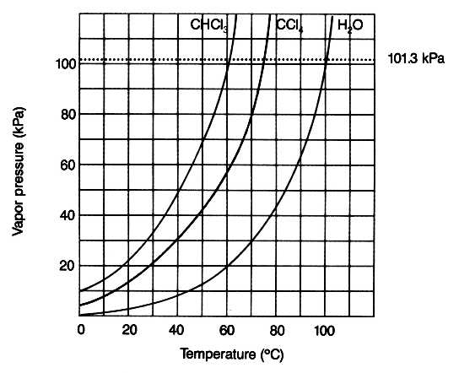
Part B – Vapor Pressure Graphs Use the graph below to answer the following questions.
- What is the vapor pressure of CHCl₃ at 50°C?
- What is the boiling point of H₂O when the
external pressure is 30 kPa?
- What is the normal boiling point of CCl₄?
- Which substance has the weakest IMF?

Part C – Heating Curves. Use the heating curve below to answer the following questions.
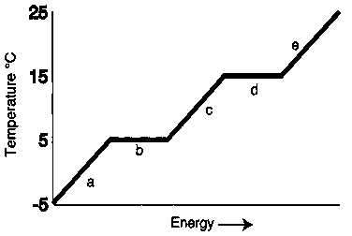
- What is the melting point of the substance?
- What is the boiling point of the substance?
- Which letter represents heating of the solid?
- Which letter represents heating of the vapor?
- Which letter represents melting of the solid?
- Which letter represents boiling of the liquid?

Part D – Phase Diagrams. Use the phase diagram for water below to answer the following questions.
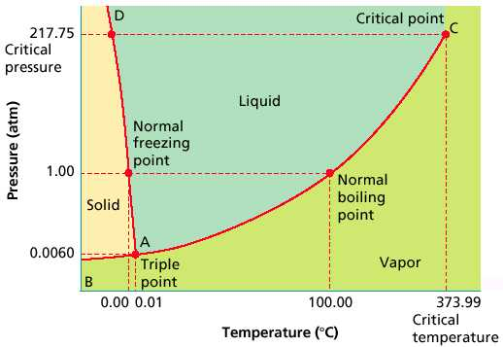
- What is the state of water at 2 atm and 50°
- What phase change will occur if the temperature is lowered from 80°C to -5°C at 1 atm?
- You have ice at -10°C and 1 atm. What could you do in order cause the ice to sublime?

