Name/archetype
Type, Superior
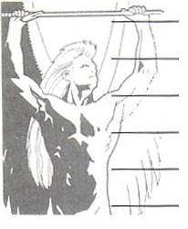 | Essence |  | 
 |  |  |  |  | 
 | Forces |  | Forces |  | Forces
 | Strength |  | Intelligence |  | Will
 | Agility |  | Precision |  | Perception
 | Hits |  | Hits |  | Hits

Role | Skills

Distinctions/  Attunements | Songs

