“The Hot Foot”?
Referencing Web site:
http://www.positivehealth.com/permit/Articles/Reflexology/sahai13.htm

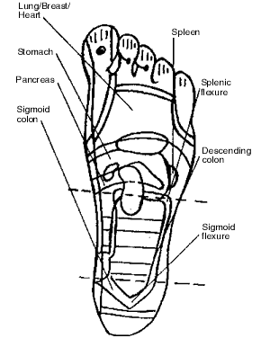
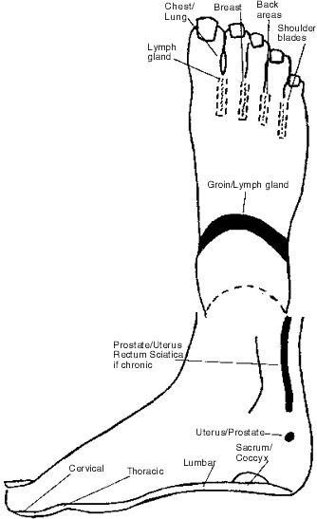

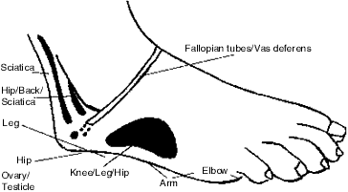
Energy Pathways (diagram 2)
