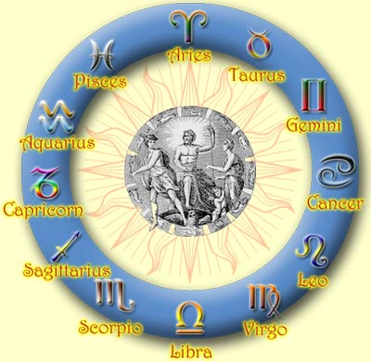
What Astrology Is

Astrology has been around in one form or another since as early as 5000BC where there is evidence of astrology in Great Britain and France. The modern astrology today began in Mesopotamia and Sumeria, and has since evolved in different forms to adjust to different cultures and their perceptions of their discoveries; such an example is Chinese Astrology.

Astrology is a method of exploring oneself. It can be used to help determine characteristics and behaviors, relationships, moods and attitudes. It is the science of stars in their environmental element at a person’s time of birth. The science of astrology believes that the alignment of planets and stars influence and affect the living word, notably in people. There are many aspects to astrology which help to explain different information. Astrology involves your ‘Stars’ or ‘Sun Sign’, your ‘Birth Chart’, and ‘Houses’.

A ‘Birth Chart’ is a representation of the positions of the planets at your time of birth; it’s your connection with the universe. The birth chart’s main components are the planets, signs and houses.

Your ‘Stars’ or ‘Sun Sign’ is the position of the Sun in your birth chart; it helps to provide a glimpse into your character and coming events. The planets also each have their individual meaning and are assigned depending on the moment of your birth.

The ‘Houses’ are twelve division of the birth chart and indicate the areas of life where the planetary energies become active. The houses are based on the signs which are part of the zodiac. This means that each zodiac sign, Aries, Taurus, Gemini, Cancer, Leo, Virgo, Libra, Scorpio, Sagittarius, Capricorn, Aquarius and Pisces are each assigned a house, the First house, Second house, Third house, Fourth, Fifth, Sixth, Seventh, Eighth, Ninth, Tenth, Eleventh and Twelfth House (respectively).

The ‘Zodiac Sign’ is representative of the days between which you were born. There are twelve signs and each represent a certain day in each month to begin a zodiac and a certain day to end a zodiac. A zodiac sign helps represent you and is used in determining your horoscope.

A good horoscope is a generalization of all of this information in relation to you. A horoscope will incorporate all of the information about you, and use it to determine a daily/weekly/monthly/yearly horoscope that can more accurately be related to you.

These links will help you learn more about astrology.

ABOUT
http://astrology.about.com/cs/sunsign/l/aa011701a.htm

MEANINGS OF THE ZODIAC SIGNS
http://www2.bitstream.net/~bunlion/bpi/Sign.html

CHINESE ZODIAC
http://www.rainfall.com/horoscop/chinese.htm

ASTROLOGY HISTORY
http://www.annabelburton.com/hitworks.html

