Ballistica Maximus Corp.

PRODUCT : Bangalore, from new manufacture, subject to market withdrawal.

TYPE : Sets of Bangalore Torpedoes, Each Set Consist of 4 Sections.

QUANTITY : Per lot of 300 sets.

DELIVERY TIME : To be made from current production, delivery period to be intimated according to quantities on individual orders after receipt of acceptable payment & export license.

PRICE : US$ 542.00 ea. Ex-works.

BANGALORE TORPEDO

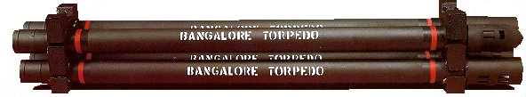

TECHNlCAL DATA: Each Section measures: 110 cm • Four Section measures: 440 cm • Diameter: 6.2 cm approx.

MATERIAL: Aluminum tube - Explosive Used: CAST TNT GRADE I • Weight of TNT per tube: 4.25 kg • Type of Booster: Compressed PETN/RDX • Method of Initiation: Standard non-electric detonators with safety-tube Standard electric detonators Detonating cord • Color: Olive green (mat finish).

PACKAGING: Standard Type: Wooden box containing 2 sets of 4 tubes each with connecting sleeves and end caps Gross Weight: 45 kg • Dimensions (mm): 270 (H) X 370 (W) X 1375 (L).

