Word 97 Mouse Tips
By
David Candy

Over 100 ways to use a mouse in Word 97

Contents
Contents 1
Welcome 2
Mouse Tips 3
Title Bar and System Menu 3
Viewing 3
Status Bar 4
Menu 4
Scroll Bars 5
Toolbars 5
Rulers 6
Intellipoint Mouse 6
Help 7
Selecting Text 8
Selecting Tables 9
Selecting Graphics 9
Graphics Tips 10
Tips 11
Add Word's Work Menu 11
Autoscroll Without a Wheelie Mouse 11
Adding Random Text 12
Repairing Word's Files and Registry Settings 12
Easter Eggs 12
Reference 13
Version History 13
Startup Command Line Switches 13

Welcome
This file contains over a hundred tips for using a mouse in Word.
Word 97 is an environment that is mouse centric. While Word has many powerful shortcut keys, using a mouse has been designed into most aspects of how Word interacts with a user. Learning these features makes many tasks easier.
This help file is designed to help with using a mouse with Word 97 effectively. Ninety-nine percent of the information is in either the online help or in the tips provided at startup. However they are difficult to find.
This file was supplied with a dot file. This file is meant to be copied to Word’s startup directory. To find out which directory is Word’s startup directory click the Tools menu, then the Options menu, then the File Locations tab. Word’s startup directory will be listed here. Copy WordMouseTips.Dot and WordMouseTips.Hlp to this directory. This will add a menu command to Word’s Help menu to start Word’s Mouse Tips.
This file is freely distributable.
Please give to new Word users.
Contact
E-Mail | davidc@sia.net.au
Web | http://www.angelfire.com/biz/serenitymacros

Yours Faithfully
David Candy
David Candy [Word MVP]
Sydney Australia
July 1998

Mouse Tips

Title Bar and System Menu
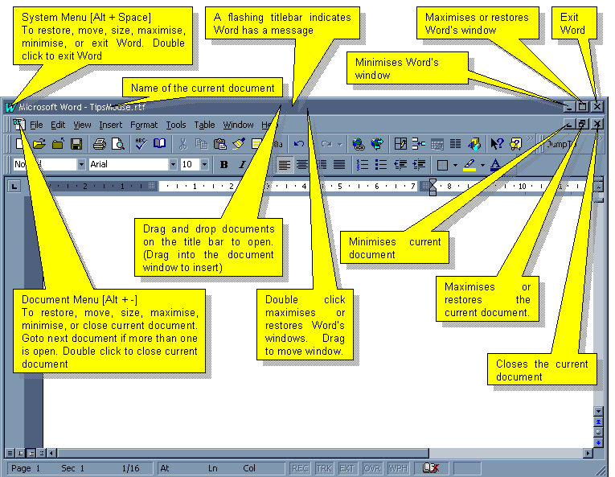

Viewing
- To edit a document while the Find or Replace dialog box is visible, click in the document window.
- To return to normal or page layout view from header/footer view, double-click the body text.
- To resize the various panes (Header / Footer, Footnotes / Endnotes, Comments, and Split Window) in Normal view mode, drag the boundary. Double click the boundary to close.
- To view a comment, point to the comment's reference mark. To delete a comment, right-click on the comment reference mark and choose Delete Comment.
- To view the text of a footnote or endnote, double-click the note's reference mark.
- Click a page number in the table of contents or table of figures to display that page.
- To display a shortcut menu, click the right mouse button.
- To switch to another open application, press ALT+TAB until the application you want appears on the screen.

Status Bar
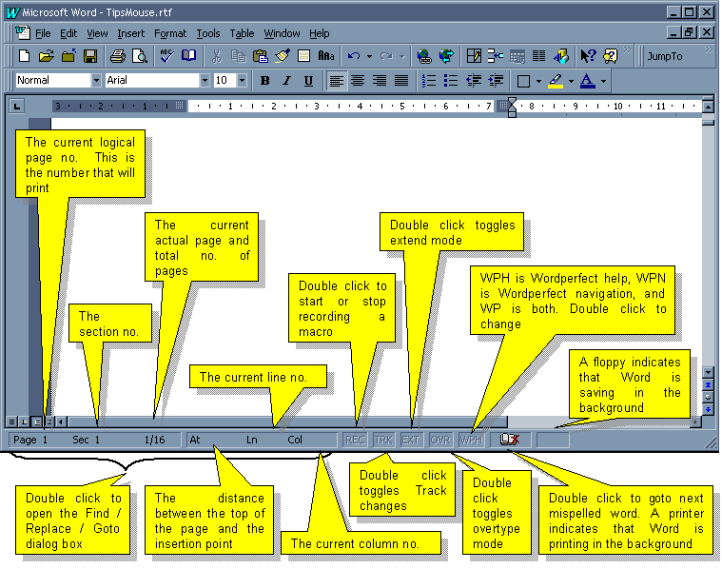

Menu
To
Close All Files | Shift + click the File Menu, Close will change to Close All.
Save All Files | Shift + click the File Menu, Save will change to Save All.
Remove a Command from the Menu | Ctrl + Alt + - then click the menu command.
Add a Command to the Menu | Ctrl + Alt + = then click the toolbar or keyboard command to be placed on a menu.
Assign a Command to a Keystroke | Ctrl + Alt + Gray Plus, then click the toolbar or menu command to be assigned. Then specify the key.
Display a Menu of Toolbars | Right click the menu.
To
Tear Off a Menu | 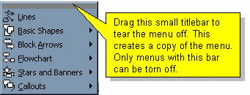

Scroll Bars
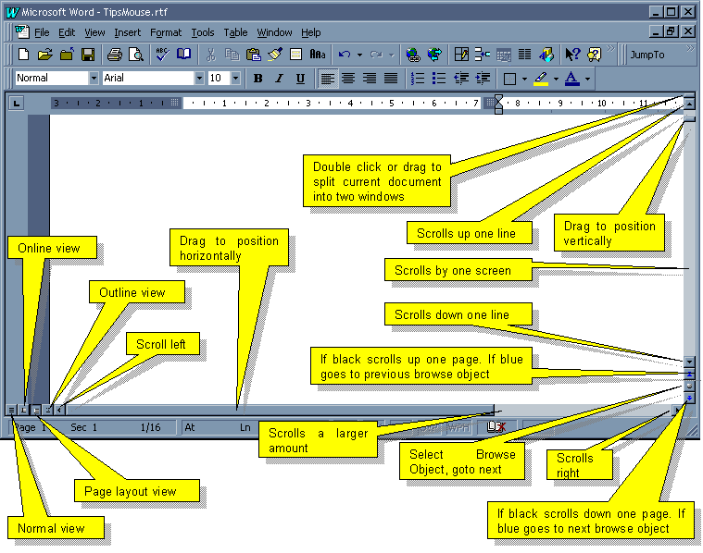

Toolbars
To
Remove Button from Toolbar | Alt + Drag button into document window.
Copy a Button | Alt + Ctrl + Drag button to new location
Move a Button | Alt + Drag button to new location
If the Tools - Customise dialog box is open don’t use the Alt key, use drag or control + drag.
To
Resize a Drop Down List Box | Open Tools - Customise dialog box, select the drop down box, and move the mouse cursor to the edge of the box. It will change to a vertical bar. Drag the width of the box.
Move a Toolbar | Click toolbar between buttons and drag. If you get close to a edge toolbar will snap to the edge. Double click between buttons to alternate between docked and floating.
Display a Menu of Toolbars | Right click the menu or a toolbar.
Add to a Toolbar | Click Customize on the Tools menu, click the Toolbars tab, and then drag any button or command onto a toolbar.
Use a Button Multiple Times | Double click the button. This works with drawing buttons and the Format Painter.
See All Styles | Shift + Click the Style Drop Down List Box.
Tell if the Toolbar extends off screen | The toolbar will show >> at the end.

Rulers
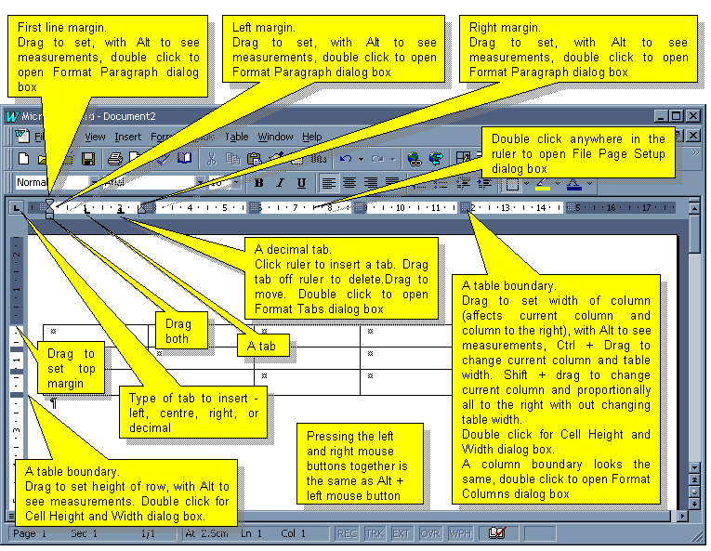

Intellipoint Mouse
Wheel Forward and Back | Scroll 3 lines at a time. (Use Tweakui to change).
Click and Hold Wheel, Move Mouse | Pan in any direction. Speed depends on distance from click point.
Click Wheel, Move Mouse | Autoscroll (Ctrl + Shf +\). For two button mouses this command can be added to the toolbar with Tools - Customise.
Ctrl + Wheel Forward and Back | Sets the View Zoom level.
Shf + Wheel Forward and Back | Point to a heading and expand or collapse headings in Outline View or the Document Map.
Shf + Wheel Forward and Back | In AutoSummarize view adjust the level of detail displayed

Help
Choose either Help - What's This? (Shf + F1) from the menu or the Help Tool from the toolbar. Use Tools - Customise to add this command to the tool bar like Word 95.
To display information that tells you how text is formatted, choose the Help Tool (or What’s This?) and click the text.
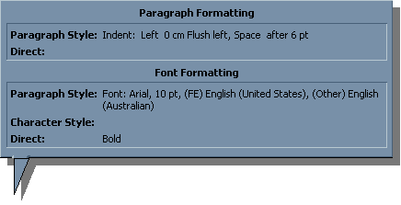
To display information about an item in Word’s window or menu command, choose the Help Tool (or What’s This?) and either click the item, menu command, or toolbar or press the keystroke for that command. For greyed out menu items and toolbar buttons this will tell you why the command is greyed out.
Hover the mouse pointer over a toolbar or screen item for a popup tip. (Turn on in Toolbars - Customize - Options).
In dialog boxes click the question mark in the titlebar then the item you want help on.
When a yellow light bulb appears in the Office Assistant, it means there is a tip available. Click the yellow light bulb to see the tip. Right click the assistant to set its options.
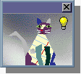
To display information about field codes, click in a field code and press F1.
To display information about a Visual Basic statement, select a keyword in a macro and press F1.

Selecting Text
The Selection Bar is an invisible area to the left of the text. The cursor changes to a right pointing arrow when over the Selection Bar as seen below.
The selection bar area can also display the style applied to that paragraph in Normal View. Set the Style Area width in Tools - Options - View.
To select a
Line | Click in the Selection Bar.
Multiple lines | Click and drag in the Selection Bar.
Paragraph | Double click in the Selection Bar.  Triple-click anywhere in the paragraph.
Multiple paragraphs | Double click and drag in the Selection Bar.
Word | Double-click the word.
Multiple Words | Double click the Word then Drag [Word does this automatically when dragging unless turned off in Tools - Options - Edit or holding down Ctrl + Shift while dragging].
Sentence | Ctrl and click the sentence.
Block of text | Click the beginning, Shf and click at the end, or drag over the text. To prevent Word from selecting whole words while dragging, turn off Automatically select entire word in Tools - Options - Edit or hold down Ctrl + Shift while dragging.
Rectangular block of text | ALT and drag.
Entire Document | Triple click in the Selection Bar.
Headers and Footers, Comments, Footnotes, and Endnotes | Open pane by double clicking grey text, then use clicks, drags, and the selection bar including triple clicks in the selection bar to select all.
Replace Text | Select it and type.
To
Copy the Formatting of Selected Text | Click the Format Painter button , then drag over the text to be formatted (Ctrl + Shf + C to copy and Ctrl + Shf + V to paste)
Copy the Formatting of Selected Text Multiple Times. | Double click the Format Painter button , then drag over the text to be formatted.
Move and Copy Text | Select text and drag it to move to a new location (or F2). Use Ctrl and Drag to copy (or Shf + F2). This doesn’t overwrite the clipboard.

Selecting Tables
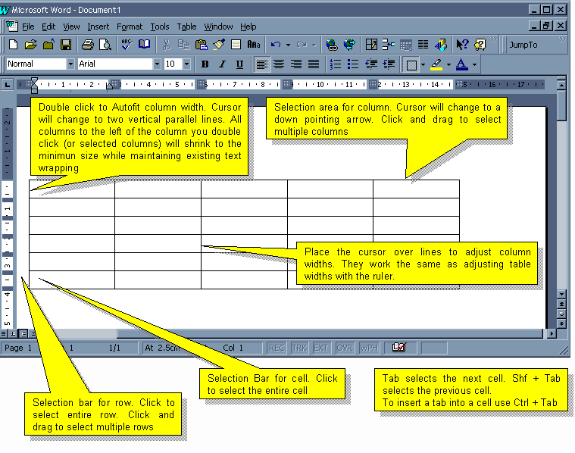

To select an entire table, click the table and press ALT+5
To insert rows or columns select the same number of rows or columns that are to be inserted and click to insert rows or to insert columns (depending if rows or columns are selected the insert table button will change to one of these). Rows are inserted above the selection, columns to the left of the selection.

Selecting Graphics
To select a
A Graphic | Click the graphic.
To Select Drawing Objects | Click the Select Drawing Objects button on the Drawing toolbar, and then click the drawing object.
To Select Several Drawing Objects | Click the Select Drawing Objects button on the Drawing toolbar, and then drag to enclose the objects. Or, select the objects you want to group by holding down SHIFT as you click each object.
To Select a Drawing Object Underneath Another | Select the drawing object on top, then press Tab to cycle through all Drawing objects.

Graphics Tips
To draw a
Square or Circle | Hold Shf while dragging an ellipse or rectangle.
Line in 15º angles | Hold Shf while dragging an line.
Line From its Starting Point | Hold Ctrl while dragging.
Square or Circle from Centre | Hold Shf + Ctrl while dragging an ellispe or rectangle.
Ellispe or Rectangle from Centre | Hold Ctrl while dragging an ellispe or rectangle.
To resize a graphic
A Graphic to Original Size | Ctrl + double click the graphic.
Without Changing Proportions | Drag a corner handle
Changing Proportions | Drag a middle handle
To resize a drawing object
Proportionally from Corner | Shf + Drag a corner handle.
Proportionally from Centre Outward | Ctrl + Shf + Drag a corner handle.
Vertically, Horizontally, Or Diagonally From The Centre Outward | Ctrl and drag a sizing handle.
Without Changing Proportions | Shf + Drag a corner handle.
Changing Proportions | Drag a handle.
To crop an object
Normal Amount | Click on the picture toolbar and drag the cropping handle.
To move an object
Normal Amount | Drag or use arrow keys.
1 Pixel at a Time | Ctrl + arrow keys or use the Nudge menu (Drawing menu on the Drawing toolbar)
Override the Snapto Grid | Alt + Drag (this applies to drawing as well)
Horizontally or Vertically | Shf + Drag
To rotate an object
Normal Amount | Click on the Drawing toolbar and drag the rotate handle.
- To center a drawing object on the page, click the Draw button on the Drawing toolbar, and then click Align or Distribute.
- To wrap text around a graphic, right-click on the graphic, choose Format, and then click Wrapping.
- To reshape the freeform, drag one of the vertexes that form its outline. To add a vertex to the freeform, click where you want to add it, and then drag. To delete a vertex, press CTRL and click the vertex you want to delete.

Tips

Add Word's Work Menu
Word 97 has an inbuilt feature called the Work Menu. It is disabled by default.
To add a file to the Work Menu, click the Work Menu and click Add To Work Menu. To remove a file press Ctrl + Alt + minus (between the zero key and equal sign) and click the filename to be removed or open the Tools - Customise dialog box, click the File Menu, click the Work Menu, then right click the filename and chose Delete.
To enable the Work Menu follow these steps.
- On the Tools Menu click Customise
- Then click the Commands Tab
- In the list box titled Catergories on the left hand side scroll down to the second last item called Built-In Menus and select it
- In the list box titled Commands on the right hand side scroll down to the last item called Work and select it by clicking
- (This menu can go on any toolbar or anywhere on any menu. I put it above the recently used file list on the File Menu)
- Holding the left mouse button down over the Work Menu, drag it and without releasing the mouse button hold it above the File Menu on the menu bar, the File Menu will now drop down.
- Still dragging without releasing the left mouse button move down the File Menu, a horizontal bar will appear showing where the Work Menu would be added if the left mouse button was released
- When the horizontal bar is between the menu separator and the list of recently used files directly underneath the separator release the mouse button.
- Close the Tools - Customise dialog box, (but come back an explore it, Word has many hidden commands).

Autoscroll Without a Wheelie Mouse
People with a Microsoft mouse with a wheel know that Word 97 can automatically scroll a page at a fixed speed by clicking the wheel. This can also be achieved with the keyboard (On Australian, NZ, & US keyboards press Ctrl + Shift + \) and any mouse. Then move the mouse up and down to control speed and direction.
Howerer using a keyboard and mouse to AutoScroll is a bit of a hassle. This shows you how to put it on a toolbar so automatic scrolling is one mouse click away.
- On the Tools Menu click Customise
- Then click the Commands Tab
- In the list box titled Catergories on the left hand side scroll down to the second last item called All Commands and select it
- In the list box titled Commands on the right hand side scroll down to the item called AutoScroll and select it by clicking
- (This menu can go on any toolbar or anywhere on any menu.)
- Holding the left mouse button down over the AutoScroll Command, drag it and without releasing the mouse button hold it above the toolbar that you want it on.
- Still dragging without releasing the left mouse button a vertical bar will appear showing where the AutoScroll Command would be added if the left mouse button was released
- When the horizontal bar is where you want it release the mouse button.
- Right click the button you just added, and choose Text Only (In Menus), right click it again and choose Change Button Image. Select a new button image.
- Close the Tools - Customise dialog box.

Adding Random Text
Type =rand() and press the Enter key. You'll get three paragraphs of five sentences of "The quick brown fox jumped over the lazy dog.
=rand(p,s)
p | the number of paragraphs
s | the number of sentences in each paragraph.
Replace text as you type must be turned on in Tools Autocorrect

Repairing Word's Files and Registry Settings
Word's setup program can be used to repair Word's registry settings.
Use Start Menu, then Run and browse to Word's Startup program (usually C:\Program Files\Microsoft Office\Office\Setup) and add /r or /r /y to the end of the line.
C:\Program Files\Microsoft Office\Office\Setup\Setup.exe /r /y
Switch | Meaning
/r | Reinstalls Word using the options of the last installation.
/y | [Used with /r] Reinstalls Word using the options of the last installation without coping the files.

Easter Eggs
- Start Word with a new document
or
Click New on the toolbar
- Type Blue
- Select Blue and click the Format, then Font menu
- Specify Font Style to Bold and Colour to Blue
- Click OK
- Press the left arrow key or click after the word so it is no longer selected
- Type a space after Blue
- Click the Help then About Microsoft Word menus
- Click the Word Icon in the About dialog box
- Your screen will be replaced with a pretty hopeless pinball game incorporating a scrolling list of developers.
Z | Left Flipper
M | Right Flipper

Reference

Version History
Version | Release Date
1.0 | 15th November 1989
1.1 and 1.1a | 18th July 1990
2.0, 2.0a, 2.0b, 2.0c, and 2.0a-CD | 21st October 1991
Word 6.0, 6.0a, and 6.0c | 27th October 1993
Word 95 (Word 7) and Word 95a (Word 7.0a) | November 1995
Word 97 (Word 8) and Word 97 SR-1 (Word 8.0a) | October 1996
Source - Q100835

Startup Command Line Switches
<Path to Word>\winword.exe [a] [n] [m[macroname]] [t] [l] [/reg] [/unreg] [filename] [filename]
Switch | Meaning
/n | No new default document.
/m | Run a macro [/mmacroname] or prevent autoexec from running [/m]  Cannot be used with the /t switch.
/a | Starts Word without a template (including startup addins) or options stored in the registry.
/l | Load a specific addin.
/reg | Re-registers Word’s registry’s settings
/unreg | Unregisters Word’s registry’s settings
/t | Bases a new document on the specified document .
/x | Starts a new instance of Word that only accepts one DDE conversation. Used by the Windows shell for printing
Filename | Opens a file
Filename Filename | Opens multiple files

Examples
C:\Program Files\Microsoft Office\Office\winword.exe Filename
C:\Program Files\Microsoft Office\Office\winword.exe Filename Filename
C:\Program Files\Microsoft Office\Office\winword.exe /a
C:\Program Files\Microsoft Office\Office\winword.exe /n
C:\Program Files\Microsoft Office\Office\winword.exe /m
C:\Program Files\Microsoft Office\Office\winword.exe Filename /mmacroname
C:\Program Files\Microsoft Office\Office\winword.exe /tDocumentPathAndName
C:\Program Files\Microsoft Office\Office\winword.exe /t
C:\Program Files\Microsoft Office\Office\winword.exe /lAddinPathAndName
C:\Program Files\Microsoft Office\Office\winword.exe Filename /w

