Mr. Goto
Sophomore World History

Topic: NINETEENTH CENTURY NATIONALISM AND IMPERIALISM
Unit Lesson #3 - European Conflict in Africa and Asia

State Standard:
1SS-P6. Analyze patterns of change during the nineteenth century era of imperialism from varied perspectives with emphasis on:
PO 3. The Nationalism that led to conflict between European nations as they competed for raw materials and markets, including the rush for colonies in Africa and Asia.

Objectives and Expectations for Learning:
The class will recognize what drew Imperial nations into Africa and China as well as analyze what lead these Imperialist nations to fight amongst each other.
Students will discuss European conflict in Africa and Asia drawing upon content learned in class as well as past meetings and assigned readings.

Anticipatory Set:
What have we learned the past couple days about Imperialism?

Direct Instruction:
This lesson will be presented in lecture format for variety. The attached notes may be written on the board or on an overhead. Go through the notes adding necessary comments and letting students voice opinions or concerns.

Guided Practice:
Hand out to students a copy of the crossword puzzle containing items from the day's lecture.

Closure:
Are there any questions needed for clarification?
What problems have countries come across in attempting to colonize an area?
Do we know any examples of two Imperialistic countries holding each other back?

Summative Assessment:
HOMEWORK: (1) Complete the crossword puzzle, it will be collected next class period, and (2) write down on a sheet of paper reasons why colonization is a good thing and also how it could be a bad thing. It will be collected for points tomorrow and is important for points in next class meeting.

Notes Date

Brief Imperial History of Africa

Scramble for Africa
Time period when European countries quickly colonized Africa.

What Interested Foreign Countries in Africa?
- Resources
  - Minerals (gold, diamonds, copper)
  - Oil
  - Agricultural produce: rubber, coffee, cotton
- Geography of the "Dark Continent"
  - Desert, mountain interior discouraged explorers until gold discovered
  - Coasts allow countries to supply passing trips
    - Easier trade/supply routes

What Countries Had the Largest Claims in Africa?
Great Britain
-1815, acquired Cape Colony from Holland (South Africa)
-Used as a supply port
-1875, purchased a portion of the Suez Canal from Egypt
-No longer had to travel around Africa
-Wanted to eventually build a railroad from "Cape to Cairo"
-Cape in South Africa and Cairo North in Egypt (Northern Africa)
-1914, British dominated South Africa
-After World War I won parts of Africa Germany owned, railroad possible
France
-1847, France took control of Algeria
-1881-1912 acquired most of West Africa
Conflict Between Countries
-1881, Tunisia (Northern Africa)
-France took it from Italy, Italy retaliated by allying itself with Germany
-1898, Sudan
-British tried to take it from the French
-French gave it up in return for alliance with the British
-1905 and 1911, Morocco
-Germany challenged France for control of Morocco
-France won
-Happened twice: Moroccan Crisis of 1905 and 1911
-Intensified hostilities between Britain/France and Triple Alliance
-Beginnings of World War I
-Triple Alliance: Italy, Germany, and Austria-Hungry
Other Countries in Africa
-Germany
-Italy
-Portugal
-Spain
-Belgium

Brief Imperial History of China

What Attracted Countries to China?
-Large population allowed cheap labor
-More manufactured goods
-Unused resources
-Coal
-Tin
-Silk and Tea, no preparation needed to sell at a market
-China lacked a strong military to protect its belongings

Britain
-1839-1842, Opium War (British vs. China)
-British victory allowed British to import Opium, a habit forming narcotic
-Extraterritoriality: a British person who commits a crime in China will be tried by a British Court.
France
-Sphere of influence in Southeastern China
Germany
-Influence in Northeastern China
Russia
-Sphere of influence over Manchuria
Japan
-1894-1895, Sino-Japanese War: influence over Korea
-1904-1905, Russo-Japanese War: influence over Southern Manchuria
United States
-Interested in trade, not territory
-Afraid of countries dismembering Chinese territories
-Open Door Policy suggested by the U.S.
-Allowing all countries to equally trade amongst each other
Boxer Rebellion
-1900, group known as the Boxers tried to drive out foreign control
-Rebellion was put down by all of the foreign powers in China

Name_____________
Date_________Pd.__

19th Century Nationalism and Imperialism
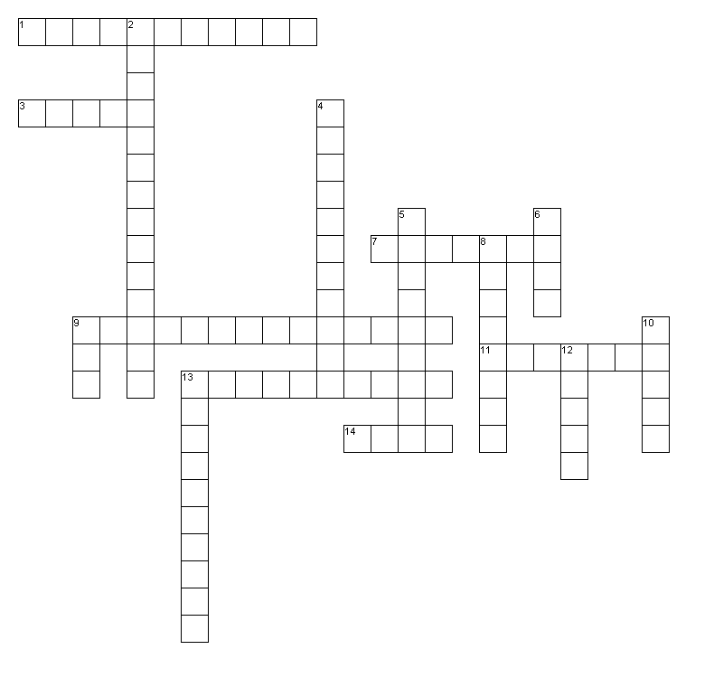
Across
1. What word can we use to define China's desire to be independent and self controlled?
3. The French let the British take this area in return for their friendship.
7. France took this area in Northern Africa from Italy causing Italy to ally with Germany.
9. Germany, Austria-Hungry, and Italy together make up what?
11. Germany challenged France twice for this land.
13. The British acquired this area in Southern Africa from Holland.
14. What mineral was discovered causing people to suddenly take an interest in Africa?

Down
2. What kind of policy did the U.S. suggest regarding Chinese trade?
4. The British wanted a railway from "where to where"?
5. By using this, the British could avoid sailing all the way around Africa.
6. Before exploration, Africa was known as the "___ continent."
8. Europe's intense colonization of Africa was known as the _______ for Africa.
9. This Chinese item didn't need any preparation before it could be sold.
10. Chinese rebellion in 1900.
12. Britain went to war resulting in this item to be imported into China.
13. What did China's large population mean in terms of native employment?

