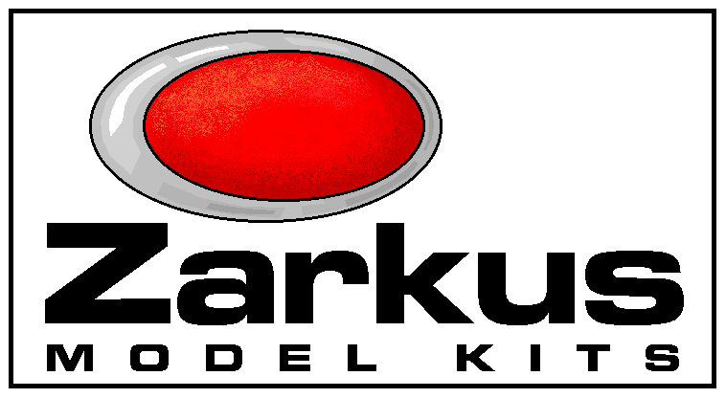

AAT
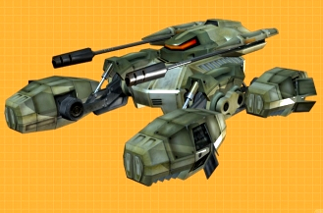
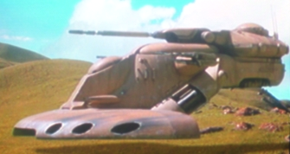
GAT
1888 BOWERS RD.
LAPEER, MI 48446
ZARKUS@IWON.COM

TX-130 SABRE-CLASS “FIGHTER TANK” 1/32 SCALE

THE POWERFUL AAT TANKS OF THE TRADE FEDERATION PROVED THEIR WORTH DURING THE INVASION OF NABOO. ACCOMPANIED BY SMALLER GAT’S, THEY QUICKLY DECIMATED ROYAL FORCES. WHEN THE TRADE FEDERATION JOINED THE CONFEDERATION OF INDEPENDANT SYSTEMS, REPUBLIC GENERALS SOUGHT OUT NEW WEAPONS SHOULD THEIR PATHS LEAD TO WAR. A REQUEST WAS MADE FOR A VEHICLE THAT COULD COUNTER THEIR MASSIVE DROID FORCES.

TX-130J, GEONOSIS
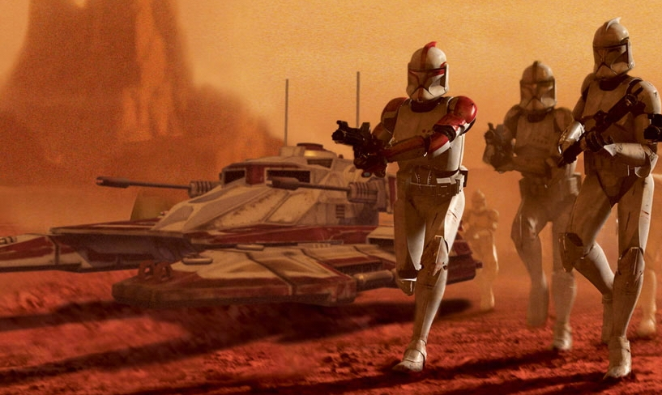
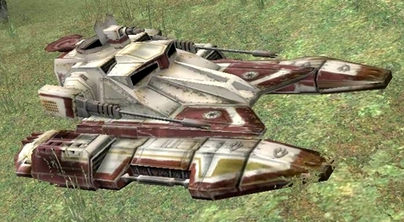
ROTHANA HEAVY ENGINEERING WAS AWARDED MANY CONTRACTS INCLUDING THE TX-130 SABRE-CLASS “FIGHTER TANK”. WHILE THE AAT WAS DESIGNED TO ASSAULT FORTIFIED POSITIONS HEAD-ON, RELYING ON THICK ARMOR AND MASSIVE PAYLOAD, “FIGHTER TANKS” WERE DESIGNED TO BE SWIFT, LIGHT, AND MANUEVERABLE. THE SABRE-CLASS’ MAIN TARGET WAS OTHER TANKS. INSTEAD OF THICK ARMOUR, IT CARRIED AN EXPERIMENTAL “PHASE 3 EXO-SHELL” SHIELD GENERATOR COMBINED WITH A LOW TARGET-PROFILE AND ANGULAR WALLS TO HELP DEFLECT BLASTS. THE MAIN HULL’S BLADE-LIKE LEADING EDGE WAS DESIGNED TO SLICE THROUGH DROID PLATOONS WITH EASE. IT HAD 2 MEDIUM LASER CANNONS IN A STURDY Z-AXIS ARRANGEMENT. PILOTS RELIED ON “CIRCLE-STRAFING” TECHNIQUE TO OUT-MANUEVER THEIR OPPONENT. IT HAD A STANDARD COMPLIMENT OF TWO MISSILE PODS CONTAINING 8 THERMAL DETONATOR ROCKETS EACH. A SPECIAL TURBO BOOST COULD BE ENGAGED FOR BRIEF BURSTS OF SPEED. EARLY MODELS HAD A FIXED TWIN BLASTER NEAR THE TOP HATCH. LESSONS LEARNED AT THE BATTLE OF GEONOSIS WOULD LEAD TO REPLACING THE TOP GUN WITH A 360* ROTATING BEAM WEAPON, CAPABLE OF BURNING THROUGH MULTIPLE TROOPS AT ONCE. JEDI PILOTS PREFERRED AN ASTROMECH DROID SOCKET INSTEAD OF A TOP GUNNER, RELYING ON THEIR FORCE POWERS FOR EXTRA PROTECTION (TX-130J).

TX-130S, KASHYYK

TX-130A, GEONOSIS
THE SABRE-CLASS TANK SERVED FOR MANY YEARS WITH THE GALACTIC EMPIRE AFTER THE FALL OF THE REPUBLIC . SOME CAN STILL BE FOUND AT OUTER RIM OUTPOSTS. YOUR KIT REPRESENTS THE MOST COMMON VARIANT, THE TX-130S (IFT-T, IMPERIAL DESIGNATION).
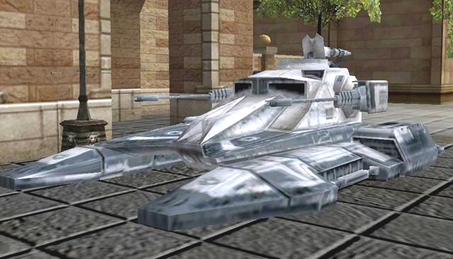

IFT-T, NABOO

IFT-T, TATOOINE

TX-130S, NABOO

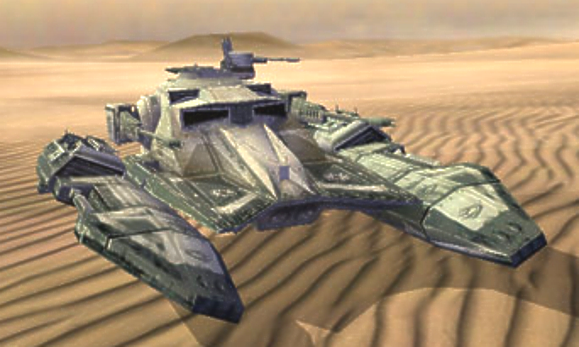

TIPS
*Wash parts with mild laundry soap for better paint adhesion, AS PARTS MAY HAVE RELEASE AGENT OR TALC RESIDUE.
*DUE TO THE NATURE OF RESIN (AIR BUBBLES, SEAMS, RELEASE AGENT, ETC.), A PRIMER COAT IS HIGHLY RECOMMENDED TO UNCOVER SUFACE FLAWS.
*Some parts are easier to paint before assembly.
*Study assembly drawings and test-fit parts before using glue.
*Use "super glue" to adhere parts OR EPOXY(STYRENE GLUE WON’T WORK). yOU CAN ALSO USE ELMER’S OR WHITE JEWELER’S GLUE FOR ATTACHING RAILING DETAILS. IT CLEANS UP WITH A Q-TIP AND WATER.
*Wear proper RESPIRATORY equipment when sanding resin or painting.
*If parts are warped, try placing them in warm water and gently bending them back.

NOTE:
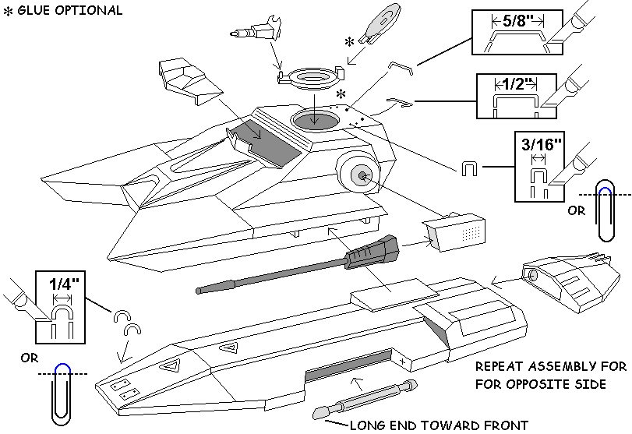
USE THE ENCLOSED FLORAL WIRE TO FORM ANY RAILING YOU DESIRE. YOU CAN GET MORE FROM YOUR LOCAL CRAFT STORE OR THE CRAFT SECTION OF YOUR LOCAL WAL-MART. YOU CAN ALSO USE THE ENCLOSED PAPER CLIPS FOR SOME DETAILS. WIRE-CUTTERS OR SMALL BOLT-CUTTERS ARE BEST FOR CUTTING, BUT A HOBBY KNIFE WITH A #16 BLADE CAN BE USED TO SCORE AROUND THE WIRE, THEN WIGGLE THE PIECES APART. NEEDLE-NOSE PLIARS ARE HELPFUL TO ACHIEVE SHARPER CURVES. THE ORIGINAL CLONE WARS VERSION HAD ANTENNAS, WHEREAS THE BATTLEFRONT VERSION DID NOT. IT COULD BE THEORIZED THAT THEY ARE RETRACTIBLE AND ONLY EXTENDED FOR LONG RANGE COMMUNICATION. I LEFT THE BASES WHERE THEY ATTACH, AND YOU CAN DECIDE WHETHER TO INCLUDE THEM OR NOT. TRY USING GUITAR STRING OR OTHER THIN WIRE.

PAINT SCHEME IDEAS
SEE PAGE 1 PICS FOR MORE PAINTING INFO

OVERALL COLOR IS A DIRTY FLAT WHITE OR FLAT LIGHT GRAY.

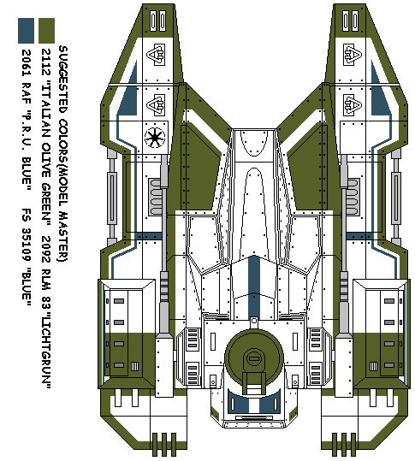
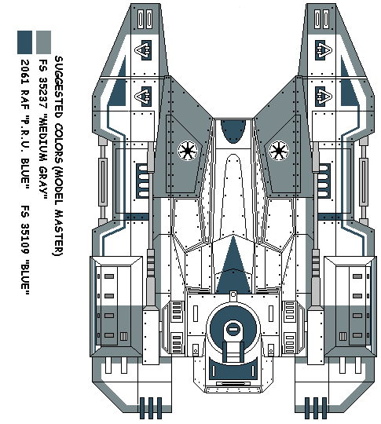
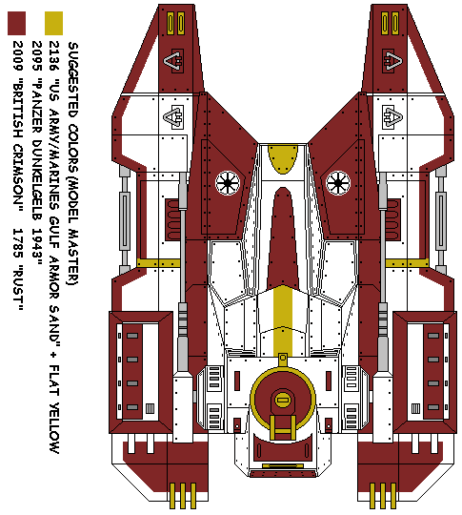
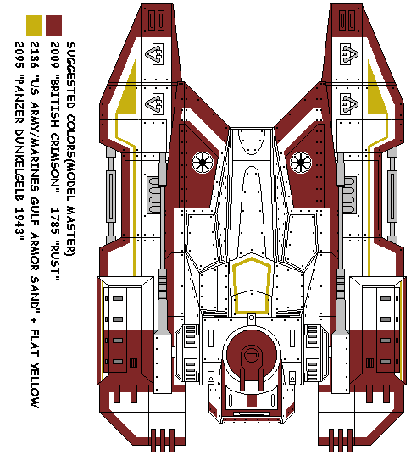

CORUSCANT ELITE GUARD

BATTLE FOR MYGEETO

TATOOINE OUTPOST

STANDARD REPUBLIC SCHEME

