

1888 BOWERS RD. LAPEER, MI 48446 USA
WWW.ANGELFIRE.COM/ART/ZARKUS/ZARKUSMODELKITS.HTML EMAIL: MARKKOZIK@YAHOO.COM

NOTE TO MODELERS: INFORMATION ON THE HAG DIFFERS FROM SOURCE TO SOURCE CONCERNING ITS SIZE, ARMAMENT, SPEED, HISTORY, ETC. PHYSICAL DETAILS ALSO CHANGE FROM THE ORIGINAL “CLONE WARS” GAME, THE PRIMA OFFICIAL STRATEGY GUIDE, AND OTHER CGI REPRESENTATIONS. I’VE INCORPORATED A BIT OF EVERYTHING, AS WELL AS MY OWN IDEAS. I HOPE YOU ENJOY THIS INTERPRETATION OF YET ANOTHER COOL SW CRAFT.
H.A.G. (HEAVY ARTILLERY GUN); MEDIUM CLASS 1/72 SCALE MODEL KIT

“HAG” IS A GENERIC TERM APPLIED TO MANY TRADE FEDERATION SELF-PROPELLED GUNS(MORTAR TANKS). THE EARLIEST AND LARGEST CLASS OF HAGS WERE BASED OFF THE MTT CHASIS. ALTHOUGH THEIR FIREPOWER WAS DEVASTATING, THEIR SIZE AND LIMITED MOBILITY RESTRICTED THEIR TACTICAL USEFULNESS. THEY WERE MOSTLY RELEGATED TO ATTACKING LARGE FORTIFICATIONS AND OTHER FIXED TARGETS. THE TRADE FEDERATION REQUESTED A NEW DESIGN FROM THE BACTOID ARMOR WORKSHOP THAT WAS EASIER TO MANUFACTURE AND TRANSPORT, MORE MOBILE AND ADAPTIBLE TO CHANGING BATTLEFIELD CONDITIONS.

THE RESULTING “MEDIUM CLASS” HAG BECAME A MAINSTAY FOR CIS FORCES THROUGH THE END OF THE CLONE WARS. AT 15.5 METERS IT WAS ABOUT HALF THE SIZE OF EARLIER HAGS AND WAS ABLE TO SUPPORT AAT’S AND GAT TANKS OPERATING IN MORE CONFINED ENVIRONMENTS. IT HAD A TOP SPEED OF 42 KPH (27 MPH), WHICH WAS LESS THAN THE AAT, BUT WAS ENOUGH TO KEEP UP WITH ARMORED SUPPLY COLUMNS. IT WAS COMPLETELY AUTOMATED, USING A CENTRALIZED COMPUTER BRAIN. HOWEVER, SOME TANKS WERE FITTED WITH A SMALL FIGHTING COMPARTMENT TO HOUSE A CREW OF 3 (DRIVER, GUNNER, AND COMMANDER), WITH THE AUTOMATIC LOADING SYSTEM BEING RETAINED. THIS WAS THE RESULT OF BATTLEFIELD REPORTS SUGGESTING THAT INDEPENDENT OPERATORS (WHETHER DROID OR LIVING) WERE ESSENTIAL FOR EFFECTIVE COORDINATION OF STRIKES. THESE BECAME KNOWN AS “COMMAND” MODELS.

A STANDARD PAYLOAD FOR THE HAG CONSISTED OF 120 ENERGY-BASED SHELLS. ITS 8 INCH ARC-TRAJECTORY CANNON COULD LAUNCH A WARHEAD 25,000 YARDS. IT USED POWERFUL REPULSOR ANCHORS TO RESTRICT RECOIL DISPLACEMENT WHEN FIRING. IT HAD THICK FRONTAL AND SIDE ARMOR PLATING, BUT WAS VULNERABLE TO ATTACK FROM ABOVE AND TO THE REAR. EARLY VERSIONS HAD A LIGHT TWIN BLASTER FOR ANTI-INFANTRY PROTECION, BUT THIS PROVED OF LITTLE VALUE. DEFENSIVE WEAPONRY WAS UPGRADED TO A LIGHT ANTI-VEHICLE CANNON PLUS A RAPID-FIRE GRENADE LAUNCHER.

VARIOUS IMPROVEMENTS WERE MADE TO THE SERIES, SUCH AS THE HAG-M AND THE HHAG-M, BUT MANY REPULSOR-BASED VEHICLES WERE PHASED OUT AT THE BEGINNING OF THE GALCATIC EMPIRE IN FAVOR OF WALKERS, SUCH AS THE NEW AT-XT.
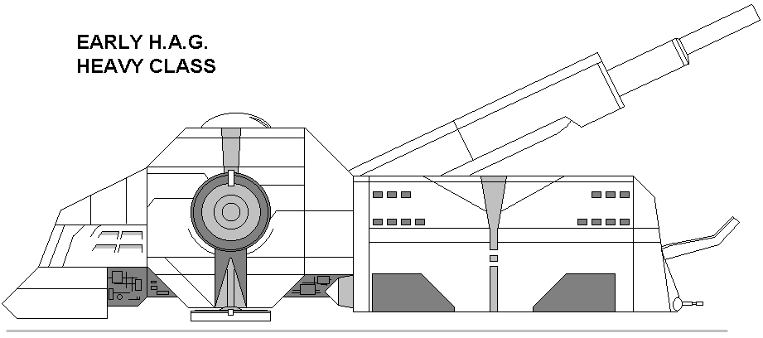
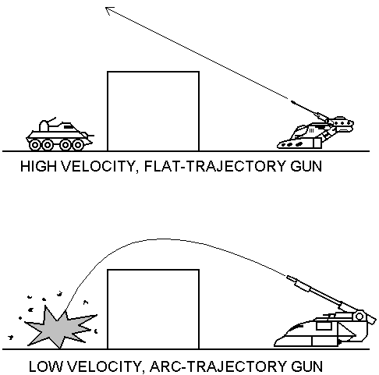

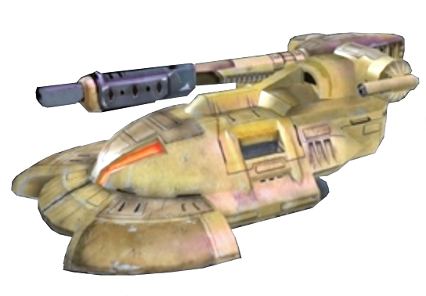
REPULSOR EMITTERS
TRANSPORT CLAMPS
POWER CONVERTER
GRENADE LAUNCHER
LIGHT ANTI-VEHICLE CANNON
(STARBOARD SIDE)
SIGNAL RECIEVER
MAIN GUN
(8-INCH HOWITZER)
SOLID ROUND STORAGE
MAIN REPULSOR GENERATORS
MULTI-SPECTRAL
OPTICAL SIGHTS
SHIELD
GENERATOR
ENERGY ROUND
GENERATOR

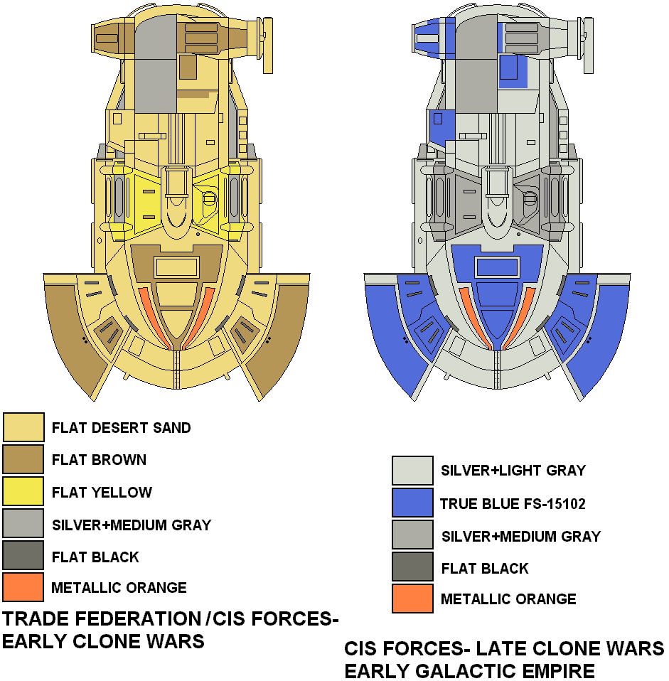

ASSEMBLY

TIPS
*Wash parts with mild laundry soap for better paint adhesion, AS PARTS MAY HAVE RELEASE AGENT OR TALC RESIDUE.
*DUE TO THE NATURE OF RESIN (AIR BUBBLES, SEAMS, RELEASE AGENT, ETC.), A PRIMER COAT IS HIGHLY RECOMMENDED TO UNCOVER SURFACE FLAWS.
*I RECOMMEND PAINTING THE INDIVIDUAL PARTS FIRST before assembly.
*Study assembly drawings and test-fit parts before using glue.
*Use "super glue" to adhere parts (STYRENE GLUE WON’T WORK).
*Wear proper RESPIRATORY equipment when sanding resin or painting.
*If parts are warped, try placing them in warm water and gently bending them back.

NOTE:
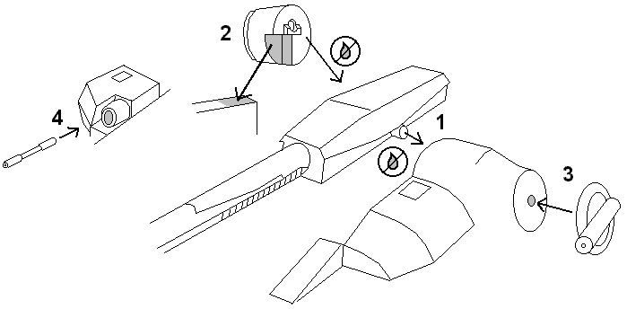
USE THE ENCLOSED FLORAL WIRE TO FORM ANY RAILING YOU DESIRE. YOU CAN GET MORE FROM YOUR LOCAL CRAFT STORE OR THE CRAFT SECTION OF YOUR LOCAL WAL-MART. WIRE-CUTTERS OR SMALL BOLT-CUTTERS ARE BEST FOR CUTTING, BUT A HOBBY KNIFE WITH A #16 BLADE CAN BE USED TO SCORE AROUND THE WIRE, THEN WIGGLE THE PIECES APART. NEEDLE-NOSE PLIARS ARE HELPFUL TO ACHIEVE SHARPER CURVES. I’VE FOUND IT EASIER TO HANDLE RAILING IF I DRILL THE HOLES DEEPER- THEN I DON’T HAVE TO WORRY ABOUT CUTTING THE INSERTED WIRE SECTIONS TO ANY EXACT LENGTH. THIS ALSO MAKES THE RAILING STURDIER AND LESS PRONE TO BREAK OFF.

